# Uncertainties Experiment 1

**Title Marbles and Cups**

**Apparatus** A4 card, A3 paper, masking tape, ruler with groove, marble, plastic cups, sharp pencil.

**Instructions**

* Draw graph axes on the A3 paper. The space left below the x-axis should be slightly greater than the diameter of a cup, see Figure 1.

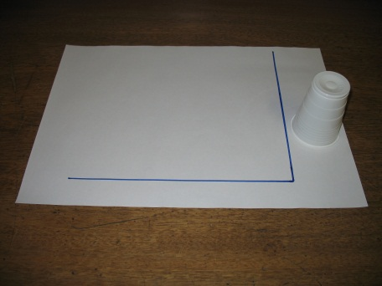

Figure 1: Axes drawn on the A3 paper

* Fold the A4 card into a triangle and tape together with the masking tape, see Figure 2.

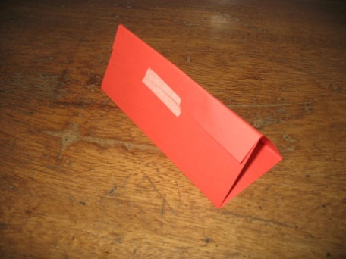

Figure 2: A4 card folded and taped to form the support for the ruler.

* Lean the ruler on the card triangle to make a ramp.
* Rest the bottom end of the ruler on the A3 paper.
* Decide on the independent variable to be investigated.
* Place an upside-down cup with the hole at the bottom end of the ruler and the edge opposite the hole on the graph axis, see Figure 3.

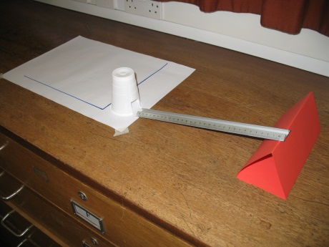

Figure 3: Ramp aligned to allow a marble to roll into the cup.

* Release a marble on the ruler so it rolls down the ruler into the cup, see Figure 4.

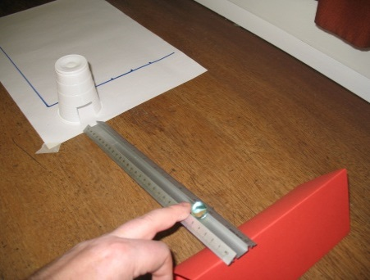

Figure 4: Releasing a marble on the ramp.

* The marble pushes the cup along the A3 paper.
* Mark the position of the furthest edge of the cup on the A3 paper, see Figure 5.

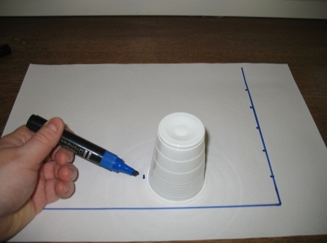

Figure 5: Marking the position the cup has been pushed to by the marble.

* Repeat an appropriate number of times and for an appropriate number of values of the independent variable.
* Plot a line of best fit.

**Issues to consider**

* Repeatability and reproducibility of measurements
* Random uncertainties
* Comparison of absolute and percentage uncertainties

# Uncertainties Experiment 2

**Title Density of Glass from a Microscope Slide**

**Apparatus** Microscope slides, micrometer, vernier callipers, top-pan balance.

**Instructions**

* Using the measuring instruments available, measure the dimensions (length, breadth and thickness) of a glass microscope slide.
* Record the results and estimate the uncertainty attached to each of these measurements. Consider the reading, calibration and random uncertainties for each measurement.
* Find the mass of the microscope slide using the top-pan balance. Again estimate the uncertainty associated with this measurement of mass.
* Calculate a value for the density of glass.
* Give your final answer in the form: density value ± uncertainty.
* In your report show clearly how you arrived at your estimate of uncertainty in volume, mass and density.
* Look up a data book and find a value for the density of glass. Compare your answer to those listed in the data book.

**Theory** 

# Uncertainties Experiment 3

**Title Density of Steel from Ball Bearings**

**Apparatus** Ball bearings, micrometer, vernier callipers top-pan balance.

**Instructions**

* Using the measuring instruments available, measure the diameter of one of the ball bearings
* Record the results and estimate the uncertainty in the measurement of diameter.
* Calculate the volume of the ball bearing.   
  Give your value for the volume in the form: value ± uncertainty.
* Find the mass of the ball bearing using the top-pan balance. Again estimate the uncertainty associated with this measurement of mass.
* Calculate a value for the density of the ball bearings.
* Give your final answer in the form: density value ± uncertainty.
* In your report show clearly how you arrived at your estimate of uncertainty in volume, mass and density.
* Look up a data book and find a value for the density of steel. Compare your answer to those listed in the data book.

**Theory** *Density* () = *Volume of sphere* =  *r*3

# Uncertainties Experiment 4

**Title The Travelling Microscope**

**Apparatus** Travelling microscope,  
double slit slide (from Young’s Interference Experiment),  
low voltage bulb and battery.

**Instructions**

* Place the double slit slide on the stage of the microscope. Focus the cross hairs in the objective of the microscope on the edge of one of the slits ruled on the slide (see below).
* If illumination is a problem try to put the low voltage bulb beneath the microscope stage below the position of the slide. The edge of the slit rulings may now be visible.
* Read this position on the vernier scale.
* Now rack the microscope along the frame until the crosshairs are at the point which gives the slit separation (see below).
* Read the new position on the vernier scale. To avoid backlash in the mechanism, do not rack the microscope back and forth; i.e. only move it in one direction when taking both readings.



* Find the separation.
* Estimate the uncertainty in the slit separation.
* Give your final answer in the form: separation ± uncertainty.
* In your report show clearly how you arrived at your estimate of uncertainty in the slit separation

# Uncertainties Experiment 5

**Title The Simple Pendulum**

This activity illustrates a graphical method to arrive at a measurement of a physical constant - the acceleration due to gravity.

**Apparatus** Pendulum bob, string (preferably fishing line), stopwatch, clamp stand, metre stick.

**Instructions**

* Set up a length of string around 1.5 to 2 metres long and clamp it so that a pendulum bob tied to the end can swing freely.
* Time 20 complete to and fro small amplitude swings. This is best done by placing a vertical mark behind the rest position of the pendulum bob and starting the stopwatch as the bob obscures the mark: this is time zero and swing number zero. Stop the timer after the 20th swing as the bob passes the mark in the same direction.
* Repeat this timing and take an average of the two times.
* Measure the length, L, of the pendulum, taking care to measure the length from suspension point to the centre of the bob.
* Decrease the length of the pendulum in approximately 0.10 m steps, repeating the timing of different oscillating lengths.
* Do not allow the swings to become elliptical - if this happens stop the measurements and repeat with the pendulum swinging in one plane.
* When the graph has been plotted use the “parallelogram” method to estimate the uncertainty in the gradient. From this, the uncertainty in “g” can be found.
* Give your final answer in the form: value ± uncertainty.
* In your report show clearly how you arrived at your estimate of uncertainty in the value of “g”.

**Theory** From simple harmonic motion, the period of oscillation of a pendulum of length L is given by: T = 2

Thus T2 = 4 2 = L

If a graph of T2 against L is plotted the gradient will be numerically equal to , from which a value for “g” can be calculated.

Note that T2 should be on the ordinate (i.e. y - axis) and that L should be the abscissa (i.e. x - axis).

# Uncertainties Experiment 6

**Title Density of Mystery Material using a graphical method**

**Apparatus** Mystery Density Set (15 rods of constant cross-sectional area and different lengths), micrometer, vernier callipers, top-pan balance.

**Instructions**

* Using the measuring instruments available, measure the diameter of the rods.
* Calculate the mean diameter and the overall uncertainty in the diameter.
* Calculate the cross-sectional area and the overall uncertainty in the cross-sectional area.
* Using the measuring instruments available, measure the length and mass of all the rods.
* Plot a graph of mass (y axis) against length (x axis).
* Use the “parallelogram” method to determine the gradient and its uncertainty, as well as the y-intercept and its uncertainty. Uncertainties for individual length and mass values are not required when the “parallelogram” method is used but could be calculated and used to plot uncertainty bars on individual points on the graph.
* As the gradient is mass divided by length, the density is gradient divided by cross-sectional area. Calculate the gradient.
* Use the gradient and cross-sectional area to find the density with its uncertainty.

**Theory** *Density* () = = = 

*Area of circle* =  *r*2