Excel is a powerful graphing and charting tool, but it requires some work to make its output suitable for AH assignments. Your graphs will be judged against the same criteria as hand-drawn graphs, and so they have to be drawn to the same standards. This guide will address the main points of making your graph presentable: layout; points; scales; line/curve; error bars.
time (seconds) | activity (becquerels)
0 | 160
10 | 125
20 | 80
30 | 63
40 | 40
50 | 32
60 | 20
70 | 16
80 | 10
90 | 8
100 | 5

Table 1

All of the screen grabs will use table 1 as the source data for the graph.

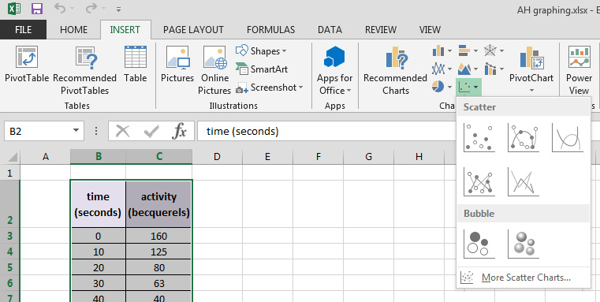
To insert a graph or chart, select the ‘Insert’ menu to see your options.
For a ‘traditional’ graph, choose ‘Scatter’ and then select the sub-type you prefer. The left-most two options are the most likely. If you are looking for a trend in your graph, select the top left option. If you want a ‘join the dots’ line graph, choose the bottom left option.

Selecting the top left option gives the graph shown below.
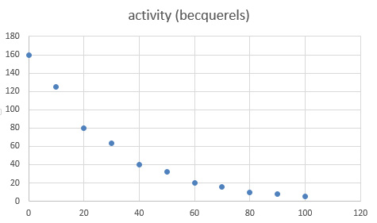
Layout
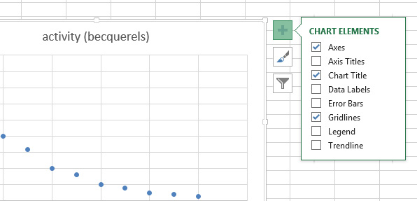
There are several improvements we can make to have our graph look more like what we’d like. We can turn off the title to start with, as we probably don’t need it. We also need to add axis titles and gridlines. To do all of this, click anywhere on your graph to select it. Now click on the ‘plus’ option that has appeared to the right of your graph.
This brings up a submenu where you can change various options:
- chart title – Uncheck ‘chart title’ on the menu.
- axis titles – Check the ‘axis titles’ box. Titles should appear for each axis – they say ‘axis title’ for now. Select each of these and edit it to show your variable and its unit.
- gridlines – Hover over ‘gridlines’ in this menu. An arrow will appear at the end of the entry – click on this to reveal other options. Choose to display major and minor gridlines for both axes.

By default, Excel displays the gridlines in a pale blue colour that won’t print out well at all. You will need to change the colour of all the gridlines to a darker colour. Black is good, but a dark grey for major gridlines and a lighter grey for minor gridlines works well. Follow these instructions to change the colours:
- Click anywhere on your graph to select it.
- Click on the ‘plus’ option that has appeared to the right of your graph.
- Hover over ‘gridlines’ in the menu that appears.
- An arrow will appear at the end of the entry – click on this to reveal other options.
- Choose ‘more options’ – this will open a sidebar on the right hand side of the screen.
You will use this sidebar to set the colour and width of major gridlines, minor gridlines, and axes. Instructions for doing this are overleaf.
- Set the axes to black.
- Set the major gridlines to a dark grey.
- Set the minor gridlines to 2 shades of grey lighter than the major gridlines.

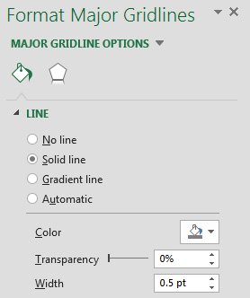
Use this option to select axis, major gridlines and minor gridlines for both horizontal and vertical. (Yes, you need to do this 6 times in total!)

Select your colour here.

Set the line width to 0.5 pt for gridlines and leave it at 0.75 pt for the axes.

This should have your graph looking more like you need it to.
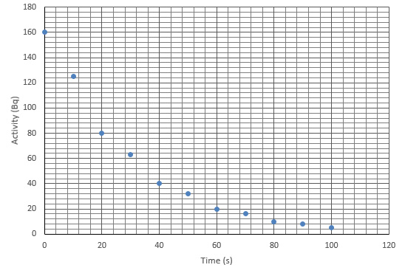

Points

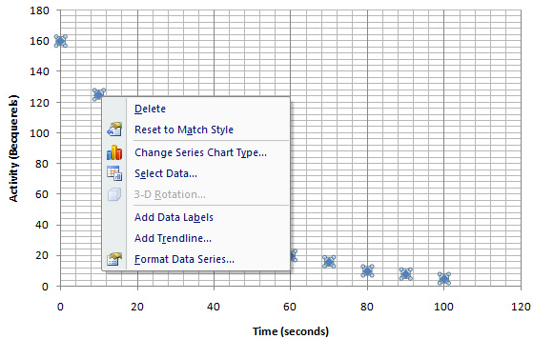
By default, Excel uses blobs to mark points on a graph. This is not accepted by the SQA – they can’t check the accuracy of your points. We have to tell Excel to use crosses to mark points. While we are making changes, we’ll change the colour of the points to black or red so that they stand out.
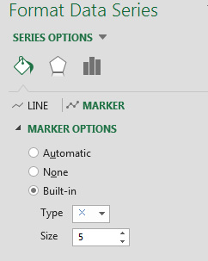
First, right-click one of the data points on your graph. This can be tricky to do, but when you manage it, you’ll have a menu as shown above. Select ‘Format Data Series…’ and this will open a sidebar on the right hand side of the screen.
Choose ‘Fill and Line’ from the row of 3 icons.
Choose ‘marker’.
Choose ‘Marker Options’.
Select ‘built in’ and choose the cross from the drop down menu as shown.

The option to change the cross colour is further down the same sidebar:
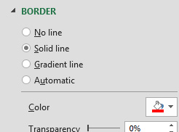
Select ‘solid line’.

Select the colour – red for screen, black for print is a good guideline.

Your graph should look like the one shown on the next page.
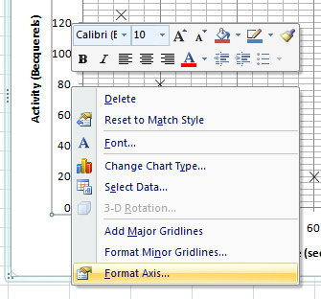
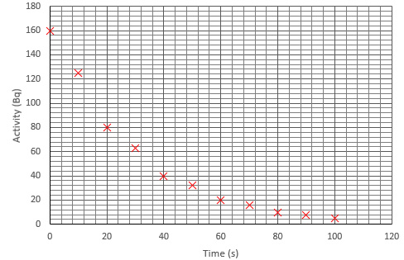
Scales
Excel chooses the scale to suit the size of graph and the values in your table. This won’t always suit; in particular, the origin may not be shown. You can override this behaviour and set your own major and minor gridline values, and maximum and minimum values shown.
First, right click on the values for an axis on your graph to pop up the menu shown. Select ‘Format Axis…’ and a new sidebar opens on the right hand side of your screen.

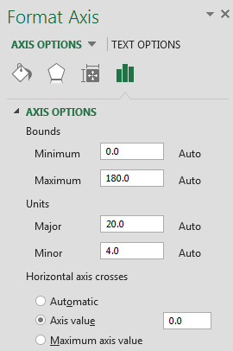

Set the minimum value to 0 if it isn’t already zero.

Leave the maximum value as is, or set it to whatever maximum you want for your graph.

Change the major and minor units if your gridlines are too close together or too far apart.

Change the horizontal axis to cross at 0 (middle option).

Remember to do this for both axes.

Line/Curve
Click anywhere on your graph to select it. Now click on the ‘plus’ option that has appeared to the right of your graph. This brings up a submenu where you can change various options.
You can add a trend line to your graph by hovering over ‘Trendline’ and clicking on the arrow that appears. There are several options. ‘Linear’ will give a best fit straight line. ‘Exponential’ will suit decay curves and certain other curves. For other graphs, play around with the options to see if anything suits. By default, the trendline is a pale blue dotted line. We need to change this.
Bring up the menu again, and this time choose ‘more options’ from the trendline drop-down. This will give you a sidebar to format the trendline.
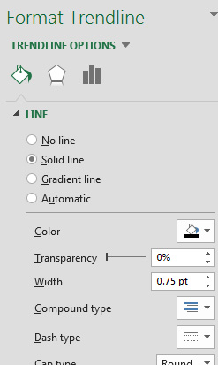
- Click on the icon for ‘fill and line’.
- Select ‘colour’ and choose black.
- Reduce the width of the line to 0.75 pt.
- Select ‘dash type’ and choose ‘solid line’.
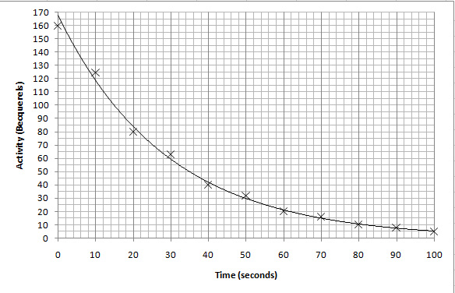
Error Bars
Click anywhere on your graph to select it. Now click on the ‘plus’ option that has appeared to the right of your graph.This brings up a submenu where you can change various options.
You can add error bars to your graph by hovering over ‘Error Bars’ and clicking on the arrow that appears. Select ‘More Options…’. This will open up the sidebar shown.
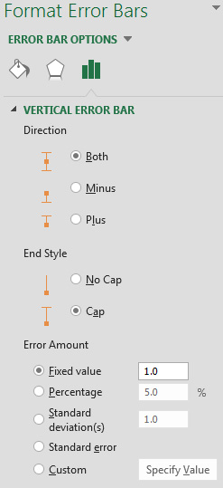
The dialogue box that opens will have the vertical error bars selected by default; if you want to edit (or delete) the horizontal error bars you will need to click on the ‘error bar options’ dropdown and choose ‘x error bars’ instead.
It is likely that you will be putting error bars on that will represent either a fixed value (± 0.5 Bq) or a percentage (± 10%). These can be filled in at the bottom of this dialogue.

Congratulations; your graph is now usable in your report!

