Setting up a template for AH Science INVESTIGATIONS

- Go to HOME
- Click on Change Styles
- Choose a style, don’t be too adventurous, I recommend Perspective, Formal, Thatch etc
- Now use your titles properly eg Title for the front page, Heading 1 for the next headings (eg headings given in the mark scheme) Use these correctly throughout the document
- Insert page numbers (click on insert on the top tab)
- Place at the bottom of the page (the marker shouldn’t but might miss it if it is at the top), again don’t be too fancy, you can make up your own if you wish but we are not marking graphic styles but ease of reading
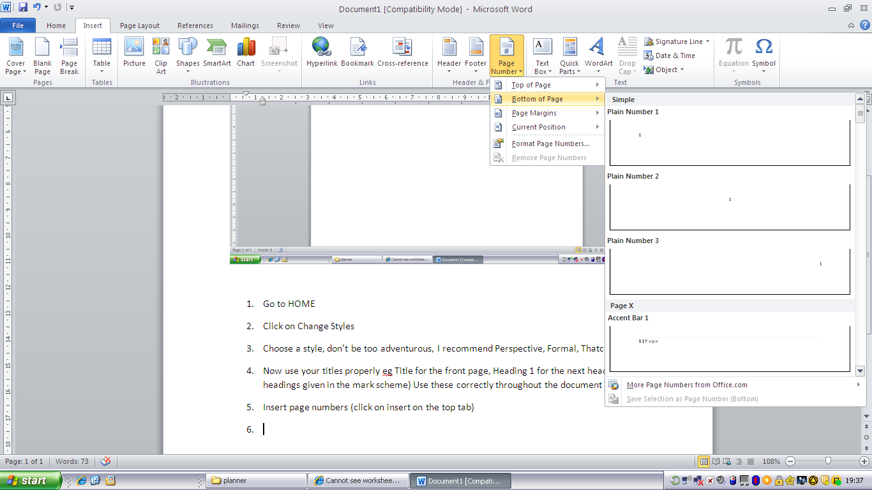
- Save this document as “Name- Subject- Invest”
- If you want to you can choose one of the cover pages given in insert cover page. 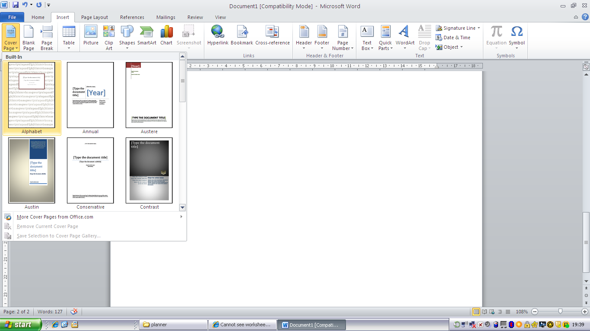
- Make sure that you include your NAME, SCHOOL, CANDIDATE No. TITLE of the PROJECT, the title is really important and often comes at the end.
- Add a header and footer. Put your name, SCN No. & School in the header, again don’t choose something too over the top.
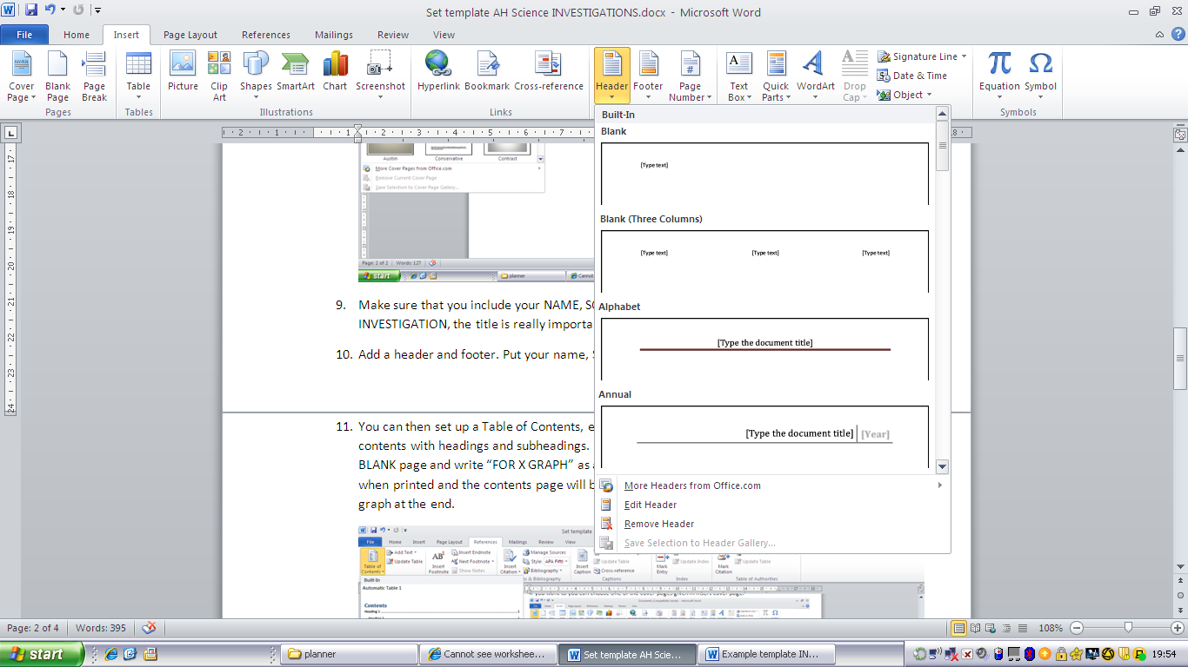
- You can then set up a Table of Contents, each time you refresh it will update your table of contents with headings and subheadings. If you are going to add hand drawn graphs leave a BLANK page and write “FOR X GRAPH” as a heading, this will then be correctly numbered when printed and the contents page will be in order. This page can then be replaced by the graph at the end.
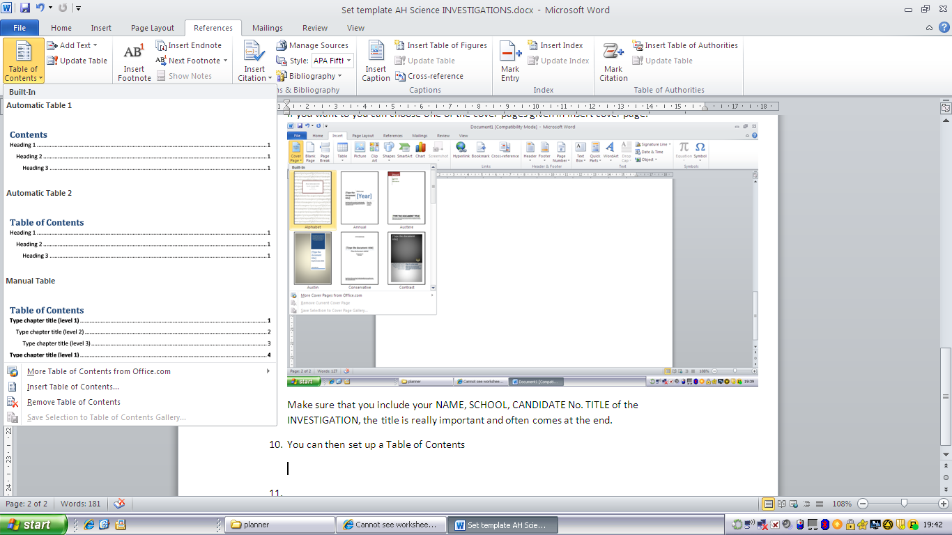
- Word 2010 will also correctly make up your references if you paste them in correctly. For Biology & Chemistry more than one reference is required. All references MUST appear in the text AND cross referenced at the back, not just in a footnote so beware. To set up a referencing system go to REFERENCE, insert citation. For book references page numbers must be included so that it is important to write these down during your research. They should be recorded in your daybook. This section should be called REFERENCES and not Bibliography. A bibliography are books that you have delved into during research, a reference is one that you have used.
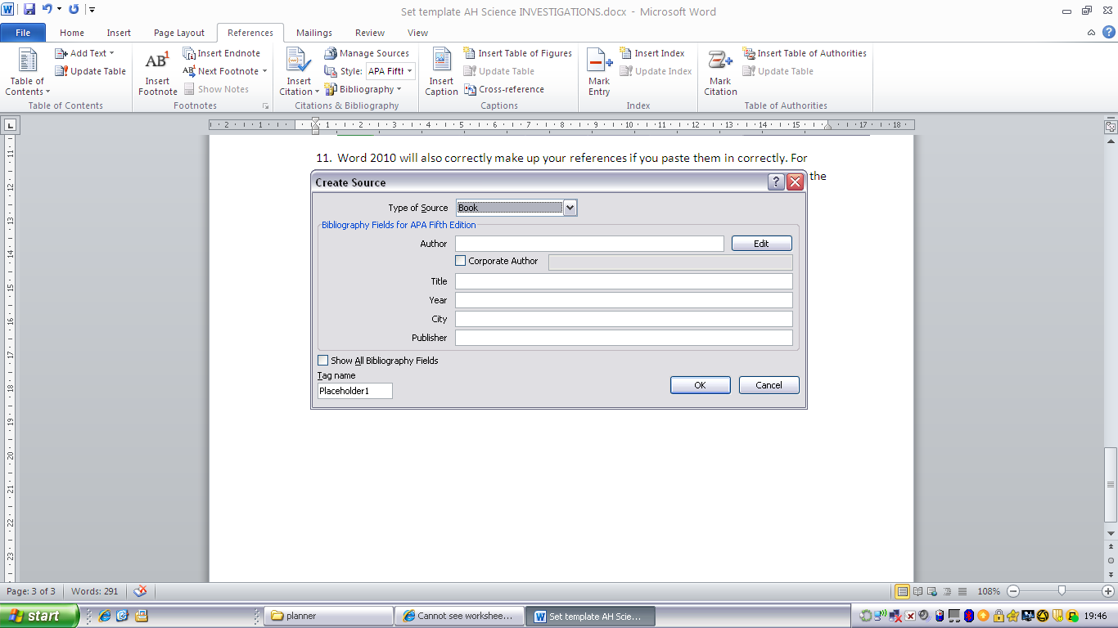

- Now keep adding in your work and updating. You can use different referencing systems to produce the work.
- Directly after the contents page you ought to have an Abstract or Summary. This MUST give your AIM, FINDINGS and CONCLUSIONS. In physics it should also have your uncertainties included. Do be careful about your title as choosing the wrong aim and title can lose you marks, subtle though it is, eg If I say to COMPARE different methods of measuring Surface Tension my Summary must include the methods I used to find the surface tension, the results that I got for each method and A COMPARISON. If my aim is to Find the Surface Tension by 3 different methods my Summary must have a list of the experiments I am doing, clearly named and explained as above but I do not need to state which method is the best or gave the most accurate answer etc. Often your aim will be tweaked at the write up stage but keep referring to it. Also your conclusions must match the aim, so again in the example above if you aim to compare then you must do this in your conclusion.
- See example

