**Use of Excel 2010 in AH Physics**

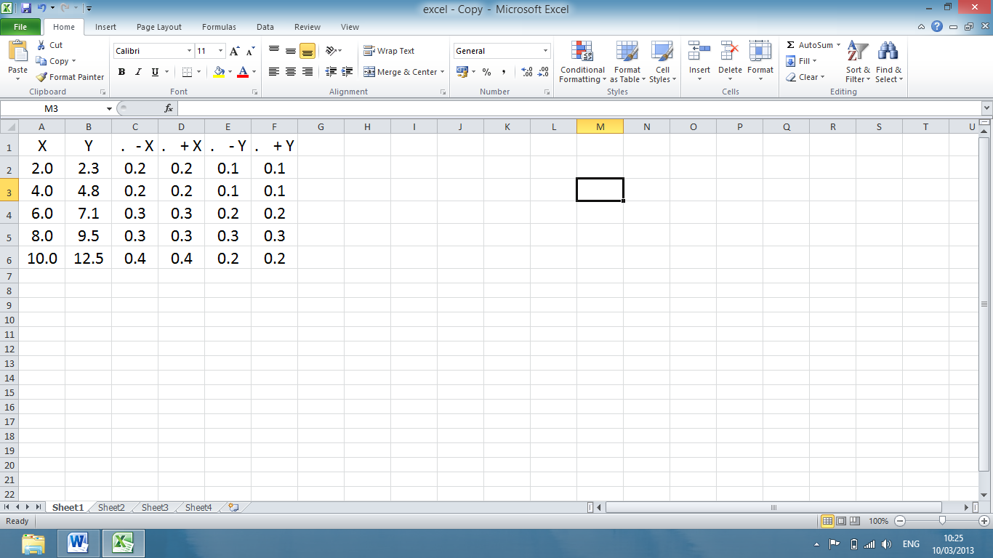

**Insert data, including uncertainties.**

**Full stop in front of uncertainties stops “arith. operation”.**

**Click on Home**

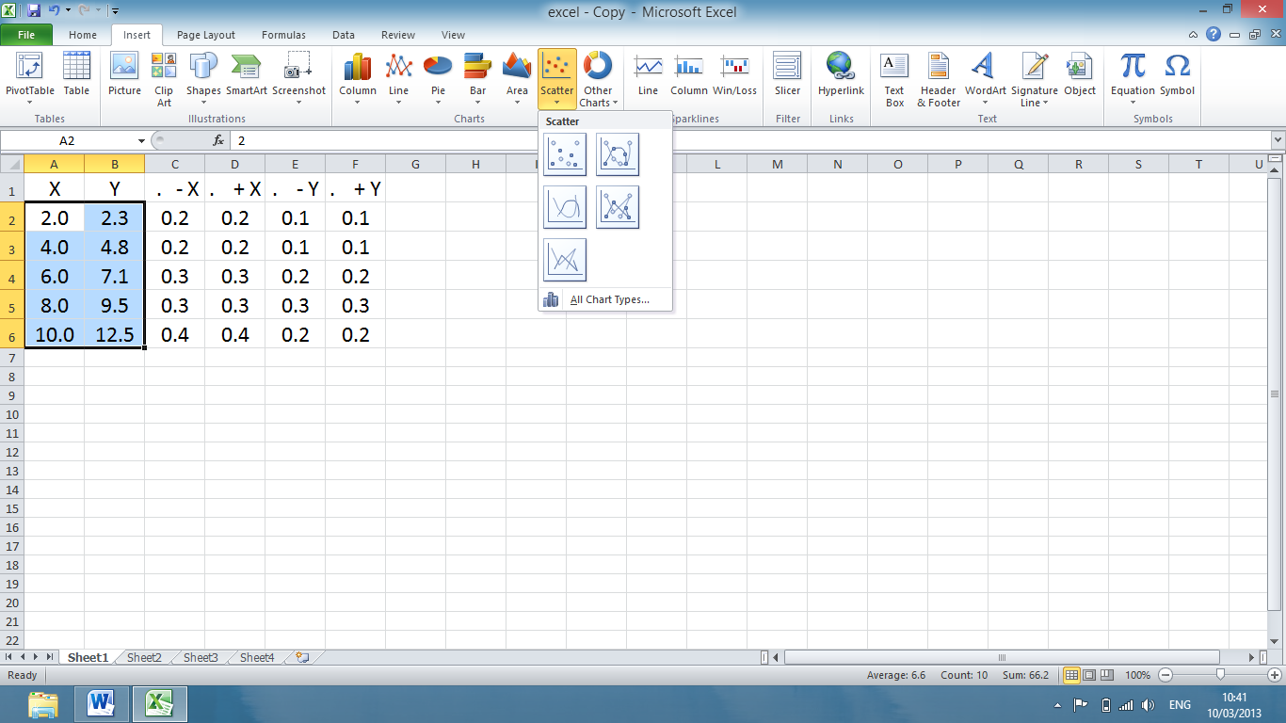

**Highlight data to be plotted.**

**Click on Insert, then select**

**“Scatter”**

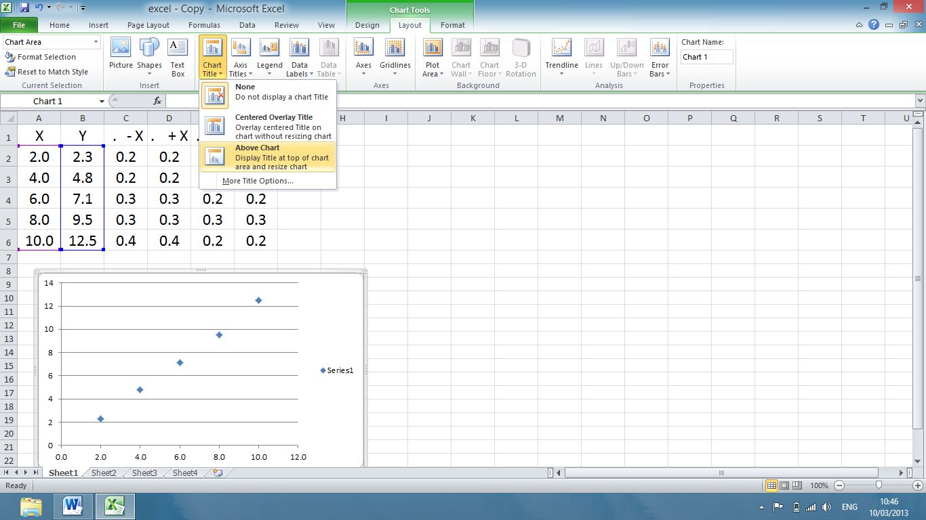

**Click on Legend – select none.**

**Ensure the graph has been selected.**

**Click on Chart Tools – Layout.**

**You can then insert Chart and Axes Titles and label axes with units.**

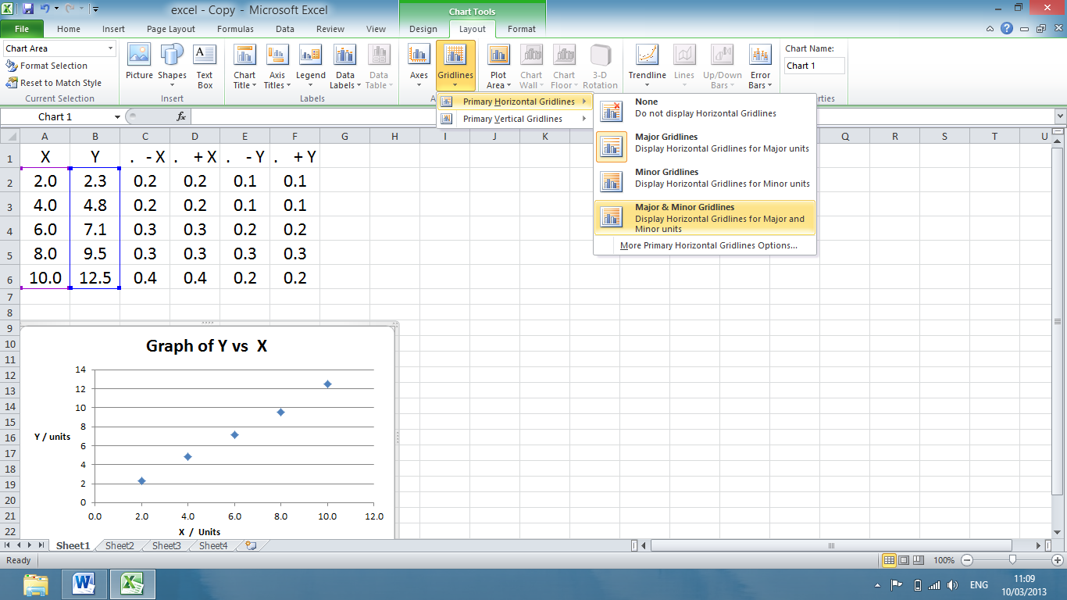

**Select Gridlines. Insert Major and Minor Gridlines – horizontal and vertical.**

**Again ensure the graph has been selected.**

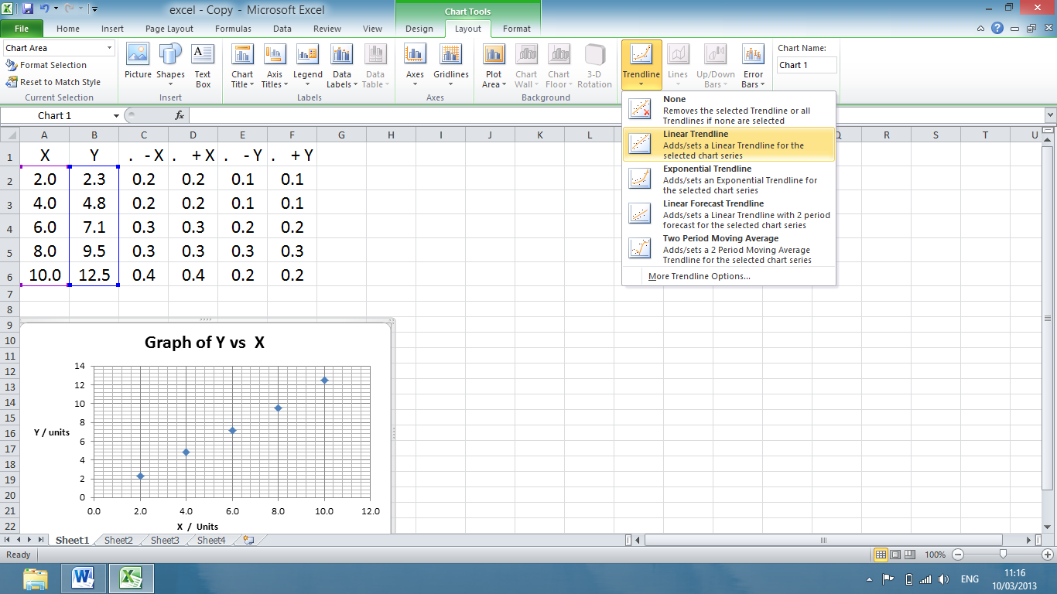

**Click on Trendline**

**Select “More Trendline Options”.**

**Select “linear” if appropriate.**

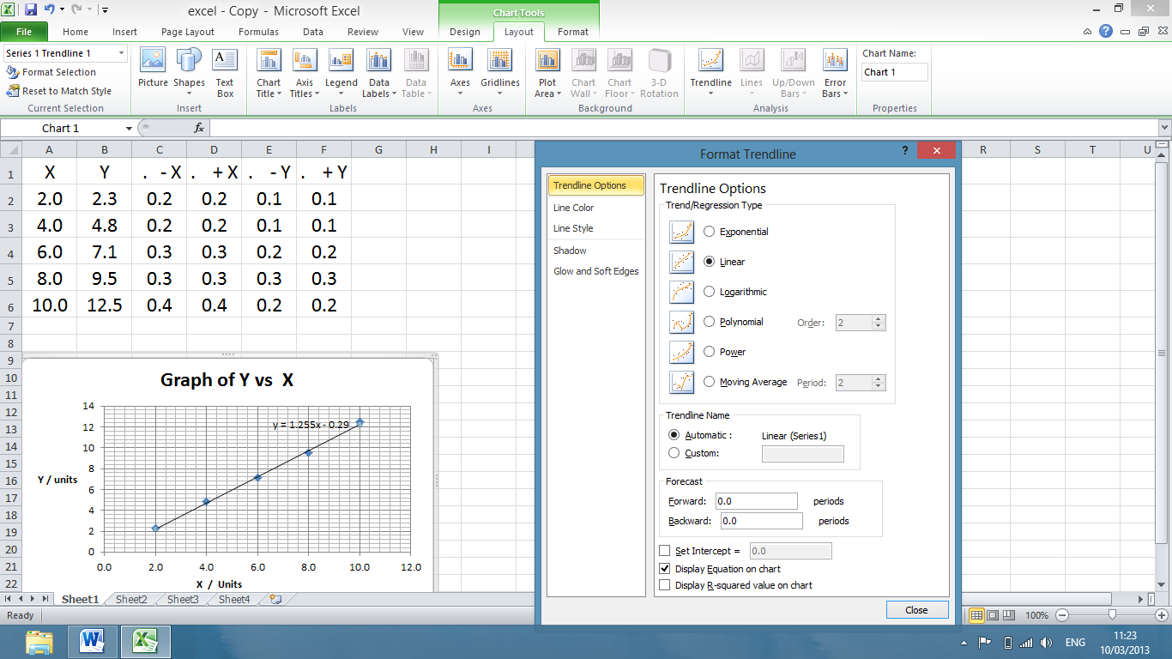

**Click on “Display Equation on Chart”**

**Custom Error Bars**

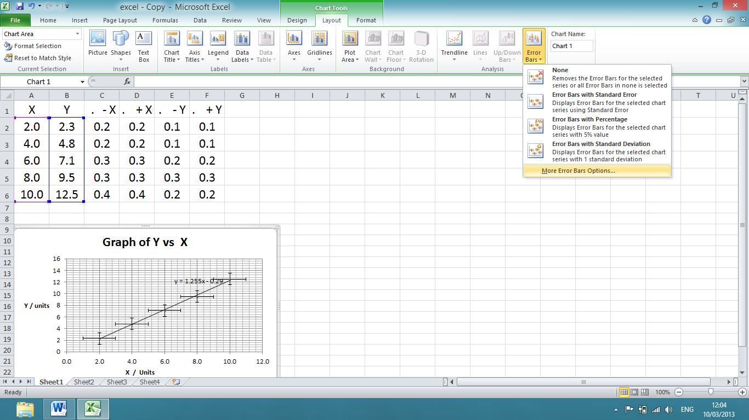

**Click on Error Bars – select More Error Bars Options**

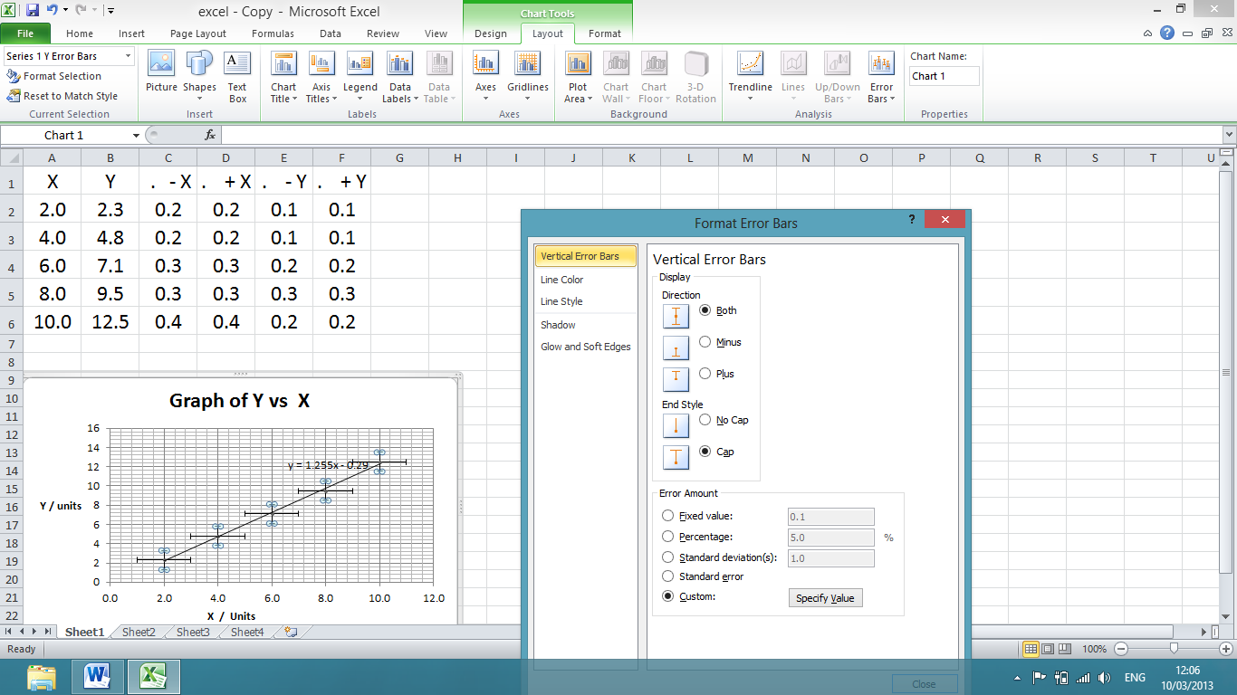

**Select Both**

**Click on Custom and then Specify Value**

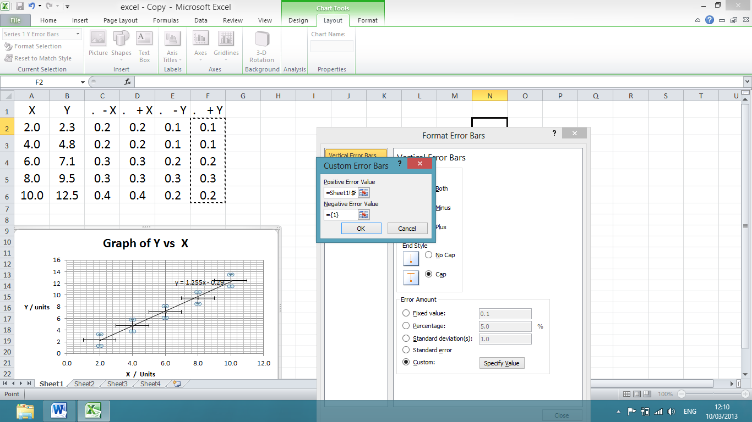

**Click to highlight data insertion box.**

**Click and drag down column to insert value of +Y in data box.**

**Repeat for Negative Error Value**

**Click Okay**

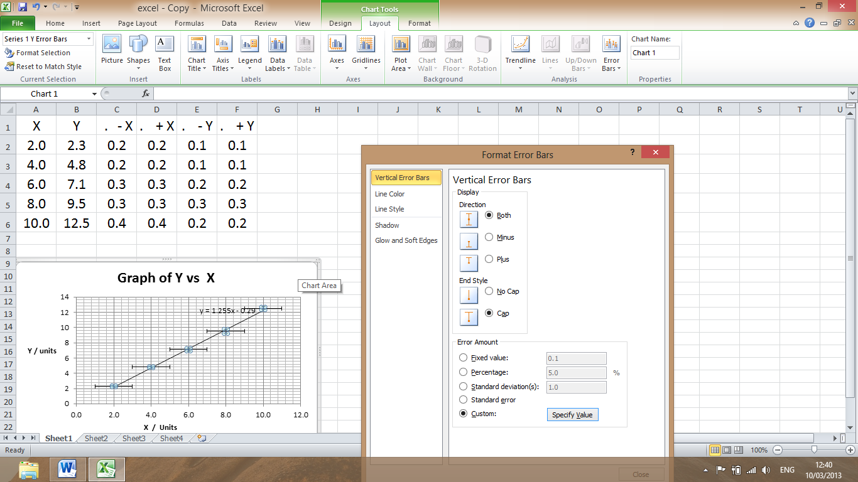

**To select horizontal error bars, click on any horizontal error bar on the graph.**

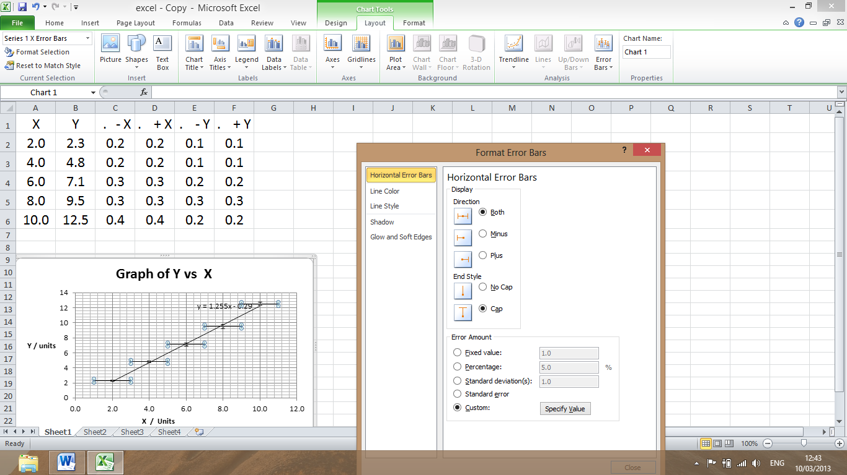

Changes to Horizontal Error Bars

**This should now read “Horizontal Error Bars”.**

**Repeat the procedure to enter customised horizontal error bars.**

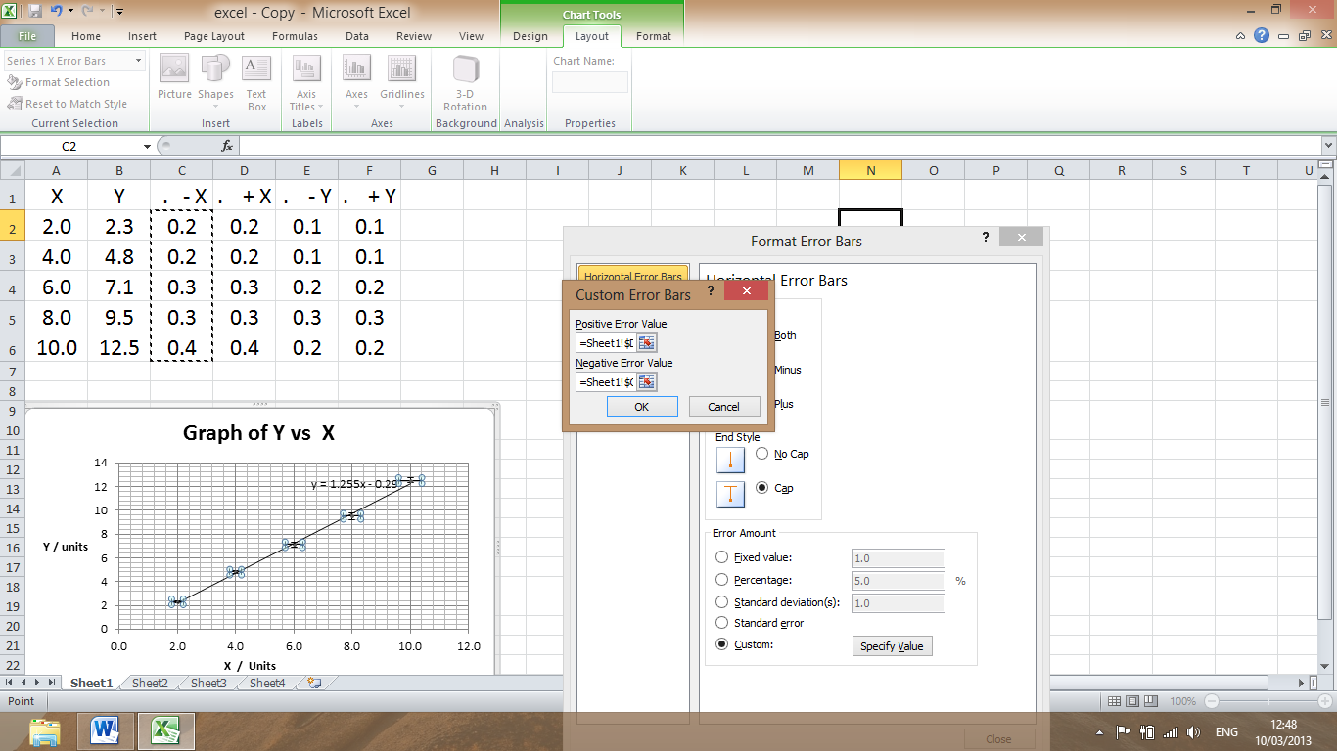

**Click to highlight data insertion box.**

**Click, Drag down vertical column to insert data in box.**

**Click okay**

**To change dot size / shape. ( Use Format Data Series)**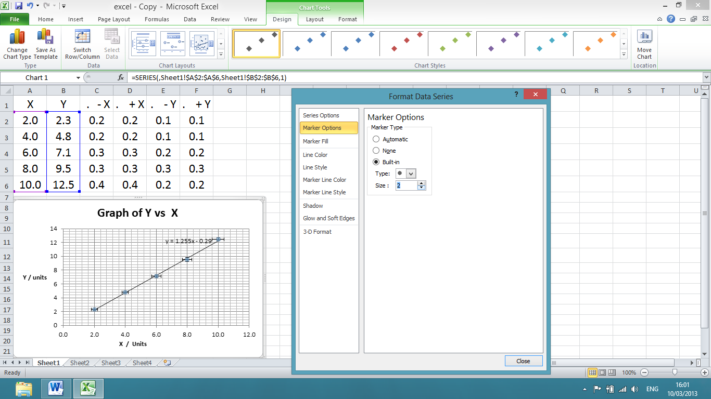

**Doubleclick or right click just next to one of the points.**

**Format Data Series should open.**

**If you get Format Trendline or Format Error bar then you have clicked on the line, point or error bar.**

**Select Marker Options.**

**Built in. Choose style and size**

**Increase the size of the graph to at least half a page.**

**Uncertainty in Gradient, Intercept - Use of Linest**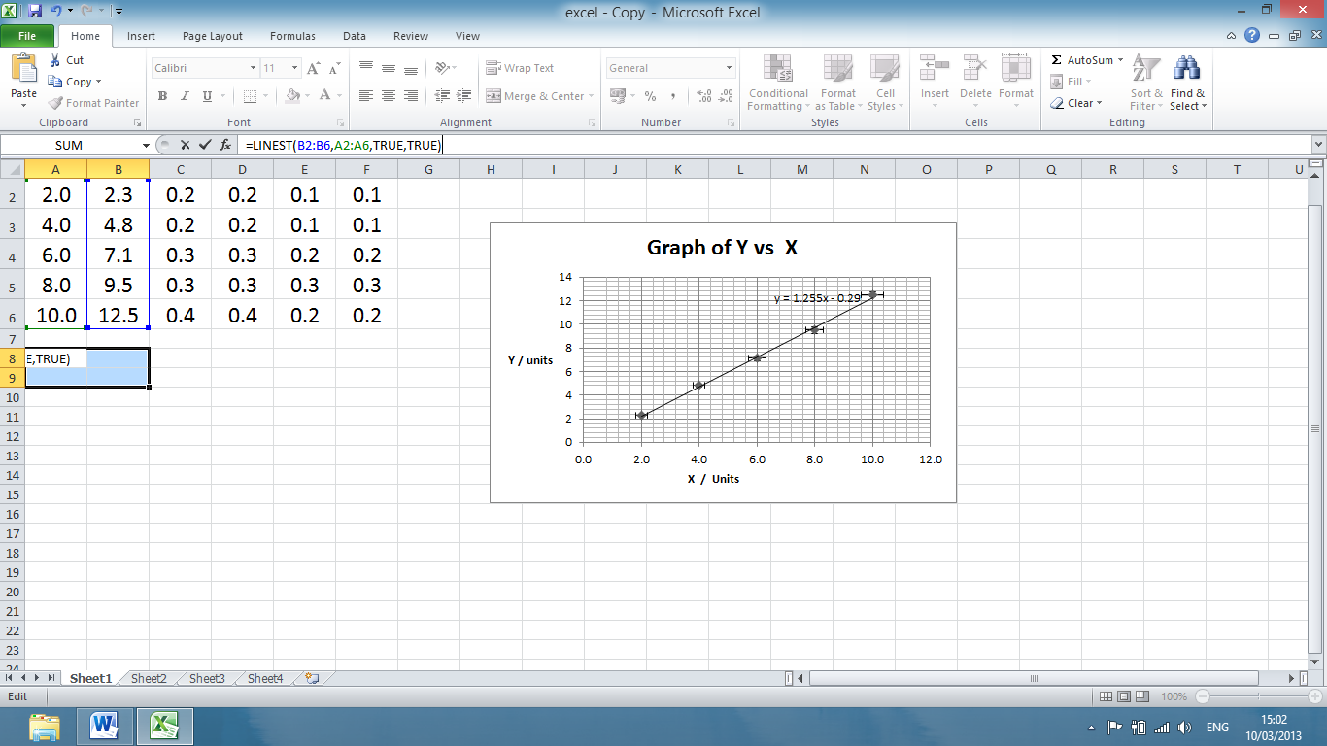

**Hold down Ctrl, Shift and press enter.**

**(CMD, Shift and enter on Apple computers).**

**Y Range of Cells**

**X Range of Cells**

**Highlight four cells.**

**Type in =LINEST(B2:B6,A2:A6,TRUE,TRUE)**

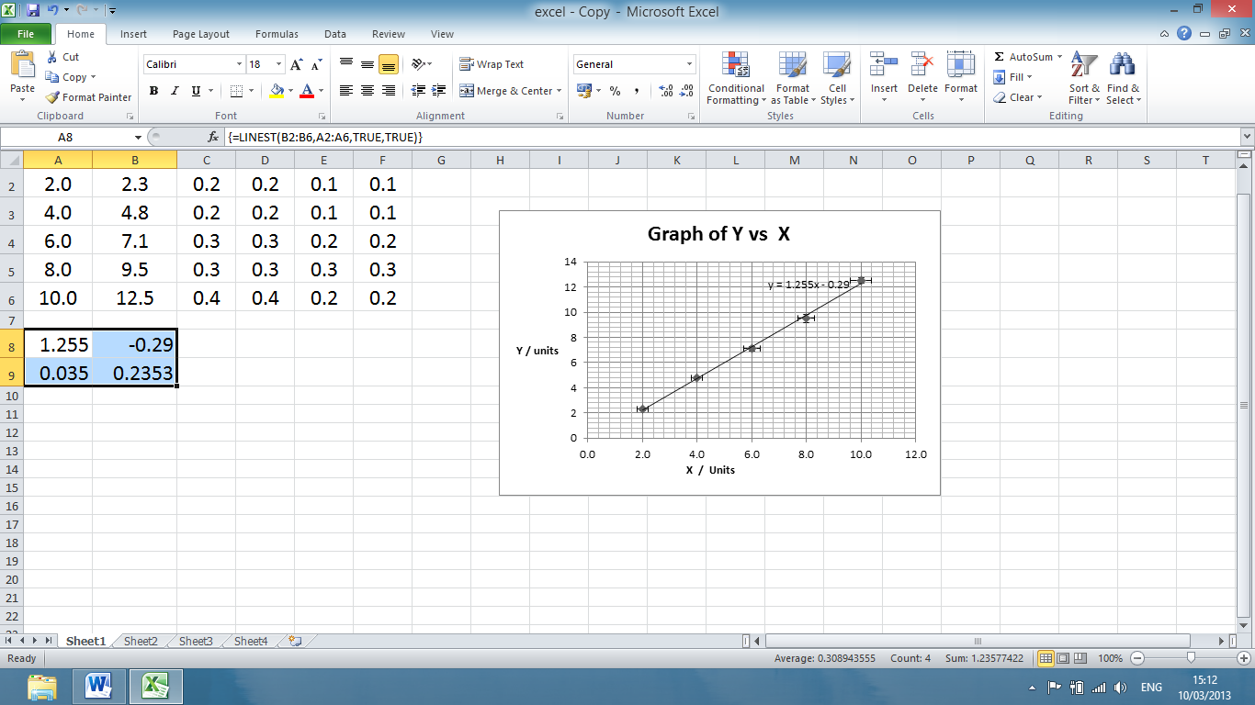

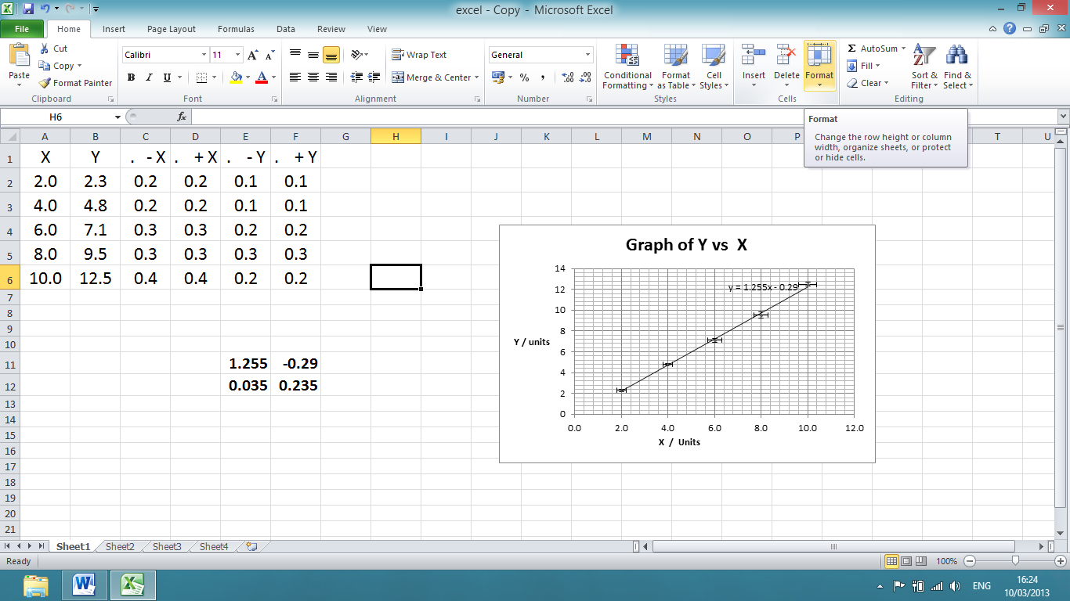

**Uncertainty in**

**Y Intercept**

**Uncertainty in Gradient**

**Y Intercept**

**Gradient**