Physics
Further Questions (AH)

7545

Summer 2000
HIGHER STILL

Physics
Further Questions (AH)


Support Materials

Contents

Introduction

General Tutorial Questions

Answers to General Tutorial Questions

IMPORTANT NOTICE

This pack contains general tutorial questions and solutions for the Mechanics(AH) unit only

Questions for the other two units will be published separately.

Introduction
The Advanced Higher student support material contains tutorials for each topic. Many of these questions are of a demanding nature and provide suitable cover of the course content. Full solutions to these tutorials have been provided.

These General Tutorial Questions are designed to provide basic practice for each topic. A number of questions are provided for each topic, together with brief solutions. These questions are intended to complement the Tutorials in the student material. These questions may be used before or in conjunction with the tutorial questions already published. Solutions are provided.

A set of Course Questions, similar to the Course Questions produced at the Higher, Int 2 and Int 1 levels, will be published separately. These questions are for use in constructing a prelim or for homework and course revision.

Data

Common Physical quantities

Quantity | Symbol | Value
Gravitational acceleration | g | 9.8 m s⁻²
Radius of Earth | R_{E} | 6.4 x 10⁶ m
Mass of Earth | M_{E} | 6.0 x 10²⁴ kg
Mass of Moon | M_{M} | 7.3 x 10²² kg
Mean radius of Moon orbit |  | 3.84 x 10⁸ m
Universal constant of gravitation | G | 6.67 x 10⁻¹¹ m³ kg⁻¹ s⁻²
Speed of light in vacuum | c | 3.0 x 10⁸ m s⁻¹
Speed of sound in air | v | 3.4 x 10² m s⁻¹
Mass of electron | m_{e} | 9.11 x 10⁻³¹ kg
Charge on electron | e | -1.60 x 10⁻¹⁹ C
Mass of neutron | m_{n} | 1.675 x 10⁻²⁷ kg
Mass of proton | m_{p} | 1.673 x 10⁻²⁷ kg
Planck’s constant | h | 6.63 x 10⁻³⁴ J s
Permittivity of free space | ε₀ | 8.85 x 10⁻¹² F m⁻¹
Permeability of free space | μ₀ | 4π x 10⁻⁷ H m⁻¹

Additional Data: see page 19 of the Mechanics - Student Material.

The solutions to the questions use the data values given above.

Equations of motion

1 The displacement, s in metres, of an object after a time, t in seconds, is given by
s = 90t – 4 t²
(a) Find by differentiation the equation for its velocity.
(b) At what time will the velocity be zero?
(c) Show that the acceleration is a constant and state its value.

2 Given that a = 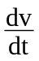, show by integration that the velocity, v, is given by
v = u + at.
State clearly the meaning of the symbol, u, in this equation.

3. Given that v = 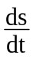 and v = u + at, show by integration that
s = ut + ½ at².
Where the symbols have their usual meaning.

4. The displacement, s, of a moving object after a time, t, is given by
s = 8 – 10t + t².
Show that the unbalanced force acting on the object is constant.

5. The displacement, s, of an object after time, t, is given by s = 3t³ + 5t.
(a) Derive an expression for the acceleration of the object.
(b) Explain why this expression indicates that the acceleration is not constant.

6. A trolley is released from the top of a runway which is 6 m long.
The displacement, s in metres, of the trolley is given by the expression
s = 5t + t², where t is in seconds.
Determine:
(a) an expression for the velocity of the trolley
(b) the acceleration of the trolley
(c) the time it takes the trolley to reach the bottom of the runway
(d) the velocity of the trolley at the bottom of the runway.

7. A box slides down a smooth slope with an acceleration of 4 m s⁻². The velocity of the box at a time t = 0 is 3 m s⁻¹ down the slope.
Using a = show by integration that the velocity, v, of the box is given by
v = 3 + 4t.

8. The equation for the velocity, v, of a moving trolley is v = 2 + 6t.
Using v = derive an expression for the displacement, s, of the trolley.

Relativistic motion
In examination questions the formula opposite for the variation of mass with speed will be given. | m = 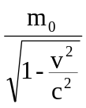

1. According to Einstein’s Special Theory of Relativity, what would be the mass of a small car travelling at the speed of light?

2. The rest mass of a football is 1.0 kg. At what speed would the football have to travel to have a mass of 2.0 kg?

3. An electron in a hydrogen atom has a speed of 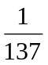 of the speed of light.
(a) Calculate the mass of the electron at this speed.
(b) Are relativistic effects important at this speed?

4. Calculate the relativistic mass of an electron travelling at 2.0 x 10⁸ m s⁻¹.

5. The mass of a proton in a high energy particle beam is three times its rest mass.
(a) What is the speed of the proton.
(b) What is the relativistic energy of the proton.

6. The relativistic energy of an electron is 1.5 x 10⁻¹³ J.
Calculate its relativistic mass.

7. (a) An electron emitted from a radioactive nuclide has a mass of 1.6 x 10⁻³⁰ kg.
Determine the speed of emission of the electron.
(b) What is the maximum speed possible for the electron?

8. Copy and complete the following table to show the mass of an electron at various speeds. The speeds, v, are given as fractions of the speed of light, c. The mass m is the mass of the electron at that speed v.

v/c | 0.1 | 0.2 | 0.3 | 0.4 | 0.5 | 0.6 | 0.7 | 0.8 | 0.9
m/10⁻³¹ kg

Draw a graph of mass of electron (y-axis) against v/c ( x-axis).

9. (a) State an expression for the relativistic energy of an object.
(b) State the expression for the kinetic energy of a car of mass m moving along a motorway at a speed v which is below the speed limit.

10. An electron is travelling at a speed of 2.3 x 10⁸ m s⁻¹.
(a) Calculate the ratio 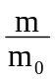 for this electron.
(b) Find the relativistic energy of the electron.
Angular motion
1. Convert the following from degrees to radians:
30º, 45º, 60 º, 90 º, 180 º, 270 º, 360 º, 720 º.

2. Convert the following from radians to degrees:
1 rad, 10 rad, 0.1 rad, π rad, 2π rad, ½ π rad, 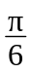 rad.

3. Convert the following from revolutions per minute to radians per second:
33 rpm, 45 rpm, 78 rpm, 300 rpm.

4. Using calculus notation write down the expression for
(a) the angular velocity in terms of the angular displacement
(b) the angular acceleration in terms of the angular velocity
(c) the angular acceleration in terms of the angular displacement.

5. State the three equations which can be used when an object moves with a constant angular acceleration, α.
State the meaning of each symbol used.

6. A disc is slowed uniformly at 5.0 rad s⁻² for 4.0 s. The initial angular velocity is 200 rad s⁻¹.
(a) Determine the angular velocity at the end of the four seconds.
(b) What is the angular displacement in this time?

7. The angular velocity of an engine is increased from 800 rpm to 3 000 rpm in 8.0 s.
(a) Determine the angular acceleration. You may assume this is uniform.
(b) Find the total angular displacement.
(c) How many revolutions does the engine make during this 8.0 s?

8. A wheel accelerates uniformly from rest at 3.0 rad s⁻² for 5.0 s.
(a) Find
(i) the final angular velocity after 5.0 s
(ii) the angular displacement after 5.0 s.
(b) The wheel has a radius of 1.50 m.
Determine the linear velocity at a point on its rim at the end of the 5.0 s.

9. Data: Radius of Earth = 6.4 x 10³ km Geostationary orbit radius = 3.6 x 10⁴ km
Radius of Earth’s orbit = 1.5 x 10⁸ km Radius of Moon’s orbit = 3.8 x 10⁵ km
Period of Earth about Sun = 365 days Period of Moon about Earth = 28 days

(a) Calculate the angular velocity in rad s⁻¹ of
(i) the Earth about the sun
(ii) the Moon about the Earth
(iii) an object on the Earth’s surface about its axis of rotation
(iv) a geostationary satellite.
(b) Find the tangential velocity in m s⁻¹ of each of the above quantities in part (a).

10. Derive the expression v = rω for a particle in circular motion.

Central force
1. (a) State the equation between radial and angular acceleration.
(b) State the units of angular and radial acceleration.
(c) Explain the difference between these two quantities.

2. Derive the expression α = rω² for the radial acceleration of an object.

3. The central force maintaining an object in a circular orbit is given by F = mrω².
Sketch graphs showing the variations of:
(a) central force with mass of the object
(b) central force with radius of the object
(c) central force with angular velocity of the object.

4. A piece of string has a breaking force of 56 N. This string is used to whirl a mass of 150 g in a horizontal circle.
(a) The 150 g mass moves in a horizontal circle of radius 1.2 m. Calculate the maximum angular velocity of the mass.
(b) The mass is rotated at 85 rpm. Find the maximum possible radius of the circular orbit.

5. A swing ball, on a cord of length 1.5 m, has a mass of 2.0 kg. After being hit by a bat, the ball moves in a horizontal circle of radius 0.50 m with a steady speed of 1.33 m s⁻¹.
(a) Draw a sketch showing the path of the ball on the string.
(b) Calculate the central acceleration of the ball.
(c) Draw a sketch showing all the forces on the ball while moving in a horizontal circle.
Determine the tension in the string.

6. A 3.0 kg mass is whirled in a vertical circle of radius 0.75 m at a steady speed of 8.0 m s⁻¹.
(a) Calculate the tension in the string at the top of the circle.
(b) Calculate the tension in the string at the bottom of the circle.

7. A hump backed bridge is in the form of a circular arc of radius 35 m.
What is the greatest speed with which a car can cross the bridge without leaving the ground at its highest point?

8. (a) In a space flight simulator an astronaut is rotated at 20 rpm in a pod which is at the end of an arm of radius 5.0 m. Show that the central force on the astronaut is 2.2g.
(b) What rotation rate would give a ‘simulated’ gravity of 3g ?

9. Comment on the words centripetal and centrifugal with respect to angular motion.

Torque and moment of inertia
1. (a) State what is meant by the moment of a force.
(b) Give two examples illustrating the moment of a force.

2. (a) State the equation between torque and tangential force.
(b) State the equation between torque and angular acceleration.

3. The moment of inertia of an object depends on two quantities. State clearly the two quantities concerned.

4. The moment of inertia of a rod about an axis through its centre is different to the moment of inertia of the same rod about an axis through one end. Explain why this is so and justify which arrangement has the larger moment of inertia.

5. A wheel has very light spokes. The mass of the rim and tyre is 2.0 kg and the radius of the wheel is 0.80 m. Calculate the moment of inertia of the wheel. State any assumptions that you have made.

6. A cylindrical solid drum is free to rotate about an axis AB as shown below.
A
B
8.0 N

The radius of the drum is 0.30 m. The moment of inertia of the drum about AB is 0.40 kg m². A rope of length 5.0 m is wound round the drum and pulled with a constant force of 8.0 N.
(a) Calculate the torque on the drum.
(b) Determine the angular acceleration of the drum.
(c) Calculate the angular velocity of the drum just as the rope leaves the drum. You may assume that the drum starts from rest.

7. A hoop has a radius of 0.20 m and a mass of 0.25 kg.
(a) What is the moment of inertia of the hoop?
(b) What torque is required to give the hoop an acceleration of 5.0 rad s⁻²?

8. A sphere has a moment of inertia of 0.40 MR² where M is the total mass of the sphere and R is the radius.
(a) Calculate the moment of inertia of the Earth as it spins on its axis.
State any assumptions made.
(b) What is the tangential speed at the surface of the Earth at the Equator?

9. Two children are playing on a roundabout. One child, Anne, of mass 50 kg, stands on the roundabout 1.25 m from the axis of rotation. The other child, Robert, starts the roundabout by applying a constant torque of 200 N m at the rim for 3 s.
When rotating there is a constant frictional torque of 25 N m acting on the roundabout. Robert stops pushing and the roundabout comes to rest.
The moment of inertia of the roundabout alone is 500 kg m⁻².
(a) Calculate the maximum angular velocity of the roundabout.
(b) Find the time taken for the roundabout to come to rest.

Angular momentum and rotational kinetic energy
1. (a) State the law of conservation of angular momentum.
(b) State the expression for the angular momentum of an object in terms of its moment of inertia.
(c) State the equation for the rotational kinetic energy of a rigid object.

2. A bicycle wheel has a moment of inertia of 0.25 kg m² about its hub.
Calculate the angular momentum of the wheel when rotating at 120 rpm.

3. A model aeroplane is flying in a horizontal circle at the end of a light wire. The mass of the aeroplane is 2.0 kg. The radius of the circular path is 20 m. The aeroplane makes 40 revolutions in one minute.
(a) Calculate the linear velocity of the aeroplane.
(b) Find the angular momentum of the aeroplane about the centre of the circle.
(c) The wire suddenly breaks. What is the new angular momentum of the aeroplane about the centre of the circle?

4. A shaft has a moment of inertia of 20 kg m² about its central axis. The shaft is rotating at 10 rpm. This shaft is locked onto another shaft, which is initially stationary. The second shaft has a moment of inertia of 30 kg m².
(a) Find the angular momentum of the combination after the shafts are locked together.
(b) What is the angular velocity of the combination after the shafts are locked together?

5. Which of the following are vector quantities:
torque, moment of inertia, angular velocity, tangential force, angular acceleration, rotational kinetic energy, radius of a circular motion.

6. Two children are playing on a roundabout of mass 250 kg. The roundabout can be considered to be a solid disc of diameter 3.0 m. (I_{disc} = ½ MR²)
One child of mass 40 kg stands on the rim of the roundabout. The other child of mass 60 kg is positioned half way between the rim and the centre.
(a) Calculate the total moment of inertia of the roundabout and children.
(b) Determine the rotational kinetic energy of this system when it is rotating at 35 rpm.

7. A disc has a moment of inertia of 2.5 kg m². The disc is rotating at 2.0 rad s⁻¹.
(a) Calculate the kinetic energy of the disc.
(b) How much energy needs to be supplied to increase its angular velocity to 15 rad s⁻¹?

8. A solid cylinder and a hollow cylinder have the same mass and the same radius.
(a) Which one has the larger moment of inertia about the central axis as shown opposite?
You must justify your answer.
(b) The cylinders do not have the same length. Does this affect your answer to part (a)? Again you must justify your answer.
9. A cylinder of mass 3.0 kg rolls down a slope without slipping. The radius R of the cylinder is 50 mm and its moment of inertia is ½MR². The slope has a length of 0.30 m and is inclined at 40º to the horizontal.
(a) Calculate the loss in gravitational potential energy as the cylinder rolls from the top of the slope to the bottom of the slope.
(b) Find the speed with which the cylinder reaches the bottom of the slope.

10. A turntable is rotating freely at 40 rpm about a vertical axis. A small mass of 50 g falls vertically onto the turntable and lands at a distance of 80 mm from the central axis. The rotation of the turntable is reduced to 33 rpm.
Find the moment of inertia of the turntable.

11. A CD of mass 0.020 kg and diameter 120 mm is dropped onto a rotating turntable. The turntable has a moment of inertia about its axis of rotation of 5.0 x 10⁻³ kg m². The turntable was initially rotating at 3.0 rad s⁻¹.
Determine the common angular velocity of the turntable and the CD.

12. A skater with her arms pulled in has a moment of inertia of 1.5 kg m² about a vertical axis through the centre of her body. With her arms outstretched the moment of inertia is increased to 10 kg m².
With her arms pulled in, the skater is spinning at 30 rad s⁻¹. The skater then extends her arms.
(a) Calculate her final angular speed.
(b) Find the change in kinetic energy.
(c) Explain why there is a change in kinetic energy.

13. A skater is spinning at 3.0 rad s⁻¹ with her arms and one leg outstretched.
The angular speed is increased to 25 rad s⁻¹ when she draws her arms and leg in.
(a) Explain why this movement of her arms and leg affects the rotational speed.
(b) Her moment of inertia about her spin axis is 5.0 kg m² with her arms and leg outstretched. Calculate her moment of inertia when her arms and leg are drawn in.

14. A roundabout has a moment of inertia of 300 kg m² about its axis of rotation. Three children, each of mass 20 kg, stand 2.0 m from the centre of the stationary roundabout. They all start to run round the roundabout in the same direction until they reach a speed of 3.0 m s⁻¹ relative to the roundabout.
Calculate the angular velocity of the roundabout.

15. A disc is rotating at 100 rpm in a horizontal plane about a vertical axis. A small piece of plasticene is dropped vertically onto the disc and sticks at a position 50 mm from the centre of the disc. The plasticene has a mass of 20 g. The disc is slowed to 75 rpm. Calculate the moment of inertia of the disc.

16. The radius of a spherical neutron star is 20 km. The star rotates at 0.5 rpm.
(a) Calculate the velocity of a point on the equator of the star.
(b) The mass of the neutron star is the same as the mass of the sun.
What is the density of the neutron star?
(c) The radius of a neutron is about 10⁻¹⁵ m. Estimate the average spacing of the neutrons in the neutron star.

Gravitation
1. State the inverse square law of gravitation.

2. Calculate the gravitational force between two cars parked 0.50 m apart. The mass of each car is 1000 kg.

3. Calculate the gravitational force between the Earth and the Sun.

4. (a) By considering the force on a mass, at the surface of the Earth, state the expression for the gravitational field strength, g, in terms of the mass and radius of the Earth.
(b) (i) The gravitational field strength is 9.8 N kg⁻¹ at the surface of the Earth. Calculate a value for the mass of the Earth.
(ii) Calculate the gravitational field strength at the top of Ben Nevis, 1344 m above the surface of the Earth.
(iii) Calculate the gravitational field strength at 200 km above the surface of the Earth.

5. (a) What is meant by the gravitational potential at a point?
(b) State the expression for the gravitational potential at a point.
(c) Calculate the gravitational potential:
(i) at the surface of the Earth
(ii) 800 km above the surface of the Earth.

6. ‘A gravitational field is a conservative field.’
Explain what is meant by this statement.

7. Calculate the energy required to place a satellite of mass 200 000 kg into an orbit at a height of 350 km above the surface of the Earth.

8. Which of the following are vector quantities:
gravitational field strength, gravitational potential, escape velocity, universal constant of gravitation, gravitational potential energy, period of an orbit?

9. A mass of 8.0 kg is moved from a point in a gravitational field where the potential is –15 J kg⁻¹ to a point where the potential is –10 J kg⁻¹.
(a) What is the potential difference between the two points?
(b) Calculate the change in potential energy of the mass.
(c) How much work would have to be done against gravity to move the mass between these two points?

10. (a) Explain what is meant by the term ‘escape velocity’.
(b) Derive an expression for the escape velocity in terms of the mass and radius of a planet.
(c) (i) Calculate the escape velocity from both the Earth and from the Moon.
(ii) Using your answers to (i) comment on the atmosphere of the Earth and the Moon.

11. Calculate the gravitational potential energy and the kinetic energy of a 2000 kg satellite in geostationary orbit above the Earth.
12. (a) A central force required to keep a satellite in orbit. Derive the expression for the orbital period in terms of the orbital radius.
(b) A satellite is placed in a parking orbit above the equator of the Earth.
(i) State the period of the orbit.
(ii) Calculate the height of the satellite above the equator.
(iii) Determine the linear speed of the satellite.
(iv) Find the central acceleration of the satellite.

13. A white dwarf star has a radius of 8000 km and a mass of 1.2 solar masses.
(a) Calculate the density of the star in kg m⁻³.
(b) Find the gravitational potential at a point on the surface.
(c) Calculate the acceleration due to gravity at a point on the surface.
(d) Estimate the potential energy required to raise your centre of gravity from a sitting position to a standing position on this star.
(e) A 2 kg mass is dropped from a height of 100 m on this star.
How long does it take to reach the surface of the star?
14. (a) How are photons affected by a massive object such as the Sun?
(b) Explain, using a sketch, why light from a distant star passing close to the Sun may suggest that the star is at a different position from its ‘true’ position.
(c) Explain what is meant by the term ‘black hole’.

Simple Harmonic Motion
1. (a) On object undergoes simple harmonic motion. State the condition which must apply to the unbalanced force acting on the object.
(b) Give three examples of simple harmonic motion (SHM).

2. (a) State the equation which defines SHM.
(b) (i) Show by differentiation that each of the following is a solution of the equation for SHM: y = a cosωt and y = a sinωt.
(ii) State the condition under which the equation for SHM is given by each of the following: y = a cosωt and y = a sinωt
(c) Derive the equation for the velocity v = ±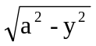 using:
(i) y = a cosωt
(ii) y = a sinωt.

3. An object moves with SHM with a frequency of 5 Hz and an amplitude of 40 mm.
(a) Find the acceleration at the centre and extremities of the motion.
(b) Determine the velocity at the centre and extremities of the motion.
(c) Calculate the acceleration and velocity at a point midway between the centre and extremity of the motion.

4. A horizontal platform oscillates vertically with SHM with a slowly increasing amplitude. The period of the oscillations is 0.10 s.
What is the maximum amplitude which will allow a mass resting on the platform to remain in contact with the platform?

5. (a) Derive expressions for the kinetic energy and potential energy of a particle executing SHM.
(b) An object of mass 0.20 kg oscillates with SHM with an amplitude of 100 mm. The frequency of the oscillations is 0.50 Hz.
(i) Calculate the maximum value of the kinetic energy of the object. State where this occurs.
(ii) State the minimum value of the kinetic energy. State where this occurs.
(iii) Find the maximum value of the potential energy of the object. State where this occurs.
(iv) Calculate the potential energy and the kinetic energy at a point mid way between the centre and extremity of the motion.
(v) What can you state about the value of the sum of the potential energy and the kinetic energy at any point?

6. The displacement, y, in mm of a particle is given by y = 0.44sin28t.
(a) Find the amplitude of the motion.
(b) Find the frequency of the motion.
(c) Find the period of the motion.
(d) Find the time taken for the particle to move a distance of 0.20 mm from the equilibrium position.

7. (a) What effect does damping have on an oscillatory system?
(b) Briefly explain the terms critical damping and overdamping.
(c) Give two examples where damping is useful.

Wave-particle duality
1. (a) Give examples to illustrates that electrons exhibit wave-particle duality.
(b) Give examples to illustrate that electromagnetic radiation exhibits wave-particle duality.

2. (a) State the expression between the momentum of a particle and its wavelength.
(b) Calculate the de Broglie wavelength for electrons travelling at 2.0 x 10⁷ m s⁻¹.

3. Calculate the de Broglie wavelength for:
(a) an electron travelling at 4.0 x 10⁶ m s⁻¹
(b) a proton travelling at 4.0 x 10⁶ m s⁻¹
(c) a car of mass 1000 kg travelling at 120 km per hour.

4. Gamma rays have an energy of 4.2 x 10⁻¹³ J.
(a) Calculate the wavelength of the gamma rays.
(b) Calculate the momentum of the gamma rays.

5. (a) What is the minimum p.d. in an electron microscope required to give the electrons a wavelength of 20 pm?
(b) In practice the p.d. calculated in part (a) will not give the electrons this 20 pm wavelength. Give one reason why this is the case.

6. (a) State the relationship for the quantisation of angular momentum.
Give the name and unit for each quantity in this relationship.
(b) Explain the meaning of the word quantisation.

7. The electron in the ground state of a hydrogen atom can be considered to orbit the nucleus with a radius of 53 pm.
(a) Calculate the speed of the electron in this orbit.
(b) Find the momentum of the electron.
(c) Determine the de Broglie wavelength of the electron.

8. Give one use of quantum mechanics in modern Physics.

Solutions
In many cases the data in the question is given to two significant figures, hence the final answer is given to two significant figures. Any interim calculations should retain more significant figures. Where possible a calculator is used once to obtain a final numerical answer.

Equations of Motion
1. (a) v = , = 90 – 8t, v = 90 – 8t
(b) 0 = 90 – 8t t = 11 s
(c) a = , = -8, a = -8 m s⁻²
2. a = , 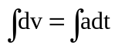, v = at + k
when t = 0, k = u, where u is the velocity at t= 0
giving v = u + at [you must show clearly that the constant of integration is u]

3. = u + at 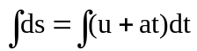
s = ut + ½ at² + k, at t = 0 s = 0, the origin of displacement is taken at t = 0.
hence k = 0 and s = ut + ½ at² [you must show clearly that k = 0]

4. s = 8 – 10t + t²
= -10 + 2t and 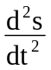 = 2, the acceleration is 2 units
The acceleration is constant. It does not depend on time t.
Hence the unbalanced force is constant, F = ma, and the mass m is constant.

5. (a) = 9t² + 5, = 18t, a = 18t
(b) The acceleration is a function of time, so it is not constant.

6. (a) = 5 + 2t, v = 5 + 2t
(b) = 2, a = 2 m s⁻²
(c) 6 = 5t + 2t² 0 = t² +5t –6 = (t + 6)(t -1) hence t = 1 s [t is positive]
(d) v = 5 + 2t velocity = 7 m s⁻¹ at t = 1

7. giving v = at + k, at t = 0 v = 3 given, hence k = 3,
thus v = 4t + 3, a = 4 given,

8. 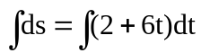
s = 2t + 3t² +k. assume s = 0 at t = 0 hence k = 0
s = 2t +3t²

Relativistic motion
1. Infinite

2. 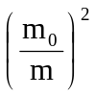 = 1 - 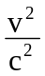 [This is a useful rearrangement of the formula when finding v]
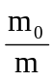 = ½ thus ¼ = 1 - ,
= 1 – ¼ = ¾ giving v² = ¾ c² and v = 2.6 x 10⁸ m s⁻¹

3. (a) m = = 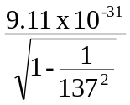 = 9.11 x 10⁻³¹ kg
(b) Relativistic effects should only be considered when the velocity is more than 10% of the speed of light, that is 0.1c.

4. m = = 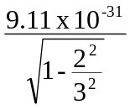 [notice that the factor 10⁸ cancels hence omitted]
m = 12.2 x 10⁻³¹ kg

5. (a) = 1 - , thus = 1 - and 1 - =
v = 2.83 x 10⁸ m s⁻¹
(b) E = mc² E = 3 x 1.673 x 10⁻²⁷ x (3 x 10⁸)²
E = 4.52 x 10⁻¹⁰ J

6. E = mc², 1.5 x 10⁻¹³ = m x (3 x 10⁸)², mass = 1.67 x 10⁻³⁰ kg
{Compare this to the rest mass of the electron 9.11 x 10⁻³¹ or 0.911 x 10⁻³⁰ kg]

7. (a) = 1 -
= 1 - 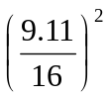 the 10⁻³¹ in m₀ and m has cancelled
v = 2.47 x 10⁸ m s⁻¹

(b) The speed of light, 3 x 10⁸ m s⁻¹

8. m = , for 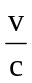 = 0.1, m = 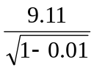 since = 0.1 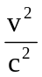= 0.01
similarly for other table entries. Notice that the factor 10⁻³¹ is in the table.

v/c | 0.1 | 0.2 | 0.3 | 0.4 | 0.5 | 0.6 | 0.7 | 0.8 | 0.9
m/10⁻³¹ kg | 9.16 | 9.30 | 9.55 | 9.94 | 10.52 | 11.39 | 12.76 | 15.18 | 20.90
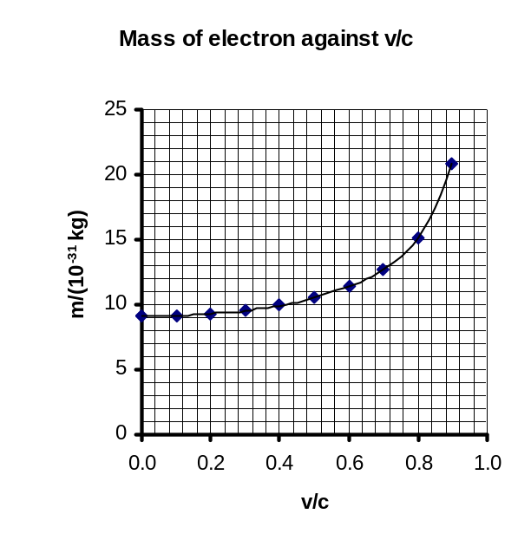
A spreadsheet is useful to plot the graph. This is not a simple function so when using ‘Trendline’ try polynomial order 6.

9. (a) Energy E = m c² where m is the relativistic mass and c is the speed of light.
(b) E_{k} = ½ m v² where m is the mass of the car and v the velocity of the car.

10. (a) = 1 - , = 1 - 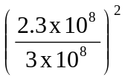 gives 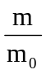 = 1.56
(b) E = mc² = 1.56 x 9.11 x 10⁻³¹ x (3 x 10⁸)² = 1.28 x 10⁻¹³ J

Angular motion
1. 360º = 2π radians, hence to convert from degrees to radians multiply by 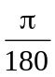
π/6 (0.52), π/4(0.78), π/2(1.57), π(3.14), 1.5 x π(4.71), 2π(6.28), 4π(12.6)
[Notice that 360º is 6.28 radians, it is useful to get a feel for the size of a radian]

2. To convert from radians to degrees multiply by 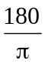.
57.3º, 573º, 5.73º, 180º, 360º, 90º, 30º [Notice 1 rad is just under 60º]

3. One revolution is 2π radians. Hence 1 revolution per minute is 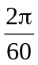 rad s⁻¹.
3.46 rad s⁻¹, 4.71 rad s⁻¹, 8.17 rad s⁻¹, 31.4 rad s⁻¹

4. (a) ω = 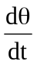 (b) α = 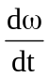 (c) α = 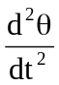

5. ω = ω₀ + αt, θ = ω₀t + ½αt², ω² = ω₀² + 2αθ
where ω is the angular velocity at time t, ω₀ is the initial angular velocity at t = 0 and θ the angular displacement.

6. (a) ω = ω₀ + αt, ω = 200 – 5 x 4 gives ω = 180 rad s⁻¹
(b) θ = ω₀t + ½αt², θ = 200 x 4 - ½ x 5 x 4² gives θ = 760 rad

7. (a) ω = ω₀ + αt, 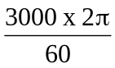 = 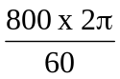 + 8 α gives α = 29 rad s⁻²
(b) θ = ω₀t + ½αt², θ = 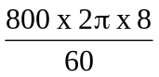 + ½ x 29 x 8² gives θ = 1.60 x 10³ rad
(c) 255 revolutions

8. (a) (i) ω = ω₀ + αt, ω = 0 + 3 x 5, ω = 15 rad s⁻¹
(ii) θ = ω₀t + ½αt² θ = 0 + ½ x 3 x 25 = 37.5 rad
(b) v = rω = 1.5 x 15 = 22.5 m s⁻¹

9. (a) (i) Time for one revolution = 365 x 24 x 60 x 60 = 3.15 x 10⁷ s
ω = 2.0 x 10⁻⁷ rad s⁻¹
(ii) Time for one revolution = 28 x 24 x 60 x 60 s ω = 2.6 x 10⁻⁶ rad s⁻¹
(iii) Time for one revolution = 24 x 60 x 60 s ω = 7.3 x 10⁻⁵ rad s⁻¹
(iv) ω = 7.3 x 10⁻⁵ rad s⁻¹ since one revolution per day
(b) using v = rω for each of the above with the orbit radius in metres
(i) 2.0 x 10⁻⁷ x 1.5 x 10⁸ x 10³ = 30 000 m s⁻¹
(ii) 2.6 x 10⁻⁶ x 3.8 x 10⁵ x 10³ = 990 m s⁻¹
(iii) 7.3 x 10⁻⁵ x 6.4 x 10³ x 10³ = 470 m s⁻¹
(iv) 7.3 x 10⁻⁵ x 3.6 x 10⁴ x 10³ = 2600 m s⁻¹

10. See Mechanics - Student Material page 6.

Central force
1. (a) a = rα
(b) angular acceleration has the unit rad s⁻², radial acceleration has the unit m s⁻²
(c) angular acceleration is the rate of change of angular velocity
radial acceleration is the rate of change of linear velocity

2. See Mechanics – Student Material page 7
It is a good idea to give a sketch to show sinθ = Δv/2v.
It is usual to derive a = 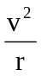, then substitute v = rω.
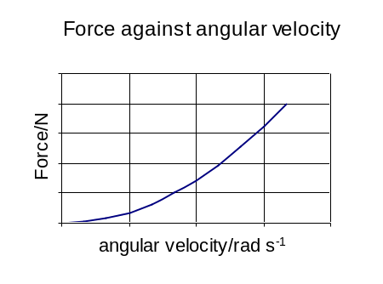
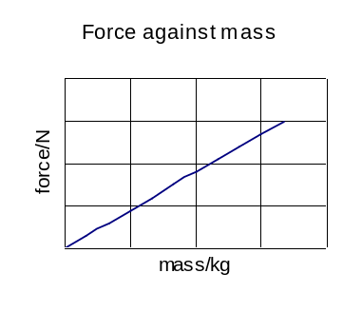
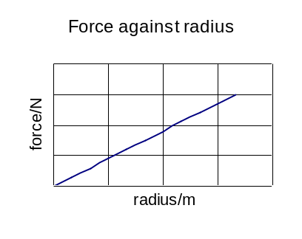
0
0
0
3.

4. (a) F = mrω² 56 = 0.15 x 1.2 x ω² giving ω = 18 rad s⁻¹
(b) 85 rpm = (85 x 2 π/ 60) rad s-1
F = mrω² 56 = 0.15 x r x 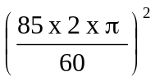 giving r = 4.7 m

5. (a) |  | (b) a = = 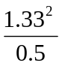  a = 3.5 m s⁻²
(c)  Y  θ  θ  mg  X  O  T |  | Central force is T sinθ  T sinθ = m (since sin θ = 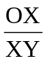)  T x 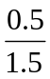= 0.2 x 3.5  T = 2.1

6. (a) At the top
T + mg = m
mg
T
mg
+
T = m - mg
= 3.0 x 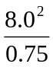 - 3 x 9.8
Tension at top = 227 N

(b) At bottom
mg + (-T) = m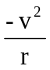
T – mg = m
Tension at bottom = 285 N

7. Weight of car = mg and central force = m
Car will leave road if central force just equals weight of car
hence greatest speed is when g = and v = 18.5 m s⁻¹

8. (a) F = m rω² =m x 5 x (20 x)² hence F/m = 22 N kg⁻¹ = 2.2g
(b) F/m = 3 x 9.8 = 5 x (Rot rate x )² thus rotational rate = 23 rpm.

9. Discuss these terms with other students and check with staff.

Torque and moment of inertia
1. (a) The moment of a force is the turning effect of a force about an axis. The magnitude of the moment of a force is the force multiplied by the perpendicular distance from the direction of the force to the turning point.
(b) Using a long handled screw driver to lever off a paint tin lid.
Using a bottle opener to remove the cap from a bottle.

2. (a) T = F x r where F is the tangential force and r is the perpendicular distance from the direction of F to the axis of rotation.
(b) T = I α where α is the angular acceleration and I is the moment of inertia.

3. The mass of the object and the distribution of the mass about a fixed axis.

4. The moment of inertia depends on the distribution of the mass about an axis. The contribution of each particle of mass in the rod to the moment of inertia is mr2 where r is the perpendicular distance to the axis. For the rod about the axis through its centre more of the mass is at smaller distances from the axis so this arrangement will have the smaller moment of inertia.
(For interest I_{rod(centre)} = 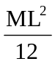 and I_{rod(end)} = 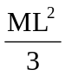.)

5. I = mr² = MR² = 2 x 0.8² = 1.28 kg m²
Assuming all the 2.0 kg mass (M) is all at a distance of 0.80 m (R) from the axis.
The mass of the spokes has been neglected, given as very light.

6. (a) T = F x r = 8 x 0.3 = 2.4 N m
(b) T = I α thus 2.4 = 0.4 x α and α = 6 rad s⁻²
(c) ω² = ω₀² + 2αθ, ω² = 0 + 2 x 6 x 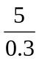 since θ = 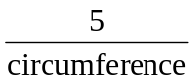 x 2π
ω = 14 rad s⁻¹.

7. (a) I = mr² = 0.25 x 0.2² = 0.01 kg m² (all the mass is at 0.2 m from the axis.)
(b) T = I α , T = 0.01 x 5 giving T = 0.05 N m

8. (a) I_{Earth} = 0.4 x 6.0 x 10²⁴ x (6.4 x 10⁶)² = 9.8 x 10³⁷ kg m²
Assume the Earth is a sphere of uniform density.
(b) Earth makes one revolution (2π radians) in 24 x 60 x 60 s
hence ω = 7.272 x 10⁻⁵ rad s⁻¹
v = rω = 6.4 x 10⁶ x 7.272 x 10⁻⁵ = 465 m s⁻¹
(It is interesting to convert this to miles per hour to get a feel for the speed!)
9. (a) Moment of inertia of roundabout and child P = 500 + 50 x 1.25² = 578 kg m²
T = Iα 200 - 25 = 578 x α, α = 0.303 rad s⁻²
Maximum angular velocity ω = ω₀ + αt, ω = 0 + 0.303 x 3 = 0.91 rad s⁻¹
(b) When decelerating -T = Iα 25 = 578 x α, α = -0.0433 rad s⁻²
ω = ω₀ + αt, 0 = 0.91 – 0.0433 x t, t = 21 s

Angular momentum and rotational kinetic energy
1. (a) In the absence of external torques, the resultant angular momentum of a rigid body before impact is equal to the resultant angular momentum after impact..
(b) L = I ω
(c) E_{rot} = ½ Iω²

2. ω = 120 x = 4π, L = I ω = 0.25 x 4π, L = 0.020 kg m² s⁻¹

3. (a) ω = 40 x , v = rω v = 20 x 40 x = 84 m s⁻¹
(b) L = mvr = 2 x 84 x 20 = 3.4 x 10³ kg m² s⁻¹ (or use L = I ω with I = 2 x 20²)
(c) zero

4. (a) Total angular momentum before = total angular momentum after
20 x 10 x = total angular momentum after
angular momentum after shafts are locked together = 21 kg m² s⁻¹
(b) L = I ω, 21 = (20 + 30) x ω, ω = 0.42 rad s⁻¹

5. Torque, angular velocity, tangential force, angular acceleration.

6. (a) Moment of inertia of roundabout = ½ MR² = ½ x 250 x 1.5² = 281 kg m²
Total moment of inertia = 281 + (40 x 1.5²) + (60 x 0.75²) = 405 kg m²
(b) E_{k}(rot) = ½ I ω² = ½ x 405 x 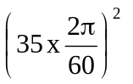 = 2.7 kJ

7. (a) E_{k}(rot) = ½ I ω² = ½ x 2.5 x 2² = 5 J
(b) New E_{k}(rot) = ½ x 2.5 x 15² = 281 J Energy required = 281 – 5 = 276 J

8. (a) The hollow cylinder has the larger moment of inertia. The moment of inertia depends on the square of the distance of the mass from the axis of rotation. For the hollow cylinder most of the mass is at a distance equal to the radius. For the solid cylinder much of the mass is at a distance less than the radius.
(b) No. The length of the cylinder does not affect the distribution of the mass about this axis. Only the radius of the cylinder will effect the moment of inertia of each cylinder.

9. (a) E_{p} = mgh = 3 x 9.8 x 0.3 sin40 = 5.7 J (change in height = 0.3 sin40)
(b) Change in E_{p} = change in E_{k}(linear) + change in E_{k}(rot)
5.7 = ½ m v² - 0 + ½ I ω² - 0 (But I = ½ MR² and v = Rω)
5.7 = ½ M v² + ½ x (½ MR² ) x 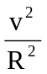
= M v² { ½ + (½ x ½ )} = v² (3 x 0.75)
v = 1.6 m s⁻¹ (Notice how the equation can be simplified)
10. Total angular momentum before = total angular momentum after
I x 40 x + 0 = {(0.05 x 0.08²) x 33 x } + I x 33 x
I (40 – 33) = 0.05 x 0.08² x 33
I = 1.5 x 10⁻³ kg m²

11. Total angular momentum before = total angular momentum after
5.0 x 10⁻³ x 3 + 0 = (5.0 x 10⁻³ + 0.2 x 0.06²) ω
ω = 2.6 rad s⁻¹

12. (a) Total angular momentum before = total angular momentum after
1.5 x 30 = 10 x ω
ω = 4.5 rad s⁻¹
(b) Initially kinetic energy = ½ I ω² = ½ x 1.5 x 30² = 675 J
Final kinetic energy ½ x 10 x 4.5² = 101 J
Change in kinetic energy = 574 J
(c) The skater will have supplied some energy to move her arms.

13. (a) The moment of inertia is altered when the distribution of the mass about the axis alters. Angular momentum is conserved in the absence of external forces. L = I ω, hence if the moment of inertia is reduced the rotational speed must increase for L to remain unchanged.
(b) Total angular momentum before = total angular momentum after
5.0 x 3.0 = I x 25
I = 0.6 kg m²

14. Total angular momentum before = total angular momentum after
0 = 3 x (20 x 2²) x + 300 x ω
ω = - 1.2 rad s⁻¹ (Notice that the roundabout moves ‘backwards’)

15. Total angular momentum before = total angular momentum after
I x 100 x = 0.02 x 0.05² x 75 x + I x 75 x
I = 1.5 x 10⁻⁴ kg m²

16. (a) v = rω = 20 x 10³ x 30 x 2π = 3.8 x 10⁶ m s⁻¹
(b) density = 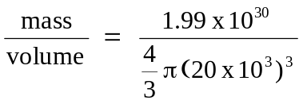 = 5.9 x 10¹⁶ kg m⁻³
(c) Volume of 1 kg of star = 1/(5.9 x 10¹⁶) = 1.7 x 10⁻¹⁷ m³
Volume of star for 1.675 x 10⁻²⁷ kg (a neutron) = 2.8 x 10⁻⁴⁴ m³
Assuming a cubic cell, length is cube root of volume, length = 3 x 10⁻¹⁵ m
Average spacing is approximately 1.5 m (diameter of neutron is 2 x 10⁻¹⁵ m)
(Notice that this is very small – consider the atomic size)

Gravitation
1. F = 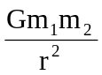
2. F = 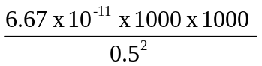 = 2.7 x 10⁻⁴ N

3. F = 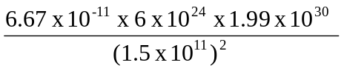 = 3.5 x 10²² N

4. (a) F = m₁g = giving g = 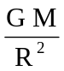 where M is the mass of the Earth
(b) (i) 9.8 = 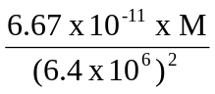 giving M = 6.0 x 10²⁴ kg
(ii) g = 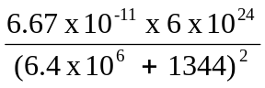 = 9.8 N kg⁻¹ (No noticeable difference!)
(iii) g = 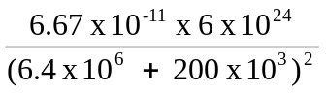 = 9.2 N kg⁻¹

5. (a) The work done to move 1 kg from infinity to that point.
(b) V_{p} = - 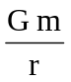
(c) (i) V_{p} = - 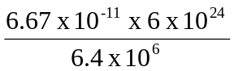 = - 6.2 x 10⁷ J kg⁻¹
(ii) V_{p} = - 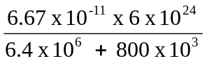 = - 5.6 x 10⁷ J kg⁻¹
(The negative sign indicates that the potential at infinity is higher than the potential on or close to the Earth.)

6. The work done by the force of gravity on a particle which moves through a round trip back to its starting point is zero. Energy is conserved.

7. Energy required = E_{k} + E_{p} and E_{k} = ½ mv² but 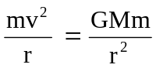
= 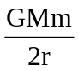 + 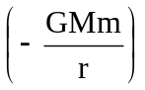 = - = -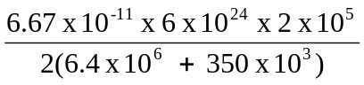
= - 5.9 x 10¹² J (The negative sign indicates a decrease in energy.)

8. Gravitational field strength, escape velocity

9. (a) -10 – (-15) = 5 J kg⁻¹
(b) 5 x 8 = 40 J
(c) 40 J

10 (a) The minimum velocity a mass must have that would allow it to escape from the gravitational field of the planet or star.
(b) Gravitational E_{p} at surface = - 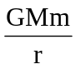 E_{p}(Infinity) = 0
Kinetic energy at surface = ½ mv² E_{k}(Infinity) = 0
Total energy at surface = total energy at infinity
- + ½ mv² = 0 thus v² = 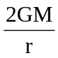 and v_{escape} = 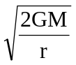
(c) (i) v_{e}(Earth) = 1.1 x 10⁴ m s⁻¹ v_{e}(Moon) = 2.4 x 10³ m s⁻¹
(ii) Escape velocity on the Moon is very small so there will be no atmosphere.

11. For a geostationary satellite T = 24 x 60 x 06 s and T = 2π 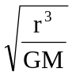
for the Earth this gives r = 4.2 x 10⁷ m, where r is from the centre of the Earth
E_{p} = - = - 1.9 x 10¹¹ J E_{k} = = 0.95 x 10¹¹ J

12. (a) See Mechanics – Student Material page 25
(b) (i) 24 hours (24 x 60 x 60 s)
(ii) radius of orbit = 4.2 x 10⁷ m, (using the equation for T as in Q 11.)
height above equator = 4.2 x 10⁷ – 6.0 x 10⁶ = 3.6 x 10⁷ m
(iii) v = rω = r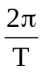 = 3.05 x 10³ m s⁻¹
(iv) central acceleration = = 0.22 rad s⁻²

13. (a) density = 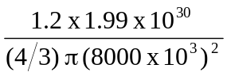 = 1.1 x 10⁹ kg m⁻³
(b) Vp = - = - 1.99 x 10¹³ J kg⁻¹
(c) g = 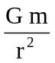 = 2.5 x 10⁶ N kg⁻¹
(d) Assume a change of height of 1 m and a mass of 60 kg
E_{p} = mgh = 60 x 2.5 x 10⁶ x 1 = 1.5 x 10⁸ J
(e) s = ut + ½ at² giving 100 = 0 + ½ x 2.5 x 10⁶ x t²
t = 8.9 x 10⁻³ s (Notice that this does not depend on the mass)

14. (a) There is a gravitational force of attraction on the photons. The photon path would be deflected.
(b)
Apparent position of star
To true position of star

The light from the star is deflected by the Sun. The observer might consider that the star position is in a straight line from his line of sight.
(c) If a dense star has an escape velocity greater than the speed of light, then no light could escape and the star would appear ‘black’.

Simple Harmonic Motion
1. (a) The unbalanced force is proportional to the displacement, and acts in the opposite direction.
(b) A mass oscillating at the end of a spring, a pendulum with small amplitude, a hack saw blade fixed at on end and vibrating at the other.

2. (a) 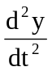 = - ω²y
(b) (i) See Mechanics – Student Material page 29
(ii) y = a at t = 0 and y = 0 at t = 0.
(c) See Mechanics – Student Material page 29

3. (a) acceleration = - ω²y acceleration at centre = 0 (y = 0)
acceleration at extremities = ± 4π² x 5² x 0.04 = ± 39 m s⁻² (ω = 2πf)
(b) velocity = ± ω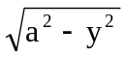
velocity at extremities = 0
velocity at centre = ± ω a = ± 2π x 5 x 0.04 = ± 1.3 m s⁻¹
(c) acceleration = ± 4π² x 5² x 0.02 = ± 20 m s⁻²
velocity = ± 2π x 5 x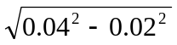 = ± 1.1 m s⁻¹

4. Acceleration of oscillations must be numerically less that g = 9.8 m s⁻²
9.8 = ω²a = 2π x 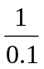 x a giving a = 0.16 m

5. (a) See Mechanics – Student Material page 33
(b) E_{k} = ½ mω²(a² – y²) E_{p} = ½ mω²y²
(i) E_{k}(max) = ½ x 0.2 x (2π x 0.5)² x 0.1² = 9.9 x 10⁻³ J at the central position
(ii) E_{k}(min) = 0 when y = a, at the extreme position
(iii) E_{p}(max) = ½ x 0.2 x (2π x 0.5)² x 0.1² = 9.9 x 10⁻³ J at the extreme position
(iv) E_{k}(min) = 0 at the central position when y = 0
(v) Sum of E_{p} and E_{k} at any point is always the same and equal to 9.9 x 10⁻³ J

6. (a) 0.44 mm
(b) 28 = 2πf f = 4.5 Hz
(c) period T = 1/f = 0.22 s
(d) 0.2 = 0.44sin 28t hence sin 28t = 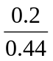 = 0.4545
28t = 0.472 (remember to work in radians) giving t = 0.017 s

7. (a) Reduces the amplitude of the oscillations
(b) When a system is critically damped the frictional resistance is just enough to prevent any oscillations occurring. The time taken for the displacement to become zero is a minimum.
When a system is overdamped the frictional resistance is large and the system takes a long time to come to rest.
(c) Critical damping for the needle on a meter.
Critical damping for car shock absorbers

Wave-particle duality
1. (a) Electrons behave like particles in an oscilloscope. A diffraction pattern can be produced when high energy electrons pass though a metal foil. (The wavelength of the electrons must be similar in size to the atomic spacing.)
(b) Photons of electromagnetic radiation can show diffraction and interference when the wavelength is similar in size to the gap or obstacle.
Photons behave like particles in the photoelectric effect where photon above a certain frequency can eject electrons from a metal surface.

2. (a) p = 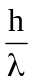
(b) λ = 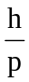 = 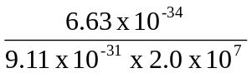 = 3.6 x 10⁻¹¹ m

3. (a) λ = = 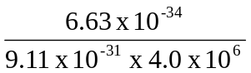 = 1.8 x 10⁻¹⁰ m
(b) λ = = 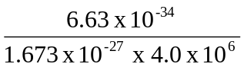 = 9.9 x 10⁻¹⁴ m
(c) λ = = 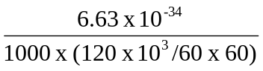 = 2.0 x 10⁻³⁸ m (very small!)

4. (a) E = hf and c = fλ λ = 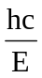 = 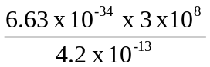 = 4.7 x 10⁻¹³ m
(b) p = = 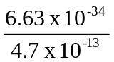 = 1.4 x 10⁻²¹ kg m s⁻¹

5. (a) E = eV = 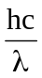 hence V = 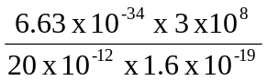 = 62 kV
(b) Relativistic effects have been neglected. It is useful to calculate the non relativistic speed and notice that it is just over 10% of the speed of light.
(For interest non uniformities in the ‘optics’ limit the resolution. Magnetic lenses have aberrations similar to chromatic aberration in optical lenses.)

6. (a) mvr = nh/2π where m – mass (kg), v – velocity (m s⁻¹), r – orbital radius (m)
h - Planck’s constant (J s), n- an integer (no units)
(b) A quantity is said to be quantised if it can only take particular discrete values and not any value.

7. (a) mvr = nh/2π and v x 9.11 x 10⁻³¹ x 53 x 10⁻¹² = (1 x 6.63 x 10⁻³⁴)/2π
v = 2.2 x 10⁶ m s⁻¹
(b) p = mv = 9.11 x 10⁻³¹ x 2.2 x 10⁶ = 2.0 x 10⁻²⁴ kg m s⁻¹
(c) λ = = 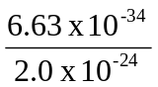 = 3.3 x 10⁻¹⁰ m

8. Classical mechanics cannot solve some problems of atomic and nuclear physics. Quantum mechanics provides methods for solving certain problems by determining probabilities .

