Kinematic relationships

2014 Revised AH

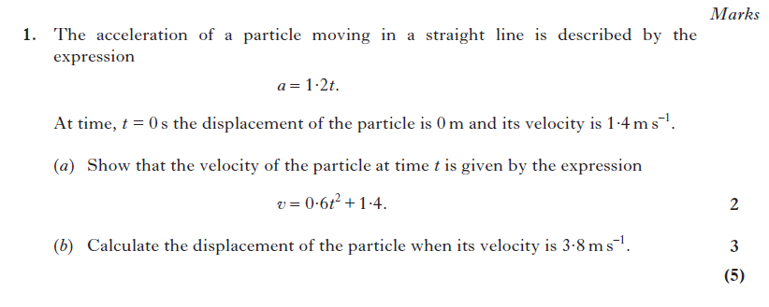
2016 CfE AH Physics
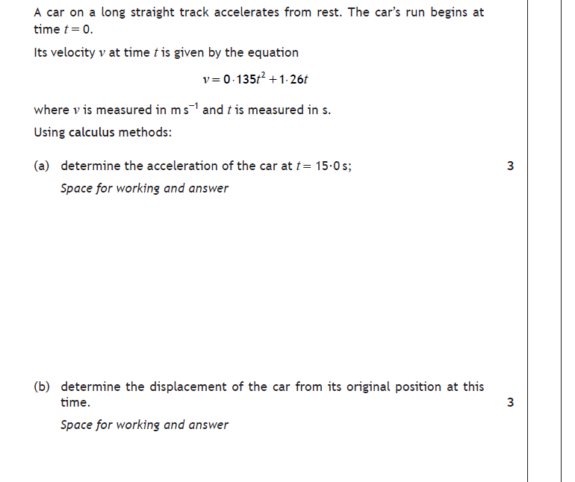

- Angular motion
- Rotational dynamics
- Gravitation
- General relativity
- Stellar physics

2017 CfE AH Physics
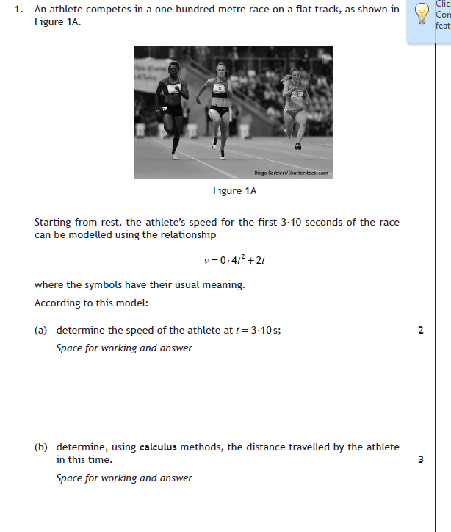

SQA Exemplar paper
