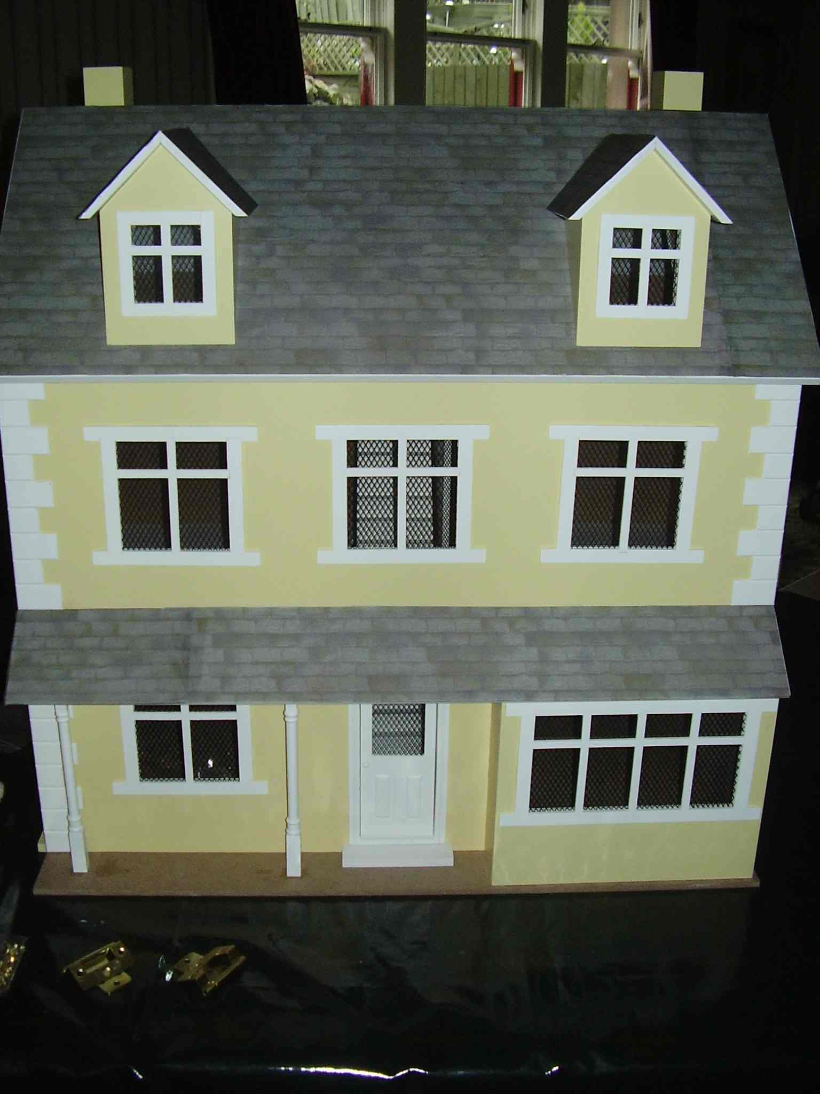
Title:

L'isolation
Title:

INSULATION
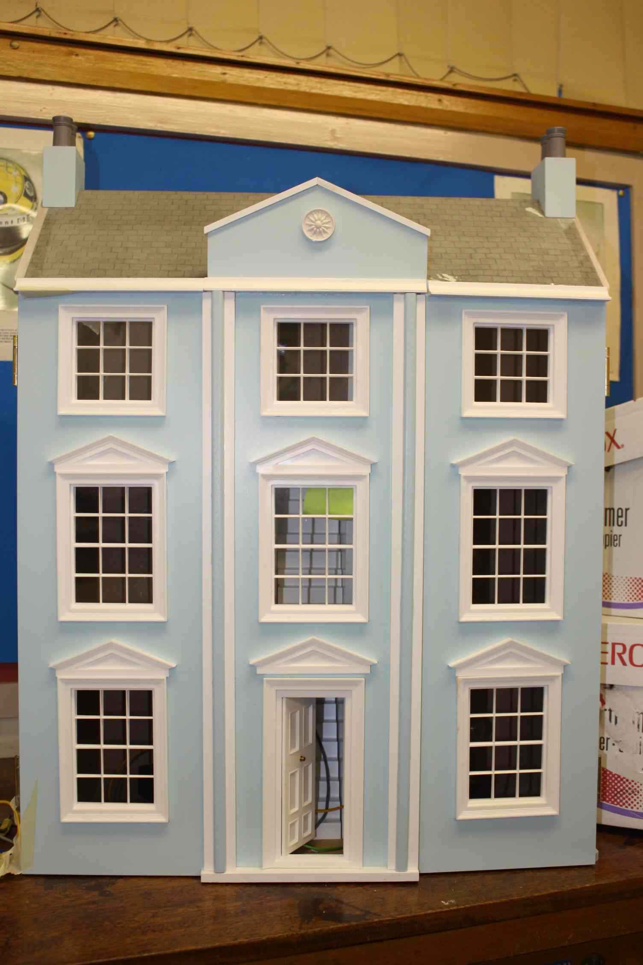
£
£

NB This investigation should only be carried out by hard working, sensible students who will carefully manage the task.

Aim:
To find out why insulating the loft is so cost effective?

Aim:
Most of us know that it is important to insulate the lofts of our homes but do you know why?

Introduction
Energy travels through liquids and gases by convection. With convection the hot fluid expands as it is heated and gradually moves upwards as it is less dense than the surrounding cooler fluid. This usually sets up a convection current in the fluid. A convection current is set up because the hot gas or liquid moves up through the heavier cold gas or liquid.

TASK 1
Look up some of the videos and images of convection
http://video.google.com/videoplay?docid=1902141755519014330
http://www.bbc.co.uk/schools/ks3bitesize/science/physics/energy_transfer_4.shtml

TASK 2
Re-write the introduction above in your own words so that it is clear that you understand the paragraph.

Observing Convection currents in a beaker of liquid (water).
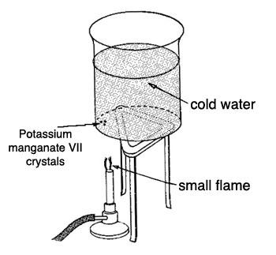
Apparatus and materials
- Bunsen burner
- Tripod
- Glass tube, approximately 150 mm long x 3 mm internal diameter
- Pyrex beaker, 600 ml
- Potassium permanganate crystals (KMnO₄)
- Technical notes
- You need to get the potassium permanganate crystals into the bottom of the beaker of water without colouring the water unduly.

Safety
- Wear eye protection
- KMnO₄ is poisonous, do not inhale, ingest etc.

Method
- ¾ fill the beaker with water.
- Put a glass tube into the beaker so that it rests on the base of the beaker. Then drop the crystal through the tube.
- Heat the water gently over the Bunsen burner (see the diagram above) and observe the motion of the dye. For a clear effect, use a small flame and no gauze between Bunsen and beaker (Pyrex beakers do stand this).
- Note the path that the coloured water takes from the bottom of the beaker to the top of the water and back down again.
- When repeating the experiment you should always start with a new batch of cold water.

TASK 3
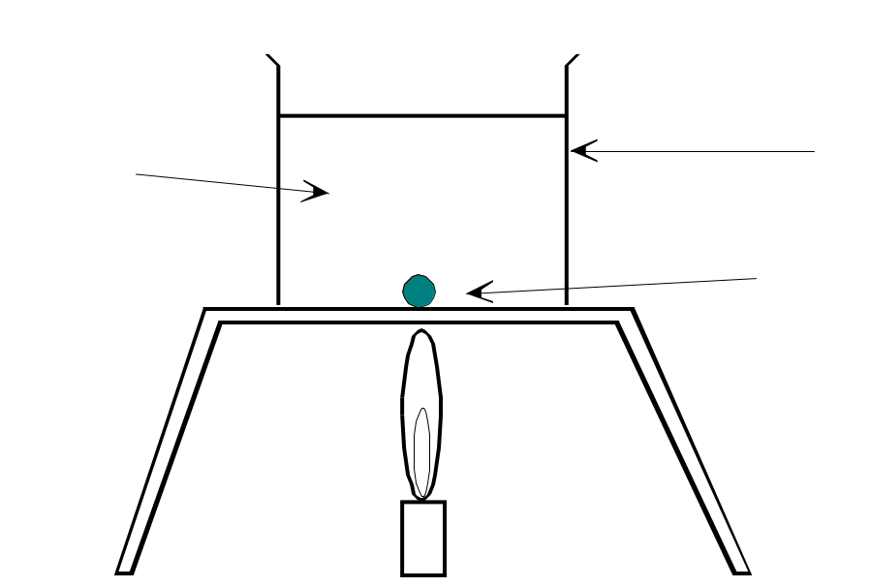
Copy and label the diagram below and show the path of the purple dye.

Can you relate this experiment to why your loft should be insulated?

TASK 4
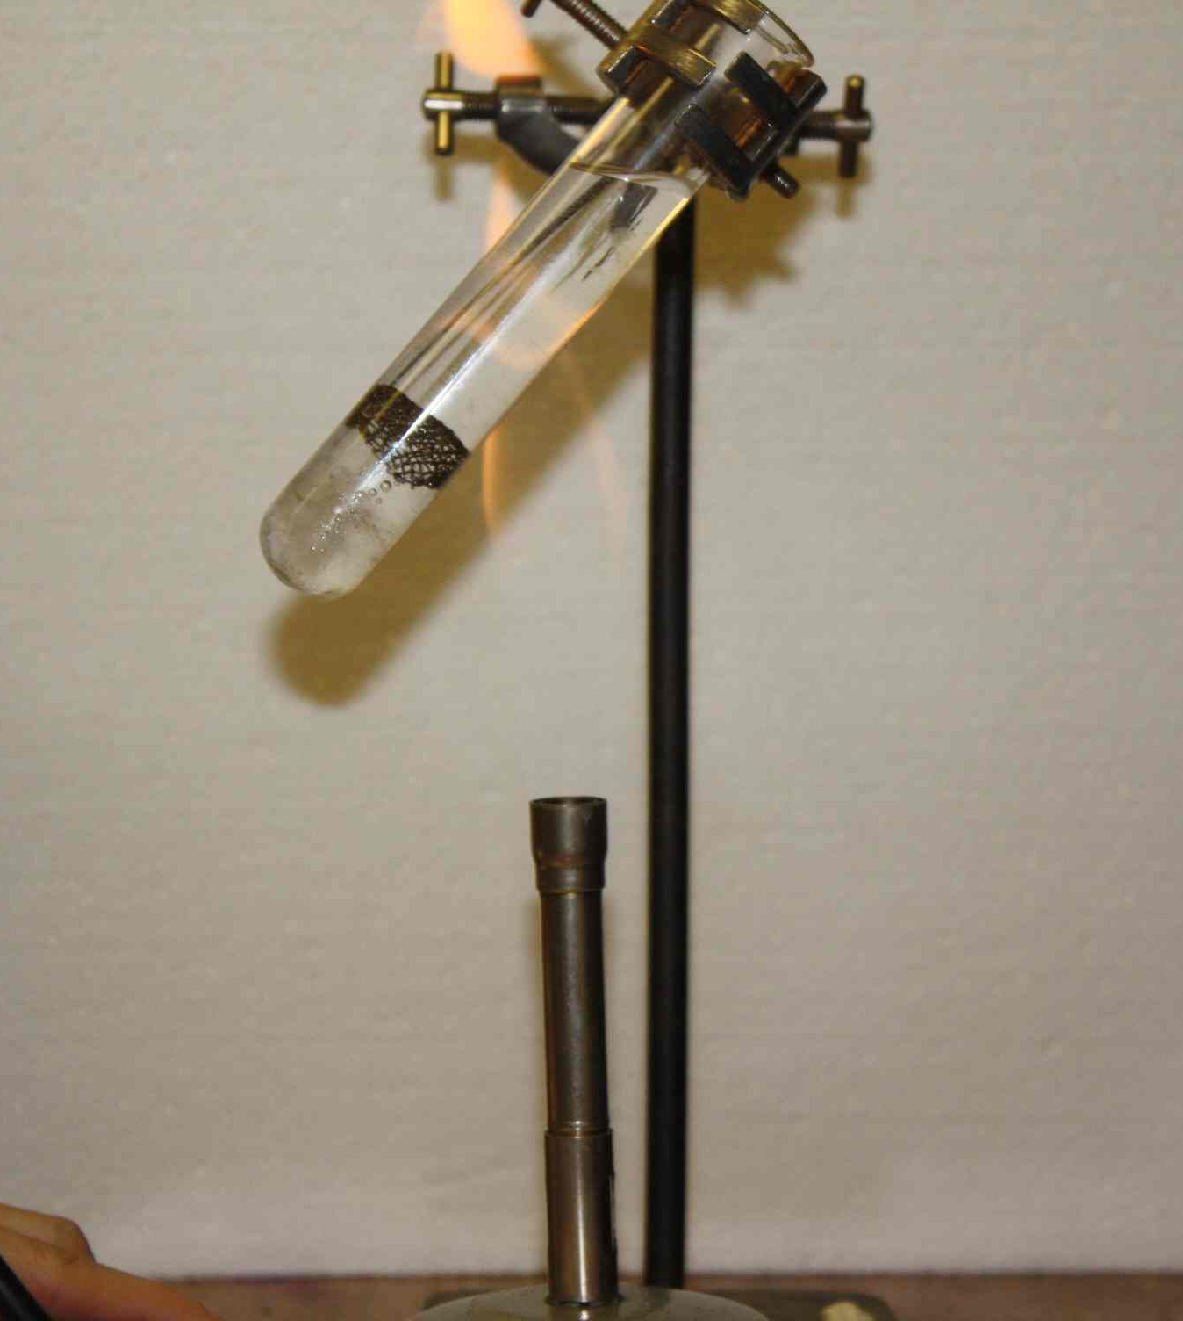
The experiment below shows how important convection is in fluids and how conduction does not occur in liquids, such as water. Either complete the experiment yourself or watch a video clip or a teacher demonstration.

- Wrap a piece of ice in a piece of gauze. Do not cut your hands.

- Place the ice wrapped in gauze at the bottom of a boiling tube.

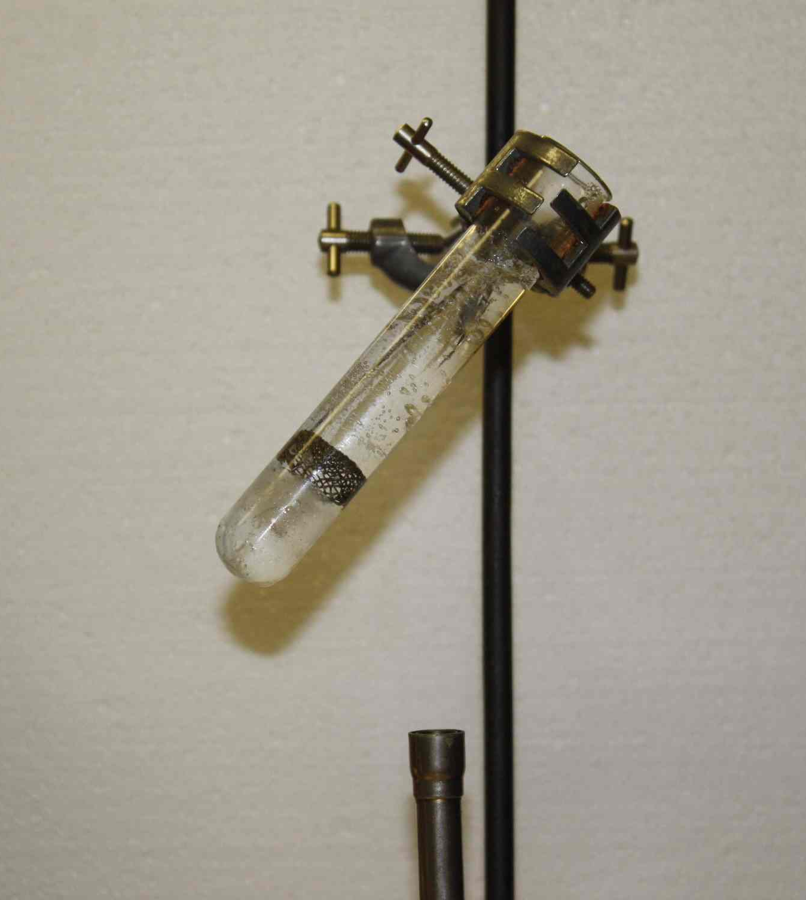
- Add water to the boiling tube until it is two-thirds full.

- Put on a pair of goggles and hold the boiling tube with a test-tube holder. (Do not heat the bottom of the boiling tube.)

- Heat the water at the top of the boiling tube with a bunsen burner until it begins to boil.

- NEXT repeat the experiment with fresh equipment but place the Bunsen at the bottom of the boiling tube.
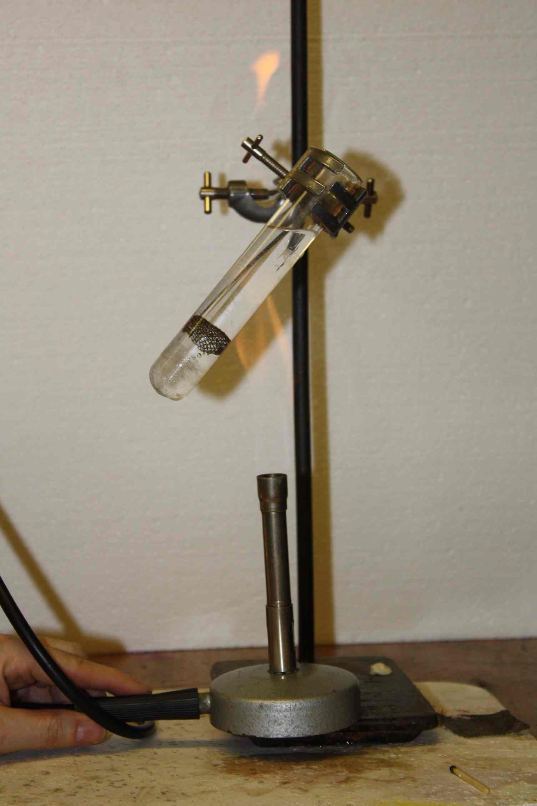

Try to explain any difference in the results from these two experiments.

TASK 5
Copy the diagrams below in your jotter and label them.

Complete these experiments with the smoke box.

On the first diagram show what happens to the smoke when the candle is not lit.

On the second diagram show what happens to the smoke when the candle is lit.

Why does lighting the candle pull smoke into the box?

Can you relate this to why your loft should be insulated?

Extension Sheet (1)

An old fashioned example of convection currents.

In the days before electric fans it was common to ventilate mines by lighting a fire at the bottom of one of the mine shafts.

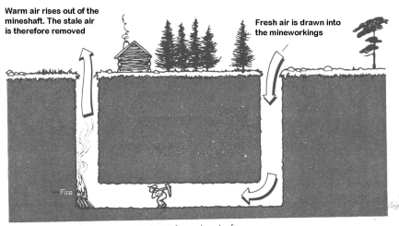

EXTENSION SHEET (2)
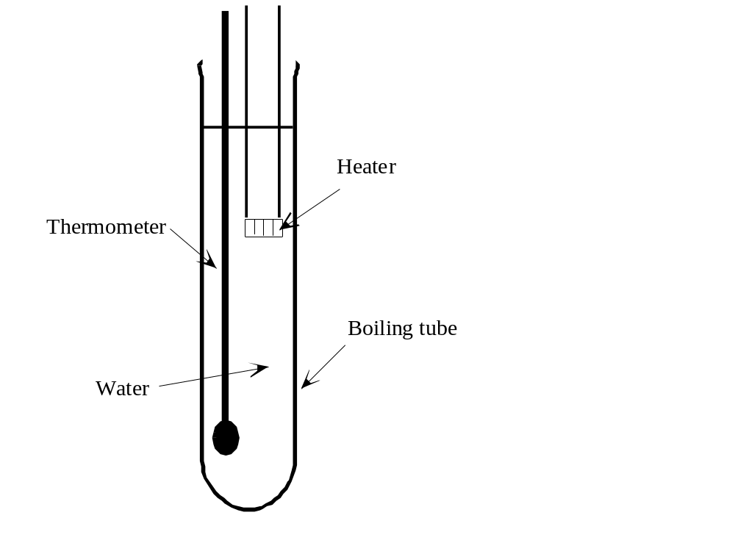
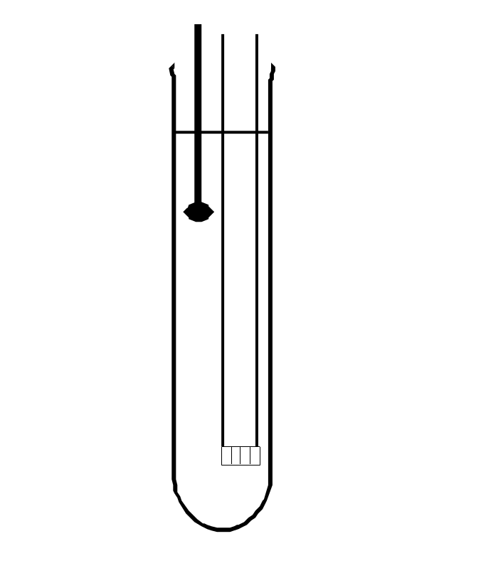
Another experiment that can be tried is to show the different in heating the water from the top of a boiling tube compared to heating the bottom
Figure 1
Figure 2

Demonstration

Visualising convection currents in air.

Apparatus and materials
- Compact light source (slide projector)
- Bunsen burner
- Heatproof mat
- Translucent screen

Safety
- Read our standard health & safety guidance

Procedure
Light the Bunsen and put it about 1/2 metre in front of the compact light source. Cast the shadow either on to the wall or on to a translucent screen. Students should look at the shadow and discuss what they see.

The convection currents from the Bunsen flame can be clearly seen. The warm air rises up above the flame and falls down away from it.

Explain how this relates to insulating the loft.

