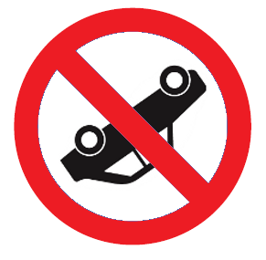
Stopping Distance, Thinking Distance, Braking Distance and Speed.

- What is the link between Stopping Distance, Thinking Distance, and Braking Distance?
- What affects the thinking distance?
- List things that affect braking distance.
- A person in a car travelling at 20 mph. has a thinking distance of 6m and a braking distance of 6m what is her stopping distance?
- Copy and complete the table filling in the missing values from the white columns.
Speed | Speed | Thinking Distance | Braking Distance | Stopping Distance | Stopping Distance | Reaction Time
(mph) | (m/s) | (m) | (m) | (m) | (car lengths) | (s)
20 | 9.0 | 6 | 6
30 | 13.5 |  | 14 | 23
40 | 18.0 | 12 |  | 36 | 9
50 | 22.5 | 15 | 38
60 | 27.0 |  | 55 | 73
70 | 31.5 | 21 |  | 96

- At 40m.p.h the stopping distance of a car is 36 m or 9 car lengths. From this information work out the average length of one car.
- In the table fill in the column with the stopping distance recorded in number of car lengths (round this value to the nearest car length).
- What is the formula that links speed distance and time?
- Rearrange this equation to find time?
- Use the equation in question 8 to find out the THINKING TIME (reaction time) used in the table. Calculate the answer for each speed.
- Try to plot a graph, either with excel or on graph paper to show the data in the table. Think what the best graph would be.
- Advanced Question: What is the conversion figure between speed in mph and speed in m/s?
Stopping Distance, Thinking Distance, Braking Distance and Speed. ANSWERS
- What is the link between Stopping Distance, Thinking Distance, and Braking Distance?

Stopping distance=thinking distance + braking distance
- What affects the thinking distance?
Person’s reaction time, alcohol, health (cold) medication, distractions such as phone, radio/CD etc, tiredness
There are many factors that affect how rapidly you are able to react to a hazard. Here are a selection:
Factor | Result
Tiredness | Your brain thinks slower - you will not be able to apply the brakes as quickly.
Alcohol | Being under the influence - even legally - seriously alters how well you can judge hazards. Your body also moves less accurately. Late or missed braking results!
Drugs | Most drugs make you less alert and less aware of hazards. Even legal pain-killers and hay-fever tablets can seriously affect reaction times.
Distractions | In-car distractions (e.g. very loud music, mobile phones, crying babies, etc.) take your mind off the road ahead.

- List things that affect braking distance.
Type of car and brakes, ABS brakes, road surface, road conditions (ice) speed, how hard you brake, state of tyres etc.
Just like thinking, there are many factors that affect how effective your braking will be:
Factor | Result
Brakes | Worn brakes won't work as well, so you'll need to brake for longer. Modern brakes are also better than old ones - they can apply bigger forces without causing skidding.
Tyres | Not all tyres are the same! Some are designed to reduce fuel consumption by rolling more easily. This is at the expense of grip in the wet. Tread patterns are designed to push water out from between the tyre and road. Good tyres can reduce braking distance by many metres! Worn tyres (with little tread) will have good grip in the dry but in the wet will lead to much longer braking distances...
Road Surface | Different types of surface provide different levels of grip, especially in the wet. If the road is wet, braking distance will always be longer. Oil spills on the road, gravel, etc. all reduce grip and increase braking distances.
Mass | The larger the total mass of the vehicle, passengers and luggage, the more kinetic energy it will have at a given speed. This increases the braking distance as it is harder to slow down.
Aerodynamics | Rather oddly, the worse your car's aerodynamics, the better it will be at slowing down during braking! The reason is that the airflow at and around the car (drag or air resistance) is an additional force acting to slow you.  The Mercedes SLR is so aerodynamic it has a flap that pops up on the boot to increase drag when braking!

- A person in a car travelling at 20 mph. has a thinking distance of 6m and a braking distance of 6m what is her stopping distance? 12m

- Copy and complete the table filling in the missing values from the white columns.
Speed | Speed | Thinking Distance | Braking Distance | Stopping Distance | Stopping Distance | Reaction Time
(mph) | (m/s) | (m) | (m) | (m) | (car lengths) | (s)
20 | 9.0 | 6 | 6 | 12 | 3 | 0.67
30 | 13.5 | 9 | 14 | 23 | 6 | 0.67
40 | 18.0 | 12 | 24 | 36 | 9 (given) | 0.67
50 | 22.5 | 15 | 38 | 53 | 13 | 0.67
60 | 27.0 | 18 | 55 | 73 | 18 | 0.67
70 | 31.5 | 21 | 75 | 96 | 24 | 0.67

- At 40m.p.h the stopping distance of a car is 36 m or 9 car lengths. From this information work out the average length of one car. 36/9=4m
- In the table fill in the column with the stopping distance recorded in number of car lengths (round this value to the nearest car length). as above
- What is the formula that links speed distance and time? speed=distance/time or v=d/t (don’t accept S=D/T)
- Rearrange this equation to find time? t=d/v or time=distance/speed
- Use the equation in question 8 to find out the THINKING TIME (reaction time) used in the table. Calculate the answer for each speed.
Speed | Thinking Distance | formula | Reaction Time
(m/s) | (m) |  | (s)
9.0 | 6 | 6/9 | 0.67
13.5 | 9 | 9/13.5 | 0.67
18.0 | 12 | 12/18 | 0.67
22.5 | 15 | 15/22.5 | 0.67
27.0 | 18 | 18/27 | 0.67
31.5 | 21 | 21/31.5 | 0.67

- Try to plot a graph, either with excel or on graph paper to show the data in the table. Think what the best graph would be.
(see excel spreadsheet but enclosed here for reference)
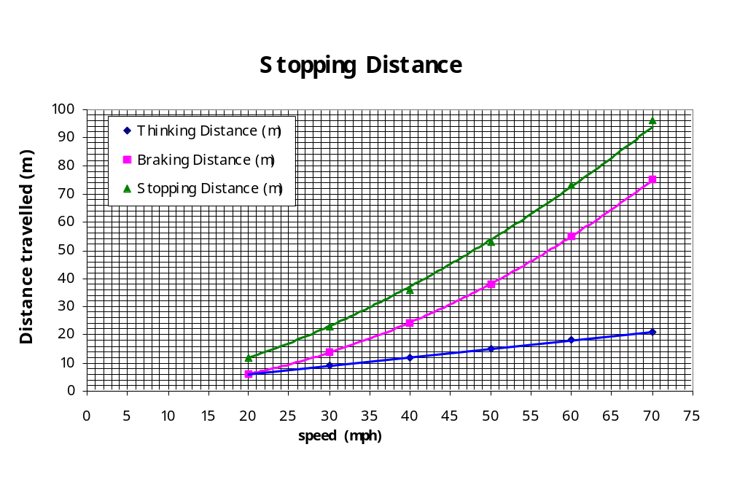
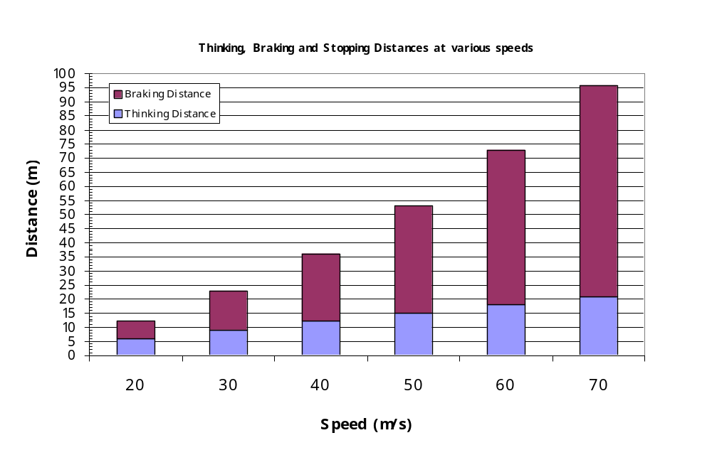
- Advanced Question: What is the conversion figure between speed in mph and speed in m/s? To change mph into m/s MULTIPLY BY 0.45

