Energy Changes 1

Energy is what makes things happen.
Energy cannot be created (made) or destroyed .
Energy can be transformed (changed) from one form into another.
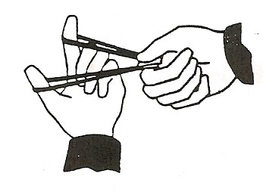
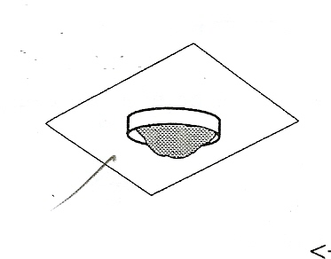
Experiment 1 – Glycerol + Crushed potassium permanganate

Chemical energy | turns into | Heat and light energy
The chemicals gave heat (or light) and light (or heat) when put together.

Experiment 2 – Catapult

Elastic Potential energy | turns into | Kinetic energy
When you stretch the spring, it stores elastic potential energy.

Experiment 3 – Heated match head |  |  | 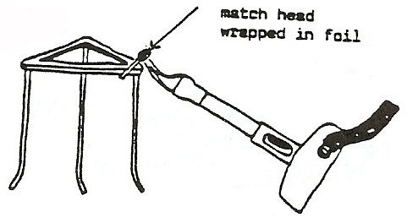
Heat (chemical) energy | turns into | Kinetic energy
The match moved when heated.

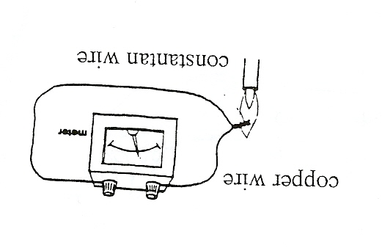
Experiment 4 – Thermocouple

Heat energy | turns into | Electrical energy
When the thermocouple was heated, the meter needle moved, showing that electrical energy was generated.

Experiment 5 – Magnesium metal burned

Chemical energy | turns into | Heat and light energy
Magnesium metal burns with a bright, white flame.

Experiment 6 – Inflated balloon

Elastic Potential energy | turns into | Kinetic energy
When you inflate the balloon, it stores elastic potential energy. When you let go, this turns into movement (kinetic) energy.

Experiment 7 – Empty tube heated

Heat (chemical) energy | turns into | Sound energy
When the Bunsen burner was placed underneath the tube, a sound was made.

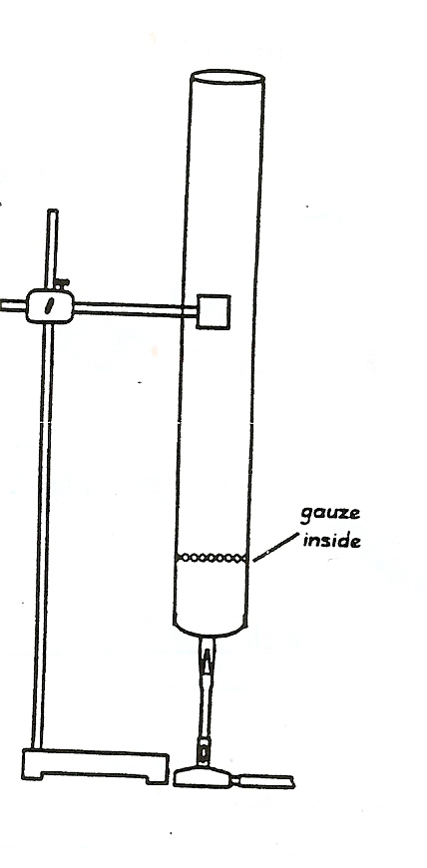
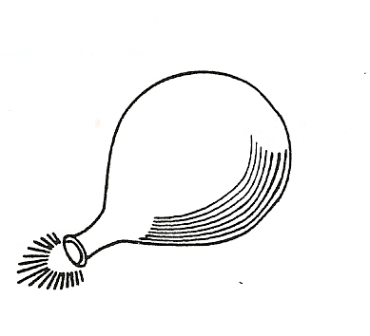
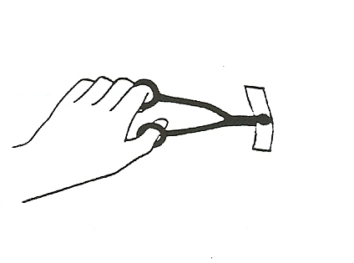

 |  |  | 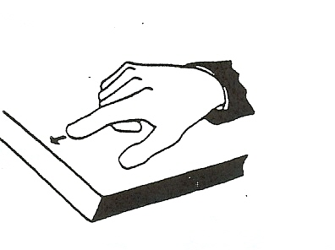
Experiment 8 | Rub your finger on the bench
 | Describe the energy change.
 | Kinetic energy | is changed into | Heat energy.

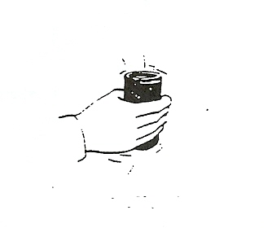
Energy Changes 2
Experiment 9 | Shake the tin with the nails in it.
 | Describe the energy change.
 | Kinetic energy | is changed into | Heat energy.
 |  |  | 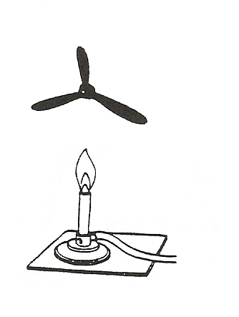
Experiment 10 | Move the clamp stand so the spiral is above the Bunsen burner.
 | Describe the energy change.
 | Kinetic energy | is changed into | Sound energy.
Experiment 11 | 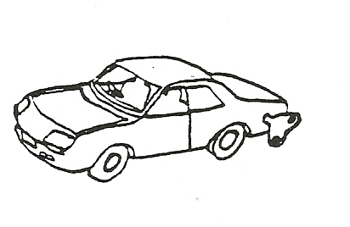  Wind up the spring in the clockwork toy, or pull it back on the bench. The wound up spring has elastic potential energy.
 | Describe the energy change.
 | Heat energy | is changed into | Kinetic energy.
 |  |  | 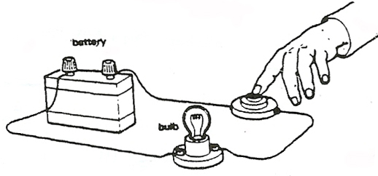
Experiment 12 | Turn on the switch. What happens to the bulb?
 | Describe the energy change.
 | elastic (pot) energy | is changed into | Kinetic energy.
Experiment 13 | 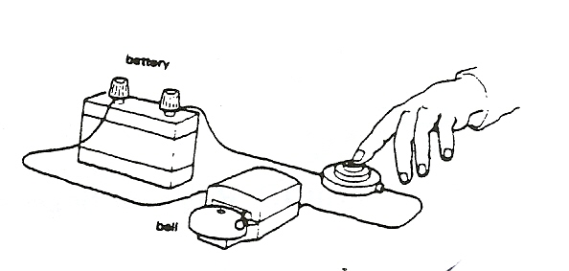  Turn on the switch. What happens to the bell?
 | Describe the energy change.
 | Electrical energy | is changed into | light (heat) energy.
Experiment 14 | 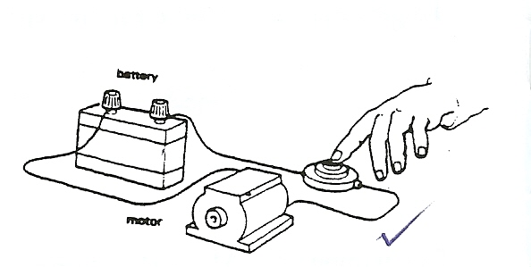  Turn on the switch. What happens to the motor?
 | Describe the energy change.
 | electrical energy | is changed into | Sound (energy.
 |  |  | 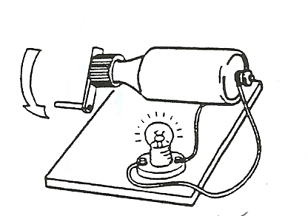
Experiment 15 | Turn the handle on the dynamo.
 | Describe the energy change.
 | electrical energy | is changed into | Kinetic energy.
 | We know that kinetic energy is changed into electrical energy in the dynamo, because this energy changes into light energy in the bulb.
Experiment 16 | 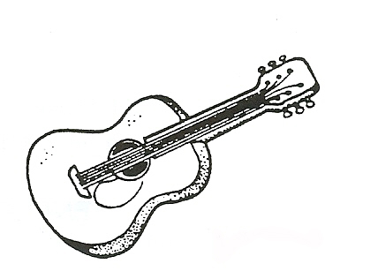  Pull the metal wire and let go.
 | Describe the energy change.
 | electrical energy | is changed into | Sound (energy.
Experiment 17 | 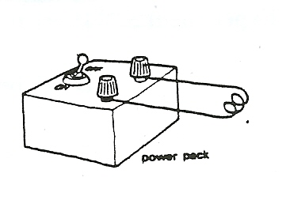  A coil has been connected to a power pack. Switch on the power pack. What happens to the coil? |  |  | DO NOT TOUCH COIL!
 | Describe the energy change.
 | electrical energy | is changed into | Heat light energy.
Experiment 18 | 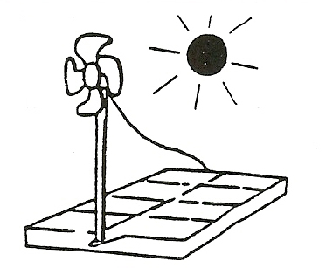  Turn the photocell so that it faces the sunlight from the window.
 | Describe the energy change in the photocell.
 | electrical energy | is changed into | Sound (energy.
 | We know that light energy is changed into electrical energy in the photocell, because this energy changes into kinetic energy in the fan .

