1 Look at this picture of Bonfire Night.
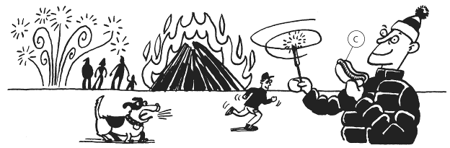

a Make a list of the things in the picture that are storing chemical energy.
b Which things are converting energy to light?
c Which things are converting energy to sound?
d Which things are converting energy to heat?
e Which of your answers to part d are transferring energy usefully as heat?
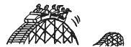
2

a In what form is this rollercoaster storing energy when it is at the top of the track?
b What energy will this be converted into as it goes down the tracks?
c Not all of the energy will be converted to the form you gave in your answer to part b.
What will happen to the rest of the energy?
d Draw a Sankey diagram to represent the energy changes as the rollercoaster goes from the top to the bottom of the slope.
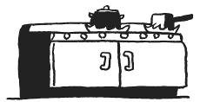
3

The natural gas in this cooker transfers 200kJ of stored energy to boil the water in the pan. When the water is boiling there is 168kJ of heat energy stored in the hot water.
a How much wasted energy has been transferred?
b Explain your answer to part a.
c Where does this wasted energy go?
d Draw a Sankey diagram to represent these changes.
I CAN...
- identify energy stores and transfers • use the idea of conservation of energy
- represent energy transfers using Sankey diagrams.

