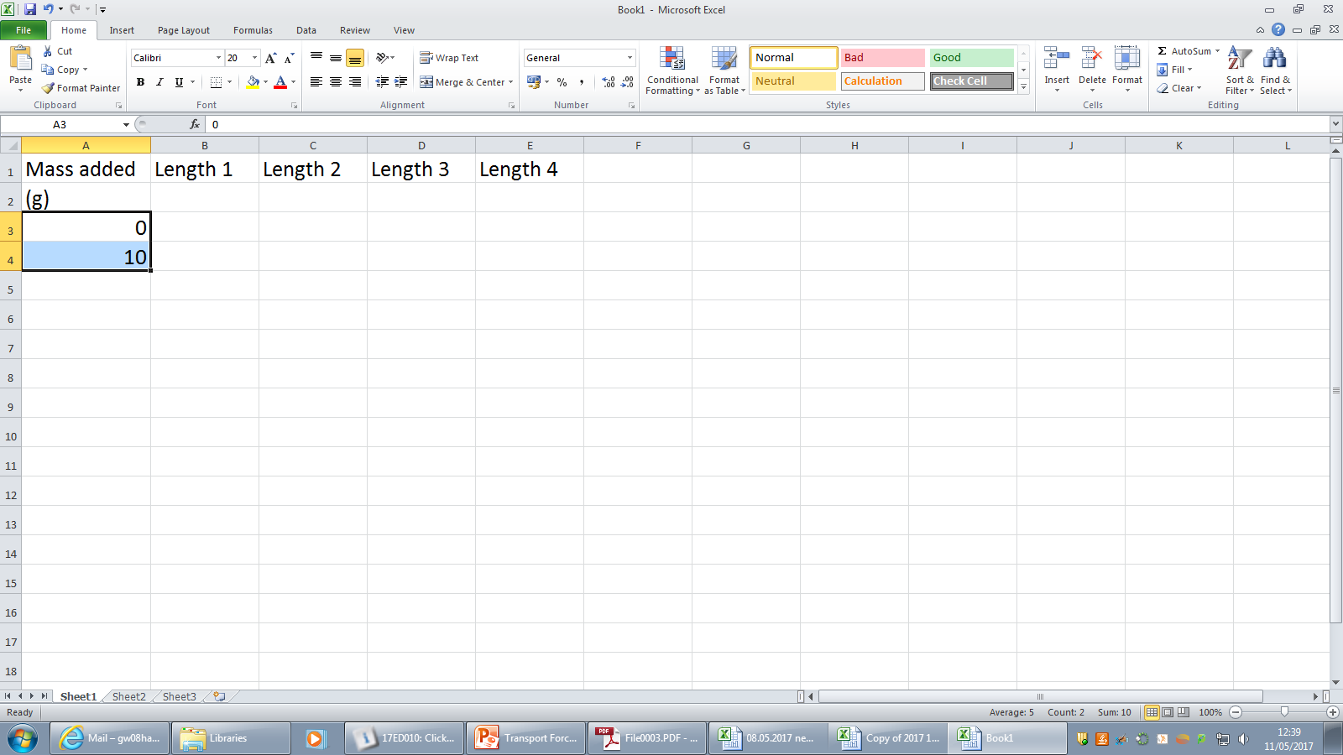

**First put in headings on each column**

**Put in the first 2 numbers. Move the white cross to the bottom right of the lower box. When it turns to a small black cross drag it down. It will add 10g or 100g (depending on boxes 1 and 2) to each line**

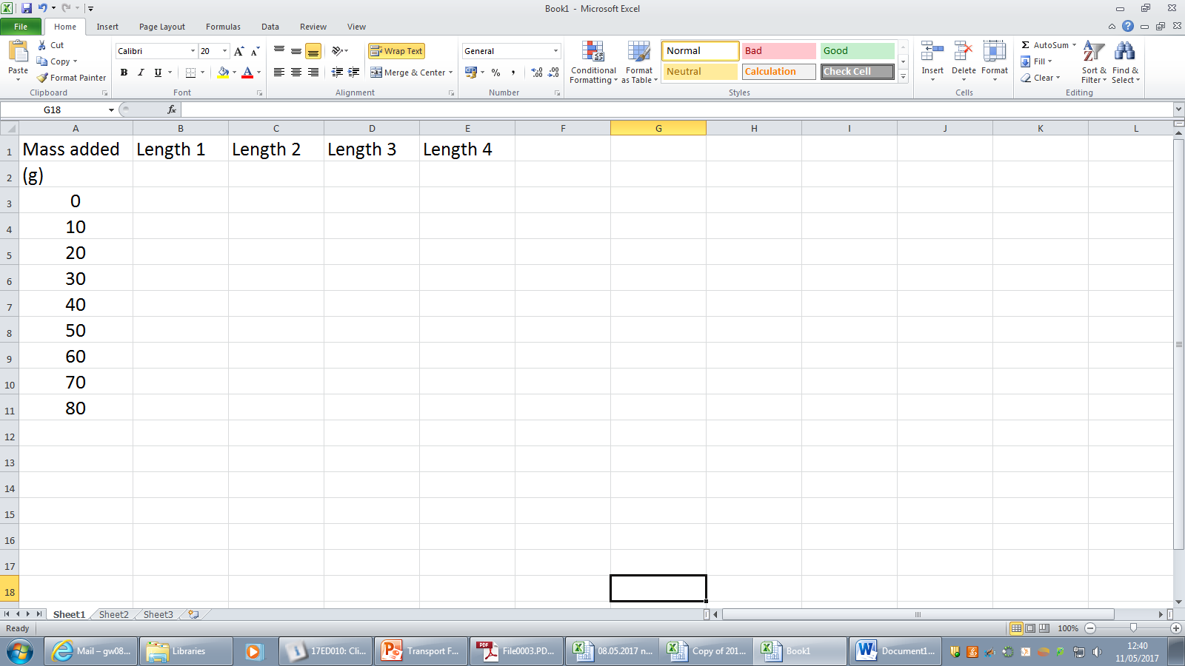

**If your headings take up too much space across a line then HIGHLIGHT THE COLUMNS go to HOME-> FORMAT -> FORMAT CELLS-> and then click on ALIGNMENT and tick the box marked WRAP TEXT**



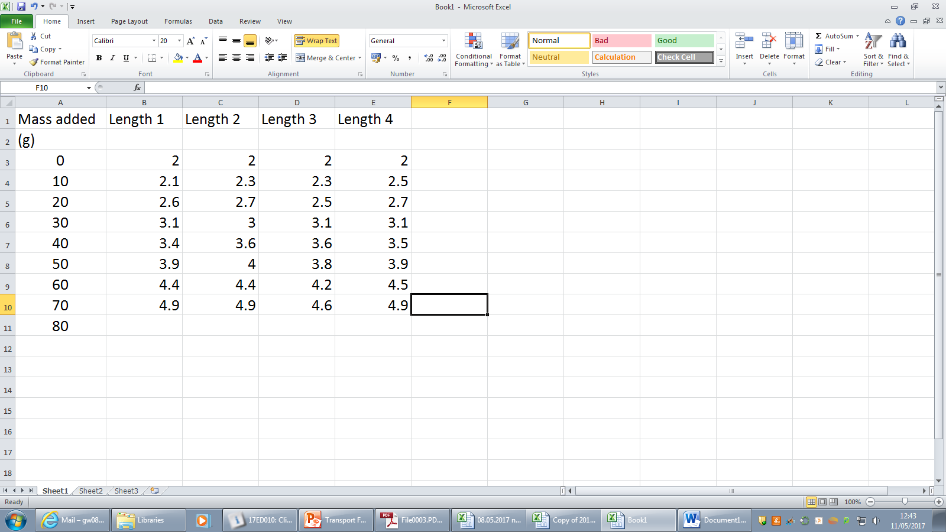

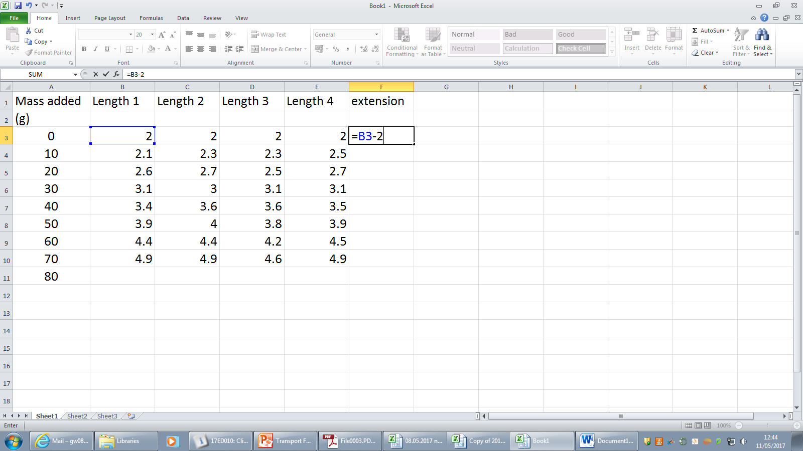

**You want to subtract the value that is in this box from each reading so either write the equation**

**={CELL}-value**

**Or ={CELL}-B$3**

**The B3 is the cell and the $ is that it is always this cell and not the one below or to the right**

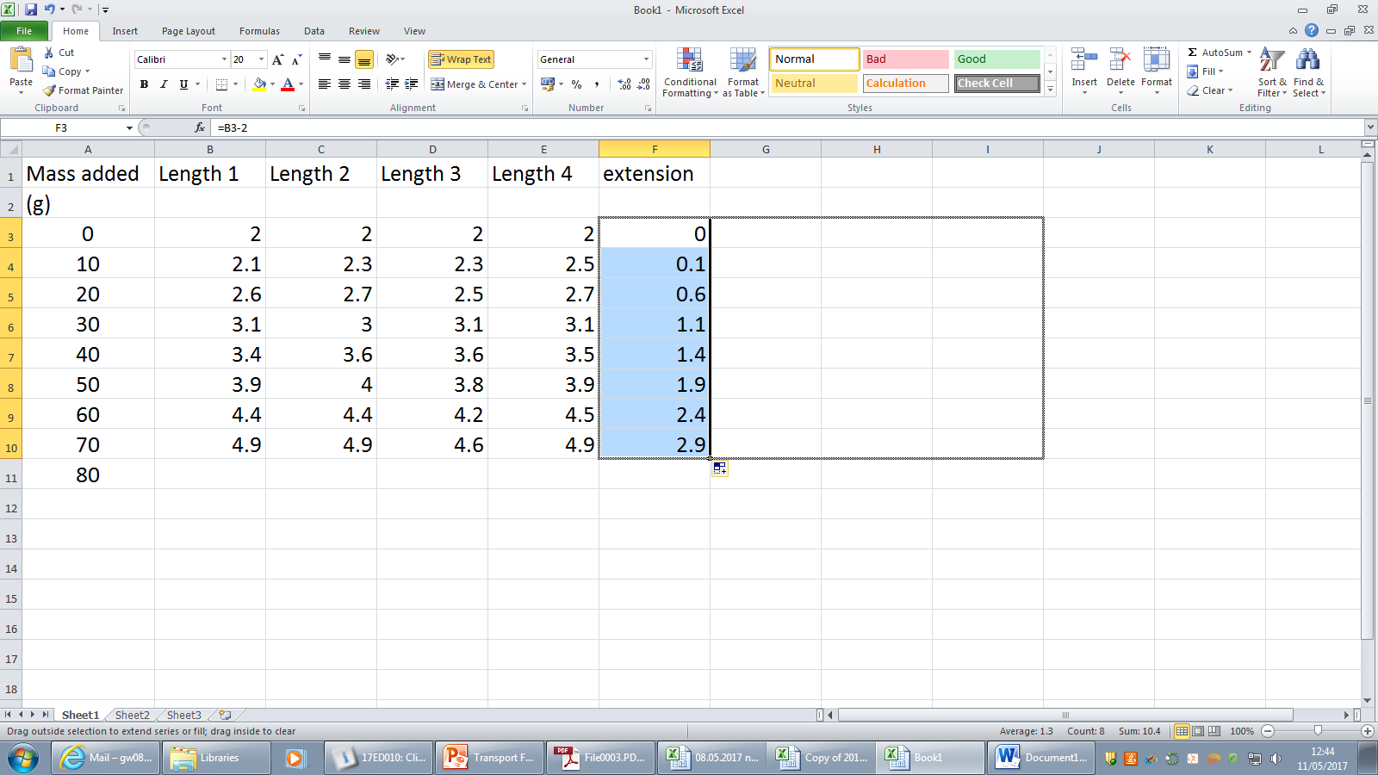

**Moving the cursor to the bottom right to get the little black cross and dragging it across the sheet will copy the formula for each column. Check that it is given you what you want!**

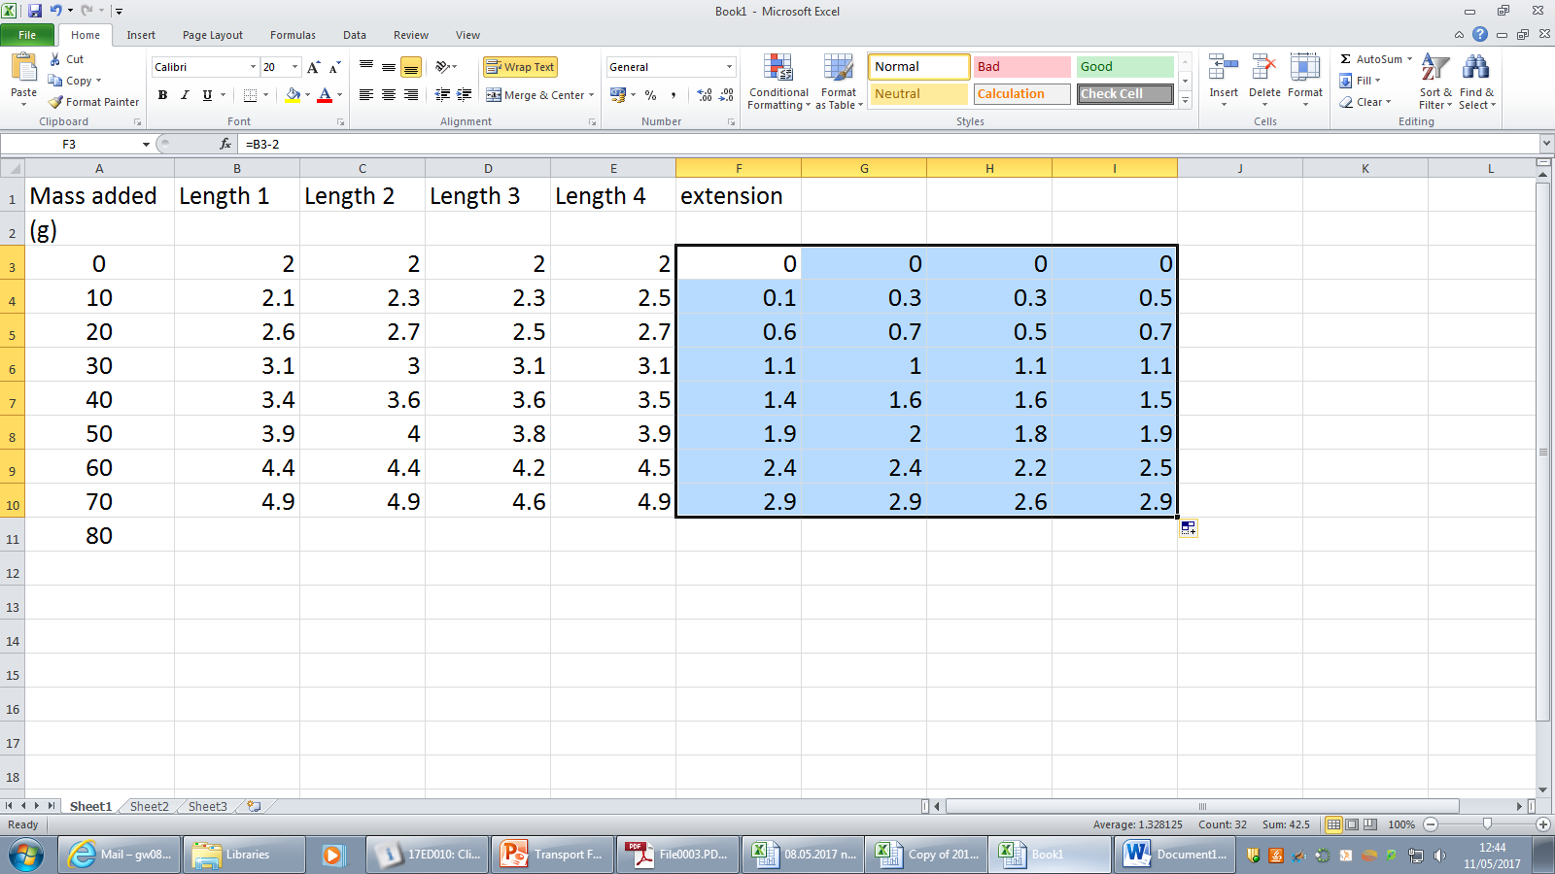

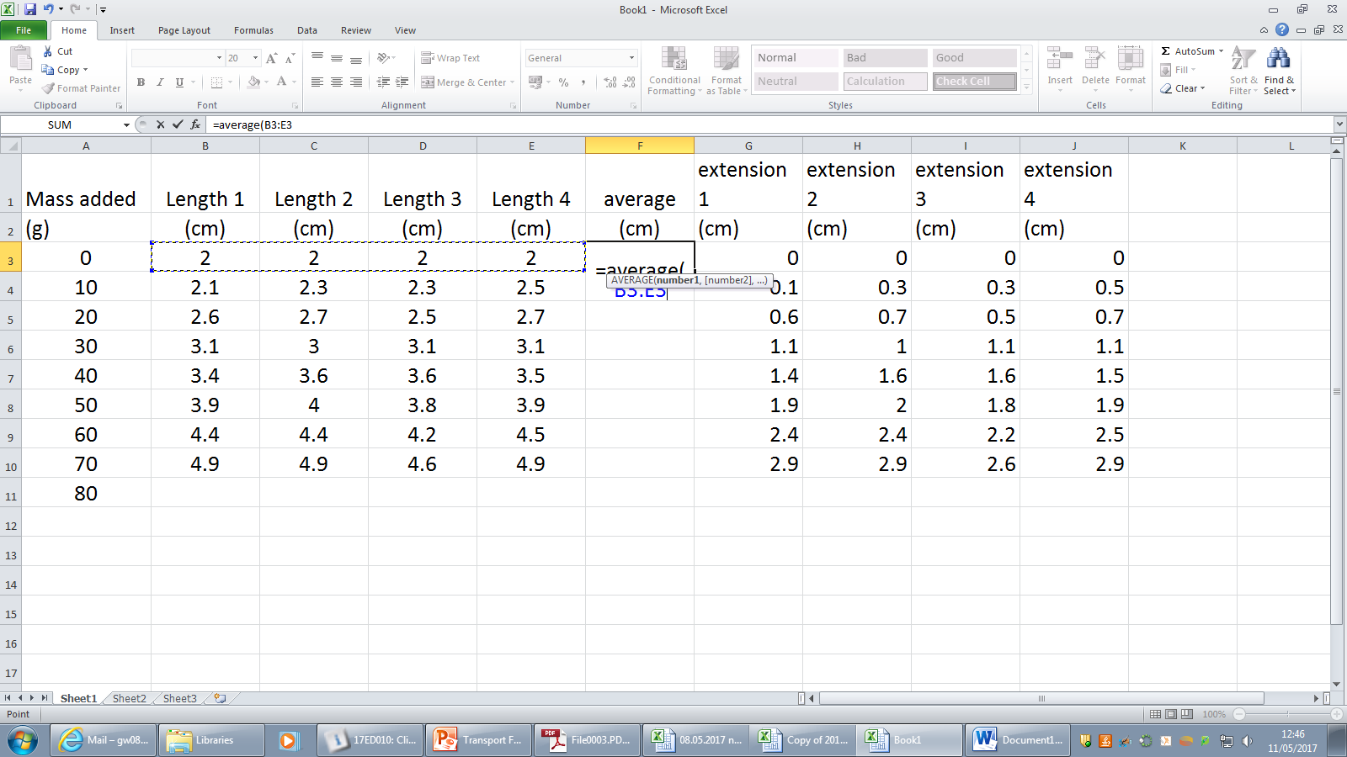

**To get an average type in**

**=average(then holding down the SHIFT key and drag the mouse across the cells you want to average). Put brackets around the cells as above.**

**Dragging the black cross down will average each line.**

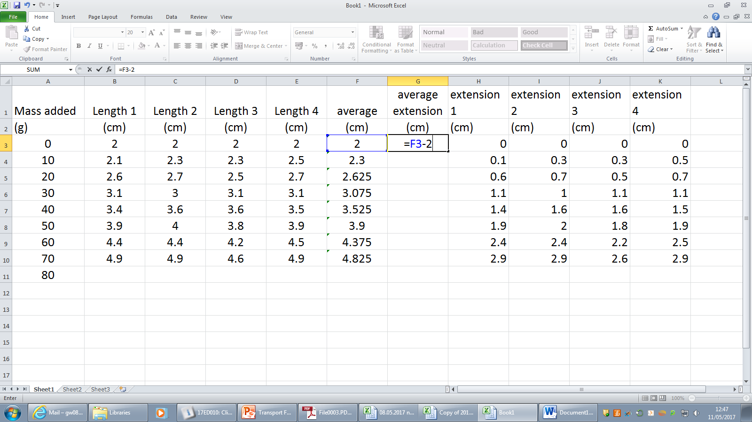

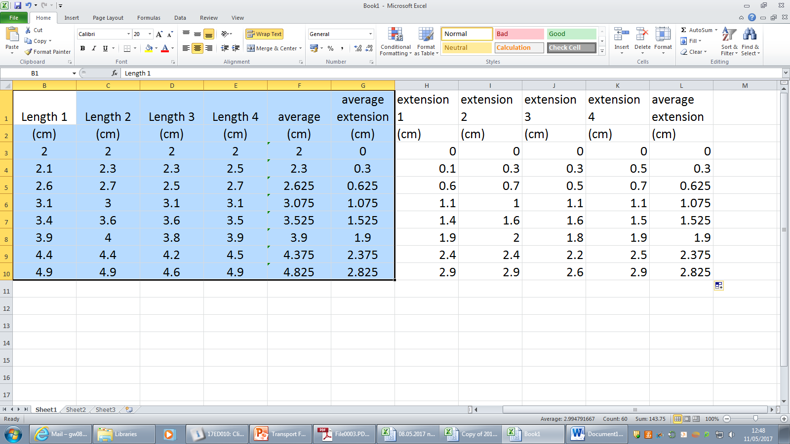

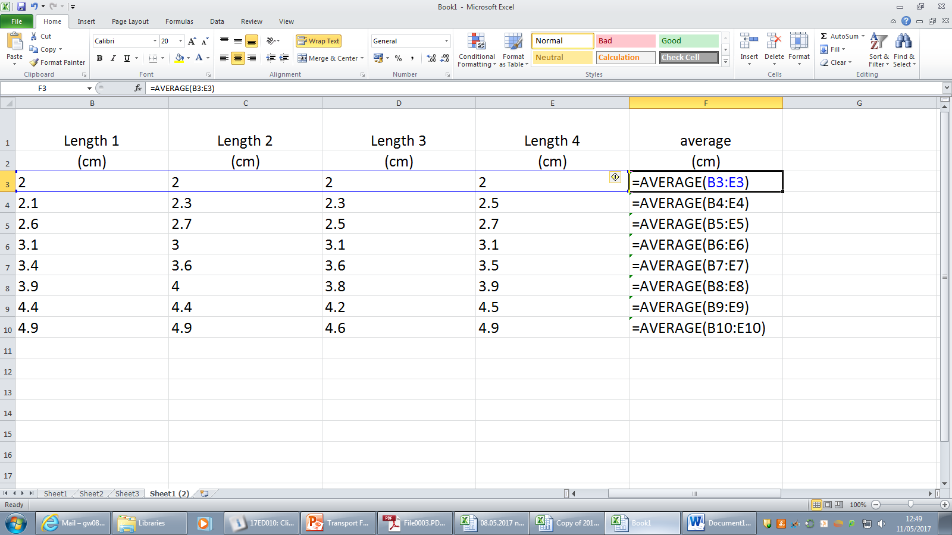

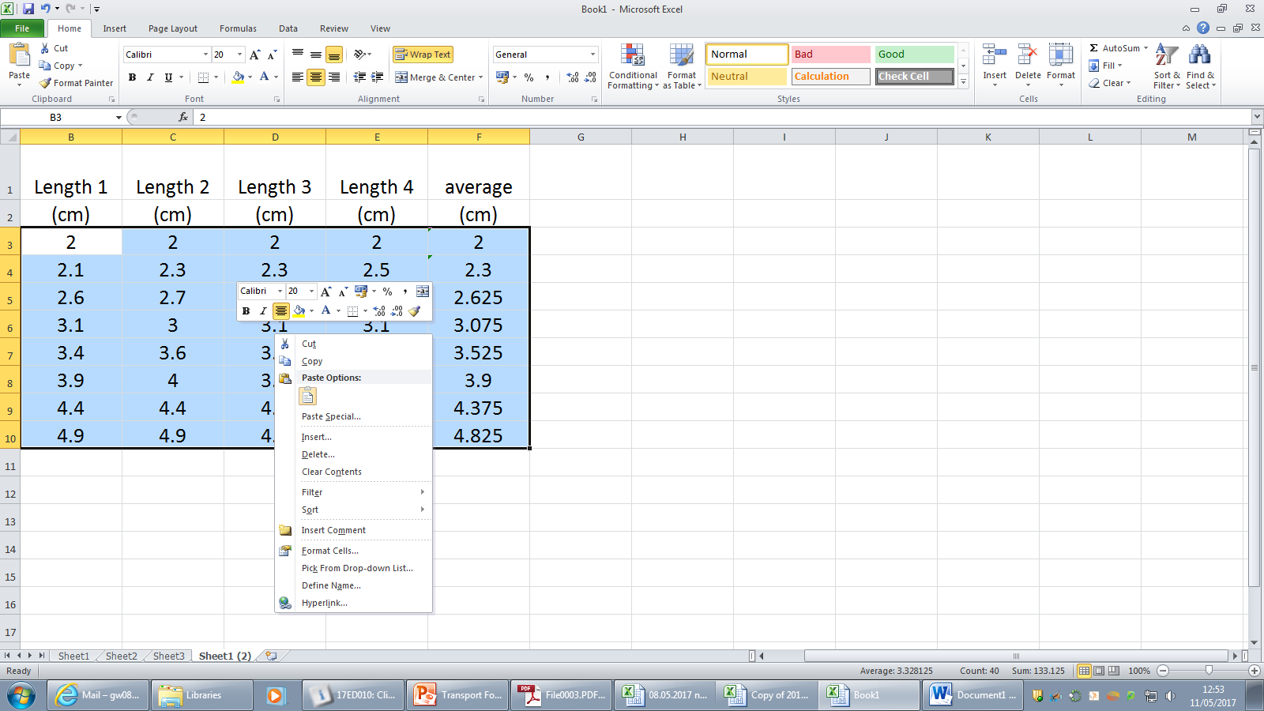

**We need to get all of your answers to 1 decimal place as the averages and numbers look a mess and are incorrect. Highlight the boxes that you need to change.**

**Go to the HOME box click on FORMAT. Click on FORMAT CELLS. Click on NUMBER and select 1 decimal place**

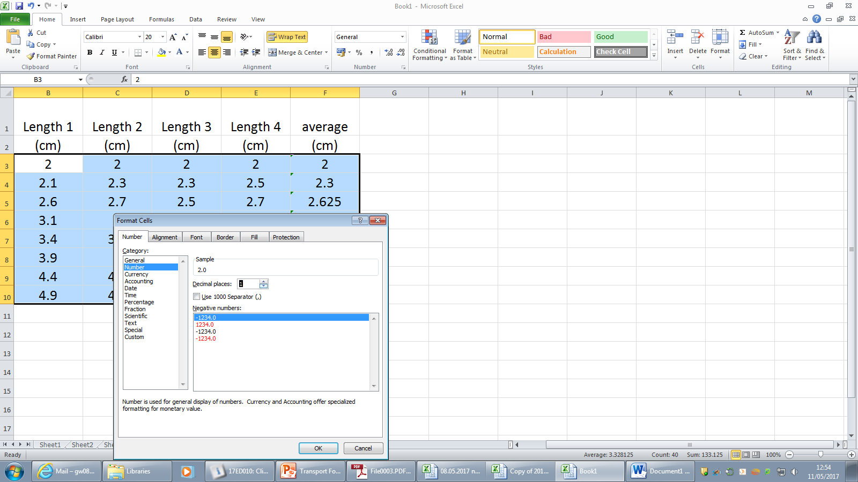

Now you are ready to plot your graph. SAVE YOUR FILE IN GROUPWORK WITH A SENSIBLE NAME THAT YOU’LL FIND THAT ISN’T TOO LONG.