Name:

Register Class:
Science Skills Passport
2019-2020

Lockerbie Academy
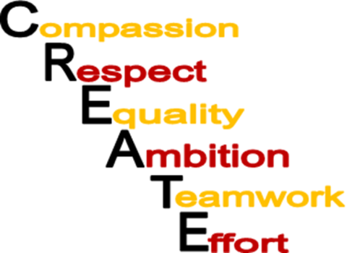
Values
These qualities summarise the type of people we want you to become and the type of school we want to CREATE:

Below is a list of skills that we will be assessing during Science. The teacher will mark, with a stamp, when you have demonstrated, to an adequate standard, any of the skills. You should record, under each skill, evidence of how you achieved this skill (see the example below). The skill is not recorded as being valid until it is signed which will occur after you record how you have achieved this skill.
Date | Skill | Teacher signature
Safety
21.2.18 | - I wore safety glasses all through the experiment  - I cleared the desk of any items that were not required  - I checked the electrical wiring of the equipment  - My bag was under my desk at all times and I was aware of others in my group and what they were doing | 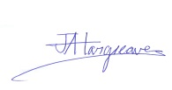

Here is a summary of the skills that we will be assessing.
Variables | Bar Graphs | Diagram
Hypothesising | Line Graphs | Referencing
Planning | Processing Data | Evaluating Experiments
Equipment Handling | Percentage & Percentage Change | Moral/Ethical Reflection
Risk Assessment | Ratios | Problem Solving
Safety | IESSUU | Showing Initiative
Measuring | Prefixes | Designing, Constructing, Testing & Modifying Solutions
Observing | Excel Graphs | Express Views (Written)
Taking Digital Readings (Including Using Alba) | Literacy Task | Express Views (Discussion/Verbal)
Participating | Research | Presenting An Argument
Recording Results | Writing A Scientific Report

Date | Skill | Teacher signature
Bar Graphs
Designing, Constructing, Testing & Modifying Solutions
Diagram
Equipment Handling
Evaluating Experiments
Excel Graphs
Express Views (Discussion/Verbal)
Express Views (Written)
Hypothesising
IESSUU
Line Graphs
Literacy Task
Measuring
Moral/Ethical Reflection
Observing
Participating
Percentage & Percentage Change
Planning
Prefixes
Presenting An Argument
Problem Solving
Processing Data
Ratios
Recording Results
Referencing
Research
Risk Assessment
Safety
Showing Initiative
Taking Digital Readings (Including Using Alba)
Variables
Writing A Scientific Report

Piece of Equipment | Experiment | Date | Date | Date
Beaker/conical flask
Blood pressure monitor
Bunsen burner
Chromatogram/chromatograph
Clamp stand
Compass
Side arm test tube with delivery tube
Dimple tile
Distillation apparatus
Dropper/syringe
Electrical circuits
Evaporating dish
Filter funnel/paper
Measuring cylinder
Microscope
Multimeter
(ammeter)
(voltmeter)
Pendulum
Pipette
Pitfall traps
Preparing a microscope slide
Protractor
Pulse meter
Quadrats
Safety goggles
Spring/Newton balance
Stopclock/ Stopwatch/Timer
Test tube/ Boiling tube
Thermometer
Top-pan balance
Tripod
Van de Graaff generator
Watch glass
Wooden splint/spill

Evaluation: S1: ELEMENTS, COMPOUNDS, MIXTURES

Date of Test: ________ Test Result: ______________%
In this topic, I mostly enjoyed

The part I found hardest was

When I got stuck, I

The most helpful class activities for me were:

I would like to ask about

Parent / Carer signature: __________________________

Evaluation: S1: HEALTHY BODIES

Date of Test: ________ Test Result: ______________%

In this topic, I mostly enjoyed

The part I found hardest was

When I got stuck, I

The most helpful class activities for me were:

I would like to ask about

Parent / Carer signature: __________________________

Evaluation: S1: ELECTRICITY

Date of Test: ________ Test Result: ______________%

In this topic, I mostly enjoyed

The part I found hardest was

When I got stuck, I

The most helpful class activities for me were:

I would like to ask about

Parent / Carer signature: __________________________

Evaluation: S1: CHEMICAL REACTIONS

Date of Test: ________ Test Result: ______________%
In this topic, I mostly enjoyed

The part I found hardest was

When I got stuck, I

The most helpful class activities for me were:

I would like to ask about

Parent / Carer signature: __________________________

Evaluation: S1: HEALTHY PLANET

Date of Test: ________ Test Result: ______________%

In this topic, I mostly enjoyed

The part I found hardest was

When I got stuck, I

The most helpful class activities for me were:

I would like to ask about

Parent / Carer signature: __________________________

Evaluation: S1 ENERGY & SOUND

Date of Test: ________ Test Result: ______________%

In this topic, I mostly enjoyed

The part I found hardest was

When I got stuck, I

The most helpful class activities for me were:

I would like to ask about

Parent / Carer signature: __________________________

EVALUATIONS: S2
Feedback |  | Test/% |  | Home Signature
Test 1:Forces/ Mighty Microbes/Action Packed Chemistry
Test 2: Heat/Chemical Engineering/Power of Genetics
Test 3: Road Safety /Life of Plants/ Environmental Chemistry

EVALUATIONS S3:

EVALUATIONS S3:

EVALUATIONS S3:

Notes

Notes

NOTES:

Improvements I should make:
Date
TEACHER COMMENTS:

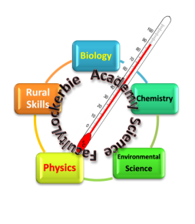
Science knows no country, because knowledge belongs to humanity, and is the torch which illuminates the world. Louis Pasteur

