Current and Voltage in Series and Parallel
A video to go with this section on current and voltage in series circuits can be found here https://youtu.be/xSMuqn5f-2o
- Open up the Phet Simulator
https://phet.colorado.edu/sims/html/circuit-construction-kit-dc/latest/circuit-construction-kit-dc_en.html

Current and Voltage in Series
- Copy out the heading and table in your jotter

Current and Voltage for SERIES CIRCUITS
Component | Current  (A) | Voltage  (V) | V/I  (V/A)
2 Cells at 12V each
10 Ω lamp
40 Ω lamp
20 Ω lamp
Add up the voltage across the 3 lamps and add your result here

- Click on the LAB
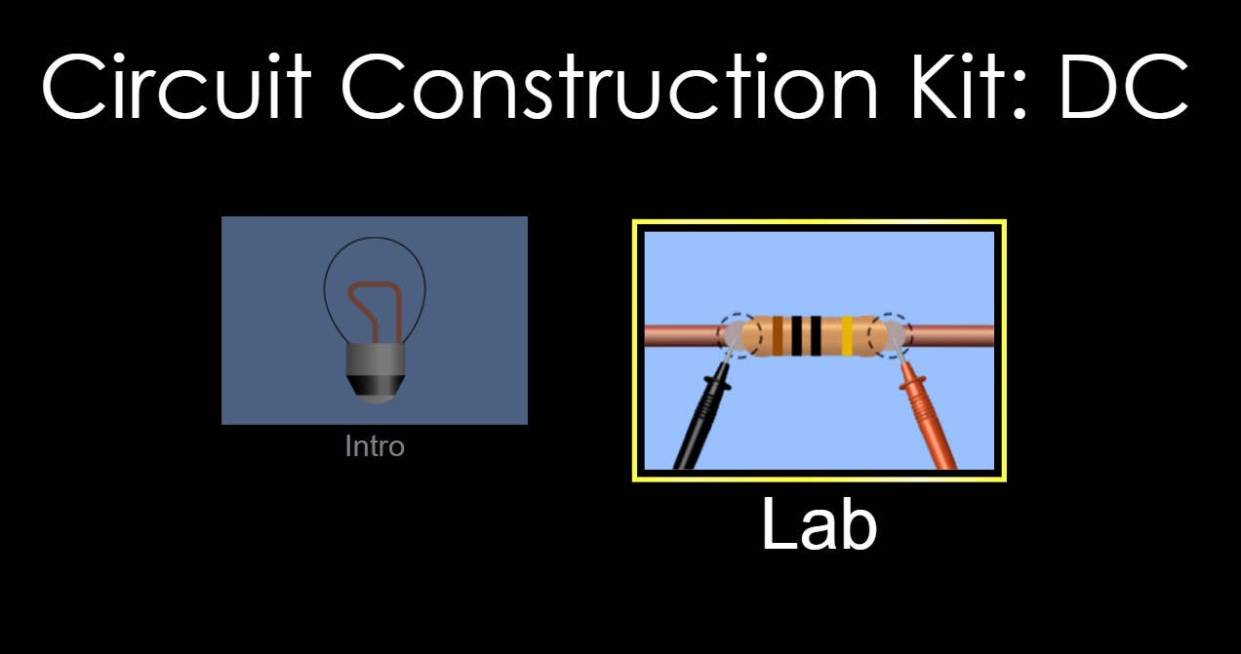
- Set up the following circuit. It contains 2 cells, 4 ammeters, 3 lamps, a switch and wires. Add Ammeters in the circuit between each lamp and between the lamp and the cells as shown below.

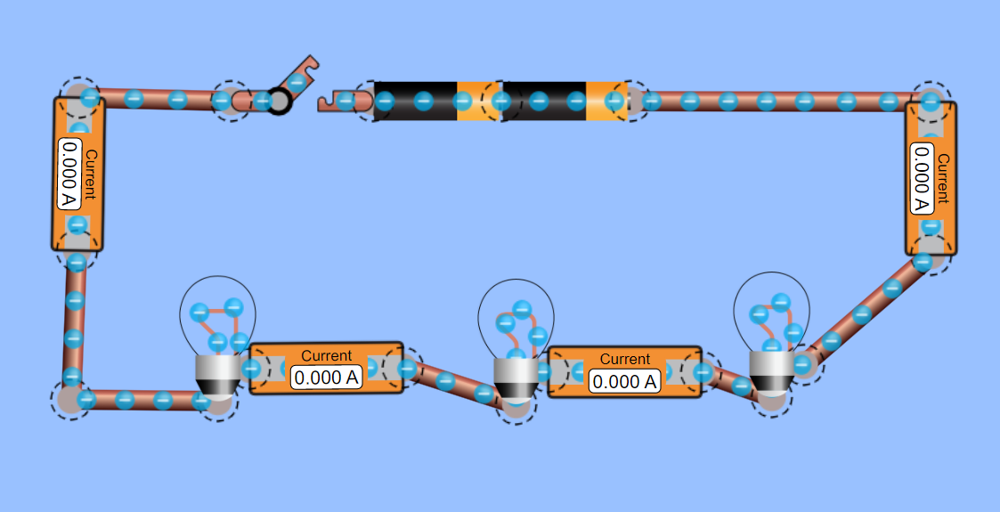
- Click on each of the lamps and set one to 10 ohms, one to 40 ohms and one to 20 ohms using the slider.
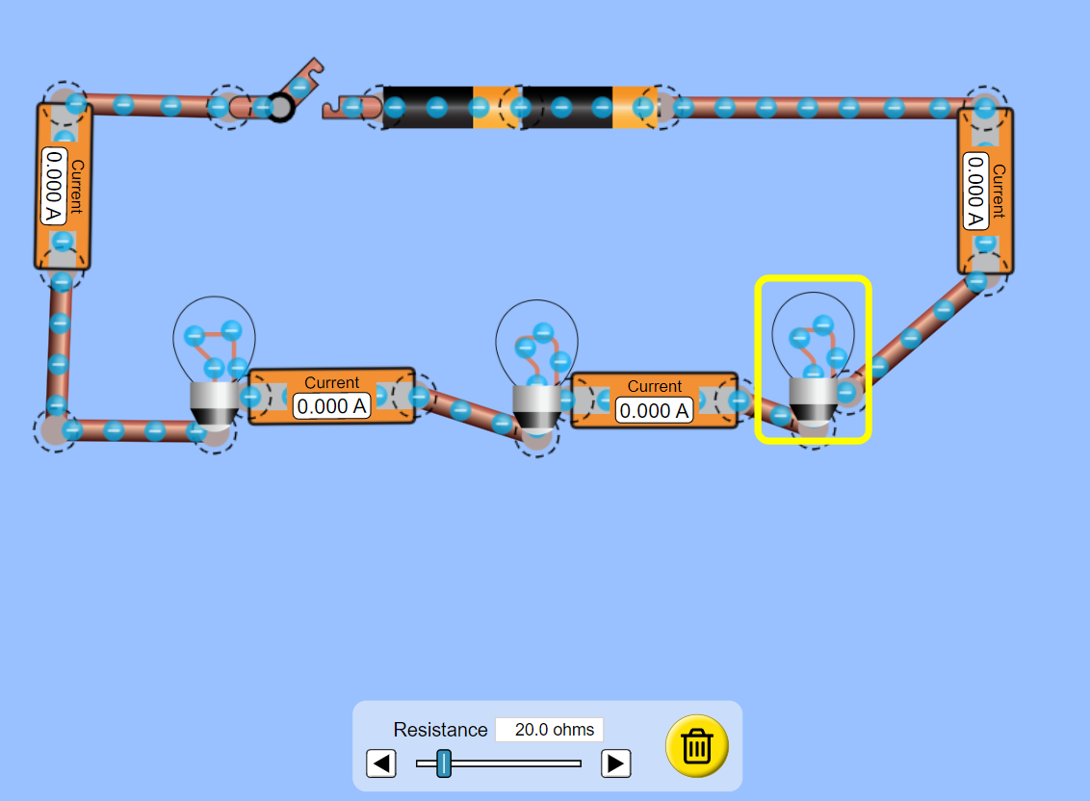
10 Ω 40 Ω 20 Ω
- Set the voltage of each cell to 12V (so 24 V in total)
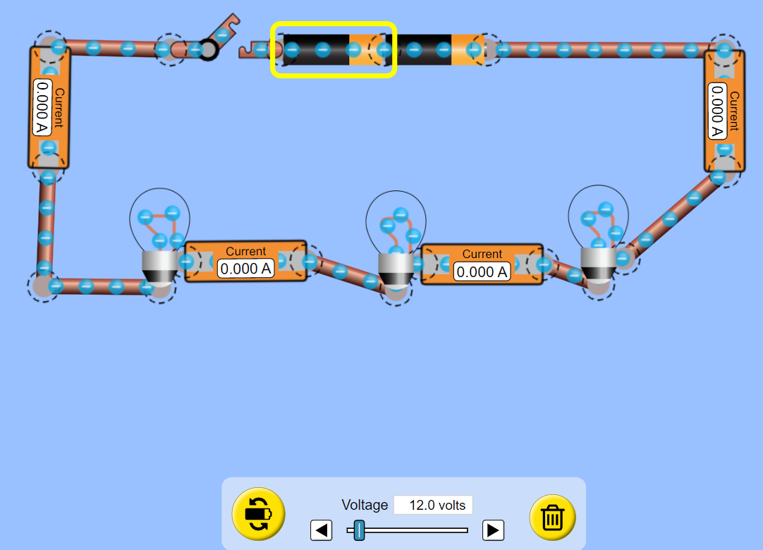

- Predict what you think the current will read when the circuit it connected together.
- Close the switch, record which of the lamps is brightest.
- With the switch closed, record the current reading on each of the ammeters and record this in your table.
- With the switch closed place a voltmeter across both cells together
- Record the voltmeter reading across the both cells this is the total voltage supplied to the circuit. Record this value in your table.

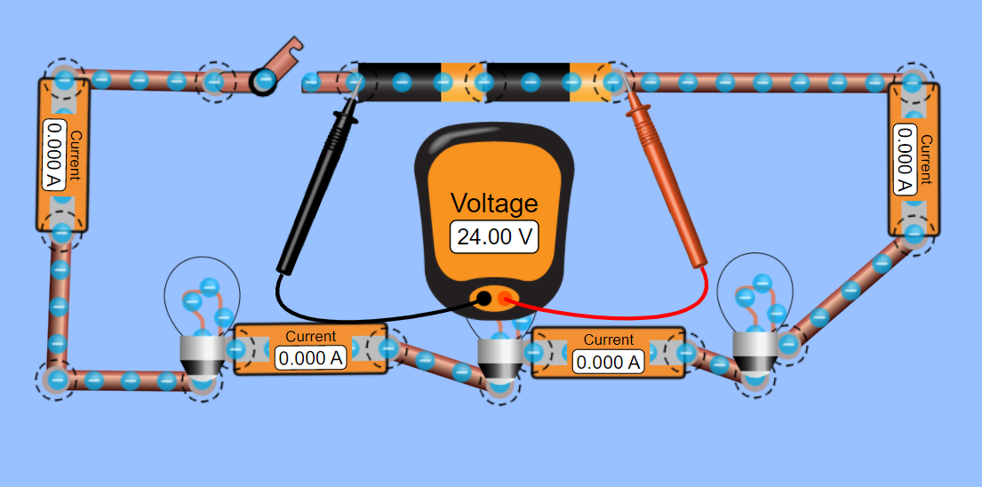
My switch is open as I don’t want to give you the answers!

- With the switch closed place the voltmeter across each lamp and record the voltage across each lamp in the table.
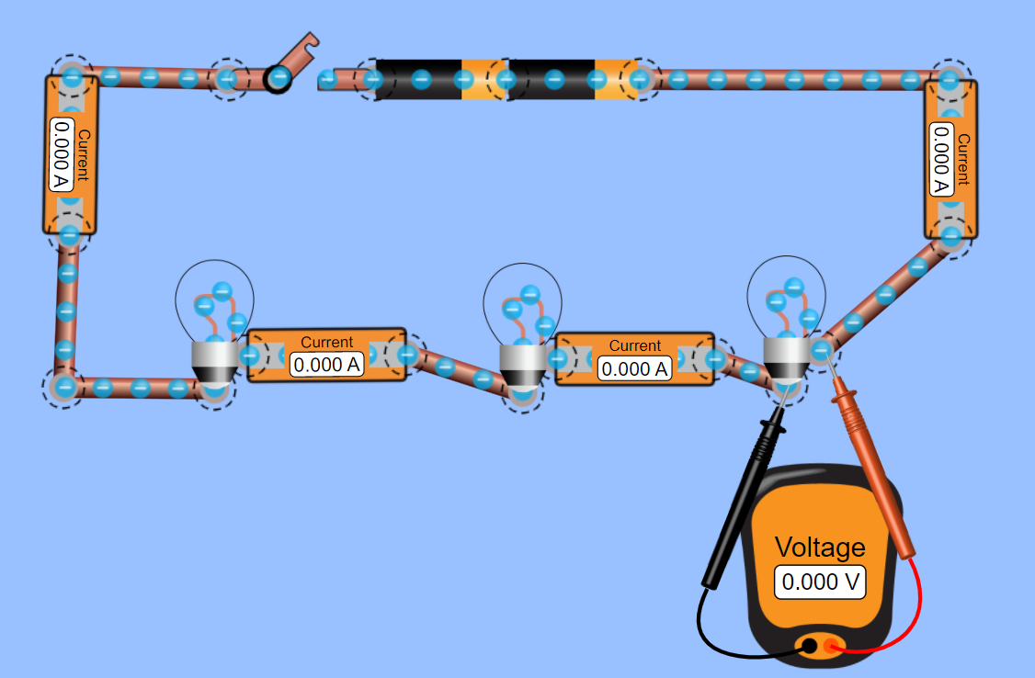
My switch is open as I don’t want to give you the answers!

- Answer the questions below.
  - What do you notice about the current reading on each ammeter? Explain the results of the current readings on the ammeters.
  - What do you notice about the voltage readings across the lamps?
  - Add up the voltages across the three lamps, what do you notice?
  - Do these results agree with the model from out last lesson?

- Now adjust the resistances of your lamps, or replace the lamps with resistors and repeat if you have time.

- ADVANCED TASK: For the smart cookies amongst you take the voltage reading across each lamp and divide it by the current reading. What do you notice? If you notice anything you’ve just done some Nat 5 Physics!

Current and Voltage in a Parallel Circuit
A video to go with this section on current and voltage in series circuits can be found here https://youtu.be/r8lrZ-0R-Vc

- Copy out the heading and table in your jotter (Notice I have changed the current and voltage columns around!)

Current and Voltage for PARALLEL CIRCUITS
Component | Voltage  (V) | Current  (A) | V/I  (V/A)
2 Cells at 12V each
10 Ω lamp
40 Ω lamp
20 Ω lamp
Along the side
Add up the current through the 3 lamps and add your result here

- Set up the circuit as shown below, it contains 2 cells (set to 12V each) 3 lamps, 5 Ammeters and a switch.
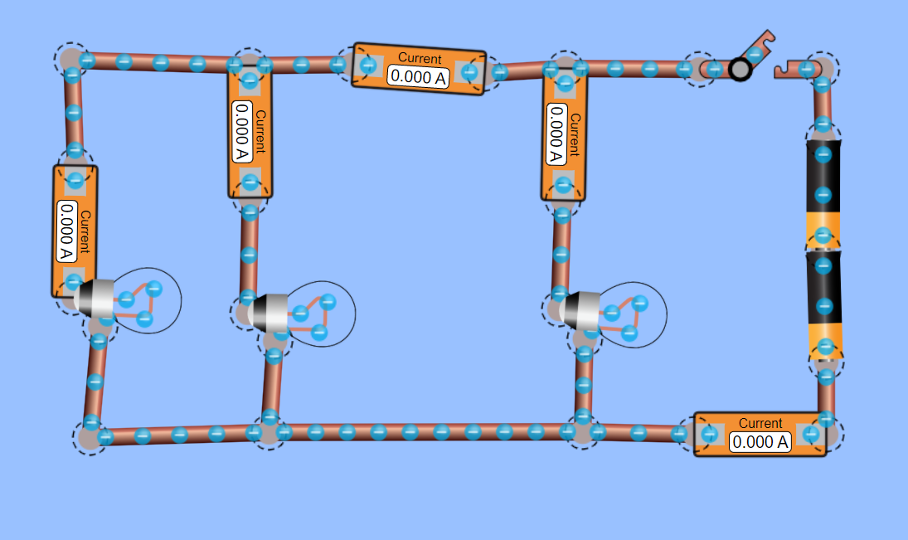
- As before set the resistance of the bulbs to 10 Ω 40 Ω and 20 Ω
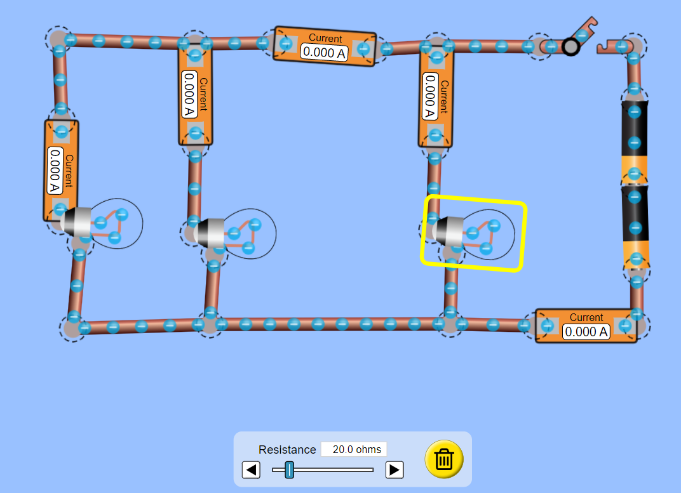
10 Ω 40 Ω 20 Ω
- Set the cell voltages to 12 V each
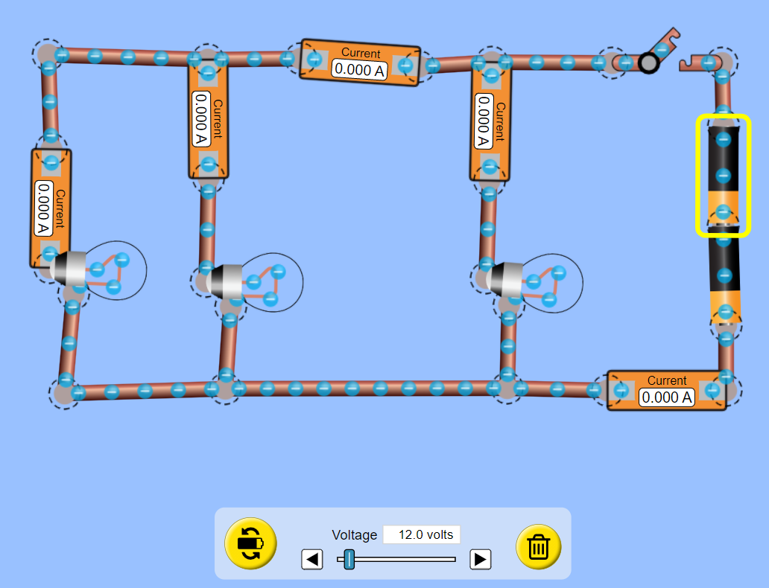
- Add Ammeters next to the cells, in each branch and one along the top side so that it can read the current in the left and middle branches
- Predict what you think the current will read on each ammeter when the switch is closed.
- Close the switch, record which of the lamps is brightest.
- With the switch closed, record the current reading on each of the ammeters and record this in your table.
- With the switch closed place a voltmeter across both cells together
- Record the voltmeter reading across the both cells this is the total voltage supplied to the circuit. Record this value in your table.
- Record the voltmeter reading across each of the lamps and record this in the table.
- Write down your conclusions from the experiment.
- Does it agree with our model?
- Now adjust the resistances of your lamps, or replace the lamps with resistors and repeat if you have time.

- ADVANCED TASK: For the smart cookies amongst you take the voltage reading across each lamp and divide it by the current reading. What do you notice? If you notice anything you’ve just done some Nat 5 Physics!

