VARIABLES
Variables are what we change or keep the same during an experiment.
They are given two names
- input / independent variable
- output/ dependent variable

The input variable is WHAT WE CHANGE
The output variable is WHAT WE MEASURE BECAUSE OF OUR CHANGE

Learning About Variables
Below there are pictures of four objects. There are certain things about these objects which we can change. We call these variables.

All these objects are the same, size, shape, and colour. These three things things (size, shape, and colour) are the variables. In our picture the variables are the same. We say they are constant.
Look at these objects

These objects are the same shape and colour but different sizes. We say that the variable which changes is size and the variables that stay the same are shape and colour.

Look at the four objects in each box and write down which variables stay the same and which change.

 |  | Variables that change | Variables kept constant
A |  | shape | size, colour
B |  | size | shape, colour
C |  | colour | size, shape
D |  | size, colour | shape
E |  | colour, shape | size
F |  | shape, size | colour
G |  | shape, size, colour

HEAT LOSS

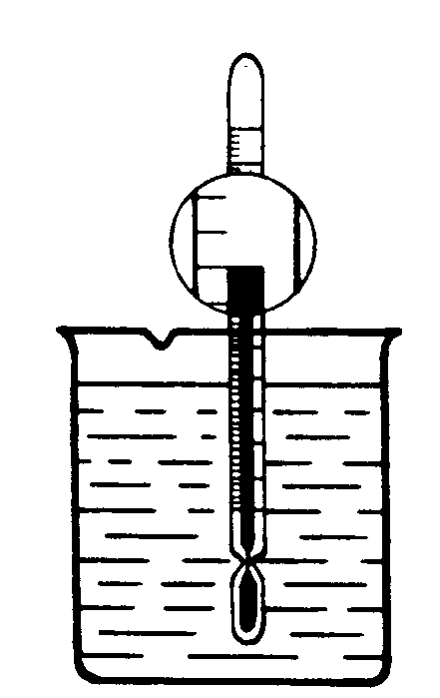
1. We are now going to consider an experiment on heat loss from a beaker of water. Look at this picture of a beaker of hot water. Try to write down things that could be changed in the experiment. (List the variables!)

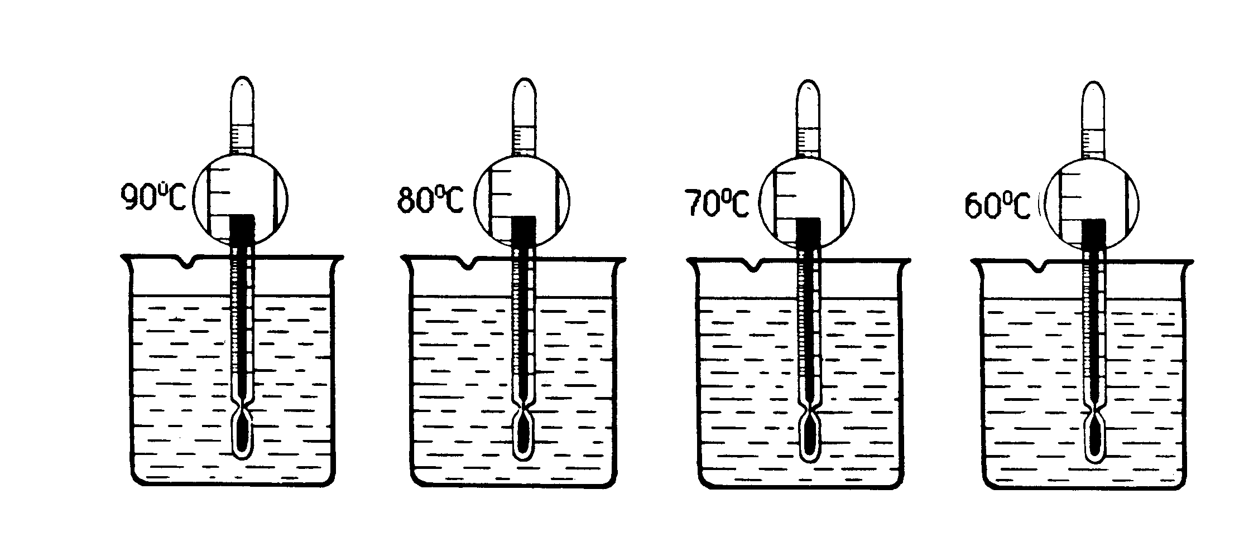
2. Look at the pictures of the four beakers of water.
Write down which variables have been changed and which variables have stayed the same.

3. Look at the pictures of the four beakers of water.
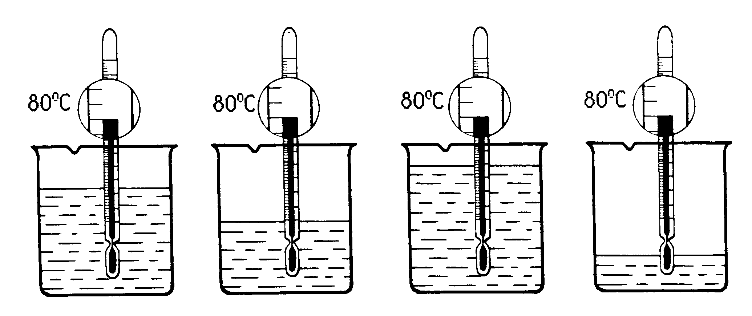
Write down which variables have been changed and which variables have stayed the same.

4. Look at the pictures of the four beakers of water.
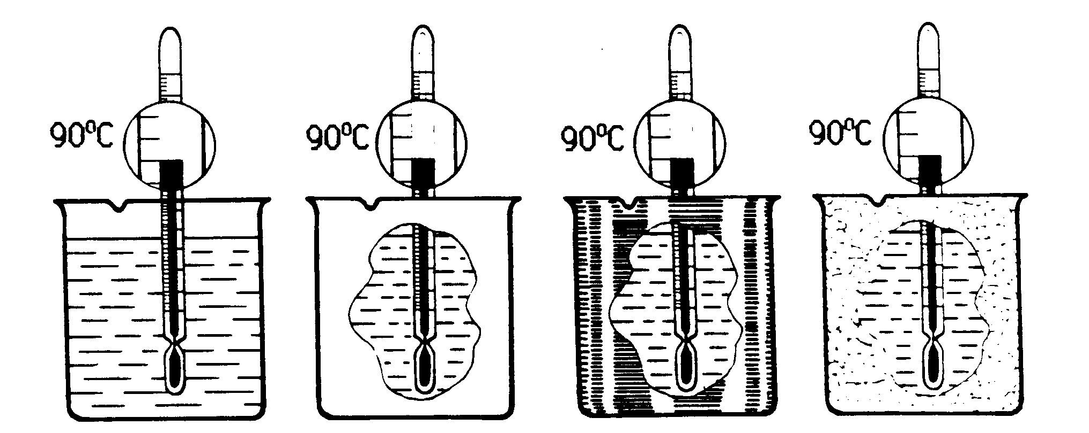
Write down which variables have been changed and which variables have stayed the same.

5. A pupil sets up the following experiment to find out how well different materials keep in heat.
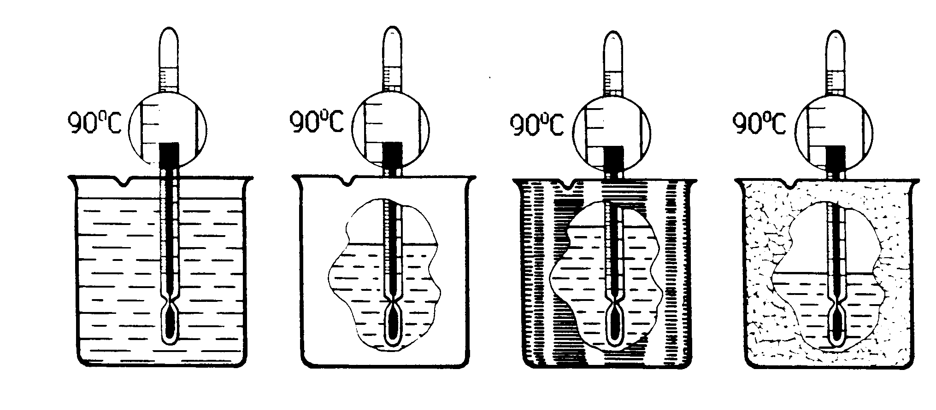
Is this a fair experiment?

Explain your answer.
____________________________________________________.

6. If you were asked to do the same experiment as in 5., which experiment from 2, 3 and 4 would you use?

Why?

Now check your answers to 5 and 6. If all your answers are correct go on to the next exercise. If not, tell your teacher.

STRENGTH OF THREAD

- The picture below shows an experiment which is designed to test the strength of thread. weights are added to the thread until it breaks. The strongest thread will be the one which will hold the largest weight.

Look at the picture then try to write down which things could be changed in the experiment (that it to say, we want to know what the possible variables are in the experiment).
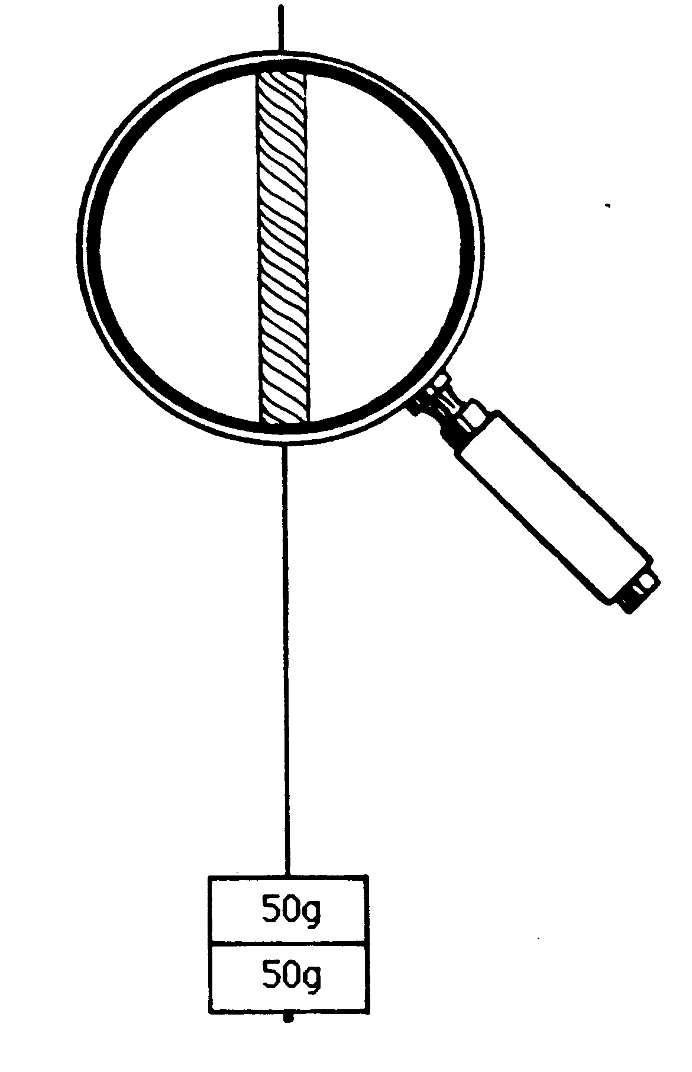
Now check your answer to 1. If you are correct carry on with the next exercise. If not, tell your teacher.

- Look at these four pictures of experiments to test the strength of threads.
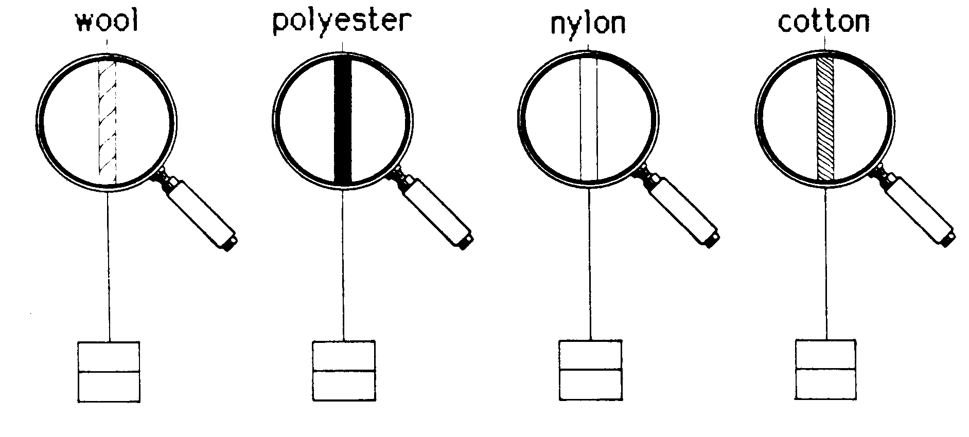

Write down which variable changes and which stay the same.

changes______________stays the same_______________________________.

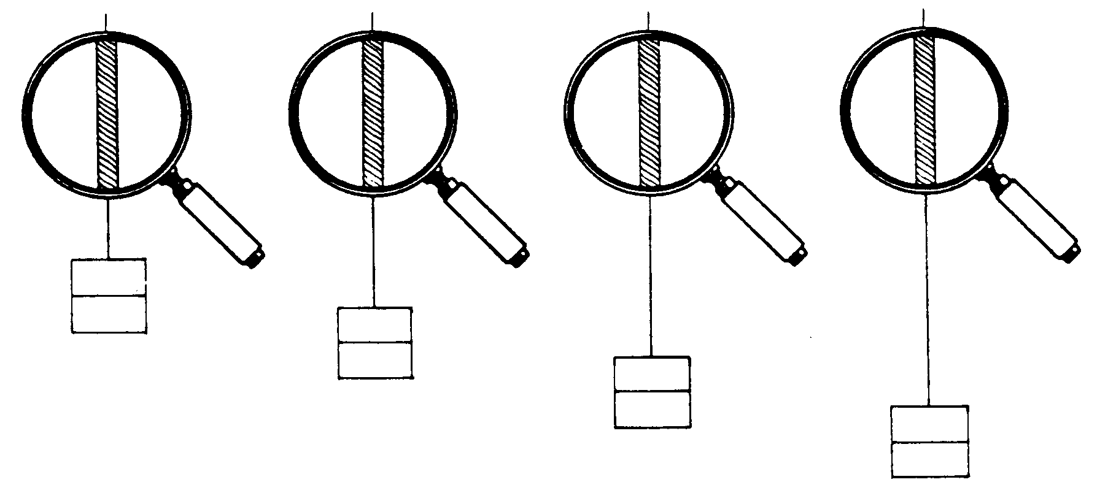
- Look at these four pictures of experiments to test the strength of threads.

Write down which variable changes and which stay the same.

changes______________stays the same_______________________________.
Look at these four pictures of experiments to test the strength of threads.
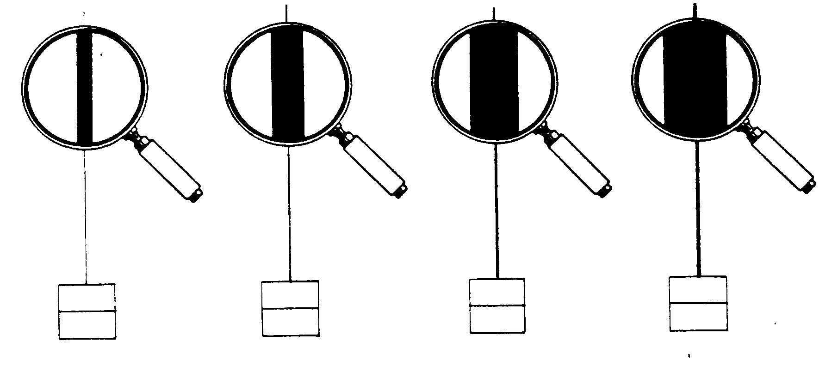
Write down which variable changes and which stay the same.

changes______________stays the same_______________________________.

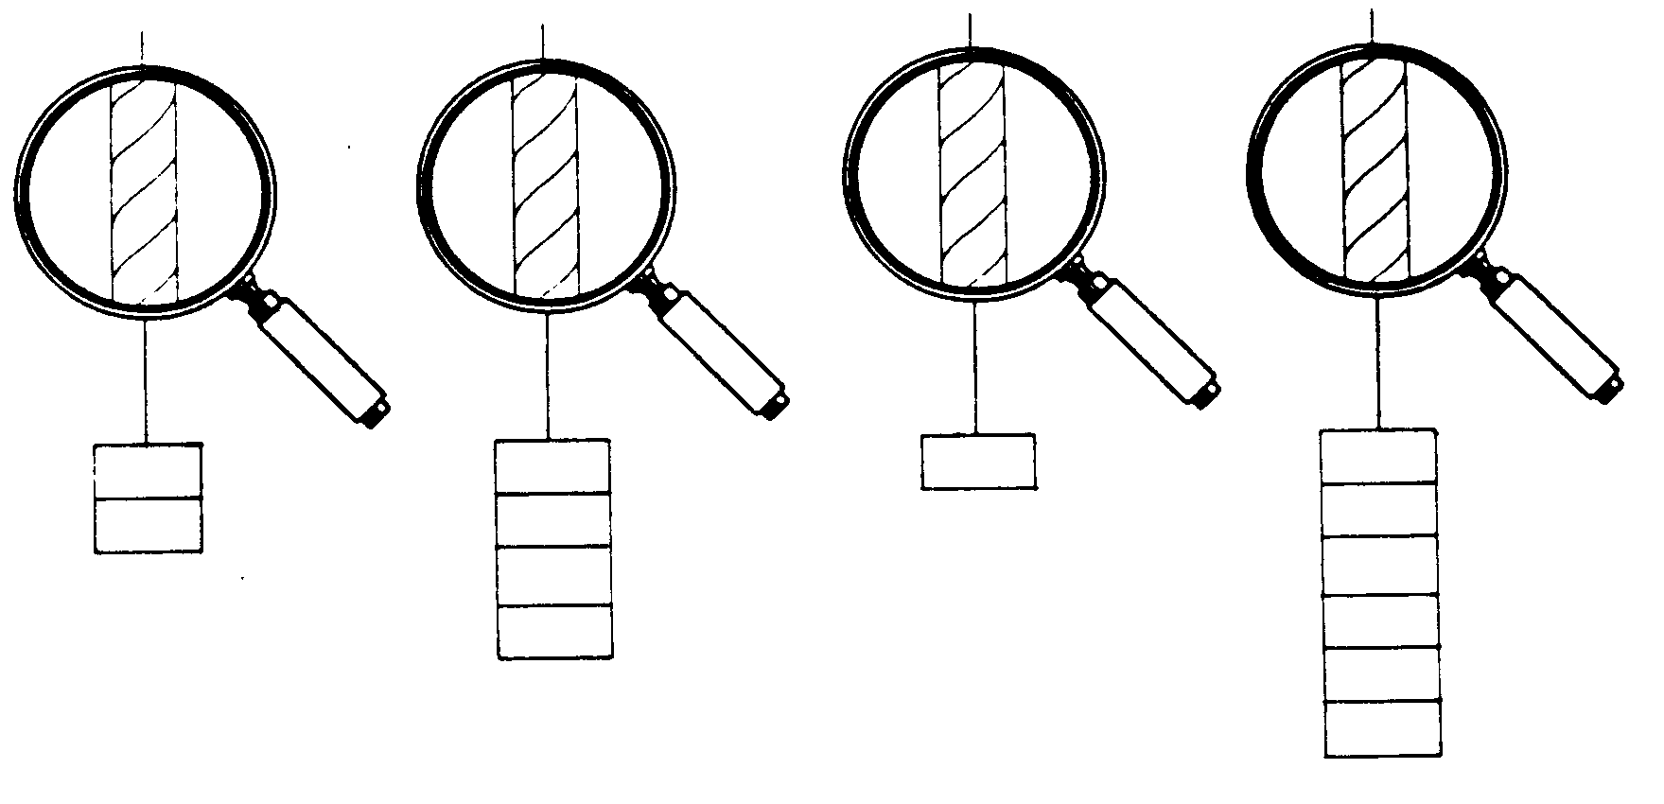
- Look at these four pictures of experiments to test the strength of threads.

Write down which variable changes and which stay the same.

changes______________stays the same_______________________________.

Now check your answers to 2, 3, 4 and 5. If all your answers are correct go on to the next exercise. If not, tell your teacher.
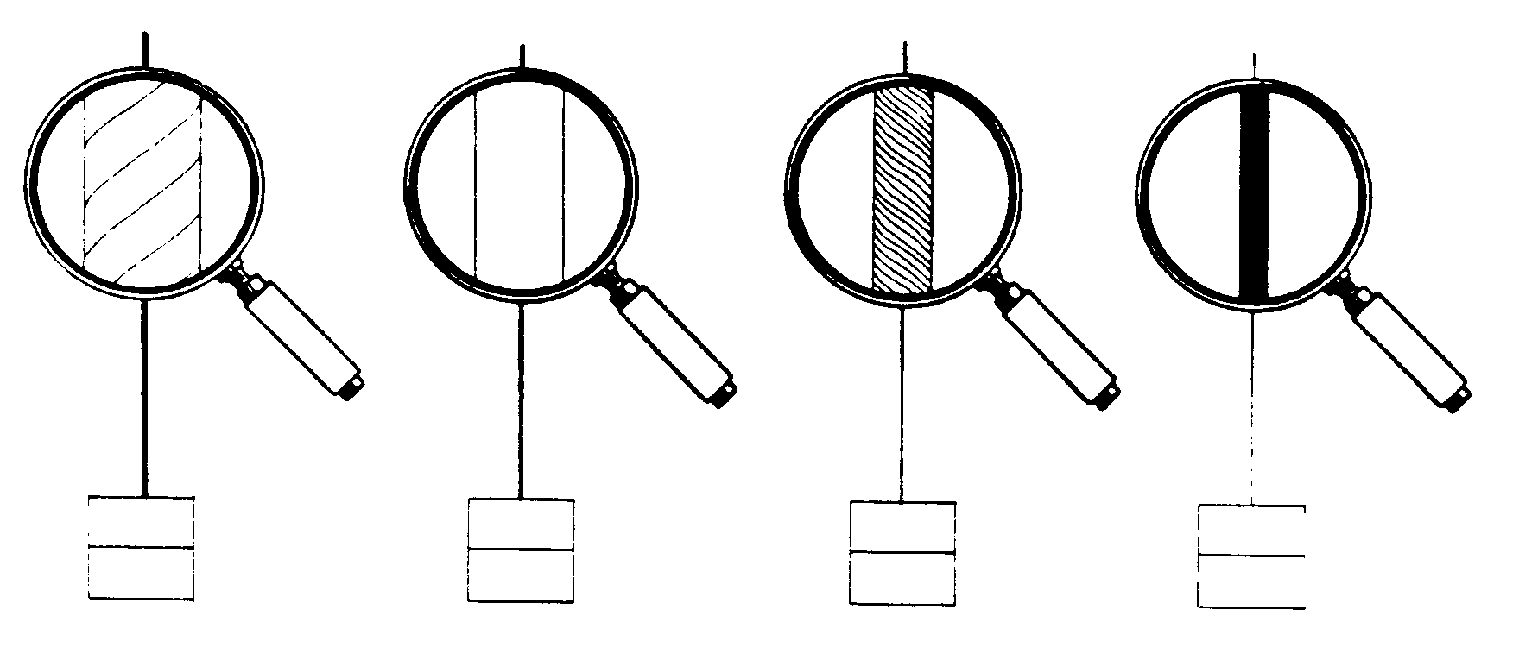
- A pupil set up the following experiment to find out which type of material was strongest.

Is this a fair experiment?

Explain your answer.

_____________________________________________________.

- If you were asked to carry out the same experiment as in 6, which experiment out of 2, 3, 4 or 5 would you use?

Why?

Now check your answers to 6 and 7.

Show all your work from this “Learning about Variables” pack to your teacher.

ANSWERS

Exercise 1: “Learning about variables”.
 | CHANGE | STAY THE SAME
A | shape | size, colour
B | size | shape, colour
C | colour | shape, size
D | size , colour | shape
E | shape, colour | size
F | shape, size | colour
G | shape, size, colour | -----

Exercise 2: “Heat loss”.
- Temperature, volume of water, material of beaker.
 | CHANGE | STAY THE SAME
A | shape | size, colour
B | size | shape, colour
C | colour | shape, size
D | size , colour | shape
E | shape, colour | size
F | shape, size | colour
G | shape, size, colour | -----

 | CHANGE | STAY THE SAME
2 | temperature | volume, material
3 | volume | temperature, material
4 | material | volume, temperature

- No. The beakers are all made of different materials but the volume of water is different in each beaker too.

- C. Only the variable which we are investigating changes (i.e. the material of the beaker).

Exercise 3: “Strength of thread”.

- Material of thread, length of thread, thickness of thread, weight added to the thread at the start of the experiment.

 | CHANGE | STAY THE SAME
2 | material | length, thickness, weight
3 | length | material, thickness, weight
4 | thickness | length, material, weight
5 | weight | length, material, thickness

- No. The threads are made of different materials but they are all different thicknesses too.

- Only the variable which we are investigating changes (i.e. the material of the thread).

