Task 6: Label the diagram and use the answers to find the code
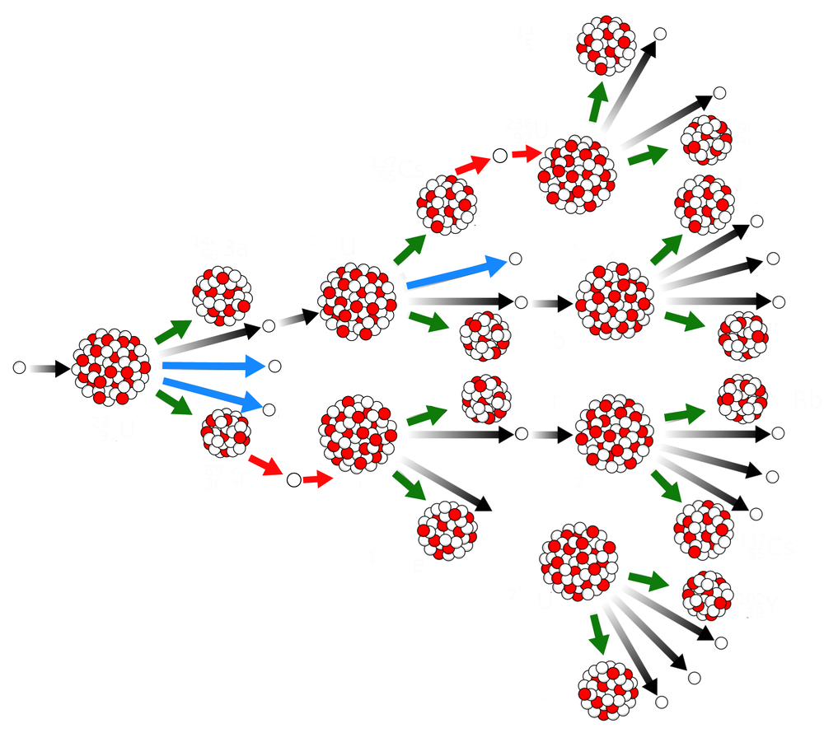
⇐ 2. Name this particle
⇐ 3. Name this
⇐ 4. Name this
⇐ 5. Name this particle
1. Best describes this type of reaction

QNo. | Options
1 | 75. Induced fission | 20. induced fusion | 35. Spontaneous fission
2 | 10. Proton | 15. fast neutron | 5. Slow neutron
3 | 8. Large Nucleus eg U-235 | 9. Small Nucleus eg He | 7. Fission product
4 | 50. Fusion product | 40. Fission product | 60. Fision product
5 | 5. fast neutron | 2. Beta particle | 10. slow neutron

Take the number next to each correct answer and add this to the equation below to find the combination to the last lock
$$CODE=\frac{\left(Q1 Q2\right)+(Q3 Q4)}{Q5}$$

