Task 6: Label the diagram and use the answers to find the code
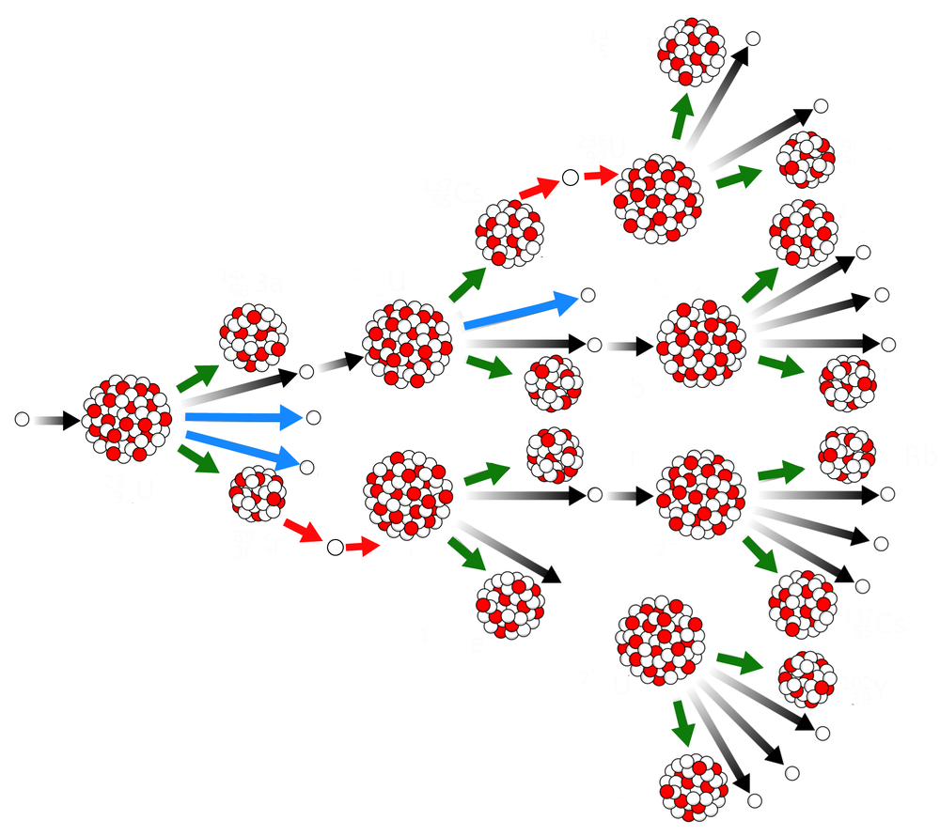
⇐ 2. Name this particle
⇐ 3. Name this
⇐ 4. Name this
⇐ 5. Name this particle
1. Best describes this type of reaction

TASK 6: Choose the correct answer for each question from the list of 3 possible answers
QNo. | Options
1 | 75. induced fission | 20. induced fusion | 35. spontaneous fission
2 | 10. proton | 15. electron | 5. neutron
3 | 8. large nucleus eg U-235 | 9. small nucleus eg He | 7. fission product
4 | 50. fusion product | 40. fission product | 60. fision product
5 | 5. neutron | 2. beta particle | 10. proton

Take the number next to each correct answer and add this to the equation below to find the combination to the last lock
$$CODE=\frac{\left(Q1 Q2\right)+(Q3 Q4)}{Q5}$$

Task 6: Label the diagram and use the answers to find the code
⇐ 2. Name this particle
⇐ 3. Name this
⇐ 4. Name this
⇐ 5. Name this particle
1. Best describes this type of reaction

TASK 6: Choose the correct answer for each question from the list of 3 possible answers
QNo. | Options
1 | 75. induced fission | 20. induced fusion | 35. spontaneous fission
2 | 10. proton | 15. electron | 5. neutron
3 | 8. large nucleus eg U-235 | 9. small nucleus eg He | 7. fission product
4 | 50. fusion product | 40. fission product | 60. fision product
5 | 5. neutron | 2. beta particle | 10. proton

Take the number next to each correct answer and add this to the equation below to find the combination to the last lock
$$CODE=\frac{\left(Q1 Q2\right)+(Q3 Q4)}{Q5}$$

