Chapter 1 – ODU – Section B questions

2. Forces, Energy and Power

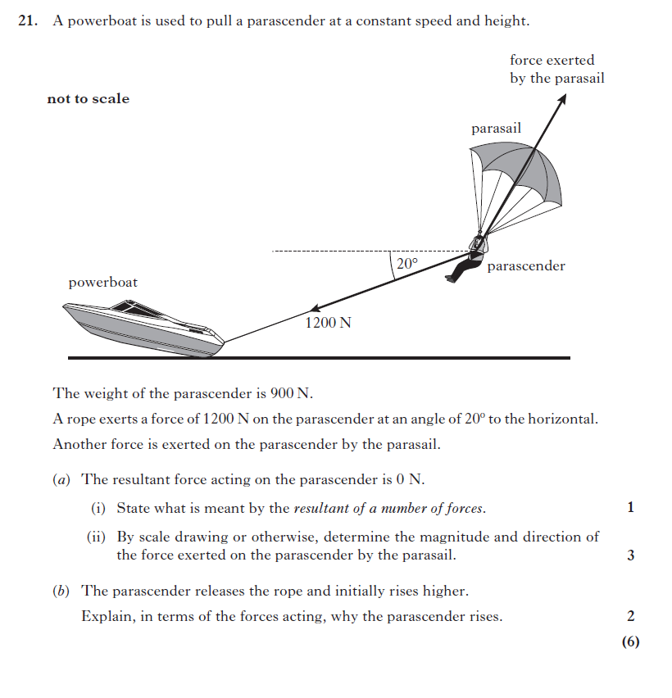^{(2014 revised)}

3. Collisions and Explosions

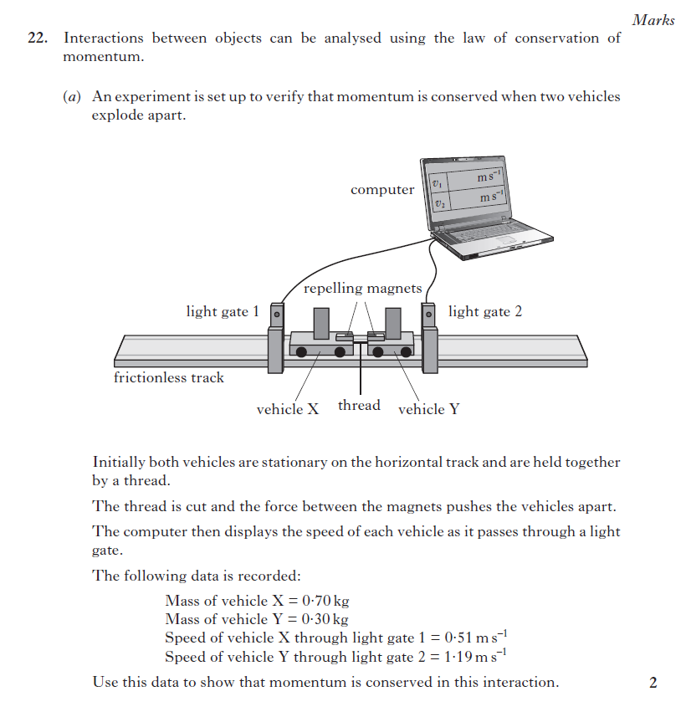^{(2014 revised)}

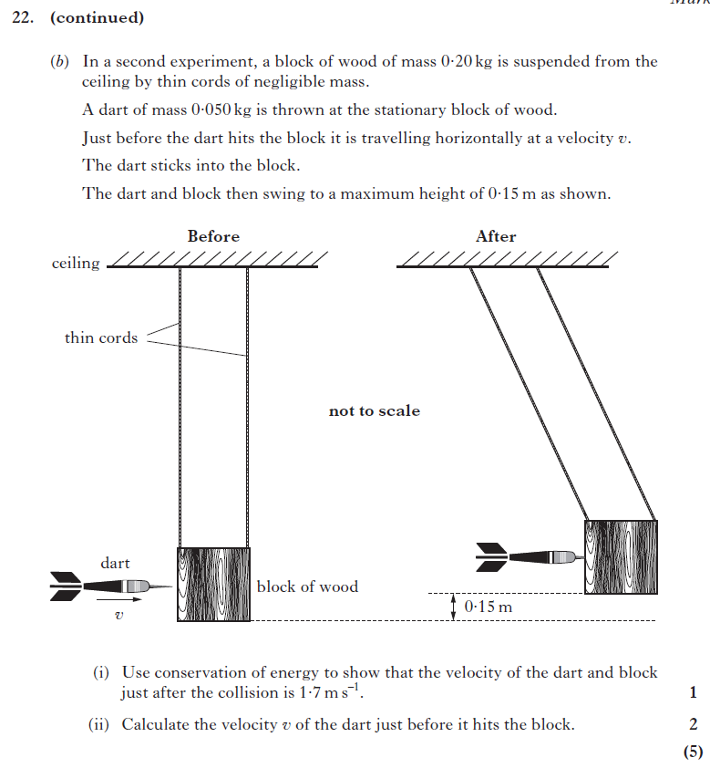^{(2014 revised)}

4. Gravitation

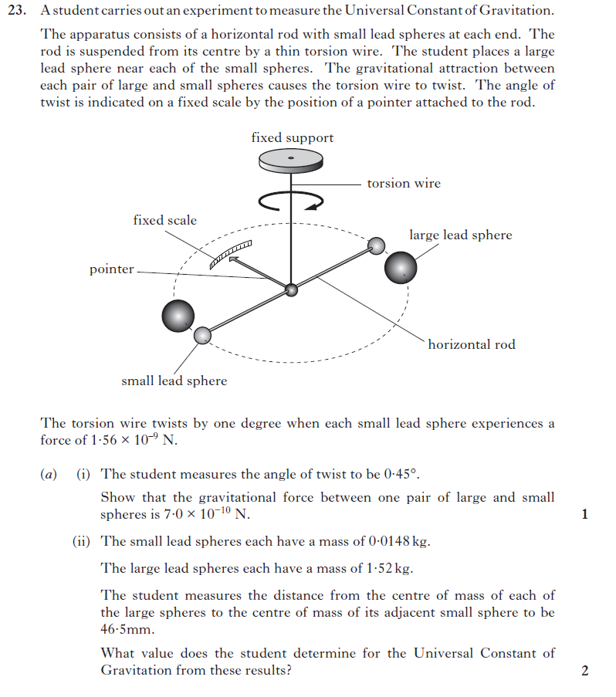

^{(2014 revised)}

5. Special Relativity

6 The expanding Universe

^{(2014 revised)}

