The Red Lion Inn

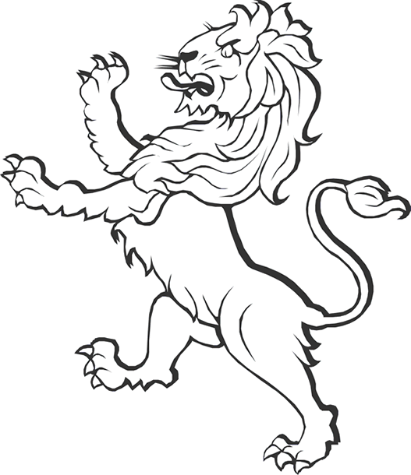

**CALDER PLACE**

**CALDER PLACE**

**NORTH STREET**