Writing Up Advanced Higher Science Project
I have marked investigations. Many great investigations score poorly and many poor investigations score highly. The thing to remember is that what is being marked is your written report. It is therefore vital that you jump through the hoops and don’t forget some of the very simple “gift” marks. Really there is no excuse for even the worst investigation to score less than 11 marks.

Before we start-saving
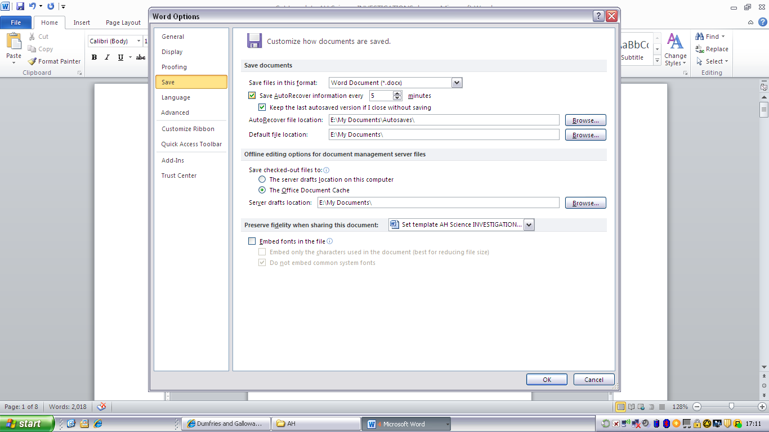
When I did my degree many years ago we had a land line and it regularly crashed. I saw many a finals student almost hysterical as a day’s typing up of their final dissertation went down the tubes as they hadn’t saved it regularly and the line went down. I therefore suggest you autosave your document every couple of minutes. It will slow it down to some extent but the least you should lose is two or three minutes of work.
How to autosave, open your document (or blank document) and give it a sensible name eg YOURNAME Subj version
jhargreavesPhysicsInvest1.docx
Then File_>options->save->adjust to the no. of minutes you want to autosave and click on this button, you are now ready to go.

Setting up a template for AH Science Project
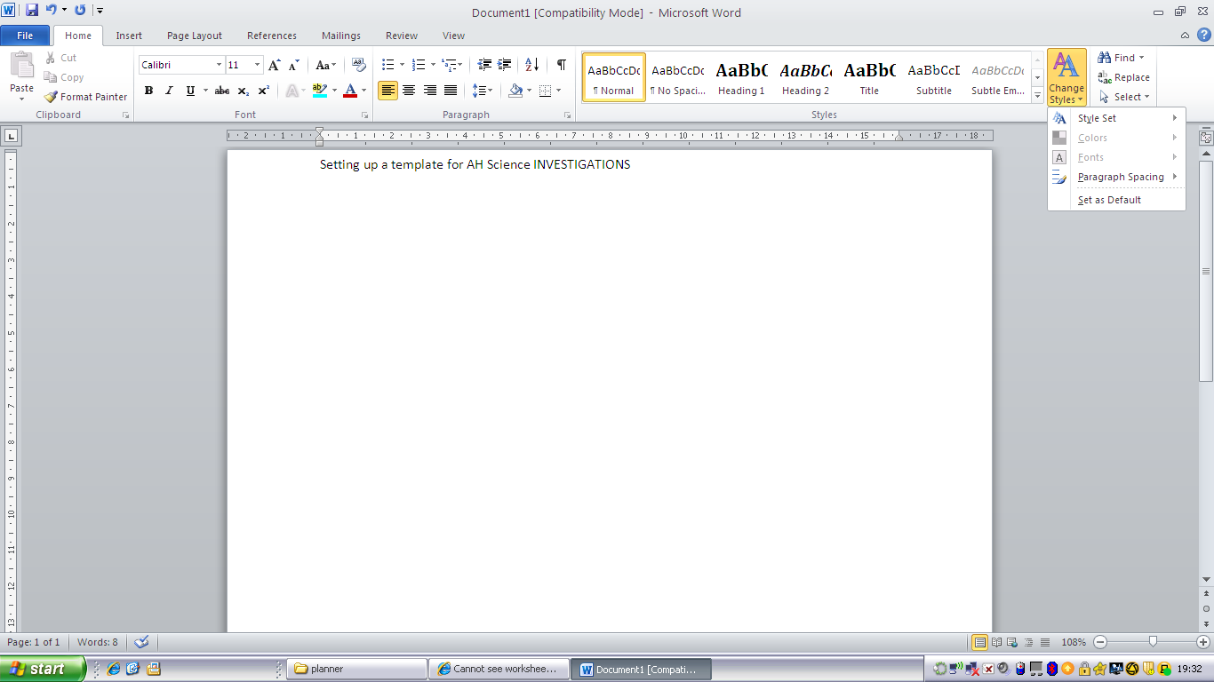

- Open up word 2010 or greater or open up the template that has been produced to help you
- Go to HOME tab
- Click on Change Styles
- Choose a style, don’t be too adventurous, I recommend something subdued eg formal, thatch, simple, perspective etc. Beware if Chemistry and Biology specify a font, size and double spacing etc
- Now use your titles properly eg Title for the front page, Heading 1 for the next headings (eg headings given in the mark scheme) Use these correctly throughout the document, as they will automatically produce your table of contents. The Report has a logical structure appropriate to the Investigation and must include: an appropriate and informative title e.g not “Pollution and plants”; but “Effect of garlic on lipase” is OK.
- Insert page numbers (click on insert on the top tab)
- Place at the bottom of the page (the marker shouldn’t but might miss it if it is at the top), again don’t be too fancy, you can make up your own if you wish but we are not marking graphic styles but ease of reading
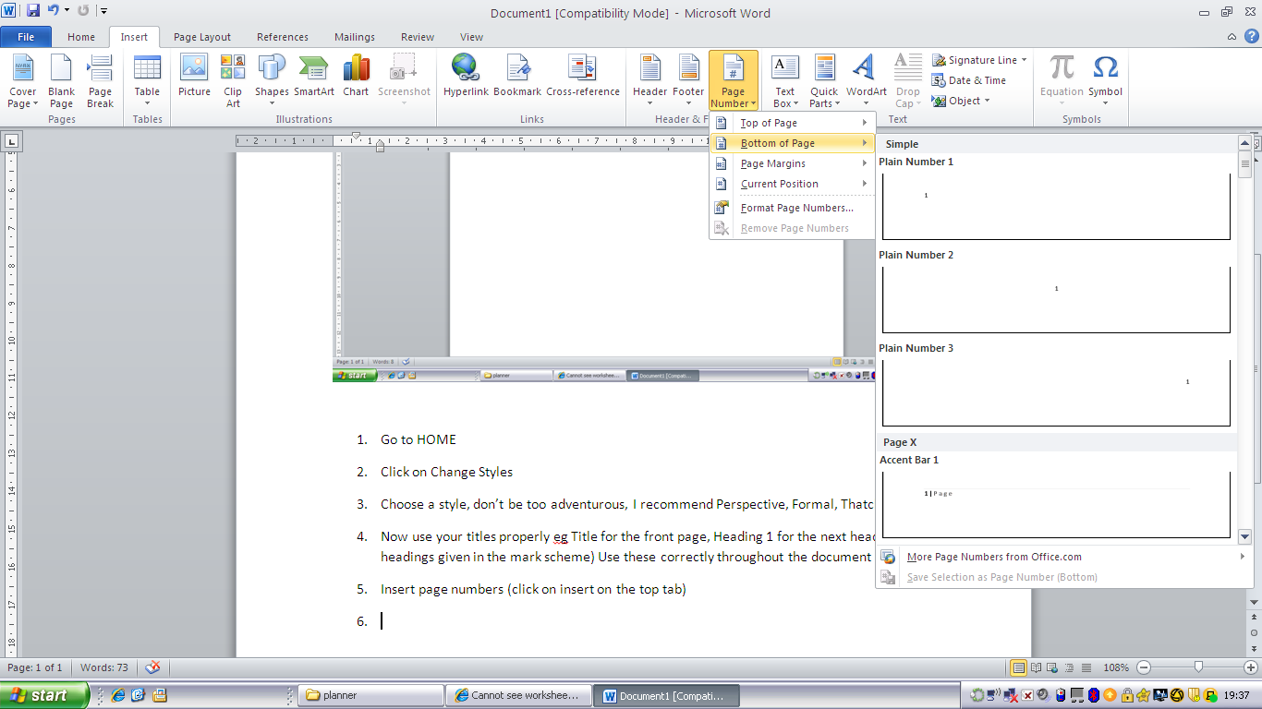
- Save this document as “Name- Subject- Invest”
- If you want to you can choose one of the cover pages given in insert cover page. 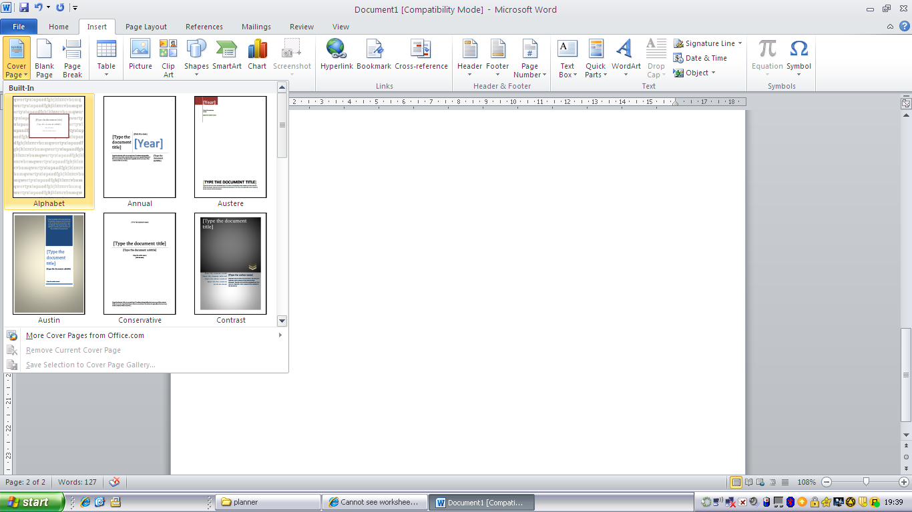
- Make sure that you include your NAME, SCHOOL, CANDIDATE No. TITLE of the INVESTIGATION, the title is really important and often comes at the end. One mark is allocated for title, table of contents and page numbers so this ought to be the first mark in the bag.
- Add a header and footer. Put your name, SCN No. & School in the header, again don’t choose something too over the top. This is a Scientific Report not a graphics AH piece.
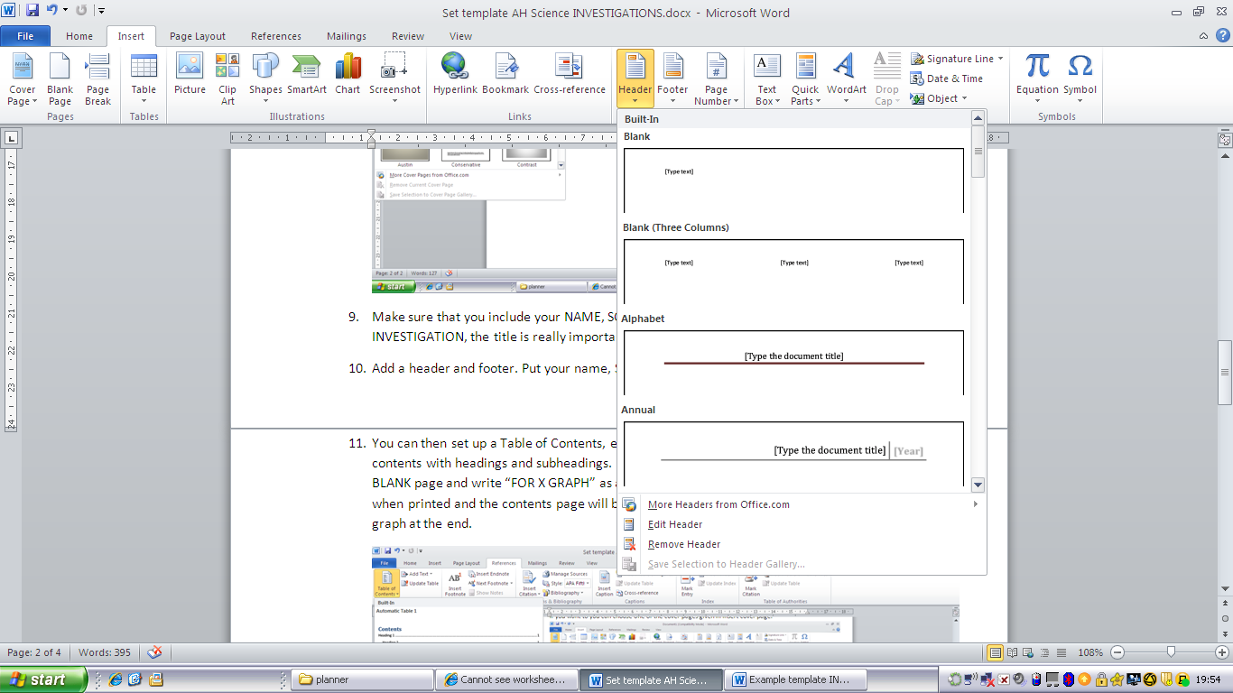
- You can then set up a Table of Contents, each time you refresh it will update your table of contents with headings and subheadings. If you are going to add hand drawn graphs leave a BLANK page and write “FOR X GRAPH” as a heading, this will then be correctly numbered when printed and the contents page will be in order. This page can then be replaced by the graph at the end.
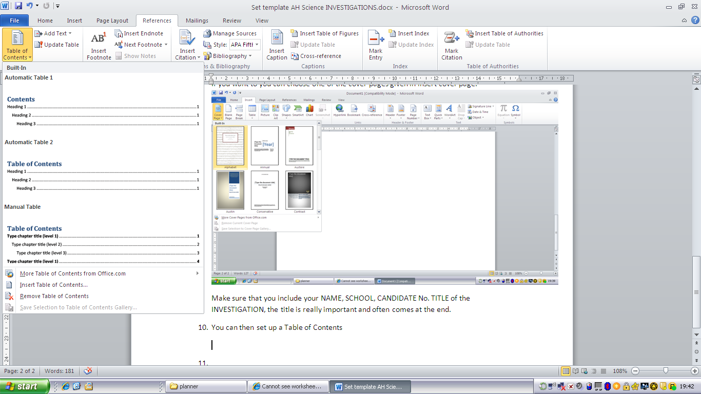
- Word 2010 will also correctly make up your references if you paste them in correctly. For Biology & Chemistry three or more references are required, for Physics one good clearly used reference is sufficient. All references MUST appear in the text AND cross referenced at the back, not just in a footnote so beware. To set up a referencing system go to REFERENCE, insert citation. For book references page numbers must be included so that it is important to write these down during your research. They should be recorded in your daybook. This section should be called REFERENCES and not Bibliography. A bibliography are books that you have delved into during research, a reference is one that you have used. REFERENCES MUST BE IN THE TEXT AND REPEATED CORRECTLY AT THE END OF THE REPORT. There is no excuse for failing to get this mark.
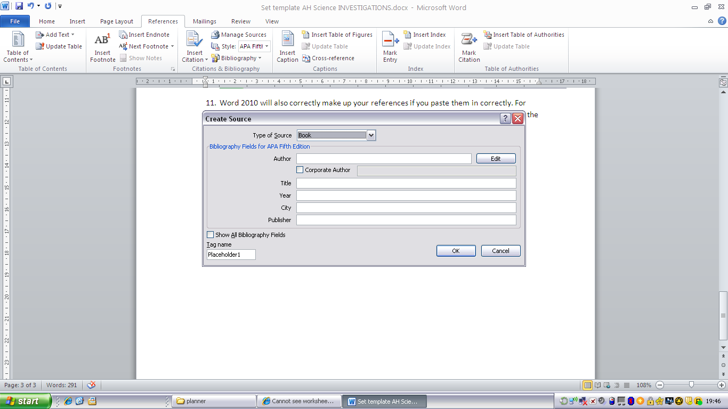

- Now keep adding in your work and updating. You can use different referencing systems to produce the work.
- Directly after the contents page you ought to have an Abstract or Summary. This MUST give your AIM, FINDINGS and CONCLUSIONS. In physics it should also have your uncertainties included. Do be careful about your title as choosing the wrong aim and title can lose you marks, subtle though it is, eg If I say to COMPARE different methods of measuring Surface Tension my Summary must include the methods I used to find the surface tension, the results that I got for each method and A COMPARISON. If my aim is to “Find the Surface Tension by 3 different methods”, my Summary must have a list of the experiments I am doing, clearly named and explained as above but I do not need to state which method is the best or gave the most accurate answer etc. Often your aim will be tweaked at the write up stage but keep referring to it. Also your conclusions must match the aim, so again in the example above if you aim to compare then you must do this in your conclusion.
- See example
- You then need to write your Introduction. There are no marks for long winded history. We want the Science, it must be relevant, it must be clear and complete. In Physics any equation must have the terms defined and where possible equations derived. Amazingly copying images from sources does not lose marks, but again diagrams and information must be clearly sourced. Here you should try to add a “little of you”. This is harder than it seems, but a cut and paste job does not indicate that you have the slightest understanding of what you are doing and this will be reflected in your score. There are 3 or 4 marks for the introduction so this is a high percentage of marks. It is good to do this as you go along and ask your teacher to check that you are on the right lines. Listen and act on advice. Do not leave this until the last minute to complete. Break down the theory into the individual experiments. This can be added to the start of each experiment or can all be contained in the introduction at the start. If you also give a reason behind why you chose your investigation this will show the marker that you thought about your work and weren’t just handed one on a plate. Remember though don’t go and waffle as there is a nominal word limit.
- Diagrams should be labelled, don’t use your mobile phone to take photos borrow a high quality camera. Photos are perfectly OK but use a camera and not a phone. The quality must be good. All photos MUST be clearly labelled, if you are using an electric circuit a circuit diagram must be produced in addition. Personally I like hand drawn diagrams. These can then be scanned. BEWARE of computer drawn diagrams as they are often not very clear. In Physics it is sometimes OK to copy diagrams but they must be clear, labelled, your exact experiment and referenced. This ought to be an easy 2 marks to achieve but few candidates manage to get the full 2 marks.
- List your apparatus, giving relevant details where you can. The markers will ask themselves “Can I repeat the experiment from the details given by the candidate?”. If the answer is yes you will be getting merit and marks if the answer is no you will not obtain marks for that section.
- The methods are best done as a recipe like a cookery book e.g. Set up the apparatus as shown in the diagram. Hang a 1m ….. . What is important is that each item that you measure clearly states the equipment you are using, how it is being used and how it is being adjusted. In Physics it is not a requirement to use the impersonal but it is vital in Chemistry. Again this should be an easy 2 marks but few candidates achieve this. This might be something to show to your fellow students before handing in and ask them if you’ve missed something obvious. Remember to record how you measured every measurement or decided on your range of variables. Include how you kept variables constant. This should be an improvement on SG /National 5 work and there you had to clearly start what measurements you were making and how you controlled variables.
- Presenting your results is a real key. Sometimes you will generate loads of data from which the material you used can be obtained. If this is the case then possibly have an example of raw data in an appendix, but again the examiner does not what to trawl through all the data. Watch out for things like wanting the radius and you measuring the diameter. Where possible include the raw data, eg the diameter and show that you have halved this to obtain the radius. Data should be presented in tables with numbers in the bulk of the table and headings, with units, in the top. Use SI units to avoid confusion in later stages or if your maths isn’t good put the data in the units that you measured and have a further column with this data converted to SI units. Excel is a great tool that can do all of these changes for you if you program it correctly. If you do have to cross a page with a table then make sure that you put headings at the top of the second page. Again word will do this for you (see below), as will excel. Personally I think just making tables look good in excel and adding these in to your final document looks neater. Include a page and heading in word (you can delete later or use this sheet to put through the printer for your excel table)so that your contents and page numbering doesn’t go wrong.
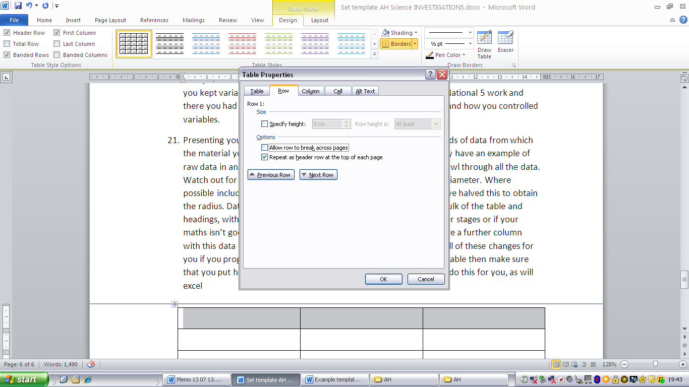
- When printing graphs, physics likes you to use excel, but I think Biology prefers graphs drawn by hand with graph paper. Using excel is a powerful tool, but there are important considerations which I will deal with separately. Points should be small (point 5-7) crosses, or pluses. DO not use the great big default diamonds and certainly don’t start experimenting with colours backgrounds. Gridlines (lots of them) must be included and generally the origin. Do not force graphs through the origin or extrapolate back too much, although some extrapolation helps with your evaluation. Put the equation for any trendline on the graph but always check sometimes excel does not put the obvious best fit line through the points. The best way to check this is to print out a graph with no trendline and look along the paper at eyelevel. Instantly it is obvious if your points form a curve or straight line. If you expect a line and it is a curve, don’t pretend. This can gain you marks in your evaluation as you will have lots to write about things not going to plan.
- In the example below the good points from this graph are that the trendline is the best line of fit, the points are marked as crosses, although at 7 point this is too large, there are plenty of gridlines vertically but a few more horizontally would help. For this example I would have made 0.20 a major gridline and 0.02 a minor gridline. On the negative side the relationship would indicate that a graph of period squared against length should have been plotted. ASK if you cannot set graphs up in excel after you have read the document “Using excel” and I will show you how to do this.

This is the basic graph generated in excel there are no proper titles, the points are huge squares and the linear trendlines are incomplete. Do check these points that your graph has been plotted correctly. For Biology it might be appropriate to do a line graph but in Chemistry and Physics a scatter graph with the best line of fit is usually required. If your results are likely to generate bar graphs or charts only think carefully if this is the right investigation to choose.
- Before writing up, if you can graph your points as you are completing the experiment, even in draft form it will often highlight odd points which you can then check and repeat. If you leave graphing to the last minute it will be too late to check your points.
- Uncertainties These will be dealt with separately in Physics as these will form a huge basis of your investigation.
- Results These should be as detailed as necessary so that markers can follow and check your data. However, if this turns out to be a thousand data points then either summarise, give a sample or banish some to an appendix. Your teacher will advise you on this.
- Conclusion Make sure this relates back to your aim. Make it succinct.
- Evaluation An evaluation is vital and ranges from 3 to 6 marks. There are hints in the mark scheme as to what you ought to be covering but you must use your results as a basis for this evaluation. Don’t pick up trivial responses

If there are any further questions then keep asking your teacher and don’t leave writing up until the last moment. The uplift date for investigations is much earlier this year due to the early exam diet.

…..and lastly, make the most of this opportunity, AH Sciences are valued more by Universities than A-levels because of your investigation which provides you with the Skills for Uni life, and if Uni isn’t your destination it just provides you with a chance to think independently.

All the best
Mrs Physics
PS I am sure I’ve missed out a few details so read the mark schemes carefully and refer to your specialist teachers.

