Use of Excel 2010 in AH Physics
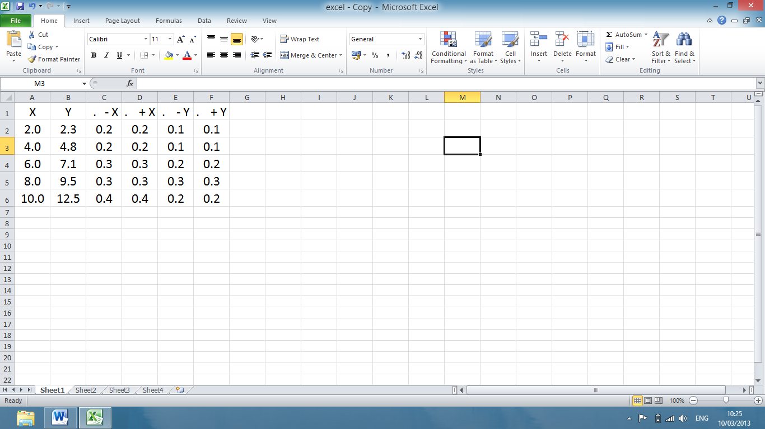
Insert data, including uncertainties.
Full stop in front of uncertainties stops “arith. operation”.
Click on Home
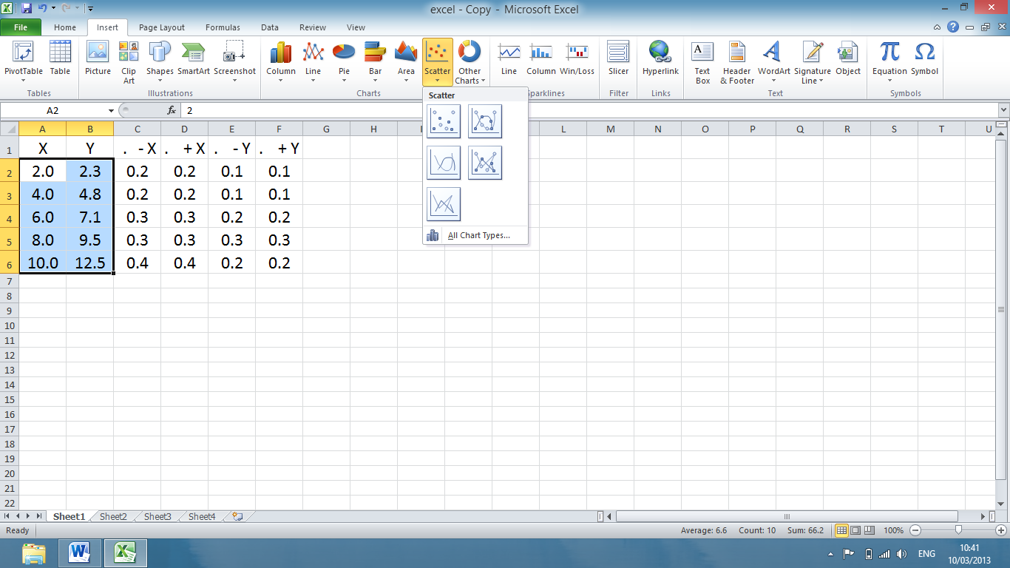
Highlight data to be plotted.
Click on Insert, then select
“Scatter”

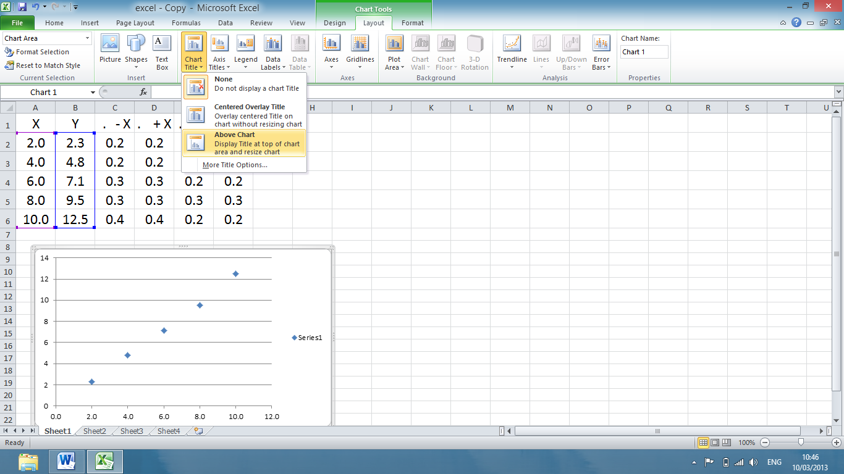
Click on Legend – select none.
Ensure the graph has been selected.
Click on Chart Tools – Layout.
You can then insert Chart and Axes Titles and label axes with units.
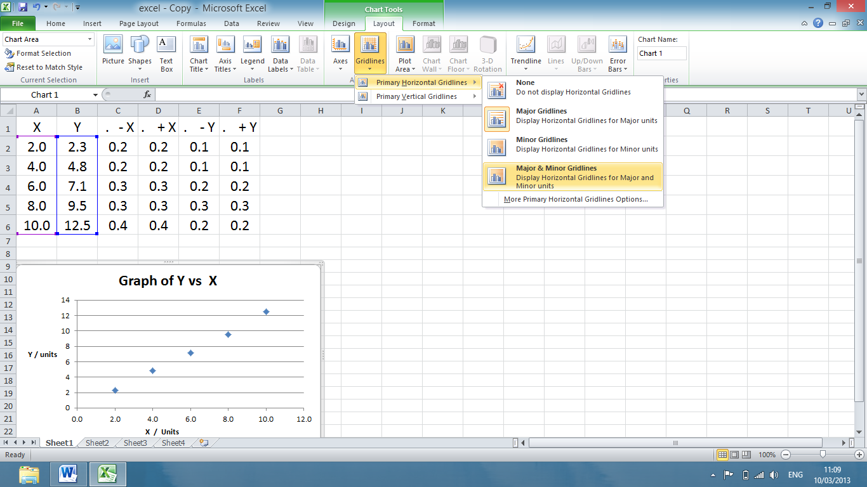
Select Gridlines. Insert Major and Minor Gridlines – horizontal and vertical.
Again ensure the graph has been selected.
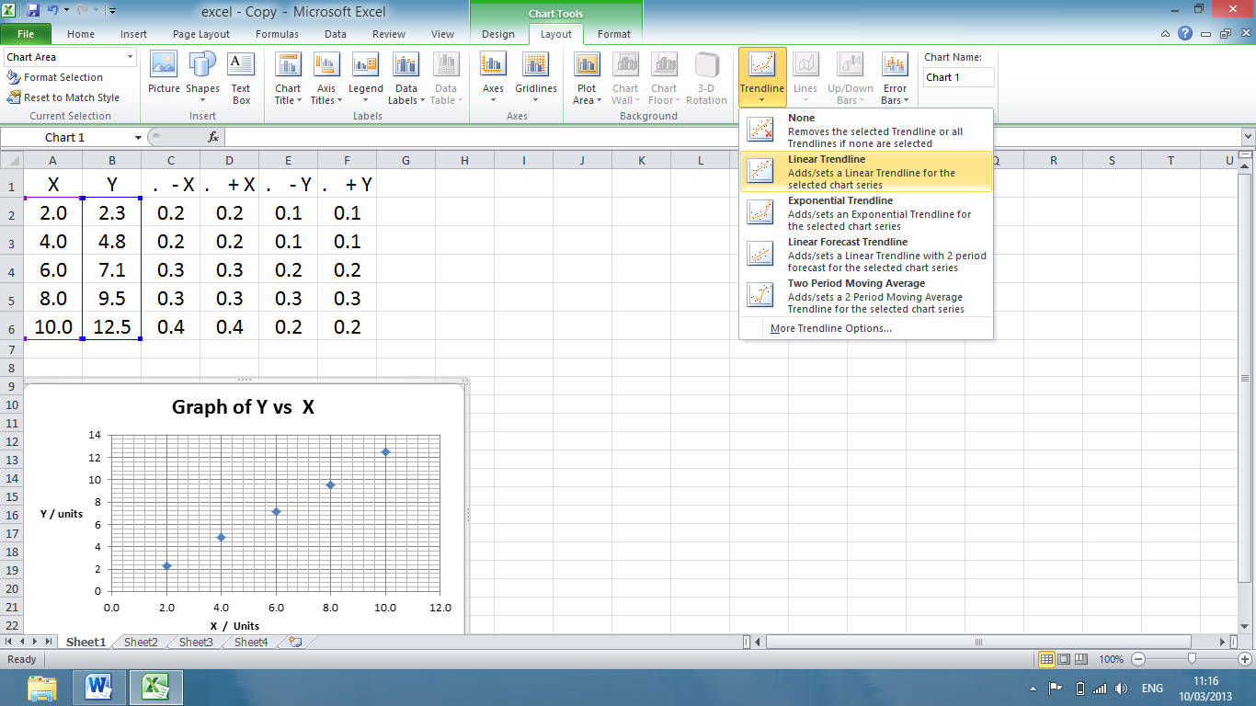
Click on Trendline
Select “More Trendline Options”.
Select “linear” if appropriate.
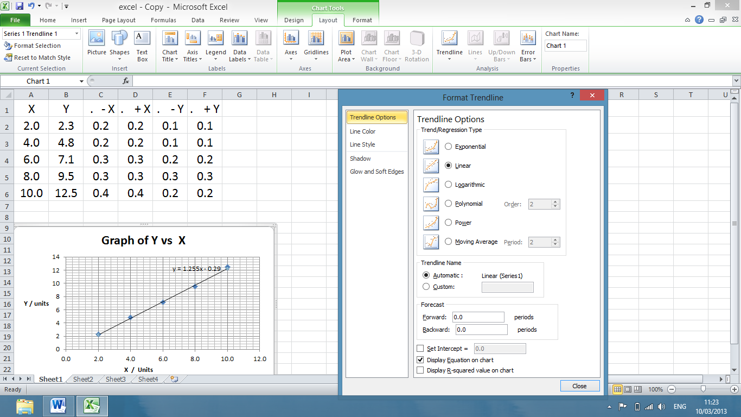
Click on “Display Equation on Chart”
Custom Error Bars
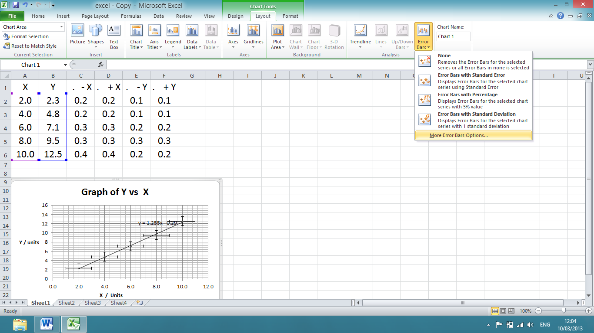
Click on Error Bars – select More Error Bars Options
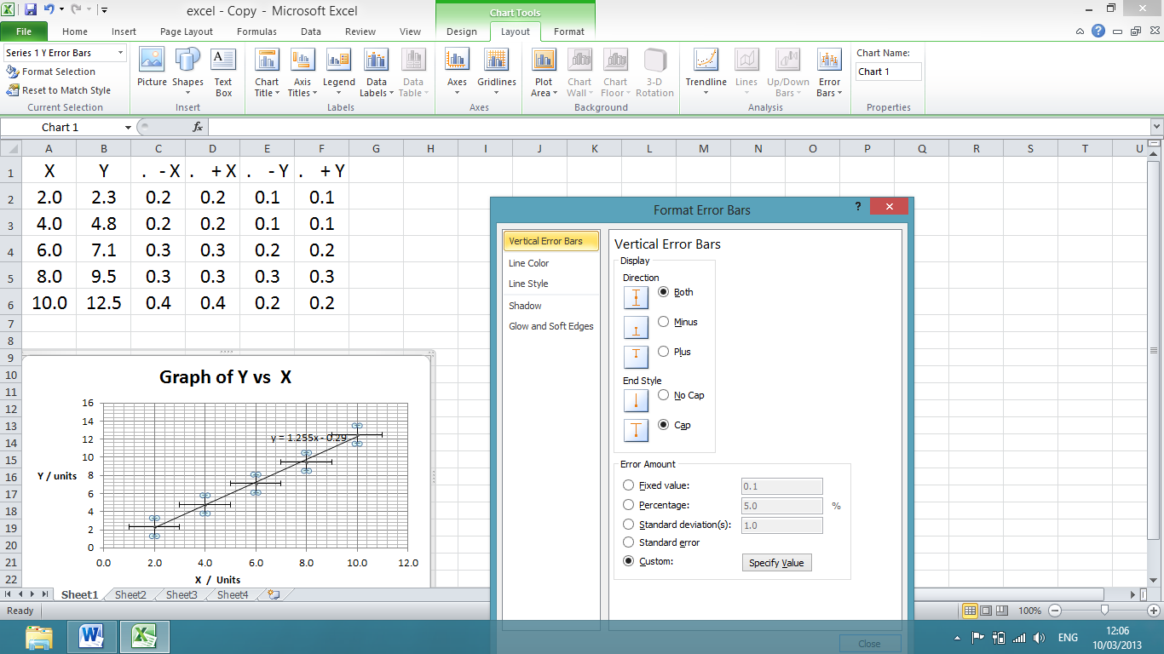
Select Both
Click on Custom and then Specify Value
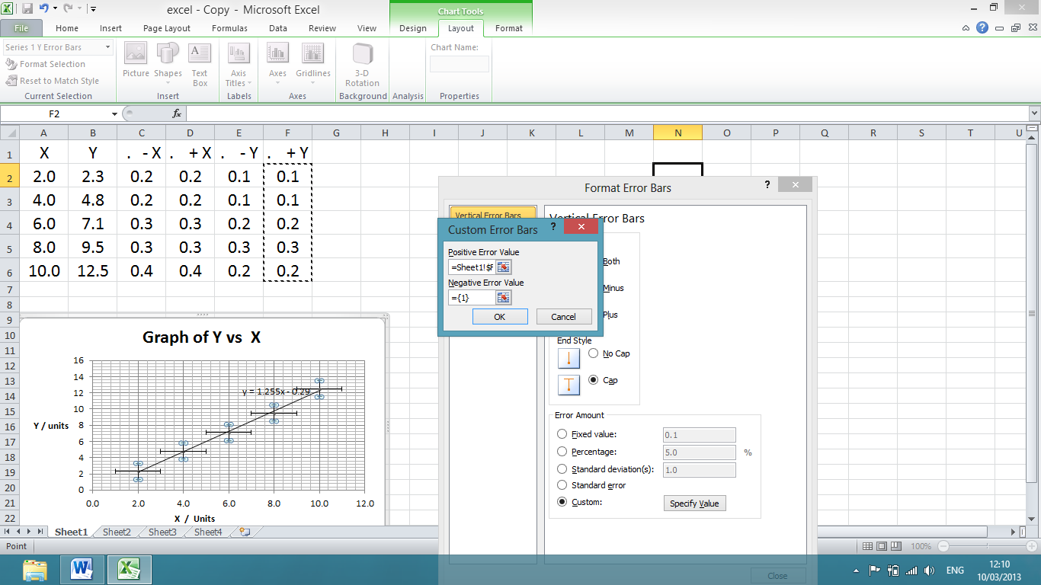
Click to highlight data insertion box.

Click and drag down column to insert value of +Y in data box.
Repeat for Negative Error Value
Click Okay
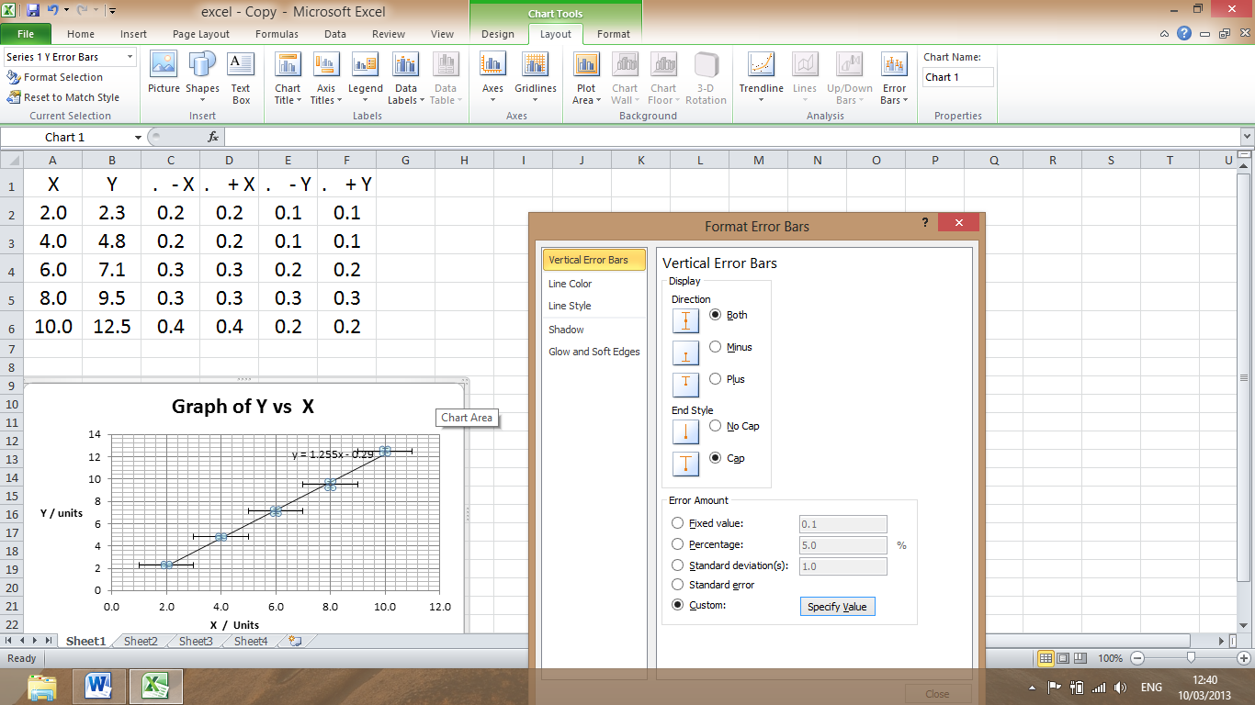
To select horizontal error bars, click on any horizontal error bar on the graph.
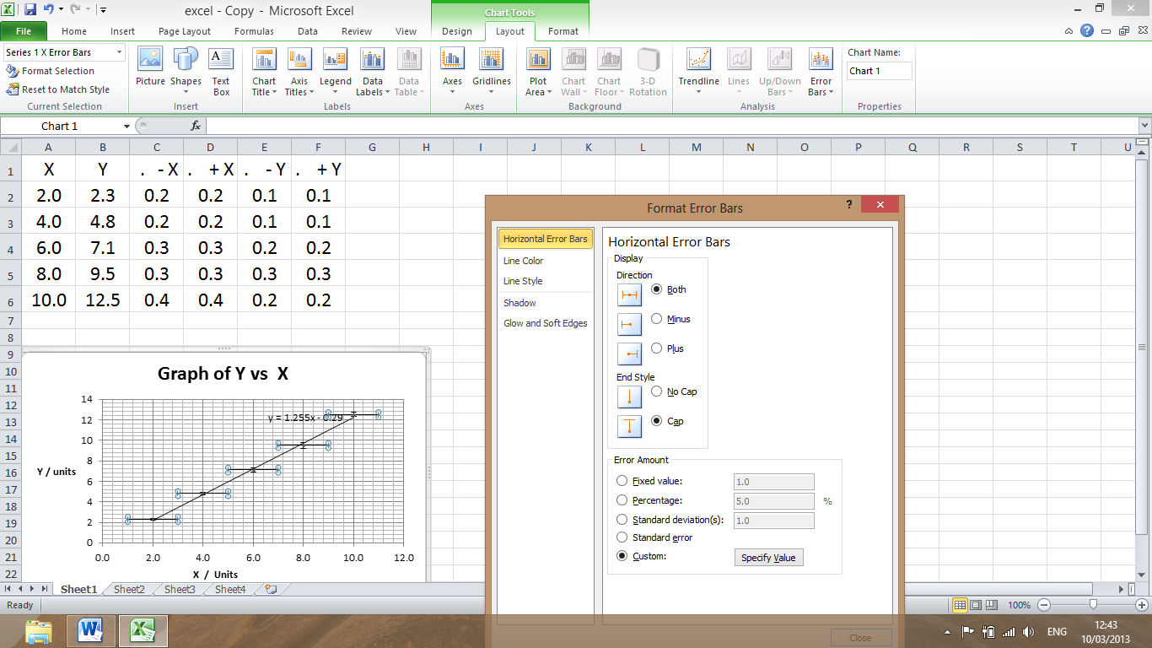
Changes to Horizontal Error Bars
This should now read “Horizontal Error Bars”.
Repeat the procedure to enter customised horizontal error bars.
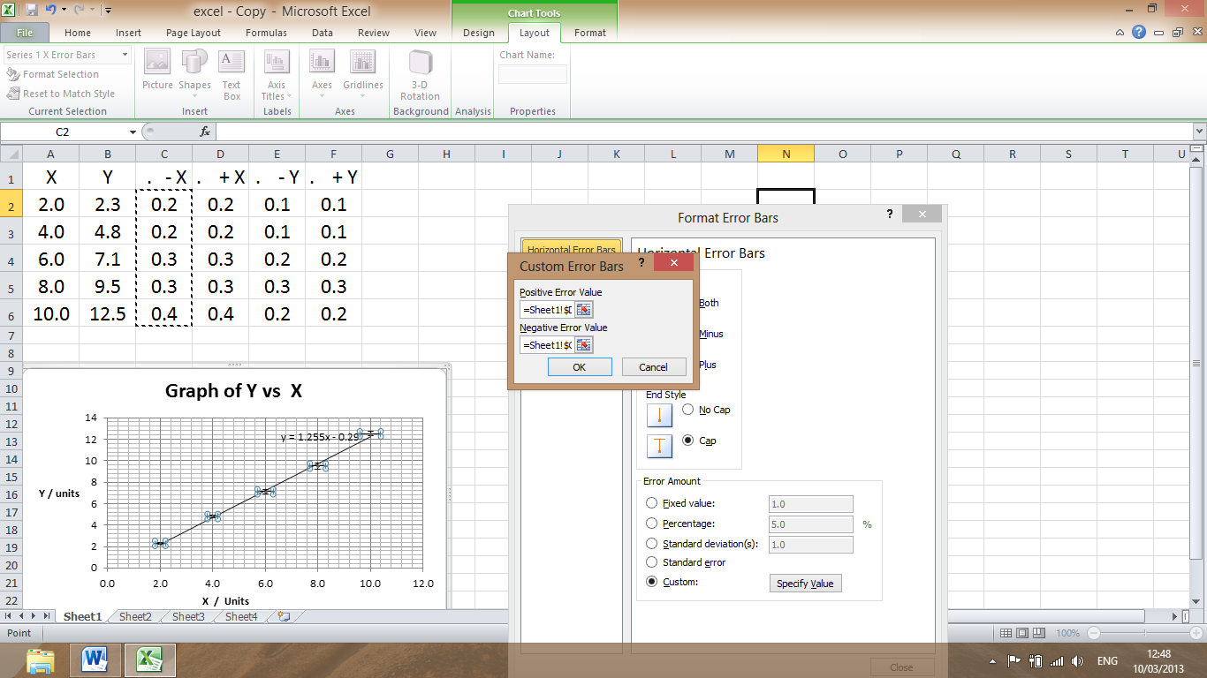
Click to highlight data insertion box.

Click, Drag down vertical column to insert data in box.
Click okay
To change dot size / shape. ( Use Format Data Series)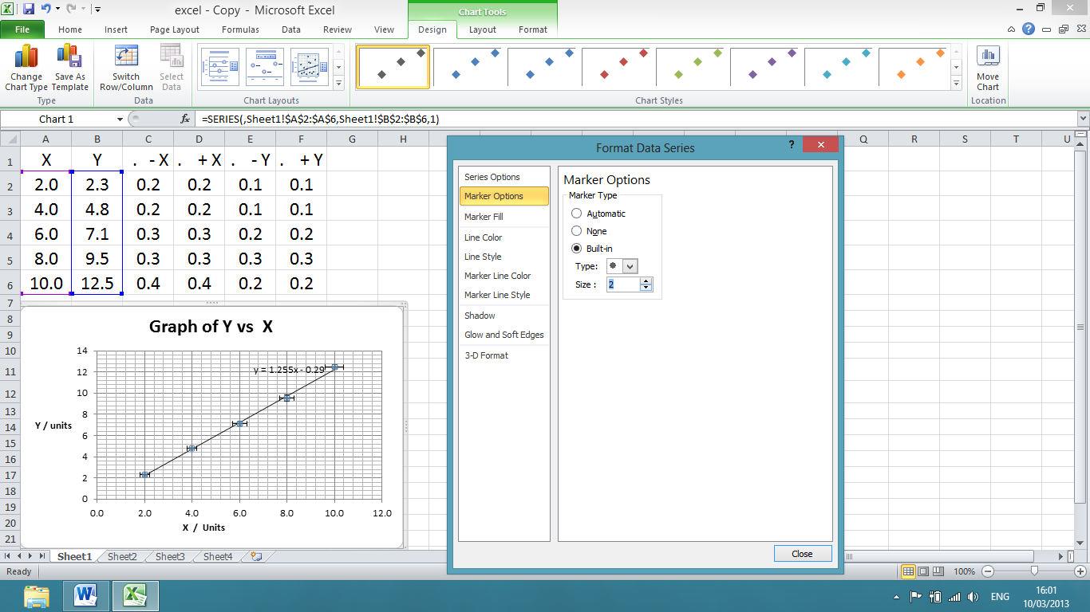
Doubleclick or right click just next to one of the points.
Format Data Series should open.
If you get Format Trendline or Format Error bar then you have clicked on the line, point or error bar.
Select Marker Options.
Built in. Choose style and size

Increase the size of the graph to at least half a page.

Uncertainty in Gradient, Intercept - Use of Linest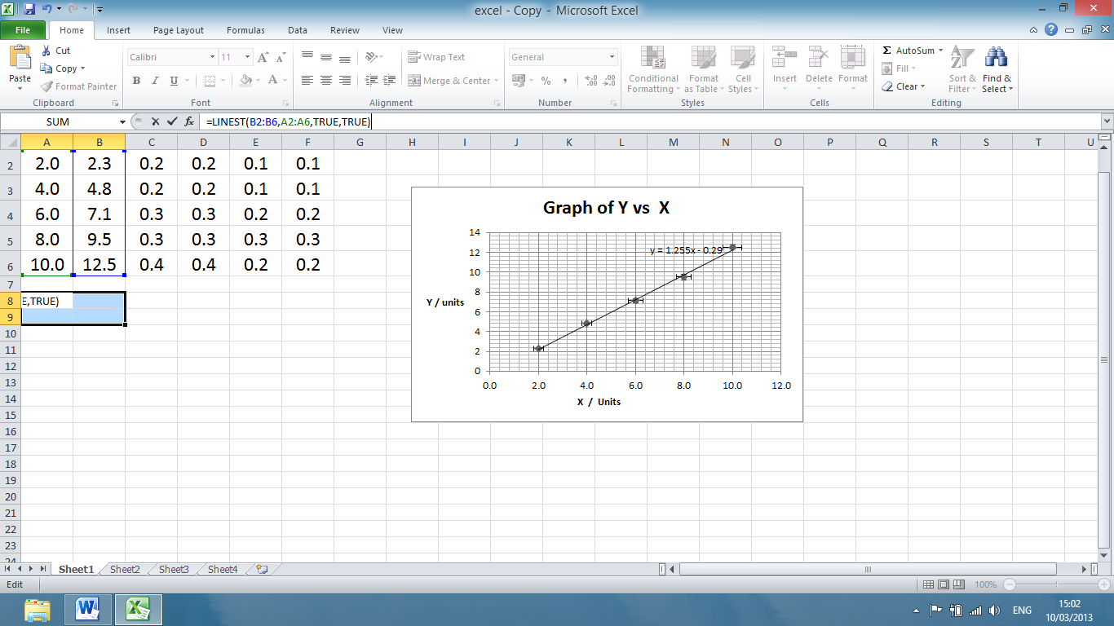
Hold down Ctrl, Shift and press enter.
(CMD, Shift and enter on Apple computers).

Y Range of Cells
X Range of Cells
Highlight four cells.
Type in =LINEST(B2:B6,A2:A6,TRUE,TRUE)
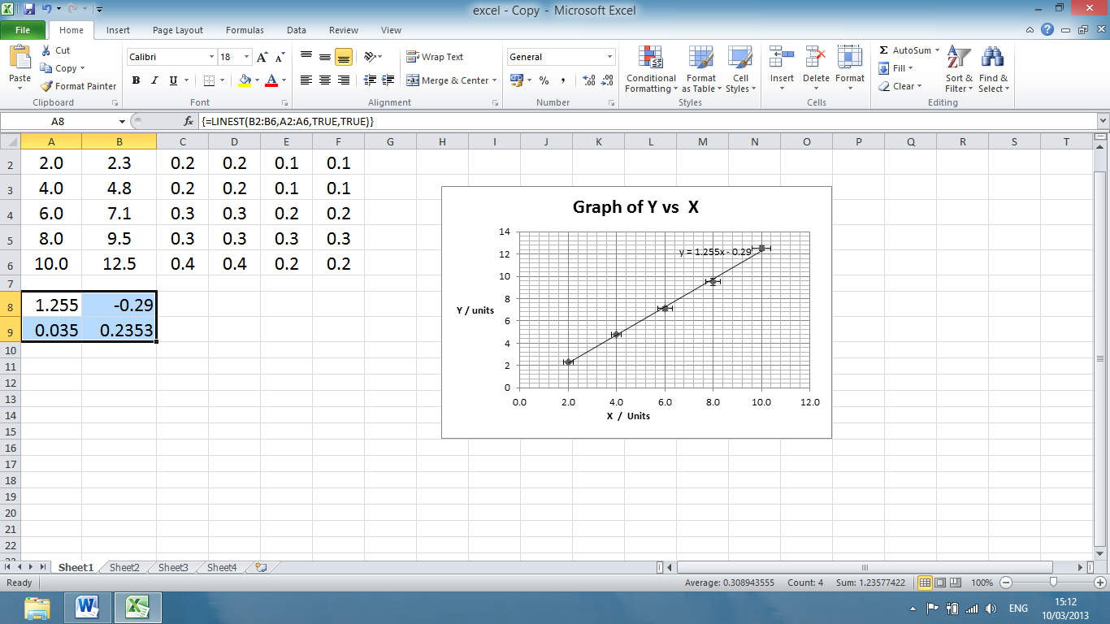
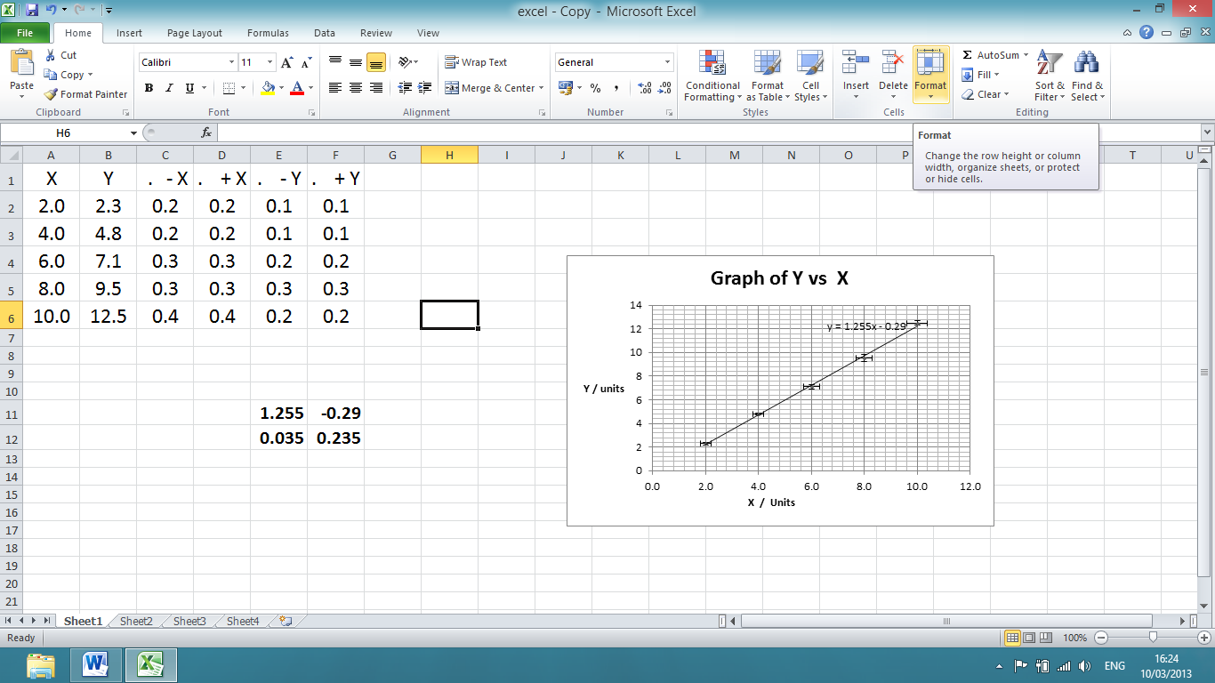
Uncertainty in
Y Intercept
Uncertainty in Gradient
Y Intercept
Gradient

