BGE – Electromagnets
Starter (10 minutes):
Pupils complete the “clock exercise.”
The pairs have to decide whether each statement is true or false and then put it in the correct position on an imaginary clock. For example:
The Earth takes 24 hours to orbit the Sun (2 = true false = 6)
As this statement is false, pupils would put the card at the bottom of the imaginary clock (where the number 6 would be). If the pairs get all of the statements right, they will have a complete clock. Allow them 7 minutes to complete the task and then go through the correct answers and discuss any issues. (Answers: F, T, F, F, T, T, F, T, F, T, T, T.)
Recap (10 minutes):
Review magnet information that they should have covered in year 6 (see PowerPoint for key points).
Use the iron filings in glass case to demonstrate.
www.Brainpop.co.uk Username: Lockerbie Password: Brainpopuk Do the sheet on ELECTROMAGNETISM
Summarise using BBC video (http://www.bbc.co.uk/learningzone/clips/the-3d-magnetic-field-of-a-bar-magnet/287.html) – Link on PowerPoint
In \\LCKA-FS1\ALL Desktools$\Desktools\Physics click on PHYSICS ANIMATONS: Look at C Current in a Magnetic Field. Click on the circuit and see what happens around the wire. If Ewan feels up to it, he can get an electromagnet (5V dc MAX) and show it picking up paperclips when switched on and when off paperclips fall.
Activity 1 (20 minutes) 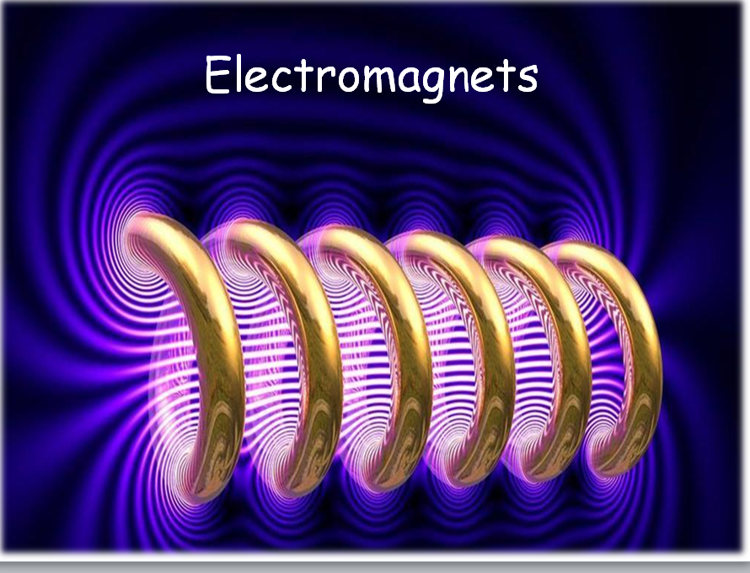 PPP Electromagnets
Show pupils an electromagnet along with PowerPoint explaining and how it works. Inform pupils that they are going to be carrying out an investigation into how changing the number of coils on an electromagnet changes its strength.
Elicit important of fair-testing and introduce planning template;
Pupil’s complete planning template in pairs (may need to go through with the pupils);
If we were investigating things (variables) which affect magnetic strength, we could change;
- Voltage / Current
- Number of Coils
- Nail material
- Different wires
- Spacing between the coils
- Thickness of wire,
- Insulation of wire,
How can we measure magnetic strength (elicit ideas)
We will change / We will keep the same.
Pupils make a prediction based on current knowledge.
Extras: Draw results table, write up method.

