

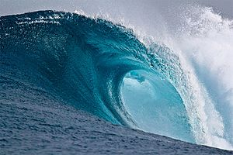

S3 / N4 / N5 Physics
Waves

Problem Booklet
Contents
Wave Properties 3
Wave Speed 4
Wave Equation 5
Sound 6
Electromagnetic Spectrum 8
Diffraction 10
Refraction 11

Wave Properties
- Copy and complete this sentence:

_______________ can be transferred from one place to another as waves.

- What is the meaning of the term ‘transverse’ when describing waves?

- What is the meaning of the term ‘longitudinal’ when describing waves?

- Copy this diagram of a wave and label the following:

Wavelength, Amplitude, Crest, Trough, Axis

- Describe the following properties of waves.

- Wavelength
- Frequency
- Amplitude
- Wave speed

- Water waves are represented in these diagrams. Calculate the wavelength and amplitude of each wave.
(a)
12 m
2 m
(d)
30 m
5.5 m
(b)
20 m
6 m
(c)
5 m
1.5 m

Wave Speed

Useful Equation:
v
=
t
d
v
d
t

where: v is the speed of a wave (m/s)
d is distance travelled by a wave (m)
t is the time taken by a wave to travel a distance (s)

- Copy and complete this table:

 | Speed / m/s | Distance / m | Time / s
(a) |  | 50 | 20
(b) |  | 280 | 1120
(c) | 12 |  | 0.8
(d) | 340 |  | 3.5
(e) | 6.8 | 272
(f) | 95 | 475

- A water wave travels along the length of a 25 metre swimming pool in 6.25 seconds. What is the speed of the water wave?

- A wave moves along a slinky with a speed of 0.75 m/s. The wave travels the full length of the slinky in 3.2 seconds. How long is the slinky?

- A seismic wave travels through the ground at 2.5 km/s after an earthquake. How long does it take the wave to travel 45 km?

Wave Equation

Useful Equation:
v = f λ
f
v
λ

where: v is the speed of a wave (m/s)
f is the frequency of a wave (Hz)
λ is the wavelength of a wave (m)

- Copy and complete this table:

 | Speed / m/s | Frequency / Hz | Wavelength / m
(a) |  | 800 | 4
(b) |  | 40 000 | 0.0085
(c) | 5 |  | 0.25
(d) | 690 |  | 2.3
(e) | 45 | 15
(f) | 180 | 750

- What is the speed of a water wave that has a frequency of 0.5 Hz and a wavelength of 3.6 metres?

- A wave moving through water has a speed of 2.8 m/s and a wavelength of 7.0 cm. What is the frequency of the wave?

- A sound wave of frequency 8.5 kHz has a speed of 340 m/s in air. What is the wavelength of the wave?

Sound

- Describe how you would measure the speed of sound in air using the following equipment:

An electronic timer, 2 microphones, a metre stick, a bottle and a knife.

- (a) How far will a sound wave travel through air in 5 seconds?

- The sound wave has a frequency of 800 Hz. What is it’s wavelength?

- An ultrasound sound wave from a dolphin travels through water with a wavelength of 3 cm. The wave travels a distance of 150 metres to a second dolphin.

- How long does it take the ultrasound wave to reach the second dolphin?

- What is the frequency of the ultrasound wave?

- A car is fitted with a parking system. This warns how close objects are behind the car. Equipment on the back of the car sends out ultrasound waves and receives the reflected waves.

There is a 5 ms gap between a wave been transmitted and received. How far away is a wall from the back of the car?
- In a classroom experiment, a student is trying to find out the speed of sound through a liquid. The student measures the time taken for a sound wave to travel through different lengths through the liquid. The results are shown in the table.

Distance / m | Time / ms
0.50 | 0.26
1.00 | 0.53
1.50 | 0.79
2.00 | 1.05
2.50 | 1.32
3.00 | 1.58

- Draw a line graph of the results, and use the gradient of the straight line to calculate the speed of sound through the liquid.

- What liquid is the sound travelling through?

- A spectator at a firework display sees a firework explode in the sky and hears the bang 1.5 seconds later.


- Explain why there is a delay between seeing the firework explode and hearing the bang?

- How far away is the firework from the spectator when it explodes?

Electromagnetic Spectrum

- The parts of the electromagnetic spectrum are shown below.
Gamma Rays
Infrared Radiation
Visible Light
X-Rays
Radio Waves
Ultraviolet Radiation

Microwaves

Rearrange these electromagnetic waves so that they are in order of increasing frequency.

- What is the speed of an electromagnetic wave in a vacuum?

- What happens to the wavelength of electromagnetic waves as frequency increases?

- What happens to the energy of an electromagnetic wave as frequency increases?

- Describe an application of each of these types of electromagnetic radiation in medicine:
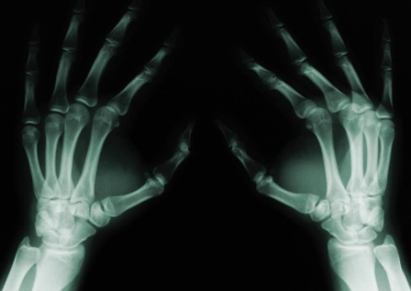
- X-Rays.

- Gamma Rays.

- Infrared Radiation.

- Ultraviolet Radiation.
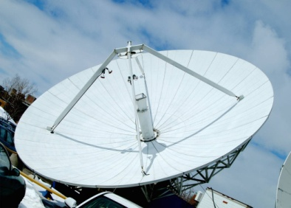
- Describe an application of each of these types of electromagnetic radiation in telecommunication:
- Radio waves.

- Microwaves.

- Describe an application of each of these types of electromagnetic radiation in the home:
- Infrared Radiation.
- Microwaves.

- Why are gamma rays unsuitable for using in mobile phone communication? Give two reasons for your answer.

- How long will it take visible light to travel through 250 km of water?

- A radio carrier wave is sent out from BBC Radio 1 in London with a frequency of 97.5 MHz. A student in Edinburgh (which is 670 km away) is listening to the broadcast.

- What is the wavelength of this radio wave?

- How long will it take the wave to travel from London to Edinburgh?
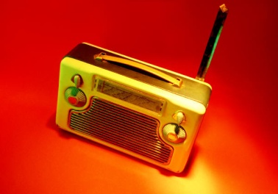

- Ultraviolet radiation is one of many types of radiation given off by the Sun. The ultraviolet radiation from the Sun takes 8 minutes to reach the Earth. How far away is the Earth from the Sun?

- What type of electromagnetic radiation is given off by a laser?

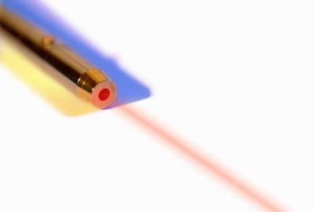

Diffraction

- What is meant by the term ‘diffraction’?

- Copy and complete these diagrams to show water waves bending around an obstacle:

(b)
(a)

- A hill lies between a radio and television transmitter and a house. The house is within the range of both the radio and television signals from the transmitter.

- The house has good radio reception but poor television reception. Suggest an explanation for this.

- A mobile phone transmitter is attached to the existing transmitter. Predict whether the mobile phone reception will be good or poor in the house. Give a reason for your answer.

- This diagram shows three types of signal in which radio waves can be sent between a transmitter and receiver.
Which of the signals has the longest wavelength? Give a reason for your answer.

Refraction

Useful Equation:
P =
f
P
1
f
1

where: P is the power of a lens (D)
f is the focal length of a lens (m)

- What is meant by the term ‘refraction’?

- What is the difference between diffraction and refraction?

- Copy this diagram and label it with the following:

Incident ray, Refracted ray, Angle of incidence, Angle of refraction, Normal.

Material 2
Material 1

- What is meant by the following statement:

“The critical angle of a glass block in air is 41°.”

- Which of these diagrams shows what happens when a ray of light:

- travels from air in to glass at an angle above the critical angle of glass?

- travels from glass in to air at an angle above the critical angle of glass?

- travels from air in to water at an angle less than the critical angle of water?

- travels from water in to air at an angle less than the critical angle of water?

X
Y
Z

- A student is given a Perspex block, a pencil, a protractor, a ruler, a piece of blank A4 paper, a ray box and a power supply.
Describe how the student could use this equipment to find the critical angle of Perspex.

- Copy and complete these diagrams to show the effect the lenses have on parallel incident rays of light.

(b)
(c)
(a)

- A student makes the following statement:

“The focal length of a convex lens is 15 cm.”

What is the meaning of this statement?

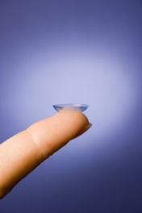
- What is the focal length of a convex lens that has a power of +4.5 D?

- What is the power of a concave lens that has a focal length of -5 cm?

- Copy and complete these ray diagrams to show the image produced. Use a separate piece of graph paper.
f
f
Convex lens
object
(a)
f
f
Convex lens
object
(b)

For each ray diagram, state whether the image is:

- Real or virtual.
- Magnified or diminished.
- Upright or inverted.

- What is the meaning of the following eye defects:
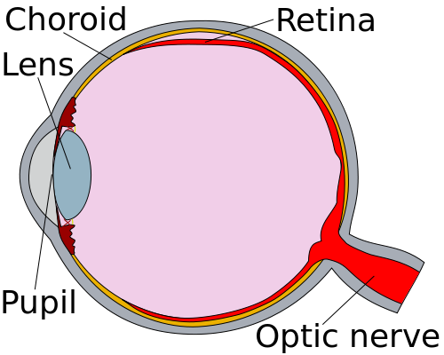
- Short sight.

- Long sight.

- What shape of lens would be used to correct the following eye defects. Use a diagram to demonstrate this.

- Short sight.

- Long sight.

- Describe how a telescope uses two convex lenses to create a magnified, virtual and inverted image of a distant object.
Objective Lens
Eyepiece Lens
Light-Tight Tube

Make reference to the focal lengths of the eyepiece and objective lenses.

- A lifeguard is looking at a swimmer in a pool. Explain, with the aid of a diagram, why the lifeguard sees the swimmer at point B rather than her actual position at point A?

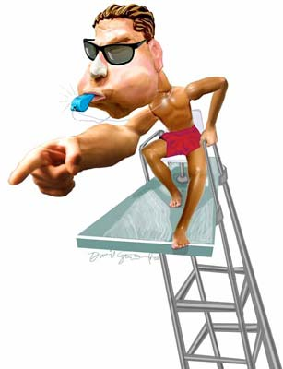
air
water
A
B

