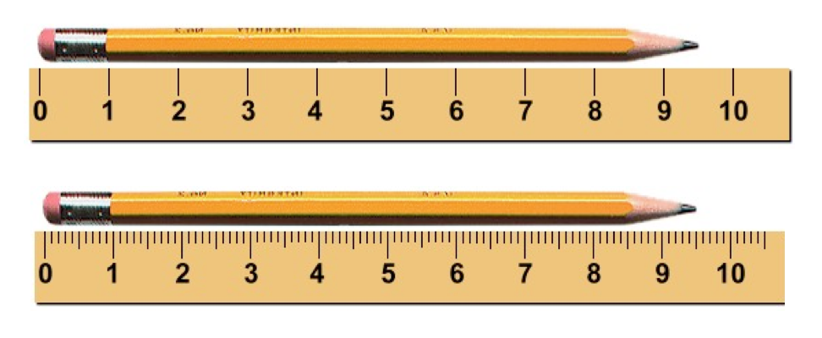



Higher Physics Topical Investigation Skin Cancer—Prevention and Cure

2

Investigation Brief
Suntan creams stop harmful UV radiation reaching the skin. Manufacturers’ products are rated with a Sun Protection Factor (SPF). Suntan creams can have SPF values from 6 to over 50.
UV radiation monitors normally measure irradiance in output intensity per unit area. Thus, a typical low intensity UV lamp may emit approximately 10 mWcm^{-2.}
The aim of this investigation is to determine the effect of various suntan creams on the transmission of UV radiation. In particular, the relationship between SPF and absorption should be found.

Investigation Notes
UV lamps can be harmful. Make sure that you read the safety leaflet which is supplied with the UV lamp. Some cheap UV monitors do not measure the irradiance of UV radiation. Rather, they give an indication of UV index. It is possible to undertake this investigation with such a monitor, but results will be less reliable and accurate. UV radiation does not pass through many transparent materials (including glass). However, UV transparent acrylics are readily available.
3

Uncertainties in AH Physics
Advanced Higher Physics
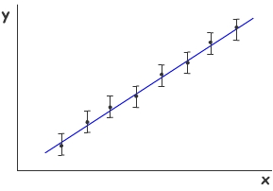
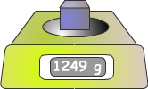

Advanced Higher Physics
Uncertainties in AH Physics

Contents

Contents

Page 3 Precision and accuracy

Page 4 A closer look at accuracy

Page 5 A closer look at precision

Page 6 Precision and accuracy

Page 7 Uncertainty - introduction

Page 8 A closer look at random uncertainty

Page 9 A closer look at scale reading uncertainty

Page 10 A closer look at calibration and systematic uncertainty

Page 11 Absolute and percentage uncertainty Advanced Higher

Page 12 Combining uncertainties in a measurement Advanced Higher

Page 13 Combining uncertainties – the rules Advanced Higher

Page 14 Combining uncertainties – examples 1 and 2 Advanced Higher

Page 15 Combining uncertainties – example 3 Advanced Higher

Page 16 Error bars Advanced Higher

Page 17 Uncertainty in a gradient Advanced Higher

Page 18 Uncertainty in a gradient - worst and best fit lines Advanced Higher

Page 19 Uncertainty in a gradient - parallelogram method Advanced Higher

Page 20 Uncertainty in a gradient - LINEST method Advanced Higher

This booklet is one of a number that have been written to support investigative work in Higher and Advanced Higher Physics. It develops the skills associated with handling uncertainties. Uncertainties were introduced in the booklet Precision, accuracy and uncertainty, written to support Higher Sciences. This booklet includes much of the material in the higher booklet and extends this as appropriate for use at Advanced Higher. Content specific to Advanced Higher is identified below.


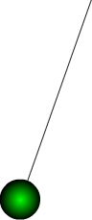

Advanced Higher Physics
Uncertainties in AH Physics

Precision and Accuracy

Precision and Accuracy

When we carry out investigations, it is important that the measurements we take are accurate and precise. Do these two words mean the same thing? Certainly most people use the words interchangeably. However, in physics, the words have different meanings. In summary, the difference between accuracy and precision is as follows:

The accuracy of a measurement tells you how close the measurement is to the “true” or accepted value.

The precision of a measurement tells you something about the number of significant figures in the measurement.

Activity

True or false?

The examples opposite illustrate measurements that are commonly made in physics. A student has made a comment about each measurement. Consider each statement. Is it true or false?

The answers and comments are on page 6.
You may like to read through the next two pages before checking your answers. You may even change your mind!

A – Measuring temperature

“The thermometer I have used to measure the temperature has a scale that reads to the nearest 0.1 ºC. Because of this, my measurement is likely to be accurate.”

B – Measuring mass

“The balance I have used to measure the mass of the block is very high quality and has been calibrated against known masses. Because of this, my measurement is likely to be precise.”

C – Measuring time

“I have used a stopwatch to measure the period of a pendulum. I have repeated the measurement and found an average. This gives me a more precise answer.”


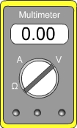
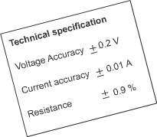
Technical specification data

Manufacturers of scientific instruments often supply data sheets that specify how accurate the instrument is. The instruments have been tested against very accurate standard instruments and the results are shown on the data sheet.
As you might expect, instruments that are guaranteed to be more accurate are usually more expensive.

Advanced Higher Physics
Uncertainties in AH Physics

A closer look at accuracy

Accuracy

When we measure something in a physics investigation, we are trying to find the actual or true value of the property being measured.
If the temperature of a liquid is actually 20 ^{O}C, then we would hope our thermometer gives us a value as close to 20 ^{O}C as possible. A thermometer that reads 15 ^{O}C say is not very good.
The accuracy of a measurement is how close it is to the true value. Our thermometer that reads 15 ^{O}C instead of 20 ^{O}C is certainly not very accurate.

Whatever we are measuring, the accuracy of our measurement depends on the quality of the measuring device we are using.
If you wish to measure your own weight you (probably) want the scales to read your true weight. However, many bathroom scales under read or over read. How can you know how close your scales are to the true value? Well, you can repeat the measurement using a higher quality scale - but even so, how can you be sure that this is more accurate? Ultimately, we can never measure a true value with 100% confidence. Despite this, we should still try to ensure that all our measurements are as accurate as possible. As a student experimenter, you may be restricted in the equipment you will use. Nevertheless, there are things that you can do to improve the accuracy of your measurements. A good start is to ensure the instrument is zeroed and used correctly!

Advanced Higher Physics
Uncertainties in AH Physics

A closer look at precision

Precision

A precise measurement is one that is more exact than one that is not precise.

Suppose someone describes themselves as being in their teens and about 2 m tall. Based on this, you don’t know much about them. The description is not very precise. However, a more precise description might have stated an age of 17 years and 2 months and a height of 1.97 m.

Where possible, measurements in science should be precise. To make precise measurements requires suitable instruments.

Consider the two rules being used to measure the length of the same pencil. The lower rule allows a more precise measurement to be taken.

The length of the pencil as measured by the upper rule is somewhere between 9 cm and 10 cm. We might guess and say 9.5 cm but the decimal place is just a guess. The smallest unit on this rule is 1 cm.
With the lower rule the length is measured to be 9.5 cm and we might guess at 9.51 cm. The smallest unit on this rule is 1 mm.

The measurement using the lower rule is more precise because it uses a smaller unit to measure with.

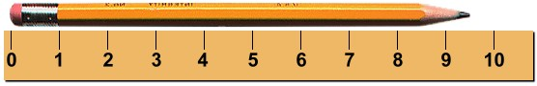
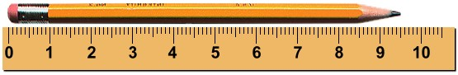
A selection of instruments is shown. Which are likely to enable precise measurements to be taken?

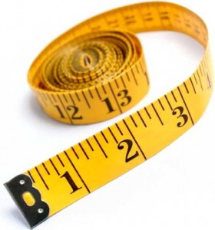
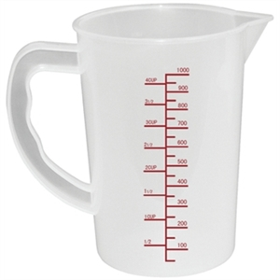
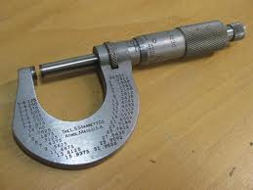
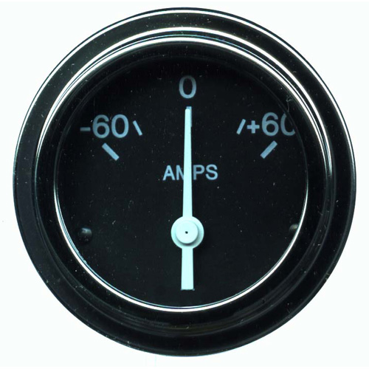
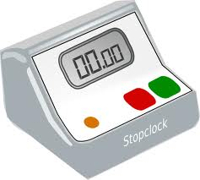
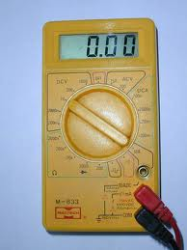

Advanced Higher Physics
Uncertainties in AH Physics

Precision and Accuracy

A measurement can be precise – that is, it may have lots of decimal places – but it can be quite inaccurate. Just because we use a measuring device that has very small smallest divisions doesn’t mean that that we can necessarily be confident that we have found the true value of the property we are measuring.
For example, if we might measure the resistance of a resistor to be 5.142 Ω. However, if the real value is 6.1 Ω. then our measurement may be precise, but it is inaccurate.

When we make measurements in our physics investigations, we should try to ensure that the measurements are precise and accurate.

To ensure our measurements are as accurate as possible, we mostly rely on the quality of the instrument we are using. Is it possible to take measurements that are completely accurate? This is an interesting question that can lead to some philosophical thoughts. It can be argued that we can never measure something with 100% accuracy. Even if we use the very best instrument that is available, that is as accurate and precise as possible, we can never be sure that our measurement is 100% correct. There will always be a certain amount of uncertainty in our measurement.

Activity – group discussion

Discuss examples of measurements that have high accuracy but low precision.

Discuss examples of measurements that have high precision but low accuracy.

Answers to the questions on page 3

A – Measuring temperature

The statement is false. The thermometer may be calibrated incorrectly so that readings are precise but inaccurate (i.e. wrong).

B – Measuring the mass

The statement is false. A high quality, well calibrated balance is likely to be accurate i.e. the value is close to the true value.
However, it may or may not
be precise. This depends
on the number of decimal
places displayed.

C – Measuring time

The statement is false. Repeating measurements is always good practice in physics investigations. By repeating the measurements and finding a mean, it is likely that value will be found that is closer to the true value i.e. the mean improves the accuracy.



Advanced Higher Physics
Uncertainties in AH Physics

Uncertainties - introduction

Measurement and uncertainty

It is impossible to measure anything with 100% accuracy. No matter how good our measuring device, and no matter how small the smallest unit on our measuring scale, there will always be an uncertainty in any measurement we make. One of the tasks of a good physicist when they carry out experiments is to make sure they have a good understanding of the uncertainties involved in measurements.

There are a number of ways in which uncertainties can arise in any measurement. These are summarised below and are discussed in detail in the following pages.

Random uncertainties occur when an experiment is repeated and slight variations occur. Random uncertainties can be reduced by taking repeated measurements.

Scale reading uncertainty is a measure of how well an instrument scale can be read. In general, instruments with small unit divisions have a reduced uncertainty.

Calibration uncertainty is a measure of how accurately an instrument has been calibrated against a known standard. Manufacturers often state the accuracy of their instrument. However, this accuracy may reduce with age.

Systematic uncertainties occur when readings taken are all either too small or all too large. They can arise because of a calibration error or poor experimental design or procedure.

Activities

1. Work with a group of students using a rule to measure the width of say a laboratory bench. Each student should measure the width on their own, aiming for as precise measurement as they can. Don’t look at each other’s measurements until all have competed the task.
How similar or different were the measurements?
Can anyone claim their measurement is “correct”?

2. Look at the two tachometers. (Tachometers measure revolutions per minute). Which one would have the largest scale reading uncertainty?

Is the tachometer that allows the most precise measurement to be made necessarily the most accurate?

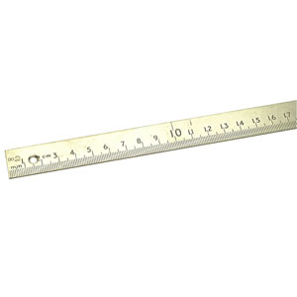
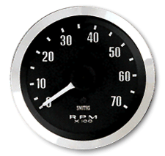
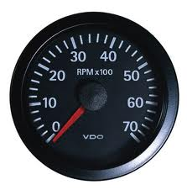
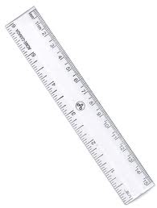
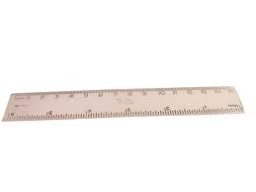
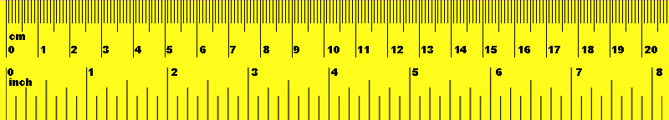
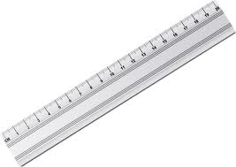
3. Gather a selection of rulers from different manufacturers. Compare their lengths. Are they all identical?
Is there any way of knowing which ruler is best (most accurate)?

Advanced Higher Physics
Uncertainties in AH Physics

A closer look at random uncertainty

Random effects

If a measurement is repeated many times, the result may not be the same each time. Small variations in the experimental conditions or differences in readings taken may result in different values being recorded.
Examples of where random uncertainty occur include:

- Using a stopwatch to measure the period of a pendulum. The reaction time of the person doing the timing may vary slightly each time.

- Measuring a force. The force applied may change slightly each time it is applied.

- Measuring the irradiance of light at distances away from the source. The distance from the light source may be measured slightly differently each time.

Random uncertainty in a mean value

Random uncertainties are equally likely to make measurements higher or lower than the true value. By repeating the measurements, the random uncertainties can be cancelled out by calculating the mean of the readings.
Suppose an experiment to determine the period of a pendulum has been repeated a number of times.

Period in seconds: 0.63, 0.59, 0.57, 0.60, 0.62, 0.59

Mean period = 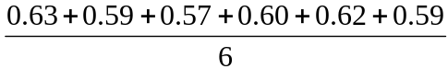

Mean period = 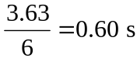

The uncertainty in this value is:

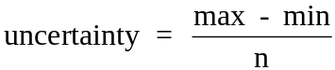

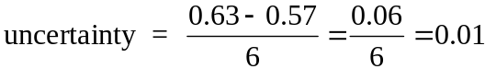

The final result is: Period = 0.60 ± 0.01 s
IMPORTANT
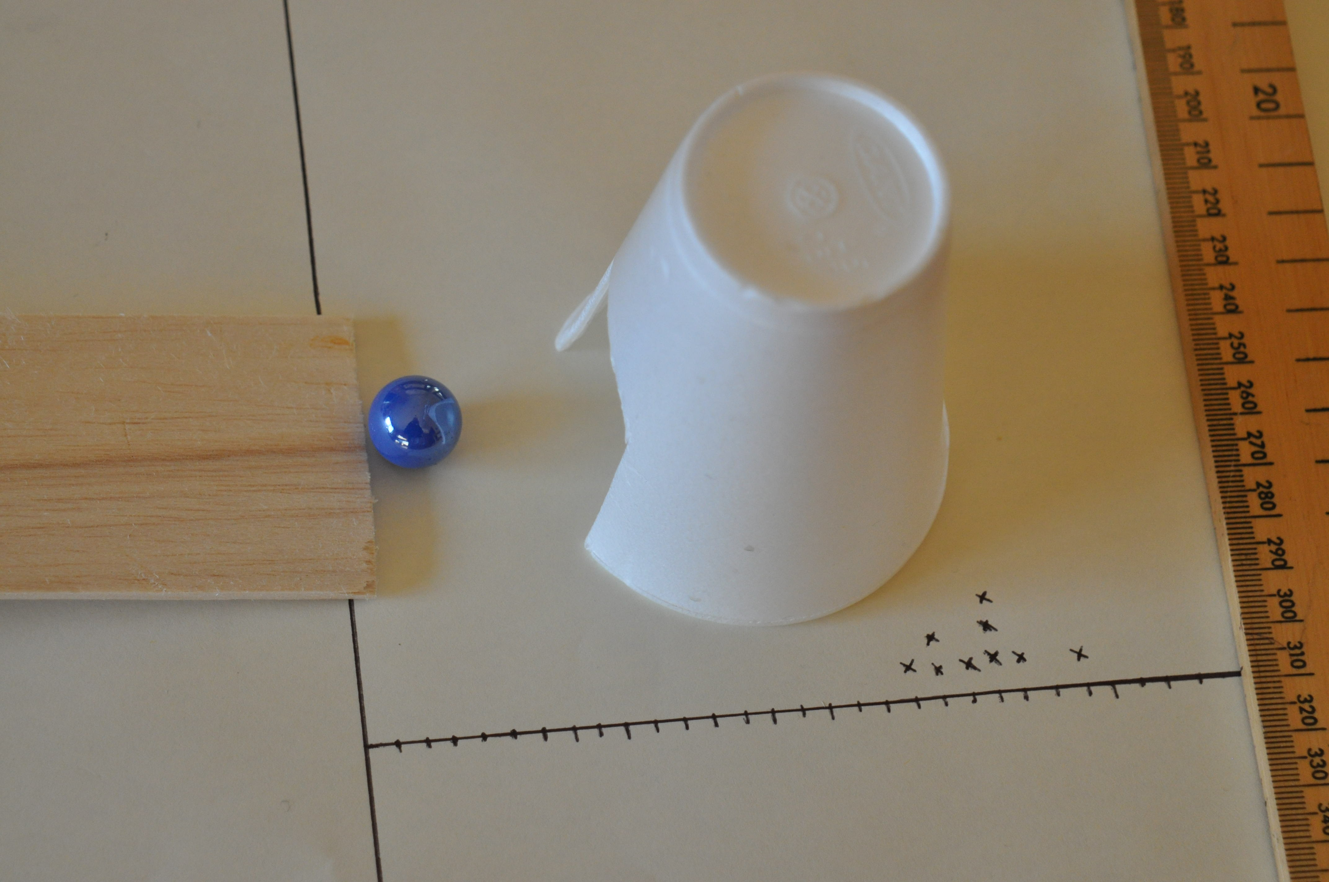
Activity

Roll a marble or ball bearing down a slope so that it collides with a polystyrene cup that has a slot cut in it. The cup gets pushed horizontally. Mark the position that the cup gets pushed to by making a cross next to the nearest line. Repeat this until a pattern of crosses is seen.
The spread of distances moved by the cup should be visible. Use the pattern to find the mean distance travelled. The maximum and minimum can be used to find the random uncertainty in this value.

Advanced Higher Physics
Uncertainties in AH Physics

A closer look at scale reading uncertainty

The digital meter shown on the right displays a voltage.
What is the uncertainty in this reading?

As a general rule, the uncertainty is taken as the smallest change that would alter the display. Usually this is the same as saying the uncertainty is 1 in the last digit of the display.

On the voltmeter shown, the display reads 12.88 V. A change of 0.01 V would change the display, so this is the uncertainty in the reading.

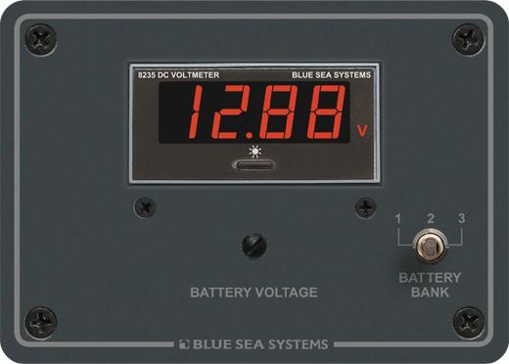
The voltage is 12.88 ± 0.01 V

The analogue ammeter shown on the right displays a current.
What is the uncertainty in this reading?

As a general rule, the uncertainty is taken as half of the smallest division on the scale.

On this ammeter, the needle is between 1.6 and 1.7 so we might reasonably estimate the current to be 1.65 A. The smallest division is 0.1 A. Half of this is 0.05 A so this is the uncertainty in the reading.

The current is 1.65 ± 0.05 A

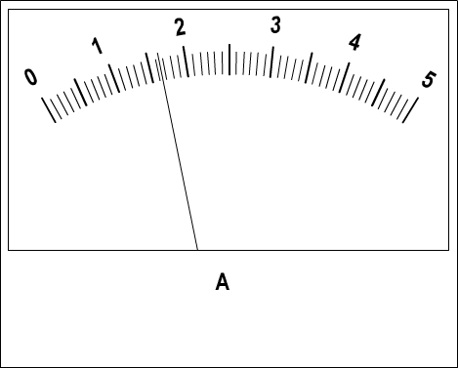
Activity

Look at each of the scales and state the reading as a value ± uncertainty.

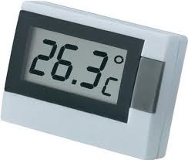
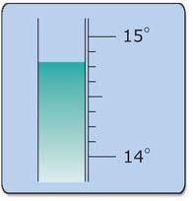
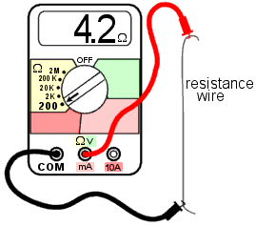
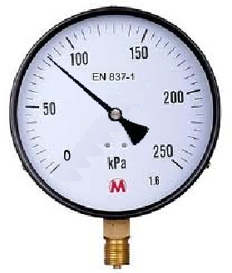
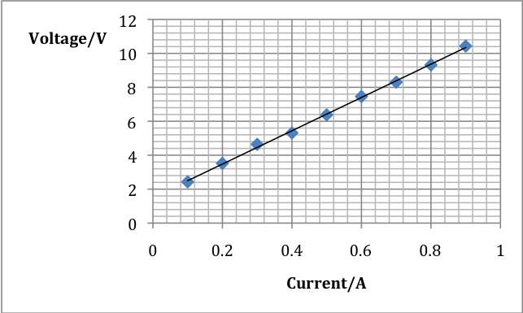

Advanced Higher Physics
Uncertainties in AH Physics

A closer look at calibration and systematic uncertainty



One example of systematic uncertainty in an experiment is using a measuring device that is not calibrated correctly. This is calibration uncertainty. Examples include:
- A meter rule that is not exactly one meter in length.
- A balance that under or over-reads mass.
- An analogue ammeter that has not had the zero correctly set will consistently read incorrectly.
- A timer that runs slowly.

Although it is true that you will occasionally use measuring devices that introduce calibration uncertainty into your results, it is much more likely that other factors have a greater effect. When evaluating your experimental procedures, try not to fall into the trap of simply stating that the experiment could have been improved by using “better equipment”.

Systematic uncertainty in experimental procedures

Systematic uncertainty occurs when there are faults in the system you use to carry out the experiment. They can be hard to spot and sometimes you may only realize that there are systematic uncertainties in your procedure when you complete your experiment.

A good way of understanding how systematic uncertainty may occur in experiments is to consider a number of examples.

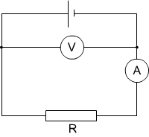
1. Determining resistance.

The voltmeter in the circuit shown measures the voltage across the supply rather than the voltage across R. The value of R determined by calculating V/I will not be the true resistance of the resistor.

2. Determining the speed of sound in air.

A loudspeaker, microphone and a computer can be used to measure the speed of sound in air. However, in the set up shown, it is likely that the sound will travel through the bench. Sound travels more quickly through a solid, so an incorrect time will be recorded by the computer.

Detecting systematic uncertainty

Systematic uncertainty may show up on a graph of results. If you expect that the graph should go through the origin and it doesn’t, then this is a sign that you have something wrong with your experimental setup and you have systematic uncertainty.
3. Determining the refractive index of a material

The refractive index of a material can be found by measuring angles of incidence and angles of refraction. These angles are measured from a line drawn at right angles to the surface of the material. If this line (the normal) is not drawn correctly, then all the measured angles will have a systematic uncertainty.

Advanced Higher Physics
Uncertainties in AH Physics

Absolute and percentage uncertainty

Absolute uncertainty

The aim of all physics investigations is to draw a valid conclusion. Before any conclusion can be considered to be valid, the uncertainty in measurements needs to be considered. If the uncertainty is large, then it is impossible to have much confidence in our results.

It is important, particularly at Advanced Higher level, to have a clear understanding of what the uncertainty is in all measurements.

The initial statement of the uncertainty in a measurement is in an absolute form. This means that the value is stated with a plus or minus indicating the range of possible values that would be possible using the instruments and techniques used in the experiment.

Examples of absolute uncertainties include:

V = 4.2 ± 0.1 V

t = 25.2 ± 0.2 s

m = 15.3 x 10³ ± 0.05 kg

Fractional and percentage uncertainty

The absolute uncertainty in a measurement does not allow us to easily compare the relative size of the uncertainties in a number of measurements. The next few pages will consider how to combine uncertainties. Before that, it is important to be able to convert absolute uncertainty into percentage uncertainty. In order to do this, it is first necessary to find the uncertainty as a fraction of the value that is measured.

In the example V = 4.2 ± 0.1 V, the fractional uncertainty is 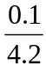 which is 0.029 (2 sig figs)

0.029 is the fractional uncertainty in the value of the potential difference V.

Fractional uncertainties are used when combining uncertainties.

In general, fractional uncertainty is given by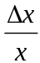 where is the absolute uncertainty in the value x.

To easily compare the magnitude of uncertainties, it is best to convert to percentage uncertainty.

The percentage uncertainty is given by 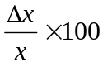

The percentage uncertainty in the value of the potential difference is 2.9%.
Activity

State the absolute, fractional and percentage uncertainty in each of the following:

I = 1.3 ± 0.2 A, T = 28.4 ± 0.1 ºC, C = 1200 ± 10 μF, r = 0.053 ± 0.001 mm, d = 1.4 x 10⁹ ± 0.1 x 10⁹ m

Which measurement has the largest percentage uncertainty?

Advanced Higher Physics
Uncertainties in AH Physics

Combining uncertainties in a measurement

Combining random, calibration and reading uncertainties

Each measurement we take is subject to a number of uncertainties. These are random, calibration and reading uncertainties. Each may have a large, small or negligible effect on the overall uncertainty in the value. They need to be added together in some way to allow a single estimate of the uncertainty in a value.

When combining random, calibration and reading uncertainties, it is not necessary to convert to fractional or percentage uncertainties.

To find the combined uncertainty find the square root of the sum of the squares of each of the uncertainties.
So, 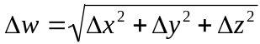 where x, y, z are the uncertainties in the values x, y, and z and w is the combined uncertainty
This is best illustrated with a number of examples.

Example 1

The mass of a metal block is measured with a digital balance which has a smallest reading of 0.01 grams. The display reads 10.42 g and the manufacturer claims the balance is accurate to within 0.005 g. One reading only is taken.

Random uncertainty = not known as only one reading has been taken.
Calibration uncertainty = 0.005g
Reading uncertainty = 0.01 g

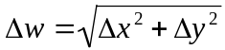
so 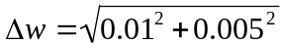
and ( to 1 sig fig)

The mass is 10.42 ± 0.02 g

(Notice that the uncertainty in the final result is given to one significant figure. Remember, uncertainties are estimates and there is no point is including meaningless significant figures)
Example 2

The period of a pendulum is measured five times and the mean period is found to be 2.12 s. The random uncertainty is calculated to be 0.01 s. The stopwatch used to time the period has an estimated calibration uncertainty of 0.05 s and the reading uncertainty is estimated at half of the smallest division which is 0.1 s.

Random uncertainty = 0.01 s
Calibration uncertainty = 0.05 s
Reading uncertainty = 0.05 s

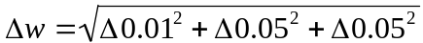

The period is 2.12 ± 0.07 s

Example 3

The length of a pendulum is measured using a steel ruler. The calibration uncertainty is 0.1 mm and the reading uncertainty is half of the smallest division which is 1 mm. The combined uncertainty is given by:

where = 0.1
and 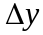 = 0.5

Notice that in this case, one uncertainty is significantly larger than the other. Its effect swamps the effect of the smaller and in this case, the smaller uncertainty can be ignored.

The uncertainty in the length of the pendulum
is ± 0.5 mm

In general, if one uncertainty is one third or less than the largest, it can be ignored.

Advanced Higher Physics
Uncertainties in AH Physics

Combining uncertainties – the rules

Uncertainties in a final result

When the measurements of an investigation are used in a calculation to find a final result, it is necessary to consider the effect of the uncertainty in each value on the final result.

Values can be added, multiplied, divided or raised to a power, or a combination of these, to find a final result. The following describes the way each arithmetic operation is handled.

Adding or subtracting values

The method for combining uncertainties for values that are added or subtracted is the same as for combining random, calibration and reading uncertainties for a single value.
The absolute uncertainty is the square root of the sum of the squares of each of the uncertainties. That is where x, y, z are the uncertainties in the values x, y, and z and w is the combined uncertainty.

Raising to a power

When raising a value by a power it is best to work with percentage uncertainties.
The percentage uncertainty in x^{n} is 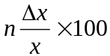 where x is the uncertainty in the value x and n is the power to which x is raised.
Once this percentage uncertainty is found, it can be converted back to absolute uncertainty.

Multiplying or dividing values

The fractional uncertainty of a result that is calculated by multiplying or dividing values is found by 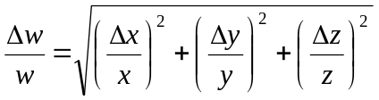
where x, y, z are the uncertainties in the values x, y, and z. w is the calculated value andw is the combined uncertainty.

Uncertainties in trigonometric functions

When an angle is measured in an investigation, it is quite common to find the sin, cos or tan of the angle. If the uncertainty in the angle is say ± 5 º, what is the uncertainty in the sin of the angle?
Trigonometric functions are non-linear i.e. doubling the angle does not double the sin of the angle. There are rigourous approaches to working with uncertainties of trigonometric functions. However, it is sufficient at AH level to simply state that the percentage uncertainty in the sin of an angle is the same as the percentage uncertainty in the angle. It is worthwhile remembering (and stating in an investigation report) that this is an approximation.
Other non-linear funtions (1/x, log, ln,
exp) may be treated in the same way.

Advanced Higher Physics
Uncertainties in AH Physics

Combining uncertainties – examples 1 and 2

Example 1 – uncertainty in a sum

The temperature of a liquid is measured to rise from T₁ = 17.5 ºC to T₂ = 24.5 ºC.

The thermometer has a reading uncertainty of 0.5ºC and an unknown calibration uncertainty. Find the uncertainty in the temperature rise T₂ - T₁.

In this case, there is no random uncertainty because each temperature has only been measured once.
Each temperature value is likely to have a calibration uncertainty. However, it is reasonable to assume that the two values of temperaure will have the same calibration uncertainty so when the values are subtracted, the two calibration uncertainties will cancel out. This means that we only need to consider reading uncertainties.

T₁ = 17.5 ± 0.5 ºC
T₂ = 24.5 ± 0.5 ºC

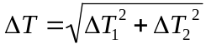

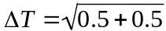

ºC

The temperature rise is 7.0 ± 0.7 ºC

(Notice that this corresponds to a 10% uncertainty in the result. This is high and is likely to make it difficult to draw a valid conclusion from this investigation. It would be better to repeat the measurements with a thermometer that had a smaller reading uncertainty.)
Example 2 – uncertainty in a value raised to a power

The speed v of a rotating object is measured to
be 2.51 ± 0.01 m s⁻¹.

Find the uncertainty in v².

v² = 6.30 m²

To find the uncertainty in v² use the relationship:

uncertainty =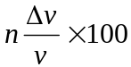

uncertainty =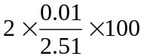

uncertainty = 0.8%

This is a percentage uncertainty.
To convert to an absolute uncertainty,
find 0.8% of 6.30. This is 0.05.

v² = 6.30 ± 0.05 m² s⁻²

Advanced Higher Physics
Uncertainties in AH Physics

Combining uncertainties – example 3

Example 3 – uncertainty when multiplying or dividing values

The centripetal force F can be found using the relationship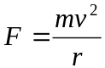where m is the mass of the rotating object, v is the speed and r is the radius.

The following values have been measured:

m = 0.0434 ± 0.0002 kg
v = 2.51 ± 0.01 m s⁻¹
r = 0.842 ± 0.002 m

Calculate the force F and determine the uncertainty in this value.

First we need to find v² and the uncertainty in v².
See example 2 on the previous page.
v² = 6.30 ± 0.05 m² s⁻²

Next find F

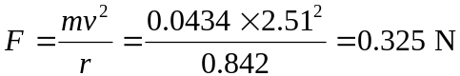

To find the uncertainty in the value of F value use the relationship

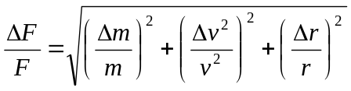

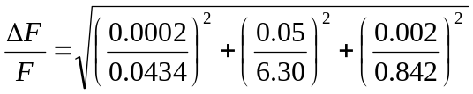

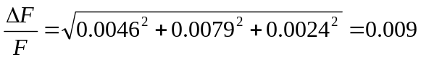

The fractional uncertainty is 0.009

The uncertainty in F is therefore 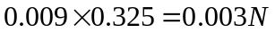

Finally we can write the value of the force F together with the uncertainty

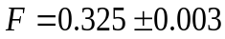 N

(Notice the significant figures in the value and the uncertainty)

Advanced Higher Physics
Uncertainties in AH Physics

Error bars

Representing uncertainty on a graph

It is very common in physics to plot graphs of variables. When the uncertainties have been estimated, it is sensible to include this information on the graph. This is done using error bars.

An error bar is a way of visually representing an uncertainty in a measurement. It is drawn so that so that the maximum and minimum values that the measurement lies within can be seen.

Error bars are useful when a graph includes a trendline (line of best fit). When a trendline is drawn, it may not go through any of the points on a graph. However, it should go through all the error bar lines. The graph below shows a trendline which goes through all the error bars except one. This suggests that something is wrong. The point could be plotted incorrectly, or a mistake was made in making the measurement. Alternatively, if the point is plotted correctly, then there is likely to be something worth investigating at the values that do not lie on the line.

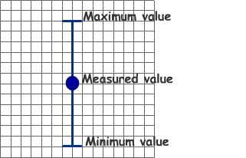
The term error bar is slightly unfortunate. In physics we try to avoid the use of the word error when we refer to uncertainties. An error is a mistake. It is something that we have done wrong. On the other hand, an uncertainty is an inevitable consequence of making a measurement. We do our best to reduce uncertainties. Despite this, the term error bar is commonly used and to put it bluntly, we are stuck with it. It may be useful to think that an error bar is a visual representation on a graph of the uncertainties in our measurements.

Error bars can be drawn to represent uncertainty in only one axis as shown, or they can represent uncertainty in both axes. The length of the two error bars may be different as shown below.

Error bars may be drawn by hand or can be generated using a spreadsheet. The graph below has been produced using Microsoft Excel and error bars have been included. The values of voltage have an uncertainty of ± 0.1 V and current has an uncertainty of ± 20 mA.

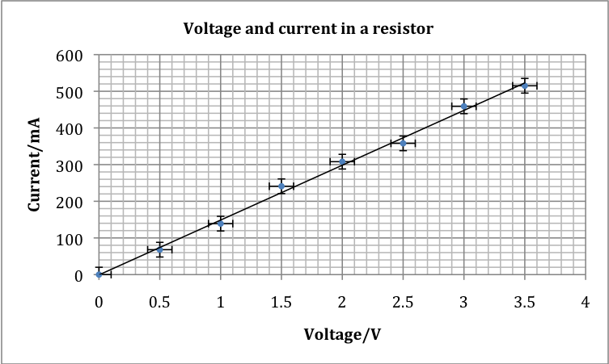
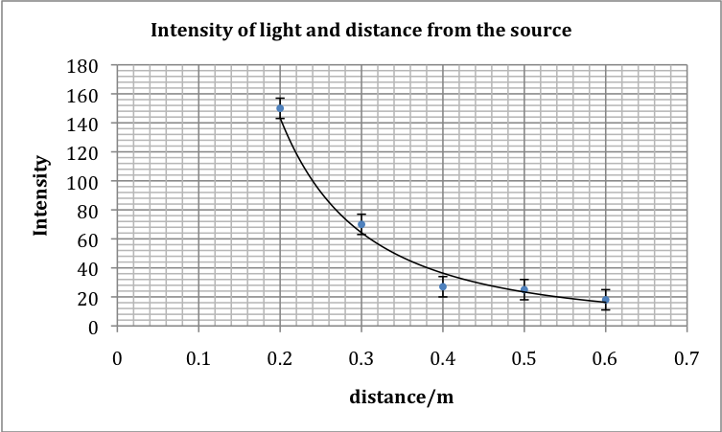
To include error bars on a graph produced by Microsoft Excel, click on the ‘Chart Tools’ tab, select the ‘Layout’ sub-tab and choose ‘Error Bars’.

Advanced Higher Physics
Uncertainties in AH Physics

Uncertainty in a gradient

The equation of a straight line

Finding the gradient of a line of best fit is a very powerful technique in physics.
For example, the gradient of a graph of voltage against current is resistance. Also, the gradient of a velocity/time graph is the acceleration.

The gradient of a straight line graph can be found using the formula 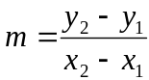.

Alternatively, if a graph has been drawn using Microsoft Excel, displaying the equation of the line is one of the options when a trendline is selected. The graph below displays the equation of the line.
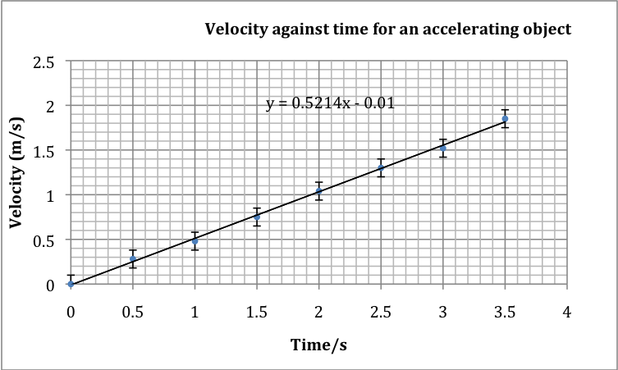
The gradient of the graph is 0.5214.
We can conclude that the acceleration of the object is 0.52 m s⁻² (2 sig figs).
The equation also indicates the point at which the graph cuts the y axis. This may be helpful in identifying systematic uncertainty.

Uncertainty in a gradient - introduction

The gradient of a graph is often used to determine a final result. The values used to plot the graph will likely have uncertainties associated with them. It therefore makes sense to consider what the uncertainty in a gradient is.

Before looking at techniques to find the uncertainty in a gradient it is necessary to consider what is meant by an uncertainty.

First, an uncertainty is an estimate. To state that the length of something is say 0.49 ± 0.1 m does not mean we are completely sure that the length is between 0.48 m and 0.50 m. There is still a chance that the true value of the length is outwith these values. However, the chance of this is small. In more advanced treatments of uncertainties, it is possible to quantify the chance of a result lying within the uncertainty. A statistical treatment allows results to be declared to be within a certain number of standard deviations (sigma). For example, the discovery of the Higgs Boson was declared to five sigma. This means that physicists could be confident of their result with 99.99997 % certainty.

It is important to recognize that there is no such thing as an absolute or true value of uncertainty. In relation to finding the uncertainty in a gradient, all we can do is apply techniques to estimate the uncertainty. The following pages describe three of these techniques. The first two have a basis in a graphical interpretation. The third is based on statistics.

Advanced Higher Physics
Uncertainties in AH Physics

Uncertainty in a gradient – worst and best fit lines

Use the error bars

Consider the following sketch of a graph.
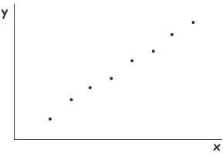
It appears that there is a linear relationship between y and x. Furthermore the constant of proportionality is the gradient. A line of best fit is included below.
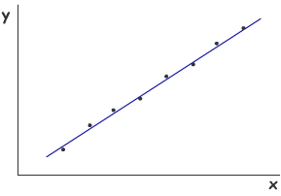
The line of best fit has been drawn by attempting to ensure that there are an equal number of points either side of the line.
The gradient m can be found using

One way of estimating the uncertainty in the gradient is to draw error bars on the graph. The graph is drawn again with these in position.
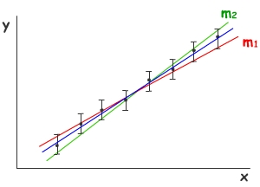
The line of best fit in the graph (at the bottom of the left column) passes through all the error bars. It is possible to draw further lines that just pass the error bars. Two lines have been added to the graph. The line with gradient m₁ shows the minimum gradient that still passes through all the error bars. The line with gradient m₂ shows the maximum gradient. By finding the gradients m₁ and m₂, the uncertainty in the gradient of the line of best fit can be estimated.
This method for estimating the uncertainty in a gradient has merit. However, there are several disadvantages.
First, it is sometimes difficult to draw lines that pass through all the error bars, especially if error bars have been drawn in both the horizontal and vertical axes.
It is also possible that the difference between the gradient of the line of best fit and m₁, and between the gradient of the line of best fit and m₂ are not equal.

Advanced Higher Physics
Uncertainties in AH Physics

Uncertainty in a gradient – parallelogram method

Find the centroid

The points on a graph can be imagined to be like masses placed on a see-saw. There is a point, called the centroid, which acts like a centre of mass. The points lie equally distributed to the left and right of the centroid. Similarly, the points are distributed equally above and below the centroid.
It is useful to find the centroid because the line of best fit will pass through it.
The centroid is found by finding the mean of all the x values of the points. This is its x co-ordinate. The y co-ordinate is found by finding the mean of all the y values.
The centroid and line of best fit are shown below.
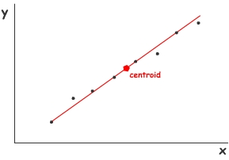
One way of estimating the uncertainty in the gradient is to draw lines parallel to the line of best fit, one above and passing through the highest point, and one below, passing through the lowest point. These have been included in the graph below.
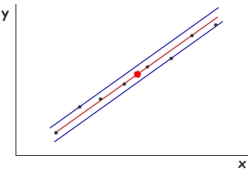
The lines can be joined as shown to form a parallelogram. This is shown below and the corners of the parallelogram have been labelled.
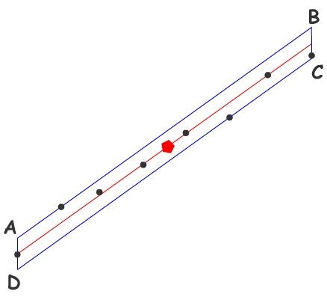
The diagonals of the parallelogram can be joined and these can be used to estimate the uncertainty in the gradient.
To do this, first find the co-ordinates of the points A, B, C and D by reading off the x and y values on the graph.
Next find the gradient of the diagonals AC and BD using .
The gradients m(AC) and m(BD) can be used to find the uncertainty m in the gradient m of the graph simply by finding the difference in the gradients of the two diagonals and dividing by two.
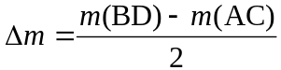

However, there is a better way of calculating the uncertainty and that is to recognise that the number of points that are plotted influences the uncertainty in the gradient. Generally, the more points that are included, the smaller is the uncertainty. This can be taken into account by using the following equation that is derived using a statistical approach. In the equation, n is the number of data points plotted on the graph.

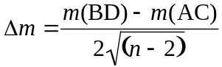

Advanced Higher Physics
Uncertainties in AH Physics

Uncertainty in a gradient – LINEST function

Statistics and Microsoft Excel

Microsoft Excel is a spreadsheet program that is commonly used to produce graphs in physics. The data that has been collected is first entered into cells to make a table of results.
One of the powerful features of a spreadsheet program is that functions can be used to process the values entered into the cells. For example, the sum of a column of values can easily be found using the function SUM. Other functions include AVERAGE, MAX and MIN. There are many other functions that can carry out statistical calculations on a table of results. One that can be used to allow us to estimate the uncertainty in a gradient is LINEST.
To learn how to use LINEST, consider the following table of results which have been entered into a spreadsheet.
Current/mA | Voltage/V
0 | 0
0.068 | 0.5
0.139 | 1.0
0.241 | 1.5
0.308 | 2.0
0.358 | 2.5
0.459 | 3.0
0.515 | 3.5

The gradient of the graph of voltage against current is V/I, which is the resistance R. LINEST can be used to determine the gradient of the line of best fit and to estimate the uncertainty in this gradient. If the LINEST function is applied to the two columns of values, it will display four values.
- The gradient of the line.
- The point at which the line intercepts the y-axis.
- The uncertainty in the gradient.
- The uncertainty in the intercept.

To display the four values using LINEST, carry out the following steps:

- Select four empty cells below the table of results (or any convenient four cells). Make sure all four cells are highlighted.
- Navigate to the LINEST function. There are a number of ways to do this.
- The simplest is to use the ‘formula builder’ window if it is available on your version of Excel.
- Alternatively, select Insert from the Tools bar, followed by Function.
- Either type in the following or use the formula builder to enter it.

=LINEST(B2:B9,A2:A9,TRUE,TRUE)
The name of the function
The cell labels for the y values.
The cell labels for the x values.
Setting this to TRUE forces the software to work out the y-axis intercept.
Setting this to TRUE ensures the uncertainty in the gradient and intercept are displayed.
Notice that the formula has to be typed in exactly as shown above.
When this has been done, hold down CTRL and SHIFT and press ENTER. (CMD +SHIFT on Apple computers). With a bit of luck (!) four values will be displayed in the four highlighted cells.

6.657005322 | 0.012521611
0.171907825 | 0.053711224

Taking into account significant figures, the resistance is 6.7 ± 0.2 Ω.

Gradient y-axis intercept
Uncertainty in gradient Uncertainty in y-axis intercept

