Cosmic Rays Answers
(Royal Society Summer Science Exhibition) We spend our lives being bombarded by sub-atomic particles. Each second, about five travel through the top of your head. Sub-atomic particles are produced in the Earth’s atmosphere by cosmic rays, which are high-energy particles that start out life in deep space.
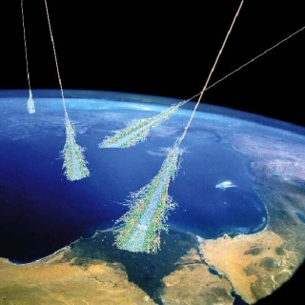
An artist's impression of cosmic rays arriving in the Earth's atmosphere. Credit: NASA
Cosmic rays were discovered 100 years ago, but their origin still remains a mystery. In 1912, Victor Hess made his discovery by taking simple radiation detectors up in a hydrogen balloon. Now these particles, their origin and their effects on Earth are studied with experiments up mountains, in space, underground and in schools.

How it works
Cosmic rays are important for understanding the energy balance of the universe and the evolution of its building blocks. They are thought to come from some of the most violent places in the universe, such as jets of material launched from black holes or the remains of supernovae explosions.
On Earth, cosmic rays almost certainly played a role when life first began and during subsequent human evolution. They may also cause lightning and might even have a role in climate change.
http://sse.royalsociety.org/2015/cosmic-ray-detectives
Science Exhibition showcases the most exciting cutting-edge UK science
Bottom of Form

- What are cosmic rays?
The term cosmic rays is not precisely defined, but a generally accepted description is ‘high energy particles arriving at the Earth which have originated elsewhere’.
- When were cosmic rays first discovered?
In the early 1900s), radiation was detected using an electroscope. However, radiation was still detected in the absence of known sources. This was background radiation. (1912 from a H₂ Balloon)
- Who first discovered cosmic rays?
Austrian physicist Victor Hess made measurements of radiation at high altitudes from a balloon, to try and get away from possible sources on Earth. He was surprised to find the measurements actually increased with altitude.
- What were cosmic rays previously called and why was the name changed?
Hess named this phenomenon cosmic radiation (later to be known as cosmic rays). Robert Millikan coined the phrase ‘cosmic rays’, believing them to be electromagnetic in nature.
- Who was awarded a Nobel Prize for his work on Cosmic Rays?
In 1936 Hess was awarded the Noble Prize for Physics for the discovery of cosmic rays.
For his Nobel lecture see: http://www.nobelprize.org/nobel_prizes/physics/laureates/1936/hess-lecture.html
- At 5000m how many more cosmic rays are detected compared with the surface of the Earth?
At an altitude of 5000 m the intensity of radiation was found to be five times that at ground level.
- Compare the energy of cosmic rays to other particles.
High energy particles. The energies of cosmic rays cover an enormous range, with the most energetic having energies much greater than those capable of being produced in current particle accelerators.
The highest energies produced in particle accelerators are of the order of 1 teraelectronvolt (10¹² eV). Cosmic rays have been observed with energies ranging from 10⁹ to 10²⁰ eV. Those with energies above 10¹⁸ eV are referred to as ultra-high-energy cosmic rays (UHECRs).
- What was thought to be the original source of cosmic rays?
It was thought this radiation was coming from the Sun, but Hess obtained the same results after repeating his experiments during a nearly complete solar eclipse (12 April 1912), thus ruling out the Sun as the (main) source of radiation.
- Why is the source of these rays so difficult to detect?
The lowest energy cosmic rays come from the Sun and the intermediate energy ones are presumed to be created within our galaxy, often in connection with supernovae. The main astrophysics (rather than particle physics) to come from the study of cosmic rays concerns supernovae since they are believed to be the main source of cosmic rays.

However, the origin of the highest energy cosmic rays is still uncertain. Active galactic nuclei (AGN) are thought to be the most likely origin for UHECRs. A group of cosmologists are working on the statistical analysis of apparent associations between the incoming direction of the highest energy cosmic rays and active galaxies.
Later experiments have helped to identify the sources of cosmic rays with greater certainty. In 2009, a paper presented at the International Cosmic Ray Conference (ICRC) by scientists at the Pierre Auger Observatory showed ultra-high energy cosmic rays (UHECRs) originating from a location in the sky very close to the radio galaxy Centaurus A, although the authors specifically stated that further investigation would be required to confirm Cen A as a source of cosmic rays.[39] However, no correlation was found between the incidence of gamma-ray bursts and cosmic rays, causing the authors to set upper limits as low as 3.4 × 10−6 erg cm−2 on the flux of 1 GeV-1 TeV cosmic rays from gamma-ray bursts.[40]
In 2009, supernovae were said to have been "pinned down" as a source of cosmic rays, a discovery made by a group using data from the Very Large Telescope.[41] This analysis, however, was disputed in 2011 with data from PAMELA, which revealed that "spectral shapes of [hydrogen and helium nuclei] are different and cannot be described well by a single power law", suggesting a more complex process of cosmic ray formation.[42] In February 2013, though, research analyzing data from Fermi revealed through an observation of neutral pion decay that supernovae were indeed a source of cosmic rays, with each explosion producing roughly 3 × 1042 - 3 × 1043 J of cosmic rays.[2][3] However, supernovae do not produce all cosmic rays, and the proportion of cosmic rays that they do produce is a question which cannot be answered without further study.[
- What forms the largest proportion of cosmic rays?

Protons at 89%
Nature | Approximate percentage of all cosmic rays
Protons | 89
Alpha particles | 9
Carbon, nitrogen and oxygen nuclei | 1
Electrons | less than 1
Gamma radiation | less than 0.1

- What is the difference between primary and secondary cosmic rays?
Primary cosmic rays are cosmic rays that arrive at the edge of our atmosphere. Secondary CR are those that have interacted with particles in our atmosphere and the decay products. Secondary CR have lower energies than primary CR.
- Record some decay series of cosmic rays from their arrival in the Earth’s atmosphere until they totally decay or reach the Earth’s surface.

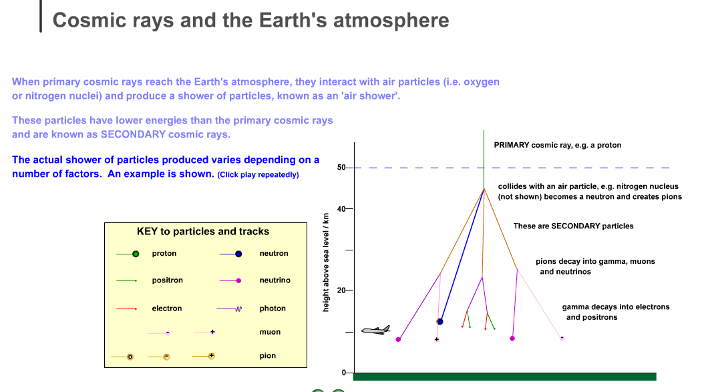

- What is the likely source of origin of the least energetic cosmic rays?
The Sun (our Sun)
- What is the term given to cosmic rays as they decay and pass through the Earth’s atmosphere?
Secondary CR
- How are primary cosmic rays detected?
From satellites above the atmosphere before they’ve interacted with particles in the atmosphere.
- How are cosmic rays detected in the school lab?
Cloud Chamber or **?
- What is the OMG particle?
The ‘Oh-my-God’ (OMG) particle with energy of 3 × 1020 eV was recorded in Utah in 1991.
Converting to joules (J), 3 × 10²⁰ eV = 3 × 10²⁰ × 1.6 × 10^{–19} J = 48 J, ie ~50 J.
That is enough energy to throw a throw a 25kg mass (eg a bag of cement) 2 m vertically upwards. It is also approximately equal to the kinetic energy of a tennis ball returned at about 100 mph by, say, Andy Murray.
Order of magnitude open-ended question opportunity here:
mass = 60 g = 0.06 kg, speed = 45 m s^{–1},
kinetic energy = 0.5 × 0.06 × 45 × 45 = 60 J
The OMG particle was probably a proton and as such had about 40 million times the energy of the most energetic protons ever produced in an Earth-based particle accelerator!
See: http://en.wikipedia.org/wiki/Ultra-high-energy_cosmic_ray
- List the particles that are produced as the cosmic rays pass through the atmosphere. Refer to the Standard Model and ensure you are aware how each of these interactions occur. You could be asked to describe some of these in an exam question.
- What is Cherenkov radiation and how does it relate to cosmic rays?
https://www.youtube.com/watch?v=_Kf2f_9MfPc
https://www.youtube.com/watch?v=VNv0Yzk00qg

- Describe how the Pierre Auger observatory detects high energy cosmic rays

See the main Auger observatory home page:
http://www.auger.org/

For information about the detector see:
http://www.auger.org/cosmic_rays/detector.html

and for an animation of an air shower see:
http://www.auger.org/features/shower_simulations.html

The next proposed ‘big thing’ in ground-based cosmic ray detection is the Cherenkov Telescope Array (CTA), which should be operational within the next decade. See: http://www.cta-observatory.org/.

Cherenkov radiation – the radiation that causes the characteristic blue colour in nuclear reactors. (This is a bit like the optical equivalent of a sonic boom.)
http://imagine.gsfc.nasa.gov/docs/science/how_l2/cerenkov.html

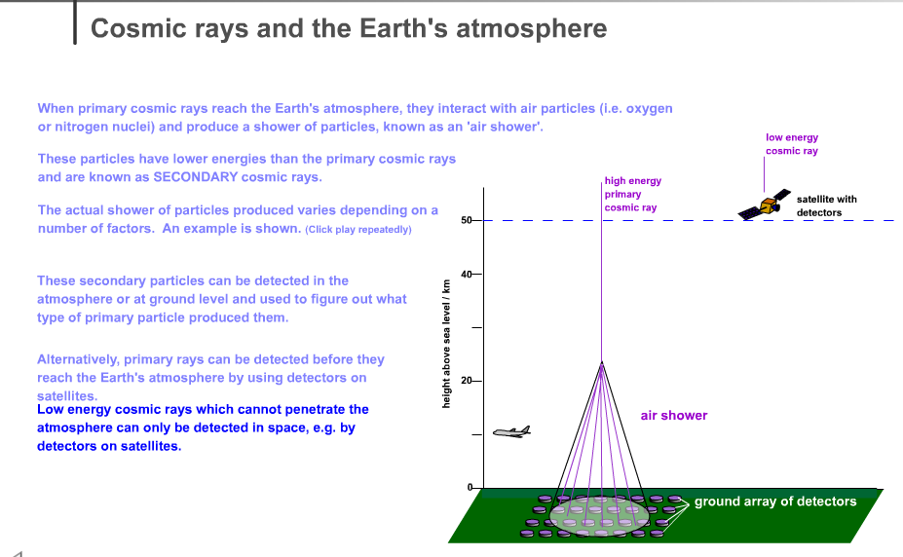

Cosmic 100 Royal Society Summer Science Exhibition 2011
http://sse.royalsociety.org/2012/exhibits/cosmic-100/

Dr Sean Paling
Head of Boulby Underground Laboratory, Science and Technology Facilities Council
Presented by University of Birmingham, School of Physics and Astronomy, Boulby Underground Laboratory, University of Bristol, School of Physics, The Cerenkov Telescope Array, Durham University, Department of Physics, Highgate School , Ilford County High School, Essex, King’s College, London, Department of Physics, University of Leeds, School of Physics and Astronomy, Prior Pursglove College, University of Sheffield, Department of Physics and Astronomy and Simon Langton Grammar School for Boys, Canterbury
Professor Alan Watson
Professor of Physics, University of Leeds
- Auger Collaboration. 2010 Update on the correlation of the highest energy cosmic rays with nearby extragalactic matter. Astroparticle Physics 34, 314-326
- Erlykin AD, Wolfendale AW. 2010 Long Term Time Variability of Cosmic Rays and Possible Relevance to the Development of Life on Earth. Surv. Geophys. 31, 383-398
- Aharonian et al. (HESS Collaboration). 2011 Primary particle acceleration above 100 TeV in the shell-type supernova remnant RX J1713.7 - 3946 with deep H.E.S.S. observations. Astron. Astrophys. 531, id.C1
We spend our lives being bombarded by sub-atomic particles. Each second, about five travel through the top of your head. Sub-atomic particles are produced in the Earth’s atmosphere by cosmic rays, which are high-energy particles that start out life in deep space.
An artist's impression of cosmic rays arriving in the Earth's atmosphere. Credit: NASA
Cosmic rays were discovered 100 years ago, but their origin still remains a mystery. In 1912, Victor Hess made his discovery by taking simple radiation detectors up in a hydrogen balloon. Now these particles, their origin and their effects on Earth are studied with experiments up mountains, in space, underground and in schools.

How it works
Cosmic rays are important for understanding the energy balance of the universe and the evolution of its building blocks. They are thought to come from some of the most violent places in the universe, such as jets of material launched from black holes or the remains of supernovae explosions.
On Earth, cosmic rays almost certainly played a role when life first began and during subsequent human evolution. They may also cause lightning and might even have a role in climate change.
The Royal Society Summer Science Exhibition showcases the most exciting cutting-edge UK science
Bottom of Form

