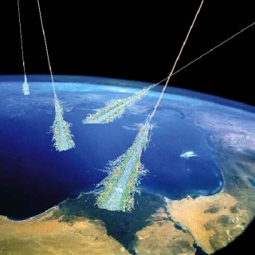
Cosmic Rays
We spend our lives being bombarded by sub-atomic particles. Each second, about five travel through the top of your head. Sub-atomic particles are produced in the Earth’s atmosphere by cosmic rays.

- What are cosmic rays?
- When were cosmic rays first discovered?
- Who first discovered cosmic rays?
- What were cosmic rays previously called and why was the name changed?
- Who was awarded a Nobel Prize for his work on Cosmic Rays?
- At 5000m how many more cosmic rays are detected compared with the surface of the Earth?
- Compare the energy of cosmic rays to other particles.
- What was thought to be the original source of cosmic rays?
- Why is the source of these rays so difficult to detect?
- What forms the largest proportion of cosmic rays?
- What is the difference between primary and secondary cosmic rays?
- Record some decay series of cosmic rays from their arrival in the Earth’s atmosphere until they totally decay or reach the Earth’s surface.
- What is the likely source of origin of the least energetic cosmic rays?
- What is the term given to cosmic rays as they decay and pass through the Earth’s atmosphere?
- How are primary cosmic rays detected?
- How are cosmic rays detected in the school lab?
- What is the OMG particle?
- List the particles that are produced as the cosmic rays pass through the atmosphere. Refer to the Standard Model and ensure you are aware how each of these interactions occur. You could be asked to describe some of these in an exam question.
- What is Cherenkov radiation and how does it relate to cosmic rays?
- Describe how the Pierre Auger observatory detects high energy cosmic rays

