Quantum Mechanics
http://particleadventure.org/other/history/smt.html
At the start of the twentieth century, scientists believed they understood the most fundamental principles of nature. Atoms were solid building blocks of nature; people trusted Newtonian laws of motion; most of the problems of physics seemed to be solved. However, starting with Einstein's theory of relativity which replaced Newtonian mechanics, scientists gradually realized that their knowledge was far from complete.
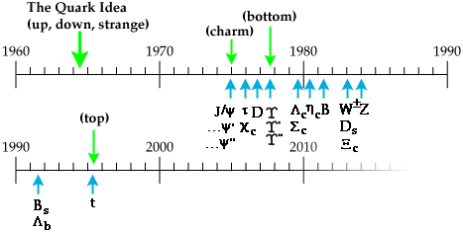

Of particular interest was the growing field of quantum mechanics, which completely altered the fundamental precepts of physics. By the mid-1960's, physicists realized that their previous understanding, where all matter is composed of the fundamental protons, neutrons, and electron, was insufficient to explain the myriad new particles being discovered. Gell-Mann's and Zweig's quark theory solved these problems. Over the last thirty years, the theory that is now called the Standard Model of particles and interactions has gradually grown and gained increasing acceptance with new evidence from new particle accelerators.
It is not necessary to learn the dates and experiments or theories / discoveries. It is to put everything into context.
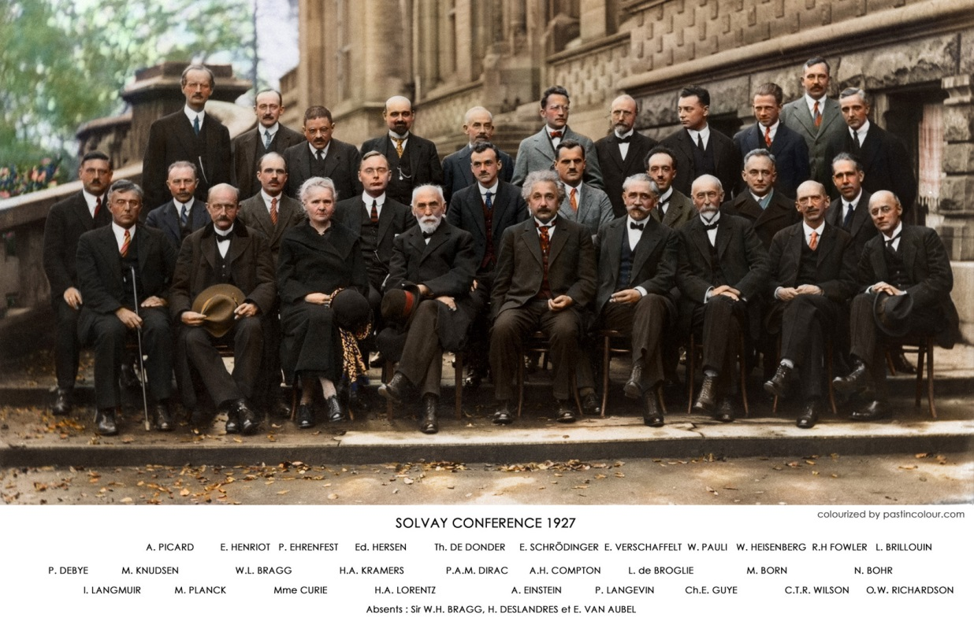
Date | Experimental Observation /Discovery / Theory
1900 | Max Planck suggests that radiation is quantized (it comes in discrete amounts.)  https://www.youtube.com/watch?v=i1TVZIBj7UA
1905 | Albert Einstein, one of the few scientists to take Planck's ideas seriously, proposes a quantum of light (the photon) which behaves like a particle. Einstein's other theories explained the equivalence of mass and energy, the particle-wave duality of photons, the equivalence principle, and special relativity.
1909 | Hans Geiger and Ernest Marsden, under the supervision of Ernest Rutherford, scatter alpha particles off a gold foil and observe large angles of scattering, suggesting that atoms have a small, dense, positively charged nucleus.
1911 | Ernest Rutherford infers the nucleus as the result of the alpha-scattering experiment performed by Hans Geiger and Ernest Marsden.
1912 | Albert Einstein explains the curvature of space-time.
1913 | Niels Bohr succeeds in constructing a theory of atomic structure based on quantum ideas.
1919 | Ernest Rutherford finds the first evidence for a proton.
1921 | James Chadwick and E.S. Bieler conclude that some strong force holds the nucleus together.
1923 | Arthur Compton discovers the quantum (particle) nature of x rays, thus confirming photons as particles.
1924 | Louis de Broglie proposes that matter has wave properties.
1925 (Jan) | Wolfgang Pauli formulates the exclusion principle for electrons in an atom.
1925 (April) | Walther Bothe and Hans Geiger demonstrate that energy and mass are conserved in atomic processes.
1926 | Erwin Schroedinger develops wave mechanics, which describes the behaviour of quantum systems for bosons. Max Born gives a probability interpretation of quantum mechanics. G.N. Lewis proposes the name "photon" for a light quantum.
1927 | Certain materials had been observed to emit electrons (beta decay). Since both the atom and the nucleus have discrete energy levels, it is hard to see how electrons produced in transition could have a continuous spectrum (see 1930 for an answer.)
1927 | Werner Heisenberg formulates the uncertainty principle: the more you know about a particle's energy, the less you know about the time of the energy (and vice versa.) The same uncertainty applies to momenta and coordinates.
1928 | Paul Dirac combines quantum mechanics and special relativity to describe the electron.
1930 | Quantum mechanics and special relativity are well established. There are just three fundamental particles: protons, electrons, and photons. Max Born, after learning of the Dirac equation, said, "Physics as we know it will be over in six months."
1930 | Wolfgang Pauli suggests the neutrino to explain the continuous electron spectrum for beta decay.
1931 | Paul Dirac realizes that the positively-charged particles required by his equation are new objects (he calls them "positrons"). They are exactly like electrons, but positively charged. This is the first example of antiparticles.
1931 | James Chadwick discovers the neutron. The mechanisms of nuclear binding and decay become primary problems.
1933-34 | Enrico Fermi puts forth a theory of beta decay that introduces the weak interaction. This is the first theory to explicitly use neutrinos and particle flavor changes.
1933-34 | Hideki Yukawa combines relativity and quantum theory to describe nuclear interactions by an exchange of new particles (mesons called "pions") between protons and neutrons. From the size of the nucleus, Yukawa concludes that the mass of the conjectured particles (mesons) is about 200 electron masses. This is the beginning of the meson theory of nuclear forces.
1937 | A particle of 200 electron masses is discovered in cosmic rays. While at first physicists thought it was Yukawa's pion, it was later discovered to be a muon.
1938 | E.C.G. Stückelberg observes that protons and neutrons do not decay into any combination of electrons, neutrinos, muons, or their antiparticles. The stability of the proton cannot be explained in terms of energy or charge conservation; he proposes that heavy particles are independently conserved.
1941 | C. Moller and Abraham Pais introduce the term "nucleon" as a generic term for protons and neutrons.
1946-47 | Physicists realize that the cosmic ray particle thought to be Yukawa's meson is instead a "muon," the first particle of the second generation of matter particles to be found. This discovery was completely unexpected -- I.I. Rabi comments "who ordered that?" The term "lepton" is introduced to describe objects that do not interact too strongly (electrons and muons are both leptons).
1947 | A meson that does interact strongly is found in cosmic rays, and is determined to be the pion.
1947 | Physicists develop procedures to calculate electromagnetic properties of electrons, positrons, and photons. Introduction of Feynman diagrams.
1948 | The Berkeley synchro-cyclotron produces the first artificial pions.
1949 | Enrico Fermi and C.N. Yang suggest that a pion is a composite structure of a nucleon and an anti-nucleon. This idea of composite particles is quite radical.
1949 | Discovery of K⁺ via its decay.
1950 | The neutral pion is discovered.
1951 | Two new types of particles are discovered in cosmic rays. They are discovered by looking a V-like tracks and reconstructing the electrically-neutral object that must have decayed to produce the two charged objects that left the tracks. The particles were named the lambda⁰ and the K⁰.
1952 | Discovery of particle called delta: there were four similar particles (delta⁺⁺, delta⁺, delta⁰, and delta⁻.)
1952 | Donald Glaser invents the bubble chamber. The Brookhaven Cosmotron, a 1.3 GeV accelerator, starts operation.
1953 | The beginning of a "particle explosion" -- a true proliferation of particles.
1953 - 57 | Scattering of electrons off nuclei reveals a charge density distribution inside protons, and even neutrons. Description of this electromagnetic structure of protons and neutrons suggests some kind of internal structure to these objects, though they are still regarded as fundamental particles.
1954 | C.N. Yang and Robert Mills develop a new class of theories called "gauge theories." Although not realized at the time, this type of theory now forms the basis of the Standard Model.
1957 | Julian Schwinger writes a paper proposing unification of weak and electromagnetic interactions.
1957-59 | Julian Schwinger, Sidney Bludman, and Sheldon Glashow, in separate papers, suggest that all weak interactions are mediated by charged heavy bosons, later called W⁺ and W⁻. Actually, it was Yukawa who first discussed boson exchange twenty years earlier, but he proposed the pion as the mediator of the weak force.
1961 | As the number of known particles keep increasing, a mathematical classification scheme to organize the particles (the group SU(3)) helps physicists recognize patterns of particle types.
1962 | Experiments verify that there are two distinct types of neutrinos (electron and muon neutrinos). This was earlier inferred from theoretical considerations.
1964 | Murray Gell-Mann and George Zweig tentatively put forth the idea of quarks. They suggested that mesons and baryons are composites of three quarks or antiquarks, called up, down, or strange (u, d, s) with spin 0.5 and electric charges 2/3, -1/3, -1/3, respectively (it turns out that this theory is not completely accurate). Since the charges had never been observed, the introduction of quarks was treated more as a mathematical explanation of flavour patterns of particle masses than as a postulate of actual physical object. Later theoretical and experimental developments allow us to now regard the quarks as real physical objects, even though they cannot be isolated.
1964 | Since leptons had a certain pattern, several papers suggested a fourth quark carrying another flavour to give a similar repeated pattern for the quarks, now seen as the generations of matter. Very few physicists took this suggestion seriously at the time. Sheldon Glashow and James Bjorken coin the term "charm" for the fourth (c) quark.
1965 | O.W. Greenberg, M.Y. Han, and Yoichiro Nambu introduce the quark property of colour charge. All observed hadrons are colour neutral.
...1966... | The quark model is accepted rather slowly because quarks hadn't been observed.
1967 | Steven Weinberg and Abdus Salam separately propose a theory that unifies electromagnetic and weak interactions into the electroweak interaction. Their theory requires the existence of a neutral, weakly interacting boson (now called the Z₀) that mediates a weak interaction that had not been observed at that time. They also predict an additional massive boson called the Higgs Boson that has not yet been observed.
1968-69 | At the Stanford Linear Accelerator, in an experiment in which electrons are scattered off protons, the electrons appear to be bouncing off small hard cores inside the proton. James Bjorken and Richard Feynman analyse this data in terms of a model of constituent particles inside the proton (they didn't use the name "quark" for the constituents, even though this experiment provided evidence for quarks.)
1970 | Sheldon Glashow, John Iliopoulos, and Luciano Maiani recognize the critical importance of a fourth type of quark in the context of the Standard Model. A fourth quark allows a theory that has flavor-conserving Z0-mediated weak interactions but no flavour-changing ones.
1973 | Donald Perkins, spurred by a prediction of the Standard Model, re-analyses some old data from CERN and finds indications of weak interactions with no charge exchange (those due to a Z₀ exchange.)
1973 | A quantum field theory of strong interaction is formulated. This theory of quarks and gluons (now part of the Standard Model) is similar in structure to quantum electrodynamics (QED), but since strong interaction deals with colour charge this theory is called quantum chromodynamics (QCD). Quarks are determined to be real particles, carrying a colour charge. Gluons are massless quanta of the strong-interaction field. This strong interaction theory was first suggested by Harald Fritzsch and Murray Gell-Mann.
1973 | David Politzer, David Gross, and Frank Wilczek discover that the colour theory of the strong interaction has a special property, now called "asymptotic freedom." The property is necessary to describe the 1968-69 data on the substrate of the proton.
1974 | In a summary talk for a conference, John Iliopoulos presents, for the first time in a single report, the view of physics now called the Standard Model. If you want to understand the various aspects of the Standard Model, please explore the Standard Model Path.
1974 (Nov.) | Burton Richter and Samuel Ting, leading independent experiments, announce on the same day that they discovered the same new particle. Ting and his collaborators at Brookhaven called this particle the "J" particle, whereas Richter and his collaborators at SLAC called this particle the psi particle. Since the discoveries are given equal weight, the particle is commonly known as the J/psi particle. The J/psi particle is a charm-anticharm meson.
1976 | Gerson Goldhaber and Francois Pierre find the D₀ meson (anti-up and charm quarks). The theoretical predictions agreed dramatically with the experimental results, offering support for the Standard Model.
1976 | The tau lepton is discovered by Martin Perl and collaborators at SLAC. Since this lepton is the first recorded particle of the third generation, it is completely unexpected.
1977 | Leon Lederman and his collaborators at Fermilab discover yet another quark (and its antiquark). This quark was called the "bottom" quark. Since physicists figured that quarks came in pairs, this discovery adds impetus to search for the sixth quark -- "top."
1978 | Charles Prescott and Richard Taylor observe a Z₀ mediated weak interaction in the scattering of polarized electrons from deuterium which shows a violation of parity conservation, as predicted by the Standard Model, confirming the theory's prediction.
1979 | Strong evidence for a gluon radiated by the initial quark or antiquark if found at PETRA, a colliding beam facility at the DESY laboratory in Hamburg,
1983 | The W± and Z₀ intermediate bosons demanded by the electroweak theory are observed by two experiments using the CERN synchrotron using techniques developed by Carlo Rubbia and Simon Van der Meer to collide protons and antiprotons.
1989 | Experiments carried out in SLAC and CERN strongly suggest that there are three and only three generations of fundamental particles. This is inferred by showing that the Z₀-boson lifetime is consistent only with the existence of exactly three very light (or massless) neutrinos.
1995 | After eighteen years of searching at many accelerators, the CDF and D0 experiments at Fermilab discover the top quark at the unexpected mass of 175 GeV. No one understands why the mass is so different from the other five quarks.
2012 | Almost half a century after Peter Higgs predicted a Higgs boson as part of a mechanism (invented by a number of theorists) by which fundamental particles gain mass, the ATLAS and CMS experiments at the CERN lab discover the Higgs boson.
Newton’s laws (now known as classical physics) are successful at explaining much of the Earth’s observations. However, there were a few discrepancies that didn’t seem to fit the rules, for example in the orbit of mercury. Einstein’s theories of Relativity explained the observed discrepancies. It is not to say that Newton’s laws are no longer valid, but that they have their limitations. They are very successful at explaining the large scale and objects travelling at non relativistic speeds.
Quantum theory developed due to some key experiments for which the classical model did not fit the data.
The key experiments were
- The shape of the black-body radiation spectrum (explained by Planck but theorised by Einstein)- the UV catastrophe of Rayleigh and Jeans https://www.youtube.com/watch?v=Ex8EvBTk9LY
https://www.youtube.com/watch?v=e5_V78SWGF0
https://www.youtube.com/watch?v=FlIrgE5T_g0

- The photoelectric effect (explained by Einstein) the production of a free electron, from the surface of a metal when e-m radiation of sufficiently high frequency is incident on it. If light was a wave then high intensity low frequency radiation should be able to provide the energy to release electrons
- Line emission spectra (explained by Bohr for Hydrogen). In 1911 Rutherford put forward his model of the atom as a central massive positive nucleus, with large amounts of empty space in which the small negative electrons can be found. He proposed that the electrons are held in place by the electrostatic attraction between the electron and nucleus providing the central force. However, classical physics would suggest that any accelerating charge would emit radiation. As circular motion is an acceleration the electron would lose energy and spiral into the nucleus. Dane, Neils Bohr felt that the line spectra produced by Hydrogen that various people had devised equations to calculate the wavelength of these lines was related to the atomic structure and that E=hf was significant. He postulated that electrons are held within orbits and that radiation is emitted when an electron moved to a lower orbit. He also postulated that angular momentum L of an electron is quantised. The stable orbits for the angular momentum of an electron are in multiples of $=\frac{h}{2π}$.
$$L=mvr=\frac{nh}{2π}$$
Where mvr is the angular momentum of the electron and n is an integer
This was a major advance allowing Bohr to produce an energy level diagram based on the physical orbits and quantisation of angular momentum, but only gives the energy levels to match H atom and an ionised He atom

Blackbody radiation
Here are some experimental facts about blackbody radiation:
a. The blackbody spectrum depends only on the temperature of the object, and not on what it is made of. An iron horseshoe, a ceramic vase, and a piece of charcoal --- all emit the same blackbody spectrum if their temperatures are the same.
b. As the temperature of an object increases, it emits more blackbody energy at all wavelengths.
c. As the temperature of an object increases, the peak wavelength of the blackbody spectrum becomes shorter (bluer). For example, blue stars are hotter than red stars.
d. The blackbody spectrum always becomes small at the left-hand side (the short wavelength, high frequency side).
The explanation of classical physics: Light is an electromagnetic wave that is produced when an electric charge vibrates. (Strictly speaking, "vibrates" means any change in how the charge moves --- speeding up, slowing down, or changing direction.) Now recall that heat is just the kinetic energy of random motion. In a hot object, electrons vibrate in random directions and produce light as a result. A hotter object means more energetic vibrations and so more light is emitted by a hotter object --- it glows brighter. So far, so good. But classical physics could not explain the shape of the blackbody spectrum.
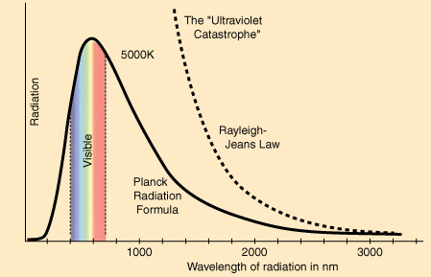
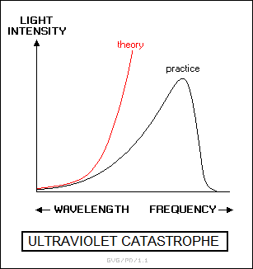
The electrons in a hot object can vibrate with a range of frequencies, ranging from very few vibrations per second to a huge number of vibrations per second. In fact, there is no limit to how great the frequency can be. Classical physics said that each frequency of vibration should have the same energy. Since there is no limit to how great the frequency can be, there is no limit to the energy of the vibrating electrons at high frequencies. This means that, according to classical physics, there should be no limit to the energy of the light produced by the electrons vibrating at high frequencies. WRONG!! Experimentally, the blackbody spectrum always becomes small at the left-hand side (short wavelength, high frequency).

At about 1900, Max Planck came up with the solution. He proposed that the classical idea that each frequency of vibration should have the same energy must be wrong. Instead, he said that energy is not shared equally by electrons that vibrate with different frequencies. Planck said that energy comes in clumps. He called a clump of energy a quantum. The size of a clump of energy --- a quantum --- depends on the frequency of vibration. Here is Planck's rule for the a quantum of energy for a vibrating electron:
energy of a quantum = (a calibration constant) x (frequency of vibration)
or E = hf
where h, the calibration constant, is today called Planck's constant. Its value is about 663 x 10⁻³⁴, very tiny!
So how does this explain the spectrum of blackbody radiation? Planck said that an electron vibrating with a frequency f could only have an energy of 1 hf, 2 hf, 3 hf, 4 hf, ... ; that is, energy of vibrating electron = (any integer) × hf
But the electron has to have at least one quantum of energy if it is going to vibrate. If it doesn't have at least an energy of 1hf, it will not vibrate at all and can't produce any light. "A ha!" said Planck: at high frequencies the amount of energy in a quantum, hf, is so large that the high-frequency vibrations can never get going! This is why the blackbody spectrum always becomes small at the left-hand (high frequency) side.
2. The Photoelectric Effect
When light shines on the surface of a metallic substance, electrons in the metal absorb the energy of the light and they can escape from the metal's surface. This is called the photoelectric effect, and it is used to produce the electric current that runs many solar-powered devices. Using the idea that light is a wave with the energy distributed evenly throughout the wave, classical physicists expected that when using very dim light, it would take some time for enough light energy to build up to eject an electron from a metallic surface. WRONG!! Experiments show that if light of a certain frequency can eject electrons from a metal, it makes no difference how dim the light is. There is never a time delay.
In 1905, Albert Einstein came up with the solution. If Max Planck's idea that energy comes in clumps (quanta) is correct, then light must consist of a stream of clumps of energy. Each clump of light energy is called a photon, said Einstein, and each photon has an energy equal to hf (Planck's constant times the frequency of the light). Therefore the energy of light is not evenly distributed along the wave, but is concentrated in the photons. A dimmer light means fewer photons, but simply turning down the light (without changing its frequency) does not alter the energy of an individual photon. So for a specific frequency light, if a single photon has enough energy to eject an electron from a metallic surface, then electrons will always be ejected immediately after the light is turned on and the photons hit the metal.
3. The Hydrogen Atom
When a small tube of hydrogen gas is heated, it begins to glow and emit light. Unlike the blackbody radiation that comes from a hot dense solid or gas, this light consists of just a few colors (wavelengths): a red wavelength, a turquoise, and several violets. Classical physicists at the beginning of the century thought they should certainly be able to understand hydrogen, since it is the simplest atom. Hydrogen consists of a positively charged proton at the centre, with a negatively charged electron orbiting around it. The electrical attraction between the positive proton and the negative electron keeps the electron in orbit, just like the gravitational attraction between the Sun and the Earth holds the Earth in orbit. According to Rutherford's theory, electrons could orbit the nucleus at any distance. When the electrons circle round the nucleus, they are constantly changing their direction. According to classical electrodynamics (which deals with the motion of electrons), such electrons which either constantly change their direction or their velocity or both should continuously emit radiation. While doing so, they should lose energy, and thus spiral into the nucleus. This means every atom is unstable, quite contrary to our observation! In fact, physicists calculated that the electron should lose all of its energy and spiral down into the proton in only about 0.000000000001 second! In other words, atoms should not exist longer than a mere 10⁻¹² seconds. WRONG!!
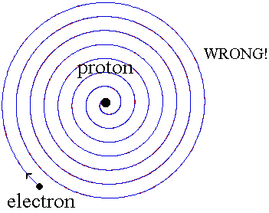
Niels Bohr provided an explanation in 1913. In the Bohr model of the hydrogen atom, the electron can't orbit the proton in any size orbit it pleases. There are only certain allowed orbits, and each allowed orbit has a certain radius and a certain energy. Bohr invented a rule that allowed him to calculate the size and energy of each orbit. If you are curious, Bohr's rule said that

2π × (electron mass) × (electron orbital speed) × (orbit radius) = (any integer) × h
which is not too obvious, to say the least! (The integer would be 1 for the smallest orbit, 2 for the next orbit out, and so on.) Bohr also made up a new rule to explain the stability of the hydrogen atom --- why it could last longer than 0.000000000001 second. He said that when an electron is in an allowed orbit, the electron will not produce electromagnetic radiation. Bohr did not explain why, he just proposed a new law of nature. And nature agreed with Niels Bohr. His new model of hydrogen gave wavelengths for hydrogen gas that precisely agreed with what was measured.
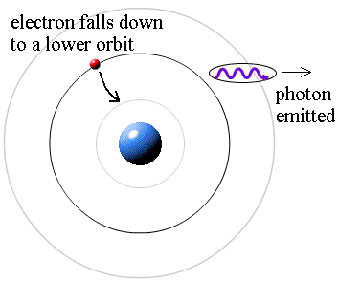
Question: If the electrons do not produce light when they are in their allowed stable orbits, where is the source of the light that comes from hydrogen? Answer: According to Bohr, electrons have more energy when they are in larger orbits. If an electron falls from a larger orbit down to a smaller orbit, it loses energy. According to the law of conservation of energy, the energy lost by the electron must go somewhere. Bohr explained that a photon carries away the lost energy from the hydrogen atom; that is,

photon energy = (electron energy in larger orbit) - (electron energy in smaller orbit)

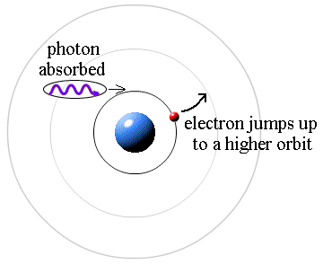
It works the other way, too. If a photon strikes an atom, the atom can absorb the photon and its energy if (and only if) the photon's energy is exactly equal to the difference between two orbital energies. In this case, an electron uses the photon's energy to jump from the smaller orbit up to the larger orbit. This is called a quantum jump.
The electron falls down to a lower orbit and the atom loses energy. A photon carries away the energy lost by the atom.
A photon is absorbed by the atom, which gains the photon’s energy. The electron uses this energy to jump up to a higher orbit.

WAVES OR PARTICLES? BOTH!
https://www.youtube.com/watch?v=1xj0MC2IuDU
When light passes through a double-slit, an interference pattern consisting of bright bands and dark bands is seen on a screen. This is produced when the wave from one slit combines with the wave from the other slit. If two wave crests meet at the screen, the waves add and you get a bright band. If a wave crest from one slit meets a wave trough from the other slit, the waves cancel and you get a dark band. This proves that light is a wave.
On the other hand, the photoelectric effect proves that light consists of massless particles called photons.
So which is it? Is light a wave or a stream of particles? The answer is "Yes!"
Light acts like a wave if you want to know how it propagates, how it travels from one place to another. To describe how light travels from the double slits to the screen, you have to use the wave characteristics of light.
Light acts like particles (photons) if you want to know how light interacts with matter. To describer how light interacts with the electrons in a metal and how it ejects them from the metal's surface, you have to use the particle characteristics of light.
We say that light exhibits a wave-particle duality. It can behave like either waves or particles (but not both at the same time), depending on the situation.
Thinking about the photoelectric effect again, how can a photon (which has no mass) knock an electron about? Einstein used his theory of relativity to show that even massless photons have momentum. Newton defined momentum = (mass) x (velocity) for a particle with mass, but Einstein was able to show that the momentum of a massless photon depends on its wavelength:
The smaller the wavelength, the greater the momentum of the photon.
In 1923, Prince Louis de Broglie of France had an idea. Maybe the wave-particle duality applies to everything in nature. He proposed that everything propagates like a wave, and that everything interacts like a particle. Say what?? What do you mean by the wavelength of an electron, or the wavelength of a baseball? De Broglie rewrote Einstein's formula for the momentum of a photon and applied it to a particle with mass:
Planck's constant, h, is so tiny that we don't notice the wavelength of a thrown baseball, which is only about 10⁻³⁵ metres! But an electron's mass is also tiny, so it has a wavelength about 10,000 times shorter than the wavelength of visible light. This is useful, because microscopes that use electron waves instead of light waves can see several thousand times more detail!
The proof that electrons propagate like a wave came when electrons were passed through a double slit and counted as they hit a screen. If the electrons travelled like a stream of particles, they would have simply piled up at two locations behind the two slits. But they didn't. They showed a double-slit interference pattern, bright bands and dark bands just like the ones produced by light waves. Without a doubt, electrons exhibit the wave-particle duality of nature. In fact, every massive object exhibits the wave-particle duality of nature. It just isn't noticeable on the large scale of our everyday world.
SUMMARY
https://www.youtube.com/watch?v=JKGZDhQoR9E (1 hour, but cut the first 5 mins)
If you look at most of the "equations" above, you will find Planck's constant, h. This is the trademark of "modern physics." The failure of classical physics to explain blackbody radiation, the photoelectric effect, and the hydrogen atom ultimately demolished the foundations of classical physics.
Max Planck, Albert Einstein, Niels Bohr, and Louis de Broglie made inspired guesses about how nature works. Other people of their time made different guesses. Nature agreed with Planck, Einstein, Bohr, and de Broglie, but not with the others whose names are now forgotten. Like Arcadia's Thomasina, these were intuitive geniuses who went beyond mere mathematics to make creative conjectures about how the world operates. Those who came later calculated the consequences of the new physics, but this was just mathematics (sometimes brilliant mathematics, but mathematics nonetheless). It is those rare intuitive geniuses who courageously discard the old rules and invent new ones who are in the first rank of physicists.
Finally, it is important to remember that Planck's constant is very tiny, only about 6.63 x 10⁻³⁴. Roughly speaking, this means that in our everyday world, quantum effects like the wave-particle duality make a difference only in the 34th decimal place when predicting the behaviour of a moving baseball. Large objects obey Newton's laws. But the behaviour of large object reflect the average behaviour of their component atoms, so it is fair to say that Newton's laws work only "on average." The behaviour of small systems is radically different than what classical physics predicts. Ultimately, the whole idea of prediction --- that the same conditions should always produce the same results --- was overthrown.
Planck and Einstein explained the observation of black body radiation and the photoelectric effect by proposing that light is transmitted in small packets of energy (known as quanta), and the theory is now known as Quantum Mechanics (E=hf). Quantum mechanics has led to a new theory about the nature of particles, waves and the nature of reality itself.
In the 1920s G P Thomson observed diffraction rings produced by the interference of electrons passing through a thin gold sheet. In another experiemtnDavisson and Germer were studying electron reflection from a nickel target, which by mistake had been crystalised. They observed that the intensity of the reflected electrons had maxima and minima, similar to the interference pattern obtained with light on a grating. Interference is the test for a wave, so this is an example of electrons behaving like waves.
In 1924 de Broglie postulated that nature was dualistic. All matter has wavelike properties and all waves have particle properties, or wave-particle duality. The de Broglie implies that waves and particles are related through their momentum where
$$λ=\frac{h}{p}$$
Where h is Planck’s constant (Js), p is the momentum (kgms⁻¹) λ is the de Broglie wavelength (m)
Comparing photon wavelength with those of an electron travelling at 60×10⁶ ms⁻¹.
Wavelength of photon of red laser 632nm
$λ=\frac{h}{p}=\frac{h}{mv}=\frac{6∙63×{10}^{-34}}{9∙11×{10}^{-31}×6∙0×{10}^{7}}=1∙2×{10}^{-11}m$
The resolution of a microscope depends on the wavelength of the light used and increases as the wavelength decreases. Fast electrons have a de Broglie wavelength less than light and this can be used in the electron microscope.
The de Broglie relationship implies that all particles have wave properties and an associated wavelength. Do large things have an associated wavelength?
So do people have a de Broglie wavelength? Imagine a 60 kg student travelling at 4 ms⁻¹
$$=\frac{h}{p}=\frac{h}{mv}=\frac{6∙63×{10}^{-34}}{60×4}=2∙8×{10}^{-36}m$$
This is so tiny we cannot observe this in everyday objects.
Double Slit Experiment
We have looked at this
https://www.youtube.com/watch?v=fwXQjRBLwsQ
https://www.youtube.com/watch?v=A9tKncAdlHQ
The upshot is
See virtual AH CfE
Some of the unexplained observations in Physics at the start of the 20th century were partially resolved by quantising energy or angular momentum in the Bohr model of the atom. But this model has limitations and does not fully explain the wave-particle duality. Physicists looked for a mathematical foundation to quantum theories and we now call this quantum mechanics

Some key concepts of quantum mechanics are:
Sub atomic particles do not follow Newtonian dynamics.
Physical properties (such as position, momentum and enery etc) can only have probabilities assigned to their values. One important consequence of only being able to assign probabilies to values is that the position of an electron at any point in time can only be stated as a probability. Shrodiner developed an equation, called a wave function which can be used to determine the probability of finding an electron at distance r from the nucleus in a hydrogen atom, enabling a probability distribution to be produced.
Matter like e-m radiation exhibits a wave-particle duality. An experiment can demonstrate the particle- like properties of matter or the wave-like properties – but not both at the same tie!!
The process of making measurements unavoidably alters the property being measures
It is not possible to know the values of all the properties of a system at the same time. There is a fundamental limitation on how accurately certain pairs of variables can be measured simultaneously. A model of this is to relate the scenario of a fast moving bullet. It is not possible to know the position and the velocity of the bullet at the same time. We can take a photo of the bullet at one moment in time to identify its position but then we have no concept of its velocity, but if we measure it’s velocity then it’s position changes as we measure it.
A classical view of physics in principal allows all future states of a system to be known if the starting details are known, quantum mechanics does not allow for this as we can only deal in probabilities
The quantum mechanical description of large systems should and does closely approximate classical description
Quantum mechanics are non-intuitive and don’t correspond to our experience
Quantum Mechanics is the most tested of all theories and give excellent agreement with the experimental observations

We conclude that
- it is impossible to simultaneously measure both wave and particle properties.
- Measuring the particles affects the result.
- Double slit experiment demonstrates the wave-particle duality
- Taking a measurement of the conditions affects the results seen.
Results
- Sending particles through a double-slit apparatus one at a time results in single particles appearing on the screen, as expected.
- an interference pattern emerges when these particles are allowed to build up one by one. This demonstrates the wave-particle duality, which states that all matter exhibits both wave and particle properties: the particle is measured as a single pulse at a single position, while the wave describes the probability of absorbing the particle at a specific place of the detector. This phenomenon has been shown to occur with photons, electrons, atoms and even some molecules,
- The particles do not arrive at the screen in a predictable order, so knowing where all the previous particles appeared on the screen and in what order tells nothing about where a future particle will be detected.
2012 AH Paper Q1b.
Electrons exhibit both wave-like and particle-like behaviour.

 | (b) | (i) | Give one example of experimental evidence which suggests an electron exhibits wave-like behaviour.
1 | b | I | Electron Diffraction  Interference  Fire electrons through crystals | (1) | 1 | Young’s/ Double Slit (1)  Bending (0)  If explanation contradicts the example then WP (0)  Defraction (0)
Thomson-Reid Experiment
Fire electrons around a crystal

 |  | (ii) | Give one example of experimental evidence which suggests an electron exhibits particle-like behaviour.
1 | b | ii | Compton Effect  Photoelectric effect  e/m experiment  electrons deflected in a deflection tube  electron’s back scattering | (1) | 1 | Electrons repel (1)  Any indication of Force due to electrostatic effects (1)  Electrons can be accelerated (1)  Electrons have mass/charge / momentum (0)  Nuclear Fission (0)  If explanation contradicts the example then WP (0)  Milikan’s oil drop (0)  Rutherford’s expt (0)  Defract (0)  Gold foil (0)  Beta radiation (0)  Must describe an effect

REFERENCES
http://physics.weber.edu/carroll/honors/failures.htm
https://en.wikipedia.org/wiki/Double-slit_experiment
https://bluesyemre.files.wordpress.com/2012/09/solvay-conference-1927-colourized-einstein.jpg
http://www.animations.physics.unsw.edu.au/jw/light/youngs-experiment-single-photons.html
http://iopscience.iop.org/article/10.1088/1367-2630/15/3/033018;jsessionid=64372E995FC132B1B58B289809FBC232.c4.iopscience.cld.iop.org
http://particleadventure.org/other/history/smt.html
http://particleadventure.org/other/history/index.html
http://phys.org/news/2013-03-feynman-double-slit-brought-life.html
http://physics.weber.edu/carroll/honors/failures.htm

