Advanced Higher Physics

Quanta and Waves

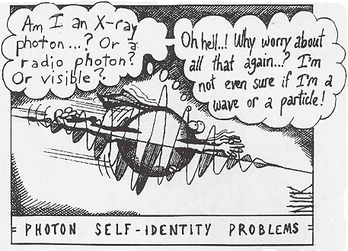Student Booklet I

**Quantum Theory**

**An Introduction**

There were several experiments which were carried out over a period of time which could not be explained using the classical Physics theories of the day.

**Quantum Theory** was developed to try to explain the results of these experiments.

**What Were These Experiments?**

**1. Photoelectric Effect** [Higher P&W]

Einstein used this experiment to suggest that the **energy** in **electromagnetic radiation** is **quantised.** That is energy of EM radiation can be thought of to exist in small packets or quanta.

**2. Black Body Radiation** [Higher ODU]

Example of a black body radiation curve

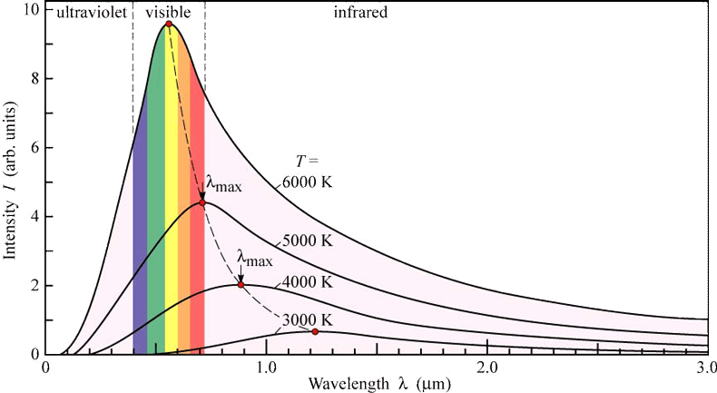

Electrical, Computer, & Systems Engineering of Rensselear. *§18: Planckian sources and color temperature*        [http://www.ecse.rpi.edu](http://www.ecse.rpi.edu/) (July 27, 2007).

Classical Physics in the early 20th century, if applied to these results, predicts that there will be an **infinite amount of energy** from an ideal black body in thermal equilibrium. This is not possible and does not happen.

Experiments showed that classical theory broke down in the short wavelength / high frequency part of the electromagnetic spectrum - ultraviolet range – hence the name **ultraviolet catastrophe.**

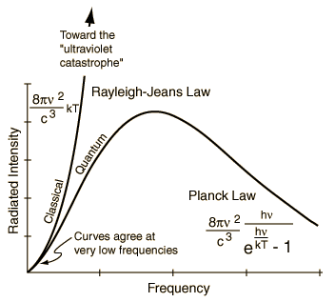

Planck solved the problem by postulating that the electromagnetic energy did not follow the classical description but was instead emitted in discrete bundles of energy, where the energy was proportional to the frequency.

E = hf

This is not dissimilar to Einstein’s conclusion for the photoelectric effect.

<http://hyperphysics.phy-astr.gsu.edu/hbase/hframe.html>

**3. Bohr Model** [Higher P&W]

Before the Bohr model the model of the atom came from the work of Rutherford.

**Rutherford Model of An Atom**

neutron

proton

electron

* Most of the atom is empty space.
* Small dense nucleus holds the neutrons and protons together by means of the **Strong Force.**
* Electrons orbit the nucleus at non-relativistic speeds.
* The atom is electrically neutral.

This model of an atom has a weakness…this is because the electrons are moving in circles and are therefore accelerating.

Any accelerating charge emits electromagnetic radiation. This emission would cause the electrons to lose energy and spiral into the nucleus.

Since matter exists this cannot be true.

**Bohr** proposed a refinement to this model in order to overcome this apparent problem. He proposed that:

* electrons could only **occupy certain discrete orbits, each with its own discrete energy.**

The full extent of Bohr’s model can only be explained by an understanding of work conducted by De Broglie.

**De Broglie interlude**

De Broglie observed that electrons, which are particles, also exhibit some wave-like behaviour.

They are seen to **diffract** and so the wave-particle duality must be extended to matter as well.

Therefore an **electron** must be

* treated as a **particle** with a rest mass of 9.11 x 10-31 kg,
* treated as a wave with a wavelength, 

where p is the momentum of the electron and h is Planck’s constant.

This is known as the **de Broglie wavelength.** This can be applied to any object, **not only** electrons.

To decide if an object (e.g. an electron) will behave as a particle or a wave then:

* calculate the de Broglie wavelength
* look at the obstacle (or gap)
* if the diameter or width of the obstacle or gap is **significantly greater than** the de Broglie wavelength then there will be **no** diffraction and so the object will behave like a particle.

What does ‘**significantly greater than’** mean?

It means that if the gap and the wavelength are of the same magnitude then the object does behaves like a wave.

e.g.

if the gap is 1·2 mm and the de Broglie wavelength is 1·0 mm then object behaves as a wave and there will be diffraction.

If the gap is 10 mm and the de Broglie wavelength is 1·0 mm then object behaves as a particle.

**Back to Bohr** - **Quantisation Of Electron Angular Momentum**

Using de Broglie’s idea that a particle has a wavelength Bohr postulated that there must be *n* complete wavelengths in the *nth* allowable electron orbit. The radius of this obit is *rn*.

As a result:



But *mvr* is the angular momentum, *L*, *(Unit 1)* of the electron, hence



The angular momentum of the electron must be an integer multiple of

, since n = 1, 2, 3, 4, ….

i.e.the angular momentum is **quantised.**

**Summary of Bohr Model**

* Electrons revolve around the nucleus of an atom but only in certain allowed orbits (energy levels)
* Angular momentum of the electron is quantised 
* Total energy in each possible energy level is constant.   
  Electron does not continuously radiate electromagnetic radiation.
* A single quantum (photon) of electromagnetic radiation is emitted on transition to a lower energy level.  
  e.g. E4 - E1 = hf

**Quantum Mechanics**

The branch of Physics known as **Quantum Mechanics** was developed to resolve the problems that could not be explained using classical Physics. As Quantum Mechanics has developed the dual nature of matter could be described.

In classical Newtonian Mechanics if the starting details are known then all future states of the system will be known.

At the core of Quantum Mechanics is the unpredictability of the nature of matter.

In Quantum Mechanics:

* only **probabilities** can be calculated
* the **Schrodinger Wave Equation** is used to describe all matter in terms of waves
* these waves have no physical significance but can be used to predict probabilities.
* it is impossible to simultaneously measure both wave and particle properties

Such a model was required because of Heizenberg's Uncertainty Principle which states that in theory **both** the **position** and **velocity** of a particle cannot be known exactly.

*i.e. no matter how good the measuring apparatus is, it is impossible to measure both the wave and particle properties simultaneously.*

**Heisenberg Uncertainty Principle**.

The position and the momentum of a particle cannot simultaneously be measured with high precision.

To help understand the uncertainty principle:

* At atomic dimensions, it is not valid to think of a particle as a hard sphere, *at these smaller dimensions, the particle becomes more wavelike*.
* It no longer makes sense to say that you have precisely determined both the position and momentum of such a particle.   
  *if electron acts as a wave, then the wave is the quantum mechanical* [*wavefunction*](http://hyperphysics.phy-astr.gsu.edu/hbase/quantum/wvfun.html#c1) *and it is therefore related to the probability of finding the electron at any point in space*.
* A perfect sinewave for the electron wave spreads that probability throughout all of space, and the "position" of the electron is completely uncertain.

**Definition – The Uncertainly Principle In Terms of Position and Momentum**



where

Δx = uncertainly in position

Δpx = uncertainty in momentum

h = Plank's constant (6.63 x 10-34 Js)

If we wanted to gain more precise information about the position of a particle we would use of short wave radiation.

However short wave radiation has high energy which therefore changes the momentum of the particle. So in practical terms our measurement affects our measurement – how mad is that!

**The Uncertainly Principle In Terms of Energy and Time**

According to Heisenberg the measurement of the energy of a particle or the energy level are subject to an uncertainty. This uncertainly is not the result of a random or systematic error.

The process of measuring itself creates an uncertainty

**Kinetic Energy Measurement**

If you want to measure the energy of an object the measurement must take a finite time interval, Δt.

**Heisenberg** proposed that:

The shorter the time interval used to make the measurement of energy, the greater the uncertainty in the measured value of energy.

**Definition**



where

ΔE = uncertainly in energy

Δt = uncertainty in time

h = Plank's constant (6.63 x 10-34 Js)

**Consider the following:**

A ball of mass 1.0 kg and energy of 9.0 J bounces up and down on the floor beside a wall of height 1.0 m To make it over the wall the ball would have to have a total energy of just under 10J

In classical Physics it cannot get over the wall as this violates the law of conservation of energy, as an extra 1 J of energy is required.

In the Heisenberg Uncertainly principle the ball can make it over the wall if the time to do this is very short.





This time is far too small for something the size of a ball, if it travelled the extra 10cm in that time it would have to travel at a speed of



which is just a bit faster than the speed of light!!

However if we apply the same theory to an electron then:

If the electron has a total energy of 1.0 eV, then if using classical Physics it cannot get over a potential barrier of 2.0 eV, as it has 1.0 eV of energy less than is required.

Applying the Heisenberg Uncertainty Principle;





This is still a short time interval but a fast moving electron can make it over the potential barrier in that time.

This is the basic principle of the tunnelling microscope.

**Alpha Decay and Quantum Tunnelling**

When alpha decay was discovered and named in the late 19th century, the understanding of its nature of production was not. Classical physics would suggest that the alpha particle was confined within the nucleus by an energy barrier which the alpha particle eventually managed to climb.

However, in some cases the observed emission energies of the alpha particles were too low to be consistent with surmounting the energy barrier at all.

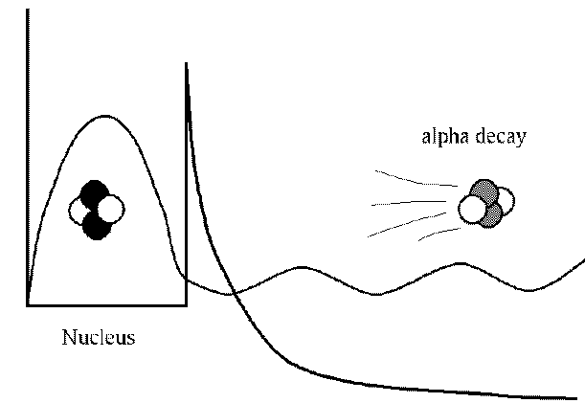

<http://www.lassp.cornell.edu/ardlouis/dissipative/decay.gif>

Gamow, Gurney and Condon, proposed a successful theory of alpha decay based on quantum tunnelling.

Initially, an alpha particle of energy Eα is confined due to the powerful but short-range interaction known as the strong nuclear force. In addition, a long-range electrostatic force acts between the positively charged alpha particle and the remainder of the positively charged nucleus, and has the effect of repelling the alpha particle from the nucleus.

**Cosmic Rays**

**Background Information**

Early in the 1900s radiation was detected when sources were present. However, when known sources were removed radiation was still detected. This is known as **Background radiation.**

Austrian Physicist Hess, went up in a balloon to measure this radiation at different altitudes. To his surprise he the measurements increased as he went higher. He named this **Cosmic Radiation**, which later became known as **Cosmic Rays.**

Initially it was thought that this radiation came from the sun. However, when the measurements were repeated during a solar eclipse, the same results were obtained and so the sun as the source was ruled out.

Using a **cloud chamber** we can observe ionizing radiation.

*Watch:* [*http://www.nuffieldfoundation.org/sites/default/files/files/cloud_chamber.mov*](http://www.nuffieldfoundation.org/sites/default/files/files/cloud_chamber.mov)



Panama

California

Cosmic rays were also measured at different latitudes and were found to be more intense in Panama than in California.

Compton showed that the cosmic rays were being deflected by the Earth’s magnetic field. This proved that the cosmic rays must consist of electrically charged particles (electrons or protons) rather than photons in the form of gamma radiation.

<http://www.toshiba.com/tai/americas/common/images/backs/map_off.gif>

**Origin and Composition**

**Cosmic Rays** are described as **high energy particles** which arrive at Earth. The source of the Cosmic rays is **not** the Earth.

There are several types of Cosmic Rays. The table below shows the most common of those detected.

|  |  |
| --- | --- |
| **Nature** | **Approximate Percentage** |
| Protons | 50 % |
| Alpha Particles | 25 % |
| Caron, Nitrogen and Oxygen Nuclei | 13 % |
| Electrons | Less than 1 % |
| Gamma Radiation | Less than 0.1 % |

As a result of the energies of cosmic rays, they have very long ranges.

The largest energies are greater than the energies produced in particle accelerators.

**Energies – Facts and Figures**

Greatest Energy produced in a Particle Accelerator is 1012 eV

Energies of most detected Cosmic Rays is 109 eV to 1020 eV

Cosmic rays with energies in excess of 1018 eV are known as

Ultra High Energy Cosmic Rays (UHECR).

A Cosmic ray with an energy of 3 x1020 eV has been detected.

*What does 3 x1020 eV mean in terms of Joules*

*3 x1020 eV = 3 x1020 x 1.6 x 10-19 = 48J*

*This is the energy needed to throw a 2.5 kg bag of potatoes 2 m in the air.*

*This is the kinetic energy of Andy Murray’s tennis ball when he serves it at around 100 mph (161 km/h; 45 ms-1)*

This UHECR was probably a proton and it had 40 million times the energy of the most energetic protons produced in the particle accelerators here on Earth.

These UHECR are thought to come from a source close (in cosmological terms) to the Earth – probably a few hundred million light years.

If they were to have travelled any further then we would have expected them to interact with Cosmic Microwave Background Radiation (CMBR – see later in these notes) and produce pions.

The exact source of these UHECR is still being investigated.

Low energy Cosmic Rays come from the sun.

Intermediate energy Cosmic Rays come from supernovae in our own galaxy

**Detection and Screening of Cosmic Rays.**

It is only the very high energy Cosmic Rays that can travel straight through our atmosphere and be detected on the ground.

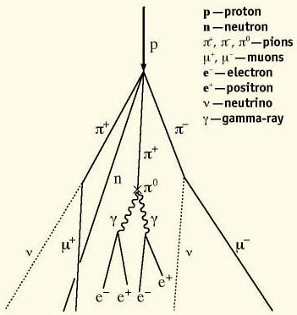When other Cosmic rays (known as **Primary Cosmic Rays**) reach the Earth they interact with the earth’s atmosphere and produce a chain of reactions. This results in the production of a large number of particles known as a **Cosmic Air Shower.** These particles have lower energies than the Primary Cosmic rays. The particles in the Cosmic Air Shower can be detected on the ground, however Primary Cosmic rays can only be detected in space and this is done using detectors on satellites.

lanl.gov

**Solar Wind**

The solar wind originates in the corona of the Sun. It is a flow of plasma which contains charged particles.

Due to the high temperature of the corona, the particles have sufficient kinetic energy to escape the Sun’s gravitational field.

Solar winds travel at speeds between 3 x 105 ms-1 and 8 x 105 ms-1. A gust of 1 x 106 ms-1 has been recorded

The plasma contains:

* equal numbers of protons and electrons (in ionised hydrogen)
* alpha particles (approx 8% )
* trace amounts of heavy ions and nuclei (Carbon, Nitrogen, Oxygen, Neon, Magnesium, Silicon, Sulphur and Iron).

**Solar Flares**

These are explosive releases of energy.   
Flares contain:

* energy from the whole electromagnetic spectrum (from gamma to long wave radio waves)
* **solar cosmic rays’** particles which have been accelerated to high energies( 1 x 10-3 eV to 1 x 1910 eV).   
  The high energy particles are:  
  protons (hydrogen nuclei) – most abundant  
  atomic nuclei (helium nuclei) – next most abundant   
  electrons - they lose much of their energy when they produce a burst of radio waves in the corona.

The flares usually occur near sunspots and it is thought that magnetic fields become so distorted and stretched that they snap, releasing large amounts of energy which heats the plasma to 100 million kelvin in a short time. This generates x-rays and can accelerate some particles to speeds close to speed of light.

Highest energy particles arrive at the Earth within half an hour of the flare maximum. This is followed by a peak number of particles approximately one hour later.

These particles can disrupt power generation and communication on Earth.

**Our Earth’s Magnetosphere**

The solar wind, and its accompanying magnet field, is strong enough to interact with planets and their magnetic fields to shape **magnetospheres**.

A magnetosphere is the region surrounding a planet where the planet's magnetic field has dominant control over the motions of gas and fast charged particles. However, the ions in the solar plasma are charged, so they interact with these magnetic fields, and solar wind particles are swept around planetary magnetospheres. The shape of the magnetosphere is determined by the magnetic field, the solar winds and the charged ions.

The Earth’s magnetosphere protects the ozone layer from the solar wind. The ozone layer protects the Earth (and life on the Earth) from dangerous ultraviolet radiation.

The Earth’s magnetic field is similar to the field generated by a bar magnet and is thought to be generated by electric currents in conducting material inside the earth.

Geological evidence suggests that the direction of the earth’s magnetic field has reversed on several occasions – the most recent being 30 000 years ago.

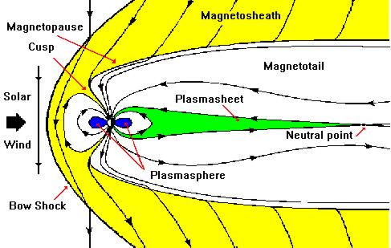

[**http://helios.gsfc.nasa.gov/magnet.html**](http://helios.gsfc.nasa.gov/magnet.html)

Many other planets in our solar system have magnetospheres of similar, solar wind-influenced shapes.

As the Earth’s magnetic field is non uniform (stronger near to the poles), both electrons and protons will spiral along the earth’s magnetic field lines at the Polar Regions. These energetic particles can interact with atoms in the upper atmosphere to produce the aurorae.

Field lines

e-

This is one of the most amazing natural phenomenon that can been seen in the Northern Hemisphere,

Unfortunately the level of street lighting means that town and city dwellers do not get the opportunity to view this unless the AuroraBorealis is very bright.

A similar phenomenon can be seen in the Southern Hemisphere and it is known as the Aurora Australis.

The closer you are to the Pole the brighter and more spectacular is the aurorae.

## Charges In A Magnetic Field

**Example**

Consider charges which are free to move through regions of space where the magnetic field direction is into the paper.

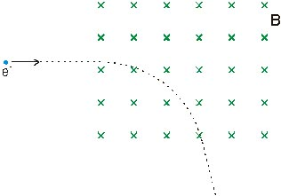

* The moving electrons experience a force due to the magnetic field.
* In the Higher Physics the force exerted on a current carrying conductor   
  was investigated.[ Unit 3]

**To find the force on one moving electron due to the magnetic field**:

* Imagine a conductor of length (l) carrying a current, I

Assume there are N conducting electrons within the conductor all travelling with a drift velocity of v

l

e

e

e

e

e

The total charge within the conductor is:   
Q = Ne

The time taken for all the total charge to cross the end of the conductor is:   


The current then is given by:



Imagine the same current carrying conductor placed in a uniform magnetic field.

The magnetic field is at right angles to the conductor.

I

l

B

Force on the conductor placed **perpendicular** to a magnetic field is given by:



Average force on each electron is given by:

# 

# Definition

When an **electron** beam enters a uniform magnetic field at right angle to the field then the force on each electron is given by:

## F = B e v

**In general**:

The magnetic force exerted on any charge (q), moving with a speed v, at right angles to a magnetic field of strength B is given by:

## F = B q v

where:

F is the magnetic force on the charge. Unit is the Newton (N)

B is the magnetic induction. Unit is the Tesla (T)

q is the charge. Unit is the Coulomb (C)

v is the velocity. Unit is ms-1

Two conditions must be met for a charge to experience a force in a magnetic field. They are:

1. the charge must be moving
2. the velocity of the moving charge **must** have a component of velocity perpendicular to the direction of the magnetic field.

If the charged particle is not placed perpendicular to the magnetic field then the equation is:

## F = B q vSinθ

where vSinθ = perpendicular component of velocity.

**Motion of A Charged Particle In A Magnetic Field**

Charge Moving Parallel To The Magnetic Field

v

B

v

The direction of the charged particle is not altered**.**

## F = B q vSinθ where θ = 0°

So there is no magnetic force acting on the charged particle in this case and it is not affected by the magnetic field.

**Charge Moving Perpendicular To The Magnetic Field**

* The direction of the magnetic force will be at right angles to both the magnetic field direction and the direction the charge is moving in.   
  This is determined by the left hand rule

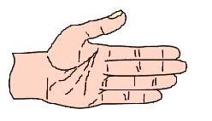

Fingers – direction of field lines

Thumb – direction of electron flow

Palm – pushes in direction of force

As the magnetic force is always perpendicular to the velocity, this force does not change the magnitude of the velocity only its direction.  
*Speed of the charge is not changed but its direction and therefore its velocity is changed.*

## Magnetic force is maximum when θ = 90°

Positively charged particles will experience a force in the opposite direction to the negatively charged particles.

The force is a central force (Unit 1) and therefore the charged particles will move with circular motion.

**X**

**X**

**X**

**X**

**X**

**X**

**X**

**X**

**X**

+q

v

F

F

F

v

v

+q

+q

The result is that the particle will move in a **circle** of radius r

For central force



Also

F = B q v

so equating gives

Path radius will then be 

**Please remember that in a magnetic field:**

* Particles with opposite charges rotate in opposite directions
* The radius of the circular path is directly proportional to:  
  the mass of the particle  
  the velocity of the particle
* The radius of the circular path is inversely proportional to:  
  the magnitude of the charge

**Helical Motion**

When the Velocity of the Charged Particle is **NOT Perpendicular** to the Magnetic Field…the result is **HELICAL Movement**

Explanation

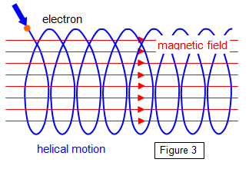

θ

If a charged particle enters the field at an angle to the field lines

* Component of velocity perpendicular to the direction of B results in uniform circular motion in a plane. This component results in a central force. [vperp = vsinθ]
* Component of velocity parallel to the direction of B results in uniform motion. Constant velocity in the direction of the field lines.

[vparall = vcosθ]

* The two components combine to give **helical movement.**  
  *Why helical?  
  One component results in circular motion with a constant angular velocity at right angles to the magnetic field  
  One component results in linear motion parallel to the magnetic field.  
   These two combine to give a helical path where the axis of the helix is along the direction of the magnetic field.*
* In problems the two motions must be treated separately.
* The helical motion will occur whenever the velocity of the charged particle is not completely perpendicular to the direction of the magnetic field.
* In **helical motion**  the radius remains constant.

The radius of the circular path, 

*where vSinθ is the component of v which is perpendicular to the magnetic fie*ld

**Simple Harmonic Motion (S.H.M.)**

SHM is a mathematical model used to describe mechanical situations where something is **oscillating**.

An object will exhibit SHM if the object is subject to a resultant force which is:

* directly proportional to the displacement from the centre of oscillation
* always in the opposite direction to the displacement   
  i.e the direction of the resultant force will be towards the centre of oscillation.

Mathematically this is written as

F = -k y

where

F is the resultant force (N)

k is the positive constant (Nm-1)

y is the displacement measured from equilibrium to either the highest or lowest point

**negative sign indicates that the force is always in the opposite direction to the displacement**

**Equation of Motion For SHM**

Substitute F = - k y into Newton's 2nd Law to give:



where

 is acceleration (ms-2)

ω2 is a positive constant (s2) known as the angular frequency

y is displacement (m)

**negative sign** implies that the **force acts in the opposite direction to the displacement**

### Please remember

If you can show that either  
  
F = - k y or   
  
then this is sufficient proof that the motion will be simple harmonic

**Solutions To The Equation of Motion**

The equation of motion 

Has two solutions



y = Asinωt is used when the amplitude of oscillation is taken to be zero at t = 0

y = Acosωt is used when the amplitude of oscillation is taken to be a maximum [A] at t = 0

**The Velocity Equation**





**Maximum Speed and Maximum Acceleration**

#### Speed



* The maximum speed occurs when y = 0
* vmax =±A
* This occurs at the centre of the oscillation.

#### Acceleration



* Maximum magnitude of this is A ω2 where A is the amplitude
* The maximum **magnitude** of the acceleration occurs at the extreme positions where

y = A or y = - A

NB vmax at y = 0, amax at y = A

**Energy and SHM**

**Kinetic Energy** = ½ mv2 = **½ m ω2 (A2 - y2)**

**Potential Energy**= **½ m ω2y2**

**Total Energy** = Kinetic Energy + Potential Energy

ET = EK + EP

= ½ m ω2 (A2 - y2) + ½ m ω2y2

= ½ m ω2 A2 - ½ m ω2 y2 + ½ m ω2y2

= **½ m ω2 A2**

Therefore the total energy at all times is ½ m ω2 A2 ; assuming that no energy is converted into heat as a result of friction.

**Damped Oscillations**

The mathematical models for SHM:

* F = -ky
* 

both ignore the effects of friction.

If friction is not negligible then some of the Kinetic Energy will be transformed into heat. As a result the amplitude of the oscillations will gradually decrease.

*The amplitude decreases exponentially with time is the exact definition.*

t

y

The damping effect of friction affects the period of oscillation in such a way that the period will increase as damping increases….**the greater the damping the greater the period.**

If an oscillating body eventually comes to rest then we say that it is **damped**.

As a result the motion decreases to zero because energy is transferred from the system.

A simple pendulum takes a long time to come to rest because the frictional effects (from the air) are small and in cases like this it can be said that the system is **lightly damped.**

If the frictional forces are much greater then the oscillating body will come to rest much quicker and it can then be said that the system is **heavily damped.**

If the damping of a system is increased to the extent that there are no oscillations beyond the zero (or rest) position then the system is said to be **critically damped.**

In some cases systems which have a very large resistance will produce no oscillations and will take a long time to come to rest. Such systems are said to be **overdamped.**