**SIMPLE HARMONIC MOTION**







We have looked at linear and circular motion; if you can’t remember then get revising! Another common motion is where an object moves to-and-fro repeating movements called *vibrations* or *oscillations*. This type of motion is called Simple Harmonic Motion (SHM).

When a mass is hung on a spring, a force equal to the weight of the mass is exerted on the spring, which causes the spring to stretch; it will often be found that this is a linear relationship. If you double the mass hanging on the spring, you will double the distance the spring stretches. The spring exerts an equal and opposite force on the mass. This force can be given by the relationship:



where *k* is what is known as the spring constant and *y* is the displacement of the spring in metres (how far it stretched from the equilibrium position). The relationship *F = -kx*, can also be used where, *F* represents the restoring force of the spring and the negative sign indicates that this force is in the opposite direction of the displacement *x*. This relationship is known as Hooke's Law.

The spring constant *k* is constant for any given spring, but is dependent on the spring; different springs will have different spring constants. The units for the spring constant are Nm-1, meaning that a spring constant of 45 Nm-1 indicates that it would take 45 N to stretch this spring 1 m (assuming that this length was within the limits of the spring; if you exceed the limits of the spring, this formula no longer holds).

Consider a spring that is allowed to hang vertically with no mass attached. See Fig 1a below. Notice that the spring has a natural length to which it always wants to return if you stretch or compress it. This is the equilibrium position.

Figure 1: Simple Harmonic Motion

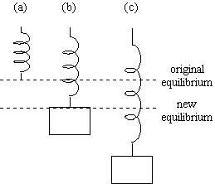

Suppose that you place a mass on the spring (see Fig 1b). The mass will cause the spring to stretch a certain distance, depending on its spring constant. This is now its new equilibrium position - at this point, the force exerted by the spring upwards is equal to the force of gravity downwards. Suppose that you now pull this mass down a bit (Fig 1c) and let it go.

What happens? You should notice that it bobs up and down repeatedly. When the mass is below its equilibrium position, the spring exerts a greater force than the force of gravity and provides an upward acceleration. When the spring is above the equilibrium point, the spring exerts a smaller force than gravity, which results in a downward acceleration. This type of oscillation (when the restoring force follows Hooke's Law) is referred to as simple harmonic motion. The period (the time for one complete vibration, or oscillation) of this motion in seconds is given by:-

$$T=2π\sqrt{\frac{m}{k}}$$

where *m* is the mass in kg and *k* is the spring constant again. Also, remember that frequency is the inverse of period (f=1/T). Simple harmonic motion can be applied to many real world situations: a raft bobbing up and down in the water, the suspension of a car, a mattress, suspension bridges, a swinging pendulum, a mass on the end of a string, the strings and air columns of musical instruments produced when playing a note spring or a weighted tube bobbing up and down in a liquid. A complex wave e.g. a sound from a musical instrument can be analysed using simple harmonic components and these are called a Fourier series

Engineers need to know about vibrations, they occur in engines, aircraft, and tall buildings and were responsible for the collapse of the Tacoma Bridge in 1940 (see MPEG file!). This is similar to the Millenium bridge in London that also developed a wobble when people walked over it

<http://news.bbc.co.uk/hi/english/static/in_depth/uk/2000/millennium_bridge/>

<http://www.bbc.co.uk/learningzone/clips/the-millennium-bridge-closure-wobble-blamed-on-pedestrians/5735.html>

<https://www.youtube.com/watch?v=eiaM_LZUsqM> (show Adam Hart Davis film when discussing damping)

In mechanical oscillations there is a continual exchange of Ek and Ep due to the system having elasticity (to store Ep) and mass (allowing the system to store Ek) Let us look at this in terms of a spring on a hook.



e.g. When an object on the bottom of the spring is pulled down and released the elastic restoring force pulls up and accelerates the mass towards the centre position (O) with increasing velocity. The force reduces, and hence the acceleration as it nears the O, but velocity is at its greatest at O. At zero the restoring force and acceleration are zero but because the mass has inertia it overshoots the zero mark and continues upwards. The spring now compresses and the restoring force and acceleration act downwards towards O. The spring slows down and at an increasing rate. The mass eventually comes to rest above O and repeats its motion in the opposite direction.

The time for one complete oscillation is called the period T of the motion. The frequency is the number of complete oscillations per second, so



When dealing with masses moving in circles in SHM then the following formulae may apply:



Simple Harmonic Motion (SHM) occurs when an object, displaced from its equilibrium position, experiences a restoring force proportional to the displacement from that equilibrium position. For this to occur, the system must have some means of storing potential energy (e.g. a spring) and some mass which allows it to possess kinetic energy. In SHM *F,a* and *v* all change in magnitude and direction during the period.

If the acceleration/force of a body is directly proportional to its displacement from a fixed point and is always is directed towards that point, the motion is simple harmonic.

SHM occurs when a force on an object is directly proportional to its displacement from a fixed point and in the opposite direction.

Usually you also get the mark for F=-ky or F= -kx , but beware!

# The graph shows the restoring force as a function of displacment for SHM such that

Displacement, x (m)

Restoring force, F (N)



where *F* is the restoring force (N),

*x* is the displacement from the equilibrium position (m) and

*k* is the force (or spring) constant (N m-1).

The minus sign is included because the force acts in the opposite direction to the vector of *x*.



SHM AND CIRCULAR MOTION

An object moving with SHM can be visualised as the projection, R on the line MN of a point, P, moving anticlockwise around a circle of radius, r, at a constant angular velocity, ω.

θ

r

P

N

M

R

Q

y

The acceleration of point P towards Q is given by



thus by trigonometry the acceleration of point R towards Q is given by



The displacement of this point, R, from the equilibrium position, Q, is denoted (by convention) by y.

However, since  we can write



but since we can write



But we can also define acceleration in terms of velocity (v) and displacement (in this case, y) as:



Thus



NOTE: The minus sign is introduced here because the direction of the acceleration is always OPPOSITE to the vector of the displacement.

Note also that the radius, *r*, is the same as the amplitude, *a*, of the oscillation.

The period, *T,* of the SHM is defined as the time taken to complete one full oscillation i.e. the path of  in the diagram above.

Since the frequency, f is given by  and  we can define ω in terms of frequency thus:



## SOLUTIONS FOR THE EQUATION OF SHM

It is possible to calculate the solutions for the equation of SHM by integration but this is quite a complex procedure, so for the purposes of this exercise we will take the solutions and prove that they are correct by differentiation.

***Solution 1:* *Solution 2:***



<http://sacademy.cbv.ns.ca/staff/bdalzell/P1I/4.2%20Energy%20changes%20during%20simple%20harmonic%20motion.pdf>

**KINETIC AND POTENTIAL ENERGY OF PARTICLES IN SHM.**

Kinetic energy is given by:



The calculation for potential energy is a little more involved.

When the particle is at the equilibrium position (y = 0) the kinetic energy is at a maximum given by



and the potential energy is zero when referenced to the equilibrium position.

Therefore the total energy of the system, E, at the equilibrium position is given by:



Since total energy, E, is conserved then at any point in the SHM it is given by



When we stretch or compress a spring, work is done on the spring; therefore, a compressed or stretched spring will have potential energy. Remember that

|  |  |
| --- | --- |
| |  | | --- | | E=W | |

so

|  |  |
| --- | --- |
| |  | | --- | | E=Fd | |

But F is not constant; it increases linearly as we move away from equilibrium. So the average force exerted will be F=[ ½ ]ky and

|  |  |  |  |
| --- | --- | --- | --- |
| |  |  |  | | --- | --- | --- | | E = ( | 1  2 | ky)(y) | |

or, since the increase in energy becomes the potential energy of the spring,

|  |  |  |  |  |
| --- | --- | --- | --- | --- |
| |  |  |  | | --- | --- | --- | | Ep= | 1  2 | kxy2 | | (2.8) |

where k is the spring constant of the spring (in N/m)and x is the displacement from equilibrium (in m).

Consider a spring supporting a mass where the mass is pulled a distance x from its rest position and then released.

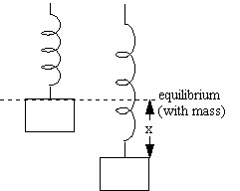

Since the total mechanical energy of a system is the sum of the kinetic and potential energies of that system, the total energy of an oscillating system can be given by[7](http://www.cbv.ns.ca/rv/physics/Physics12/#tthFtNtAAH)

|  |  |  |  |  |  |  |
| --- | --- | --- | --- | --- | --- | --- |
| |  |  |  |  |  | | --- | --- | --- | --- | --- | | Et = | 1  2 | mv2 + | 1  2 | ky2 | | (2.9) |

If no energy is being introduced to, or removed from, the system, the total energy remains the same. At equilibrium, x=0 and all of the energy is kinetic; at the maximum displacement (the amplitude A), v=0 and all of the energy is potential. The total energy of the system can therefore be expressed as Et=[½]kA2.

## DAMPING OF OSCILLATIONS

In the above descriptions we have assumed that energy is conserved in the system and the oscillations of SHM retain the same magnitude indefinitely. In **real systems** energy is lost from the system due to factors such as air resistance and friction in bearings and pivots, thus the amplitude of the SHM steadily decreases. This removal of energy is called **damping**.

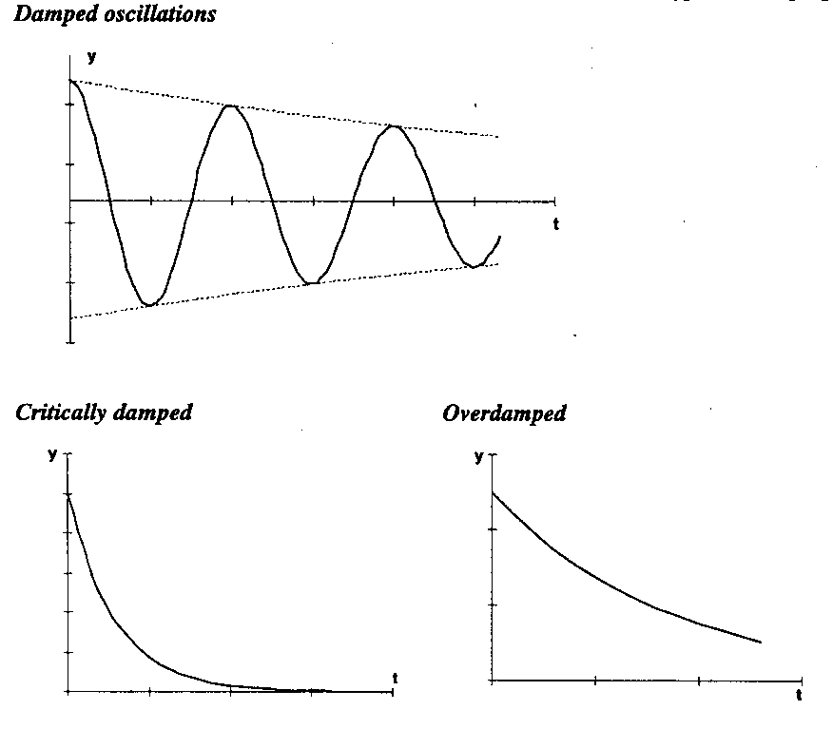SHM in a system such as a simple pendulum is usually only lightly damped since air resistance is fairly small. However, if the damping force is increased sufficiently there comes a point at which the damping just prevents the oscillation passing the rest position and in this situation the system is described as **critically damped**.

If the damping is increased even more the system may become **overdamped**, meaning that the oscillation takes a long time to return to the rest position.

The best known practical application of damping is probably in the use of shock absorbers (or dampers) on road vehicles. In a correctly working system, when the vehicle spring is deflected as it passes over a bump the shock absorber should provide **critical damping** to avoid the vehicle bouncing up and down on its springs. As the damper ages it produces less damping force and therefore the vehicle will tend to bounce more on rough roads. Conversely, a damaged (bent) damper may offer a higher resistance to motion and result in **overdamping.**

Note that the pendulums in clocks are subject to light damping, but maintain a steady amplitude from the energy stored either in the clock’s mainspring or from the potential energy available as the weights descend.

Questions

1. A piece of rubber is 45 cm long when a weight of 8.0 N hangs from it and is 58 cm long when a weight of 12.5 N hangs from it. What is the spring constant of this piece of rubber? 34.6 N/m
2. If a particle undergoes SHM with an amplitude A, what is the total distance it travels in one period? 4A
3. When an 80.0 kg person climbs into an 1100 kg car, the car's springs compress vertically by 1.2 cm. What will be the frequency of vibration when the car hits a bump? 1.18 Hz
4. A spring vibrates with a frequency of 2.4 Hz when a weight of 0.60 kg is hung from it. What will its frequency be if only 0.30 kg hangs from it? 3.4 Hz
5. A mass m at the end of a spring vibrates with a frequency of 0.62 Hz; when an additional 700 g mass is added to m, the frequency is 0.48 Hz. What is the value of m?
6. A 300 kg wooden raft floats on a lake. When a 75 kg man stands on the raft, it sinks deeper into the water by 5.0 cm. When the man steps off, the raft vibrates briefly. What is the frequency of vibration? 1.11 Hz
7. A small cockroach of mass 0.30 g is caught in a spider's web. The web vibrates at a frequency of 15 Hz. At what frequency would you expect the web to vibrate if an insect of mass 0.10 g were trapped? 26 Hz
8. A mass of 2.70 kg stretches a vertical spring 0.325 m. If the spring is stretched an additional 0.110 m and released, how long does it take to reach the (new) equilibrium position again? 0.29 s
9. It takes a force of 60 N to compress the spring of a popgun 0.10 m to load a 0.200 kg ball. With what speed will the ball leave the gun?
10. How much would a spring scale with k=120 N/m stretch, if it had 3.75 J of work done on it?
11. A block of mass 0.50 kg is placed on a level, frictionless surface, in contact with a spring bumper, with a spring constant of 100 N/m that has been compressed by an amount 0.30 m. The spring, whose other end is fixed, is then released. What is the speed of the block at the instant when the spring is still compressed by 0.10 m?
12. A spring stretches 0.150 m when a 0.30 kg mass is hung from it. The spring is then stretched an additional 0.100 m from this equilibrium point and released. Determine:
    1. The maximum velocity 0.81 m/s
    2. The velocity when the mass is 0.050 m from equilibrium 0.7 m/s
    3. The maximum acceleration of the mass. 6.53 m/s
13. A geologist's simple pendulum, whose length is 37.10 cm, has a frequency of 0.8190 Hz at a particular location on the earth. What is the acceleration of gravity at this location? 9.84 m/s
14. How long must a simple pendulum be if it is to make exactly one complete vibration per second?
15. A simple pendulum oscillates with frequency f. What is its frequency if it accelerates at [ 1/2]g
    1. upward?
    2. downward?