Mechanics Learning Outcomes 1 – Revision

Revision Questions for the Equations of Motion

- Long jumper

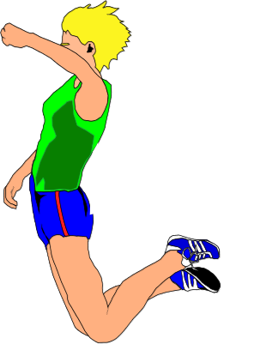
A poor, sick long jumper devises a method for estimating the horizontal component of her velocity during a jump (she’d obviously nothing better to do!). Her method involves first finding out how high she can jump vertically.
0.86 m

She finds the maximum height she can jump to is 0.86 m.

a) i) Show that her initial velocity is 4.1 m s⁻¹.

She now assumes that when she is long jumping, the initial vertical component of her velocity at take-off is 4.1 m s⁻¹.

The length of her long jump is 7.8 m.

- Calculate the value that she should obtain for the horizontal component of her velocity, v_{H}.

b) Her coach tells her that, during the 7.8 m jump, her maximum height above the ground was less than 0.86 m. Ignoring air resistnce, state whether her actual horizontal component of velocity was greater or less than the value calculated in part a) ii). You must justify your answer.

- A girl stands on a platform and throws a large plastic dart at a target marked on the ground. The centre of the target is 5 m from the base of the platform.

5 m
53º
6.25 m s⁻¹
SCORING
Distance from target | Points
< 0.5 m | 10
0.5 - 1.0 m | 5
1.0 -1.5 m | 3
1.5 – 2.0 m | 1

The dart leaves the girl’s hand with a velocity of 6.25 m s⁻¹ at an angle of 53º above the horizontal. The dart is then in flight for 1.5 s.

Calculate how many points the girl scores.

- Bridge Building

A construction company has been contracted to build a link bridge between two buildings from A to B as shown below.

60º
10 m s⁻¹
A
B
50 m
15 m

As an initial step it is intended to fire a light but strong wire rope from A to B. The wire is to be connected to an arrow which is to be fired from a gun positioned at angle of 60º to the horizontal at point A. The arrow should attach itself at position B on the smaller building.

Assuming air resistance to be negligible:

- What time will it take for the arrow to reach point B if fired from position A as shown above?

- What height is point B above ground level?

- What is the resultant velocity of the arrow just prior to striking the building at point B?

