Circular Motion

*So far we have looked at motions in straight lines. At AH we also spend time working with circular motion.*

Before we can talk about circles we need to know some basic geometry

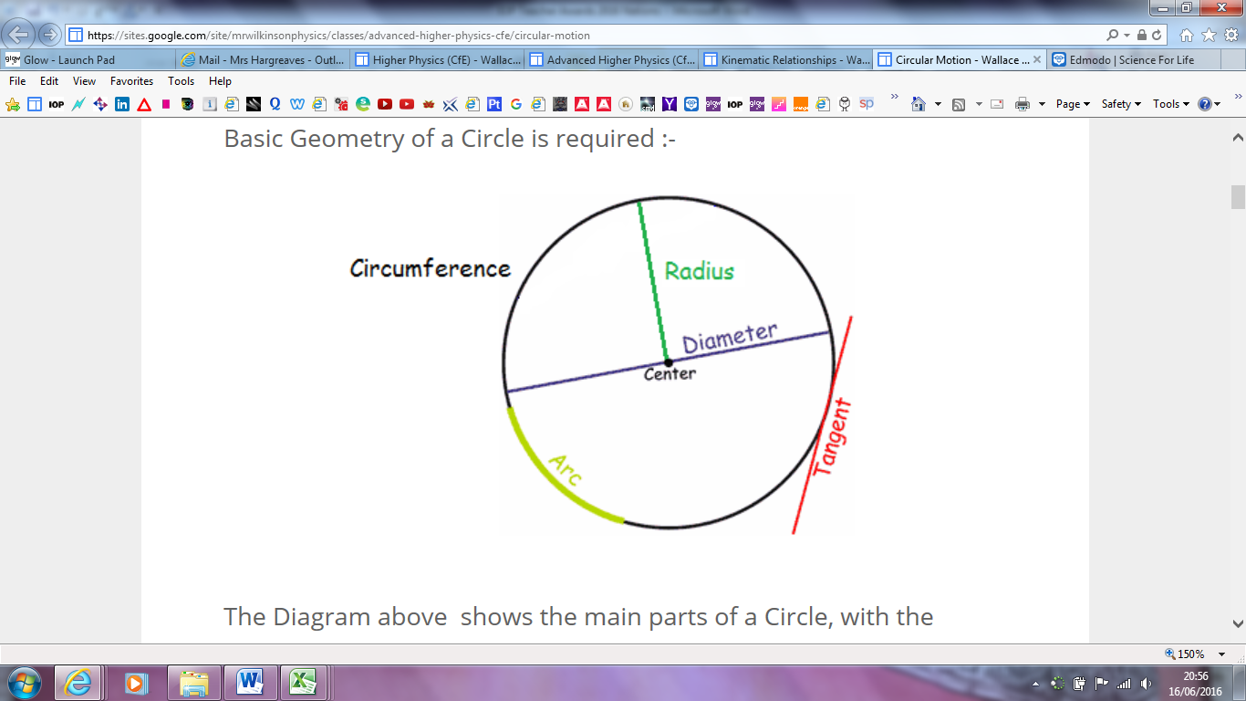

The diagram shows a circle with separate parts marked

* Circumference - The Length of the Perimeter of a Circle
* Arc - The length of a section of the Circumference of a Circle
* Diameter - The Length of the Line connecting opposite sides of a Circle through its center
* Radius - The Length of the Line connecting the Edge of a Circle to its center
* Tangent - A Line at a right angle to the Radius that 'touches' the edge of a Circle.

# Measuring Angles

*Angles are measured in radians (rad) on the SI system.*

*P*

*Q*

*r*

*r*

*r*

*1rad*

*1 radian is equal to the angle subtended at the centre of a circle when an object moves around the circle a distance equal to the radius of the circle.*

If we move round the circle a distance, r, we subtend 1 rad.

If we move round the circle a distance, 2r, we subtend 2 rad.

If we move round the circle a distance, 1.76r, we subtend 1.76 rad.

*P*

*Q*

*r*

*r*

*s*

θ

If we move round the circle a distance, 2πr, we subtend 2π rad.

But 2πr = circumference of a circle



If we move a distance, s, we subtend rads.



To describe how quickly an object moves around a circle we measure the angular velocity.

The angular velocity is the rate at which an object turns through an angle. If, in t seconds the object subtends θ rads then:



eg.

1. An electric drill rotates at 800 rpm, find its angular velocity.

In 1 rev there are 2π radians.

∴ in 800 revs there are 2π x 800 radians.



2. What is the angular velocity of the earth?

*1 rev takes 24 hours*

*∴ 1 rev takes 24 x 60 x 60 seconds = 86400 seconds*

*1 rev is 2π radians so:*



*3. Find the angular velocity of a washing machine which spins at 1300 rpm.*



NB. radians have no dimensions.

To relate linear speed, v, to angular speed take an object, P, moving around a circle or radius, r.

In time, t, P moves a distance, s, and reaches point P1:

*P*

*P1*

*r*

*r*

*s*

*θ*

*v*



*Looking back at the three questions from before we can now calculate the linear speed on the outer circumference of each object:*

|  |  |  |  |
| --- | --- | --- | --- |
|  | *ω (rad s-1)* | *radius (m)* | *v (m s-1)* |
| *Drill* | *83.8* | *0.005* | *0.42* |
| *Earth* | *7.3 x 10-5* | *6.4 x 106* | *467* |
| *Washing machine* | *136* | *0.2* | *27.2* |
| *Geostationary satellite* | *7.3 x 10-5* | *36 000 km above the Earth!!* | *3095* |

*(467 m s-1 represents the speed at the Earth’s equator, and is equivalent to 1045 mph!),*

*Remember that the radius of the earth MUST be added to the height above the earth when calculating satellite problems*

*Angular Acceleration α*

*α is defined as the rate of change of angular velocity with time, ie.*



*Equations of angular motion*



*ω = final angular velocity (rad s-1)*

*ω0= initial angular velocity (rad s-1)*

*α = angular acceleration (rad s-2)*

*t = time for change (s)*

*θ = angular displacement (rad)*

ANGULAR MOTION

|  |  |  |  |
| --- | --- | --- | --- |
| Concept | Translational | Rotational | Comments |
| Displacement |  |  |  |
| Velocity |  |  |  |
| Acceleration |  |  |  |
| Equations of motion  for constant  acceleration. |  |  |  |
|  |  |  |
|  |  |  |

# Angular Acceleration α

α is defined as the rate of change of angular velocity with time, ie.



# Equations of angular motion

ω = final angular velocity (rad s-1)

ω0= initial angular velocity (rad s-1)

α = angular acceleration (rad s-2)

t = time for change (s)

θ = angular displacement (rad)

# ANGULAR MOTION

1. A body moves with constant angular acceleration of 2 rad s-2. The angular velocity of the body is 4 rad s-1 at time t = 0 and a line OP on the body is then horizontal. Calculate the angle made by this line and the angular velocity when t = 3 s.

(21 rad, 10 rad s-1)

1. A wheel of diameter 2.4 m starts from rest and accelerates uniformly to an angular velocity of 100 rad s-1 after 20 s. Calculate the constant angular acceleration and the angle turned through.

(5 rad s-2, 1000 rad)

1. A flywheel rotates through 234 rad and attains an angular velocity of 108 rad s-1 after 3 s. Calculate the constant angular acceleration.

(20 rad s-2)

1. A wheel starts from rest and attains a speed of 30 rad s-1 in 40 s. Calculate the angular acceleration and the number of revolutions made by the wheel.

(0.75 rad s-2, 95.5 revs).

## Worked Answers

|  |
| --- |
| 1 |
| 2. |
|  |
|  |
| 4. |

|  |  |
| --- | --- |
| B  B  A  A  r  s = rθ | s = rθ |
| s  r  s = rθ  θ |  |
| ω  r  θ  v |  |
| ω  v = vT | Tangential speed, vT = rω |

ACCELERATION IN CIRCLES

All particles travelling in a circular motion experience **centripetal** (**radial acceleration)**. Only those whose **angular velocity** is changing experience **tangential acceleration**.

Any particle moving in a circular path has radial acceleration (although the linear velocity maybe constant). A particle may have angular acceleration which is described as the rate of change of angular velocity.

# ANGULAR ACCELERATION

**Angular acceleration α = dω / dt** . This is the rate of change of angular velocity. This may have the effect of increasing the velocity of the orbit.

α

## (Rate of change of angular velocity)



where ω-ωo is the change in angular velocity during the time interval t.

# TANGENTIAL ACCELERATION

a⊥

## (only experienced by objects whose angular velocity is changing)



If ω is increasing for a rotating wheel, then vT must be increasing.



where ω-ωo is the change in angular velocity during the time interval t.

**a⊥** If ω is increasing for a rotating wheel, then vT must be increasing.

**Tangential acceleration**

angular acceleration **α = dω/dt** but v=rω

dv/dt = r dω/dt

tangential acceleration a⊥ = rα



From the formula for tangential acceleration it can be seen that angular acceleration and tangential acceleration are related by the radius of the circle of motion.

# RADIAL OR CENTRIPETAL/ CENTRAL ACCELERATION

**Radial (centripetal acceleration) a= v2/r** . This is the rate of change of the direction of motion.

a

## (if objects are moving in circles their direction is changing and hence they are accelerating)



**Radial Acceleration**

**a= v2 / r** but v=rω

therefore v2 = r2 ω2

so a = r2 ω2 /r = **rω2**

A 150g ball at the end of a string is swinging in a horizontal circle of radius 0.60m. The ball makes exactly 2.00revs per second. What is its centripetal acceleration?

acc= v2/r therefore first find v

v= 2πr/t = 2 x 3.14 x 0.6/0.5 = 7.5 ms-1

acc. = v2/r = (7.5)2 /0.6 = 95 ms-2 (note the units of centripetal acc. are ms-2)

eg 2

The moon’s nearly circular orbit about the earth has a radius of about 385000 km and a period T of 27.3 days. Determine the acceleration of the moon towards the earth.

In orbit the moon travels a distance of 2πr where r =3.85 × 108 m

v = 2πr /T = 1.02×103 ms-1

a = v2/r = (1.02 × 103 )2/ 3.85 × 108 = 2.73 ×10-3 ms-2

or ω = 2π / t rads-1 = 2.66 ×10-6

a = rω2 = 3.85 x 108 ×2.66 ×10-6 = 2.73 × 10-3 ms-2

Central Force

# To calculate the size of a central force

We imagine an object moving with constant speed, v, around a circle of radius r. In a time, t, the object moves a distance, s, around the circle and subtends an angle θ.

We can find Δv using a vector triangle:

θ

r

r

O

S

#### B

#### A

#### D

θ

##### Diagram 1

We can find Δv using a vector triangle:

From diagram 1, AOBD contains two right-angled triangles + θ.



The magnitude of v1 and v2 are the same therefore redraw as:

v

v

Δv

θ/2

θ/2



v2

Δv

v1

θ

##### Diagram 2



The time taken for this change in velocity is t, where:

The acceleration at one instant is found by letting t become small (tend to zero). As t gets smaller so does .



# Radial/Centripetal Acceleration

dθ

r

r

#### B

#### A

#### C

#### D

#### VA

#### VB

#### -VA

#### VB

#### Y

#### X

#### Z

Consider a body moving with constant speed, v, in a circle of radius r.

(s = rθ, s = vt)



Change of velocity between A and B is given by subtracting vA from vB

(Δv = v – u as vectors can subtract or :-)



This acceleration vector is towards the centre of the circle as XZ is perpendicular to vB for very small changes in time.

This is called RADIAL ACCELERATION.

eg.

A 150g ball at the end of a string is swinging in a horizontal circle of radius 0.60m. The ball makes exactly 2.00revs per second. What is its centripetal acceleration?

acc= v2/r therefore first find v

v= 2πr/t = 2 x 3.14 x 0.6/0.5 = 7.5 ms-1

acc. = v2/r = (7.5)2 /0.6 = 95 ms-2 (note the units of centripetal acc. are ms-2)

eg 2

The moon’s nearly circular orbit about the earth has a radius of about 385000 km and a period T of 27.3 days. Determine the acceleration of the moon towards the earth.

In orbit the moon travels a distance of 2πr where r =3.85 × 108 m

v = 2πr /T = 1.02×103 ms-1

a = v2/r = (1.02 × 103 )2/ 3.85 × 108 = 2.73 ×10-3 ms-2

or ω = 2π / t rads-1 = 2.66 ×10-6

a = rω2 = 3.85 x 108 ×2.66 ×10-6 = 2.73 × 10-3 ms-2

ROUNDING A BEND

When a vehicle goes round a bend the friction force F1 between the wheels and the road acting towards the centre of the bend provides the centripetal force . As the speed of the vehicle increases so must the friction force. Eventually the friction will reach its maximum value (the friction force is then said to be overcome) this causes the vehicle to slide outwards thus increasing the value of *r*.

When a bike turns a corner the rider leans over at an angle to the vertical. The greater the speed of the cyclist the greater the angle of lean.

For the cyclist to move round a circle:



As there is no movement vertically:

 

Take moments about G (the centre of gravity), the total moment is 0.

θ





Combining (1), (2) and (3) gives:

As the velocity increases the value of *tan θ* must also increase. So the cyclist leans further over. As the cyclist turns faster the friction force has to increase. Eventually friction would be overcome and the cyclist would skid. However if the track is banked there will be a force towards the centre even when friction is overcome. This is the horizontal component of the reaction force. The vertical forces cancel each other out as the object is moving neither up nor down. So: 

θ

Horizontally there is a resultant force *R* sin *θ* towards the centre.



# The Conical Pendulum

As the mass moves in a horizontal circle there are two forces acting on it:

θ

l

# T

**W=mg**

θ

r

* the weight vertically downwards;
* the tension in the string.

Resolve the forces vertically – the forces should balance as the mass is in equilibrium vertically.



Horizontally the tension force has an unbalanced component towards the centre which is therefore providing the centripetal force.



## Question

1. An object, O, of mass 0.2 kg is whirled in a vertical circle at the end of a piece of string 1 m long at a steady rate of 5 revolutions per second.
2. Find the speed of the object. [31.4 m s-1]
3. Find the tension in the string when O is at the bottom of the circle. [199 N ]
4. Find the tension in the string when O is at the top of the circle. [195 N ]

Worked Answer.

i)



ii)



iii)



Torque

Some terms to get to grips with

# Inertia

Inertia is the property of a material that makes it easy or difficult to move/ start to move. *This property is directly related to mass*. The greater the mass the greater the inertia.

# Moment of inertia

This is another instance where linear and angular motions are analogous. The moment of inertia I is the property of a material which causes it to resist angular/ circular motion.

Here

*I=mr2*

The moment of inertia is not just related to the mass of the object but the distribution of its particles.

Moment of Inertia

Moment of inertia is defined as:-



e.g The moment of inertia depends on the size of the object and its mass distribution compared with the axis of rotation.

For AH the actual formula would be given as it varies with the shape and mass distribution of the particles

eg for a solid disc I= ½ mr2

for a rod fixed at one end 

for a rod fixed at in the middle 

# Moment of Force (term used for static problems)

The moment of force is its turning effect. It is given by

moment of force, Torque, T=F×r

It is easier to push open a door when pushing on the handle side than when pushing at the hinge.

# Torque (term used for dynamic problems)

When the force applied to an object causes rotation then we can call the force torque,

## T=F×r

T is a vector quantity and acts at right angles to the plane containing both F and r

In this example τ acts out of the page!

**F**

r

An unbalance torque causes an angular acceleration.

# Torque

We have already seen analogies between linear and rotational motion in ω, ωo, θ, t, α etc.

Analogies:

s=

u=

v=

a=

t=

### So there must also exists equivalents between Newton’s Laws of Motion.

#### Newton’s First Law of Linear Motion states:

An object will remain at rest, or move at constant velocity (speed in a straight line) unless acted upon by an unbalanced Force.

This becomes equivalent to

A freely rotating body will continue to rotate with constant angular velocity as long as no net force (or other torque) acts to change that motion.

A more difficult analogy exists for Newton’s 2nd law. That is, what gives rise to α? To start an object rotating requires a force. But the direction and point of application are important.

eg. a door:

The effect of F2 on the door is much less than F1.

r2

F2

r1

F1

α is proportional to F, but α is proportional to r (perpendicular distance from the axis of rotation to the line along which the force acts).

α ∝ F× distance from the pivot

α ∝ F×r

where F×r is called the ***moment of force or torque***

α ∝τ

So Newtons second law becomes ***τ=Iα***

We will see later what the term I means!.

If you talk in terms of momentum for Newtons second law then the equivalent is easy to follow

Newtons Second Law

“In the absence of external forces momentum is conserved” becomes

“In the absence of external torque, angular momentum is conserved”