

Name

Class Teacher

**Advanced Higher Physics**

**Electromagnetism**



**Problems**

# Data

**Common Physical Quantities**

|  |  |  |
| --- | --- | --- |
| Quantity | Symbol | Value |
| Gravitational acceleration | g | 9.8 m s-2 |
| Radius of Earth | RE | 6.4 x 106 m |
| Mass of Earth | ME | 6.0 x 1024 kg |
| Mass of Moon | MM | 7.3 x 1022 kg |
| Mean radius of Moon orbit |  | 3.84 x 108 m |
| Universal constant of gravitation | G | 6.67 x 10-11 m3 kg-1 s-2 |
| Speed of light in vacuum | c | 3.0 x 108 m s-1 |
| Speed of sound in air | v | 3.4 x 102 m s-1 |
| Mass of electron | me | 9.11 x 10-31 kg |
| Charge on electron | e | -1.60 x 10-19 C |
| Mass of neutron | mn | 1.675 x 10-27 kg |
| Mass of proton | mp | 1.673 x 10-27 kg |
| Planck’s constant | h | 6.63 x 10-34 J s |
| Permittivity of free space | 0 | 8.85 x 10-12 F m-1 |
| Permeability of free space | 0 | 4 x 10-7 H m-1 |

**Astronomical Data**

|  |  |  |  |  |  |  |  |
| --- | --- | --- | --- | --- | --- | --- | --- |
| Planet or  satellite | Mass/ kg | Density/  kg m-3 | Radius/ m | Grav. accel./ m s-2 | Escape velocity/ m s-1 | Mean dist from Sun/ m | Mean dist from Earth/ m |
| Sun | 1.99x 1030 | 1.41 x 103 | 7.0 x 108 | 274 | 6.2 x 105 | -- | 1.5 x 1011 |
| Earth | 6.0 x 1024 | 5.5 x 103 | 6.4 x 106 | 9.8 | 11.3 x 103 | 1.5 x 1011 | -- |
| Moon | 7.3 x 1022 | 3.3 x 103 | 1.7 x 106 | 1.6 | 2.4 x 103 | -- | 3.84 x 108 |
| Mars | 6.4 x 1023 | 3.9 x 103 | 3.4 x 106 | 3.7 | 5.0 x 103 | 2.3 x 1011 | -- |
| Venus | 4.9 x 1024 | 5.3 x 103 | 6.05 x 106 | 8.9 | 10.4 x 103 | 1.1 x 1011 | -- |

# Tutorial 1.0

**Coulomb’s inverse square law and electric field strength**

1. State Coulomb’s inverse square law for the force between two point charges.

State the name and unit for each symbol used in the above equation.

2. Calculate the electrostatic force between two electrons placed 1.5 nm apart.

3. The electrostatic repulsive force between two protons in a nucleus is 14 N.

Find the separation between the protons.

4. Four charges of +4.0 nC are situated at each of the corners of a square 0.10 m wide as shown below.



(a) Determine the electrostatic force on charge P.

(b) What is the electrostatic force on a –1.0 nC charge placed at the centre of the square. You must justify your answer.

5. Three +20 nC charges X, Y, Z are placed on a straight line as shown below.



Calculate the electrostatic force acting on charge Z.

6. State the meaning of the term ‘electric field strength at a point’.

7. State the equation for the electric field strength, *E*,

(a) at a distance *r* from a point charge *Q*

(b) between two parallel plates, a distance *d* apart, when a p.d. *V* is applied across the plates.

8. Derive the equation stated in 7 (b) above for a uniform electric field.

9. What is the electric field strength at 10-10 m from a helium nucleus?

10. A small sphere has a charge of +2.0 C. At what distance from the sphere is the magnitude of the electric field strength 72 000 N C-1?

11. Two parallel plates are separated by 0.020 m. A potential difference of 4.0 kV is applied across the plates.

+4.0 kV

0 V

(a) State the direction of the electric field strength between the plates.

(b) What is the value of the electric field strength

(i) mid-way between the plates

(ii) just below the top plate.

# Tutorial 1.1

**Coulomb's Inverse Square Law**

1 A charge of + 2.0 x 10-8 C is placed a distance of 2.0 mm from a charge of - 4.0 x 10-8 C.

(a) Calculate the electrostatic force between the charges.

(b) The distance between the same charges is adjusted until the force between the charges is   
1.0 x 10-4 N.

Calculate this new distance between the charges.

2 Compare the electrostatic and gravitational forces between a proton and electron which have an average separation of 2.0 x 10-10 m.

3 Let us imagine the Earth (mass 6.0 x 1024 kg) suddenly has an excess of positive charge and the Moon (mass 7.3 x 1022 kg) suddenly has an equal excess of positive charge. Calculate the size of the charge required so that the electrostatic force balances the gravitational force.

4 The diagram below shows three charges fixed in the positions shown.



Q1 = - 1.0 x 10-6 C, Q2 = + 3.0 x 10-6 C and Q3 = - 2.0 x 10-6 C.

Calculate the resultant force on charge Q1. (Remember that this resultant force will have a **direction** as well as magnitude).

5 Two like charged spheres of mass 0.10 g, hung from the same point by silk threads are repelled from each other to a separation of 1.0 cm by the electrostatic force. The angle between one of the silk threads and the vertical is 5.7°.

(a) By drawing a force diagram, find the electrostatic force FE between the spheres.

(b) Calculate the size of the charge on each sphere.

(c) The average leakage current from a charged sphere is 1.0 x 10-11 A. How long would it take for the spheres to discharge completely?

(d) Describe how the two spheres may be given identical charges.

6 In an experiment to show Coulomb's Law, an insulated, light, charged sphere is brought close to another similarly charged sphere which is suspended at the end of a thread of length 0.80 m. The mass of the suspended sphere is 0.50 g.

It is found that the suspended sphere is displaced to the left by a distance of 16 mm as shown below.



(a) Make a sketch showing all of the forces acting on the suspended sphere.

(b) Calculate the electrostatic force acting on the suspended sphere.

7. Explain how a charged strip of plastic can pick up small pieces of paper even although the paper has no net charge.

# Tutorial 2.0

**Electric fields and electrostatic potential**

1. A metallic sphere has a radius of 0.040 m. The charge on the sphere is + 30 C.

Determine the electric field strength

(a) inside the sphere;

(b) at the surface of the sphere;

(c) at a distance of 1.0 m from the centre of the sphere.

2. Describe, with the aid of a diagram, the process of charging by induction.

3. What is meant by the ‘electrostatic potential at a point’?

4. State the expression for the electrostatic potential at a distance *r* from a point charge *Q*.

5. Determine the electrostatic potential at a distance of 3.0 m from a point charge of + 4.0 nC.

6. Point A is 2.0 m from a point charge of – 6.0 nC . Point B is 5.0 m from the same point charge. Determine the potential difference between point A and point B.

7. What is meant by an equipotential surface?

8. A very small sphere carries a positive charge. Draw a sketch showing lines of electric field for this charge. Add lines of equipotential to your sketch using broken dashed lines.

9. Two charges of + 4.0 nC and –2.0 nC are situated 0.12 m apart.

Find the position of the point of zero electrostatic potential.

10. Which of the following are vector quantities:

electrostatic force, electric field strength, electrostatic potential, permittivity of free space, electric charge, potential difference.

11. Two charges each of +2.5 nC are situated 0.40 m apart as shown below.



(a) (i) What is the electrostatic potential at point X?

(ii) What is the electrostatic potential at point Y?

(b) Determine the potential difference between X and Y.

12. In a uniform electric field an electron gains 10-14 J when travelling between two points. What is the p.d. between these two points?

# Tutorial 2.1

**Electric Field Strength**

1 What is the electric field strength at a point where a small object carrying a charge of 4.0 C experiences a force of 0.02 N?

2 (a) Calculate the size of a point charge required to give an electric field strength of 1.0 N C-1 at a distance of 1.0 m from the point charge.

(b) State the magnitude of the electric field strength at a distance of 2.0 m from the point charge.

3 (a) Calculate the electric field strength due to an -particle at a point 5.0 mm from the   
-particle.

(b) How would the electric field strength calculated in (a) compare with the electric field strength at a point 5.0 mm from a proton?

4 The diagram below shows two charges of +10.0 nC and +18.8 nC respectively separated by 0.13m.



(a) Calculate the magnitude of the resultant electric field strength at the point P as shown in the diagram above.

(b) Make a sketch like the one above and show the direction of the resultant electric field strength at the point P.

Angles are required on your sketch.

5 A negatively charged sphere, of mass 2.0 x 10-5 kg, is held stationary in the space between two charged metal plates as shown in the diagram below.



(a) The sphere carries a charge of - 5.0 x 10 -9 C. Calculate the size of the electric field strength in the region between the metal plates.

(b) Make a sketch of the two plates and the stationary charged sphere. Show the shape and direction of the resultant electric field in the region between the plates.

6 Two charges of +8.0 x 10-9 C and +4.0 x 10-9 C are held a distance of 0.20 m apart.

(a) Calculate the magnitude and direction of the electric field strength at the mid-point between the charges.

(b) Calculate the distance from the 8.0 x 10-9 C charge at which the electric field strength is zero.

(c) The 4.0 x 10-9 C charge has a mass of 5.0 x 10-4 kg.

(i) Calculate the magnitude of the electrostatic force acting on the charge.

(ii) Calculate the magnitude of the gravitational force acting on the mass.

7 Copy and complete the electric field patterns for:

(a) the electric field between two parallel plates which have equal but opposite charges



(b) the electric field around 2 **unequal** but opposite charges.



8 Draw electric field lines and equipotential surfaces for the two oppositely charged parallel plates shown in the sketch below. (Include the fringing effect usually observed near the edge of the plates).



# Tutorial 3.1

**Electrostatic Potential**

1 Calculate the electrostatic potential at a point, P, which is at a distance of 0.05 m from a point charge of + 3.0 x 10-9 C.

2 Small spherical charges of +2.0 nC, -2.0 nC, +3.0 nC and +6.0 nC are placed in order at the corners of a square of diagonal 0.20 m as shown in the diagram below.



(a) Calculate the electrostatic potential at the centre, C, of the square.

(b) D is at the midpoint of the side as shown.   
Calculate the electrostatic potential **difference** between point C and point D.

3 A hydrogen atom may be considered as a charge of + 1.6 x 10-19 C separated from a charge of −1.6 x 10-19 C by a distance of 5.0 x 10-11 m.

Calculate the potential energy associated with an electron in a hydrogen atom.

4 Consider an equilateral triangle PQR where QR = 20 mm. A charge of   
+1.0 x 10-8 C is placed at Q and a charge of −1.0 x 10-8 C is placed at R. Both charges are fixed in place.

(a) Calculate the electric field strength at point P.

(b) Calculate the electrostatic potential at point P.

5 The diagram below shows two horizontal metal plates X and Y which are separated by a distance of 50 mm.. There is a potential difference between the plates of 1200 V. Note that the lower plate, X, is earthed.



(a) Draw a sketch graph to show how the potential varies along a line joining the mid-point of plate X to the mid-point of plate Y.

(b) Calculate the electric field strength between the plates.

(c) Explain how the value for the electric field strength can be obtained from the graph obtained in (a).

6 (a) State what is meant by an equipotential surface.

(b) The sketch below shows the outline of the positively charged dome of a Van de Graaff generator.



Copy this sketch and show the electric field lines and equipotential surfaces around the charged dome.

7 Two oppositely charged parallel plates have a potential difference of 1500 V between them. If the plates are separated by a distance of 20 mm calculate the electric field strength, in V m−1, between the plates.

8 A uniform electric field is set up between two oppositely charges parallel metal plates by connecting them to a 2000 V d.c. supply. The plates are 0.15 m apart.

(a) Calculate the electric field strength between the plates.

(b) An electron is released from the negative plate.

(i) State the energy change which takes place as the electron moves from the negative to the positive plate.

(ii) Calculate the work done on the electron by the electric field.

(iii) Using your answer to (ii) above calculate the velocity of the electron as it reaches the positive plate.

9 A proton is now used in the **same** electric field as question 8 above. The proton is released from the positive plate.

(a) Describe the motion of the proton as it moves towards the negative plate.

(b) (i) Describe how the work done on the proton by the electric field compares with the work done on the electron in question 8.

(ii) How does the velocity of the proton just as it reaches the negative plate compare with the velocity of the electron as it reaches the positive plate in the previous question?

10 (a) A sphere of radius 0.05 m has a potential at its surface of 1000 V. Make a sketch of the first 5 equipotential lines outside the sphere if there is 100 V between the lines. (i.e. calculate the various radii for these potentials).

(b) Calculate the charge on the sphere.

11 (a) Using the equation v = , calculate the speed of an electron which has been accelerated through a potential difference of 1.0 x 106 V.

(b) Is there anything wrong with your answer?

# Tutorial 4.0

**Charges in motion**

1. Two parallel plates are connected to a 1000 V supply as shown below. A –6.0 C charge is just at the lower surface of the top plate.



(a) How much work is done in moving the –6.0 C charge between the plates?

(b) Describe the energy transformation associated with the movement of a -6.0 C charge, when it is released from the **bottom** plate.

2. A p.d. of 3.0 x 104 V is applied between two large parallel plates. The electric field strength between the plates is 5.0 x 105 N C-1.

(a) Determine the separation of the parallel plates.

(b) The separation of the plates is reduced to half the value found in (a). What will happen to the magnitude of the electric field strength between the plates?

(c) An electron leaves one plate from rest and is accelerated towards the positive plate. Show that the velocity of the electron just before it reaches the positive plate is given by   
 where V is the p.d. between the plates.

3. An electron is projected along the axis midway between two parallel plates as shown below.



The kinetic energy of the electron is 2.88 x 10-16 J.

The magnitude of the electric field strength between the plates is 1.4 x 104 N C-1.

The length of the plates is 0.15 m. The plate separation is 0.10 m.

(a) Determine the initial horizontal speed of the electron as it enters the space between the plates.

(b) What is the vertical deflection, y1, of the electron?

(c) Describe the motion of the electron after it leaves the space between the plates.

4. A beam of electrons is accelerated from rest at a cathode towards an anode. After passing through the hole in the anode the beam enters the electric field between two horizontal plates as shown below.

A screen is placed 0.180 m beyond the end of the plates.

You may assume that there is no electric field between the anode and parallel plates and no electric field between the parallel plates and screen.



(a) The p.d. between the cathode and anode is 200 V.

Calculate the speed of each electron as it enters the space between the plates.

(b) The p.d. across the plates is 1.0 kV. The plates are 30 mm long and their separation is 50 mm. Calculate the deflection of an electron on leaving the parallel plates.

(c) Calculate the total deflection on the screen.

5. Electrons are accelerated through a p.d. of 125 kV.

(a) What speed would this give for the electrons, assuming that qV = ½ mv2?

(b) Why is the answer obtained in (a) unlikely to give the correct speed for the electrons?

6. Explain how the results of Millikan’s experiment lead to the idea of quantisation of charge.

7. In a Millikan oil drop experiment the oil drop has a mass of 0.01 g. It is suspended between two plates that are 20 mm apart. The charge on the drop is found to be –5e.

(a) Draw a sketch of the drop showing the forces acting on the drop. The upthrust of the air may be neglected.

(b) Determine the p.d. between the plates.

(c) The p.d. between the plates is increased.

Describe and explain what would happen to the drop?

8. In a Millikan type experiment, a small charged oil drop is held stationary between two plates by adjusting the p.d. between the plates. The experiment is repeated a number of times with different oil drops. The readings below show the mass of each oil drop and the p.d. required to hold it stationary.

Mass of drop/10-15 kg 2.6 1.2 1.6 2.3 4.8 5.9 1.8 3.7

p.d. / V 1592 2940 1960 2818 2940 14455 1470 4533

The plate separation is 40 mm.

(a) For each set of readings calculate the number of excess electrons on the oil drop.

(b) Suggest why these readings indicate that charge is quantised.

9. An alpha particle is about to make a head on collision with an oxygen nucleus. When at a large distance from the oxygen nucleus, the speed of the alpha particle was 1.9 x 106 m s-1. The mass of the alpha particle is 6.7 x 10-27 kg.

(a) State an expression for the change in kinetic energy of the alpha particle as it approaches the oxygen nucleus.

(b) State an expression for the change in electrostatic potential energy of the alpha particle.

(c) Using your answers to (a) and (b) derive an expression for the distance, *r*, of closest approach.

(d) Calculate the distance of closest approach for the alpha particle to the oxygen nucleus.

10. The distance of closest approach between an alpha particle and an iron nucleus is   
1.65 x 10-13 m. The mass of an alpha particle is 6.7 x 10-27 kg and the atomic number   
of iron is 26.

What was the speed of approach of the alpha particle?

# Tutorial 4.1

**Charges in Motion**

1 (a) Calculate the acceleration of an electron in a uniform electric field of strength   
1.2 x 106 V m−1.

(b) An electron is accelerated from rest in this electric field.

(i) How long would it take for the electron to reach a speed of 3.0 x 107 m s−1?

(ii) Calculate the displacement of the electron in this time

2 In a Millikan type experiment a very small oil drop is held stationary between the two plates.

|  |  |
| --- | --- |
| The mass of the oil drop is 4.9 x 10−15 kg.  (a) State the sign of the charge on the oil drop.  (b) Calculate the size of the charge on the oil drop. |  |

3 An -particle travels at a speed of 5.0 x 106 m s−1 in a vacuum.

(a) Calculate the minimum size of electric field strength necessary to bring the   
-particle to rest in a distance of 6.0 x 10−2 m.   
(The mass of an -particle is 6.7 x 10−27 kg).

(b) Draw a sketch of the apparatus which could be used to stop an -particle in the way described above.

(c) Can a -ray be stopped by an electric field? Explain your answer.

4 In an oscilloscope an electron enters the electric field between two horizontal metal plates. The electron enters the electric field at a point midway between the plates in a direction parallel to the plates. The speed of the electron as it enters the electric field is   
6.0 x 106 m s−1. The electric field strength between the plates is 4.0 x 102 V m−1.

The length of the plates is 5.0 x 10−2 m. The oscilloscope screen is a **further**   
0.20 m beyond the plates.

(a) Calculate the time the electron takes to pass between the plates.

(b) Calculate the vertical displacement of the electron on leaving the plates.

(c) Calculate the final direction of the electron on leaving the plates.

(d) What is the total vertical displacement of the electron on hitting the oscilloscope screen.

5 Electrons are accelerated through a large potential difference of 7.5 x 105 V. The electrons are initially at rest.

Calculate the speed reached by these electrons.

6 In the Rutherford scattering experiment -particles are fired at very thin gold foil in a vacuum. On very rare occasions an -particle is observed to rebound back along its incident path.

(a) Explain why this is not observed very often.

(b) The -particles have a typical speed of 2.0 x 107 m s−1.

Calculate the closest distance of approach which an -particle could make towards a gold nucleus in a head-on collision. The atomic number of gold is 79. The mass of the -particle is 6.7 x 10−27 kg.

7 In Millikan's experiment, an negatively charged oil drop of radius 1.62 x 10−6 m is held stationary when placed in an electric field of strength 1.9 x 105 V m−1.

(The density of the oil is 870 kg m−3, and the volume of a sphere is  r3.)

(a) Calculate the mass of the oil drop.

(b) Calculate the charge on the oil drop.

(c) How many electronic charges is your answer to (b) equivalent to?

8 A charged particle has a charge-to-mass ratio of 1.8 x 1011 C kg−1.

Calculate the speed of one such particle when it has been accelerated through a potential difference of 250 V.

# Tutorial 5.0

**Electromagnetism**

1. (a) State the condition for a magnetic field to exist.

(b) Under what conditions will a charged particle experience a force in a magnetic field?

(c) State the definition of the tesla.

2. (a) State the expression for the force on a current carrying conductor placed at an angle  in a magnetic field.

(b) Draw a sketch to show the position of this angle , the direction of the electron flow in the conductor, the direction of the magnetic induction and the direction of the force.

(c) A straight conductor of length 25 mm carries a current of 2.0 A. It experiences a force of 9.5 mN when placed in a magnetic field with a magnetic induction of 0.70 T.   
Calculate the angle between the direction of the magnetic field and the conductor.

3. A wire, carrying a current of 10 A, is placed at right angles to a magnetic field. A straight section of the wire 0.80 m long has a force of 0.20 N acting on it.

Calculate the size of the magnetic induction of the magnetic field.

4. A straight wire of length 0.50 m is placed in a region of magnetic induction 0.10 T.

(a) What is the minimum current required in the wire to produce a force of 0.30 N on the wire?

(b) Why is this a minimum value?

5. A wire of length 200 mm is placed at an angle of 35o to a magnetic field of magnetic induction 0.15 T.



(a) The current in the wire is 7.0 A.

Calculate the magnitude of the force on the wire.

(b) State the direction of this force.

6. State the expression for the magnetic induction at a perpendicular distance r from an infinite straight conductor carrying a current I.

7. Derive the expression



using the expression stated in question 6. State clearly the meaning of all the symbols in this expression.

8. Two long parallel wires are placed 90 mm apart in air. One of the wires is carrying a current of 2.0 A and the force per unit length on the wire is 8.89 x 10-6 N m-1. What is the current in the other wire?

9. A long wire X is fixed horizontally to the ground. A second very thin wire, Y, of weight 0.075 newtons per metre length, runs parallel to wire X. The magnetic repulsion between the wires causes wire Y to be suspended 5.0 mm above wire X. The wires carry the same current, I. Calculate the value of I.

# Tutorial 5.1

**Force on a Conductor**

1 A straight wire, 0.05 m long, is placed in a uniform magnetic field of magnetic induction 0.04 T.

The wire carries a current of 7.5 A, and makes an angle of 60° with the direction of the magnetic field.

(a) Calculate the magnitude of the force exerted on the wire.

(b) Draw a sketch of the wire in the magnetic field and show the direction of the force,

(c) Describe the conditions for this force to be a maximum.

2 A straight conductor of length 50 mm carries a current of 1.4 A. The conductor experiences a force of 4.5 x 10−3 N when placed in a uniform magnetic field of magnetic induction 90 mT.

Calculate the angle between the conductor and the direction of the magnetic field.

3 A wire of length 0.75 m and mass 0.025 kg is suspended from two very flexible leads as shown.



wire is in a magnetic field of magnetic induction 0.50 T. The magnetic field direction is ‘into the page’.

(a) Calculate the size of the current in the wire necessary to remove the tension in the supporting leads.

(b) Copy the sketch and show the direction of the electron current which produced this result.

4 The sketch below shows the rectangular coil of an electric motor. The coil has 120 turns and is 0.25 m long and 0.15 m wide and carries a current of 0.25 A. It lies parallel to a magnetic field of magnetic induction 0.40 T. The sketch shows the directions of the forces acting on the coil.

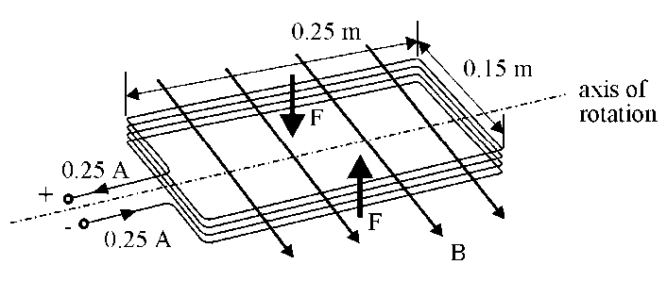

(a) Calculate the magnitude of the force, F, on each of the wires shown.

(b) Calculate the torque which acts on the coil when in this position.

(c) State and explain what will happen to this torque as the coil starts to rotate in the magnetic field.

5 The diagram below shows a force-on-a-conductor balance set up to measure the magnetic induction between two flat magnets in which a north pole is facing a south pole.

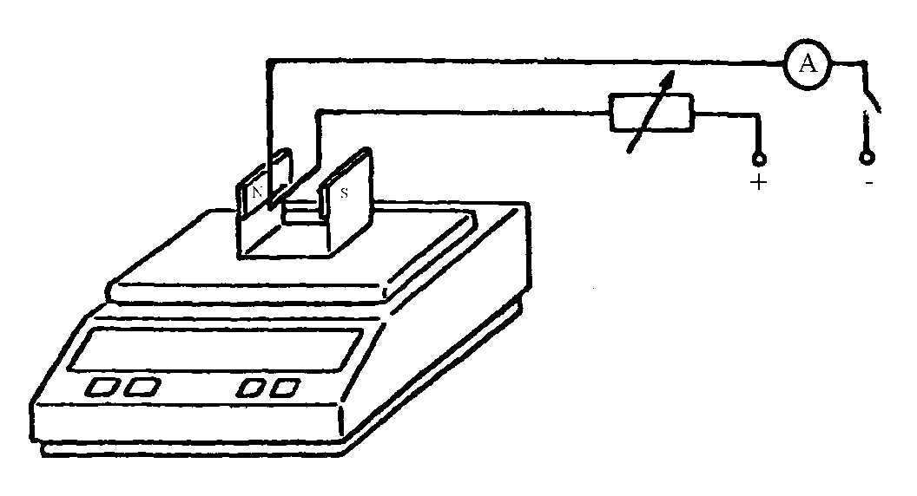

The length of the wire in the magnetic field is 0.06 m.

When the current in the wire is zero, the reading on the balance is 95.6 g. When the current is 4.0 A the reading on the balance is 93.2 g.

(a) Calculate the magnitude and direction of the force on the wire from these balance readings.

(b) Calculate the size of the magnetic induction between the poles of the magnets.

(c) Suggest what the reading on the balance would be if the connections to the wire from the supply were reversed. Explain your answer.

(d) Suggest what the reading on the balance would be if one of the magnets is turned over so that the north face on one magnet is directly opposite the north face of the other magnet. Explain your reasoning.

6 Two parallel wires 0.20 m apart carry large direct currents to an iron recycling plant. The large currents passing into the metal generate enough heat to make the iron melt. It can then be made into new shapes.

(a) Calculate the force between two such wires 16 m long if they each carry a current of 2500 A.

(b) Hence explain why these wires are not suspended freely on their route to the iron smelter.

# Tutorial 6.0

**Motion in a magnetic field**

1. Derive the expression F = qvB using the relationship F = I*l*Bsin with  = 90°.

State clearly the name and unit of all the symbols in this expression.

2. A proton travels at right angles to a magnetic field of magnetic induction 0.80 T.

The speed of the proton is 3.0 x 104 m s-1. Determine the force on the proton.

3. An electron is moving at right angles to a magnetic field of magnetic induction 0.50 T. The velocity of the electron is 2.0 x 105 m s-1.

(a) Calculate the magnitude of the force on the electron.

(b) State the direction of the force on the electron.

(c) Determine the radius of the circular path of the electron.

4. The movement of an electron in a uniform magnetic field is found to be helical.

Explain how this helical movement arises.

5. ‘Crossed’ electric and magnetic fields can be used in a velocity selector.

(a) Explain what is meant by ‘crossed’ electric and magnetic fields.

(b) The velocity selector ‘selects’ charged particles, which pass through the fields without being deflected. By considering the magnetic force and electrostatic force on a charged particle show that the ‘selected’ velocity is E/B.

(c) State, with a reason, if the selected velocity depends on:

(i) the charge of the particle;

(ii) the mass of the particle.

(d) In a mass spectrometer ions from a velocity selector enter a region that only has a magnetic field. With the aid of a sketch, explain how the ions can be identified by their deflection.

6. In a J J Thomson type experiment the charge to mass ratio is to be determined. Crossed magnetic and electric fields are used to produce an undeflected beam.

(a) Derive an expression for the velocity of the electrons in this undeflected beam in terms of the magnetic induction, B, the p.d. across the plates, V, and the plate separation, d.

(b) The magnetic field is then applied by itself and the electron beam moves in a circular path of radius, r.

By considering the central force on the electrons derive an expression for e/m in terms of the velocity of the electrons and this radius, r.

(c) Use the expressions stated in (a) and (b) above to show that

.

7. In a mass spectrometer two isotopes of single ionised carbon-13 and carbon-12 ions are accelerated by a p.d. of 4.0 kV. They emerge from a small slit into a uniform magnetic field of magnetic induction 0.25 T as shown below.



Calculate the separation, d, of the two carbon ions.

# Tutorial 6.1

**Charged Particles in Magnetic Fields**

1 A particle carrying a positive charge of 1.6 x 10−19 C travels at 1.0 x 107 m s−1 and enters a magnetic field at an angle of 45°. The force experienced by the particle is 3.0 x 10−17 N.  
Calculate the size of the magnetic induction required to produce this result.

2 Close to the equator the horizontal component of the Earth's magnetic field has a magnetic induction of 3.3 x 10−5 T. A high energy proton arrives from outer space with a vertical velocity of 2.8 x 108 m s−1.   
  
Show that the ratio of the magnetic force, Fm, to gravitational force, Fg, experienced by the proton is given by = 3.2 x 1010.

3 Inside a bubble chamber, a proton is injected at right angles to the direction of the magnetic field of magnetic induction 0.28 T. The kinetic energy of the proton is 4.2 x 10−12 J.

Calculate the radius of the circle described by the track of the proton.

4 An electron and an alpha particle both make circular orbits in the same magnetic field. Both particles have the same orbital speed. The mass of an alpha particle is 6.68 x 10−27 kg.

Calculate the ratio .

5 A cyclotron has an oscillator frequency of 1.2 x 107 Hz and a maximum effective dee radius of 0.50 m. The sketch below shows the geometry of the cyclotron. The deflector plate is mounted at the maximum radius of 0.50 m and its purpose is to ensure that the charged particles exit successfully.

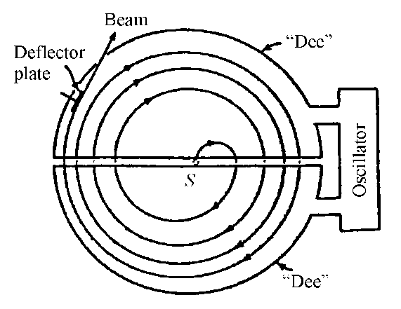

(a) Show that the frequency of rotation is given by f = .

(b) The cyclotron is used to accelerate deuterons from rest. Calculate the magnetic induction, of the magnetic field of the cyclotron, needed to accelerate the deuterons. (A deuteron is an isotope of hydrogen, containing a proton and a neutron, with a mass of 3.34 x 10−27 kg.)

(c) Calculate the kinetic energy of the emerging deuterons.

6 (a) Certain charged particles can be 'selected' from a beam of charged particles if they are made to enter crossed electric and magnetic fields. The directions of the fields are mutually perpendicular.  
Show that those particles with a velocity equal to the ratio will be undeflected.

(b) A velocity selector such as that in (a) above has a magnetic induction of   
0.70 T and an electric field strength of 1.4 x 105 V m−1.

Calculate the velocity of the undeflected charged particles which pass through the crossed fields.

(c) The sketch below shows a mass spectrometer arrangement used to deflect ions. After the exit slit from the velocity selector there is only a magnetic field present. (The final position of the ions is detected by a photographic plate).

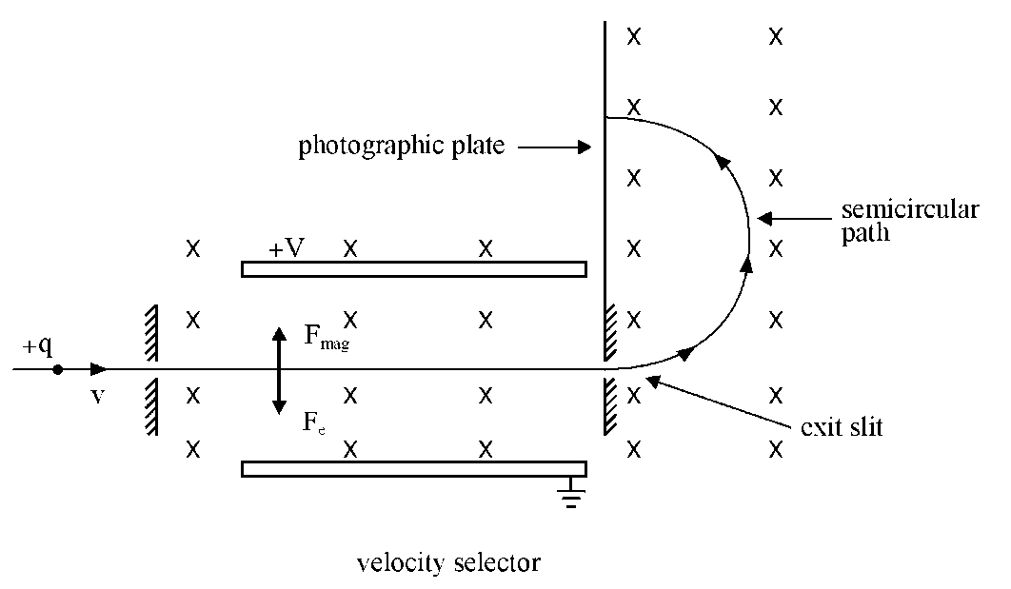

(i) Negatively charged neon ions, which carry one extra electron, emerge from the velocity selector into a uniform magnetic field of magnetic induction 0.70 T. The ions follow the semi-circular path shown above. The radius of the circle is 70 mm.

Calculate the mass of the neon ions.

(ii) Isotopes are nuclei having the same atomic number but different mass numbers. Explain how the mass spectrometer can show the presence of different isotopes of neon.

7 An alpha particle travels in a circular orbit of radius 0.45 m while moving through a magnetic field of magnetic induction 1.2 T. Calculate:

(a) the speed of the alpha particle in its orbit

(b) the orbital period of the alpha particle

(c) the kinetic energy of the alpha particle in its orbit.

8 The diagram below shows the Earth's magnetic field. Three positively charged particles, X, Y and Z approach the Earth along the directions shown.  
Path Y is perpendicular to the direction of the Earth’s magnetic field lines.

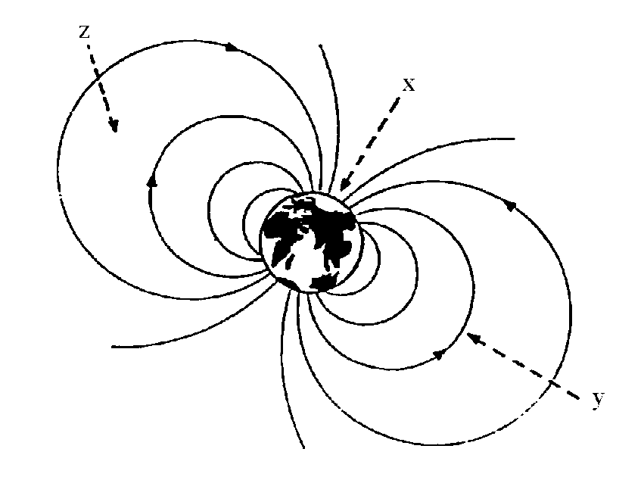

(a) For each of the particles, describe the path followed in the Earth's magnetic field.

(b) A proton approaches the earth along path Y with a speed of 2.0 x 106 m s−1.  
Calculate the radius of the path of the proton at a point where the magnetic induction of the Earth is 1.3 x 10−5 T.

9. In an experiment to measure the charge to mass ratio for an electron, an electron beam is fired between parallel plates in a vacuum tube. The vacuum tube is placed between a pair of Helmholtz coils.

(a) Crossed electric and magnetic fields are applied to produce an undeflected beam. The current, I, in the Helmholtz coils is measured to be 0.31 A.   
The p.d., V, across the plates is 1200 V.

(i) Show that the velocity, v, of the electrons between the plates is given by   
v =  where d is the plate separation and B the magnetic induction.

(ii) The magnetic induction, B, is given by  where N, the number of turns, is 320 and a, the effective radius of the coils, is 0.073 m.  
Calculate the magnetic induction B.

(iii) The plate separation, d, is 0.045 m.  
Calculate the magnitude of the velocity of the electrons.

(b) The electric field is switched off and the above magnetic field only is applied. A deflection, y, of 0.015 m is measured.

(i) Show that the charge to mass ratio = where r is the radius of the curved path of the electrons when only the magnetic field is applied.

(ii) The radius, r, is given by r = (L2 + y2)/2y where L, the length of the plates, is 0.055 m.   
Calculate the charge to mass ratio for the electrons from this data.

10 The sketch below shows the layout of the apparatus which allows crossed electric and magnetic fields to be applied to an electric beam. (The Helmholtz coils which produce the magnetic field 'into the paper' have been omitted for clarity).

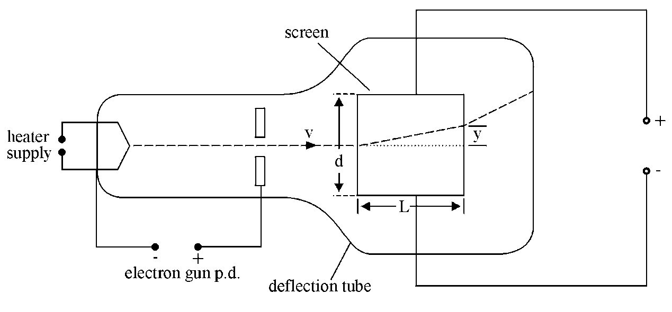

The screen is 0.05 m square. The length, L, and separation, d, are both 0.05 m.

(a) With only the electric field switched on the p.d. between the plates is set at 1200 V. The vertical deflection, y, of the electron beam at the end of the plates is 1.0 cm.  
Calculate the electric field strength between the plates which provides this deflection.

(b) (i) **Both** the electric and magnetic fields are now applied. The electron beam is undeflected when the current to the Helmholtz coils is 0.25 A. The coils have 320 turns and an effective radius of 0.068 m.

Using the expression B = , calculate the value this gives for the magnetic induction between the plates.

(ii) Calculate the speed of the electrons as they enter the plates.

(c) With the electric field **only** applied, the electron beam has a vertical deflection, y of 1.0 cm at the end of the plates.

(i) Show that the deflection y =a    
where a is the acceleration produced by the electric field and v is the speed of the electrons entering the plates as shown in the diagram.

(ii) Using the data in the question, calculate a value for the charge to mass ratio, , for the electron.

11. Apparatus similar to that shown in question 10 is used in another experiment to determine the charge to mass ratio for the electron. The length of the plates L and their separation d are 0.05 m.

In **this** experiment the p.d. across the electron gun is set at 1000 V. Assuming the electrons leave the cathode with zero speed, the speed of the electrons entering the plates can be determined using this electron gun potential difference.

(a) Show that =  where v is the speed of the electrons as they leave the electron gun.

(b) Both the electric and magnetic fields are applied to give an undeflected beam. The p.d. across the plates is 1000 V. The current in the Helmholtz coils to give an undeflected beam is measured to be 0.26 A.

(i) Use the expression B =  where the number of turns, N, is 320 and the effective radius r of the coils is 0.068 m, to calculate the size of the magnetic induction between the plates.

(ii) Calculate the magnitude of the speed v of the undeflected electrons when they are between the plates.

(c) Calculate the charge to mass ratio for the electrons from this data.

(d) The overall uncertainty in this experiment was estimated to be 5 %.

(i) Express the measured value of the charge to mass ratio as   
(value ± absolute uncertainty).

(ii) Consider the accepted value and comment on the accuracy of this experiment.

# Tutorial 7.0

**Capacitors in d.c. circuits**

1. A 50 µF capacitor is charged until the p.d. across it is 100 V.

(a) Calculate the charge on the capacitor when the p.d. across it is 100 V.

(b) (i) The capacitor is now ‘fully’ discharged in a time of 4·0 ms.

Calculate the average current during this time.

(ii) Why is this average current?

2. A capacitor stores a charge of 3·0 × 10–4 C when the p.d. across its terminals is 600 V.

What is the capacitance of the capacitor?

3. A 15 µF capacitor is charged using a 1·5 V battery.

Calculate the charge stored on the capacitor when it is fully charged.

4. (a) A capacitor stores a charge of 1·2 × 10–5 C when there is a p.d. of 12 V across it. Calculate the capacitance of the capacitor.

(b) A 0·10 µF capacitor is connected to an 8·0 V d.c. supply. Calculate the charge stored on the capacitor when it is fully charged.

5. In the circuit below the capacitor C is initially uncharged.

9 V

C

A

V

S

**+**

**–**

Switch S is now closed. By carefully adjusting the variable resistor R a constant charging current of 1·0 mA is maintained.

The reading on the voltmeter is recorded every 10 s. The results are shown in the table.

|  |  |  |  |  |  |
| --- | --- | --- | --- | --- | --- |
| Time / s | 0 | 10 | 20 | 30 | 40 |
| V / V | 0 | 1·9 | 4·0 | 6·2 | 8·1 |

(a) Plot a graph of the charge on the capacitor against the p.d. across the capacitor.

(b) Use the graph to calculate the capacitance of the capacitor.

6. The circuit below is used to charge and discharge a capacitor.

100 V

*V*R

*V*C

1

2

A

B

The battery has negligible internal resistance.

The capacitor is initially uncharged.

*V*R is the p.d. across the variable resistor and *V*C is the p.d. across the capacitor.

(a) Is the position of the switch at 1 or 2

(i) in order to charge the capacitor

(ii) in order to discharge the capacitor?

(b) Sketch graphs of *V*R against time for the capacitor charging and discharging. Show numerical values for the maximum and minimum values of *V*R.

(c) Sketch graphs of *V*C against time for the capacitor charging and discharging. Show numerical values for the maximum and minimum values of *V*C.

(d) (i) When the capacitor is charging what is the direction of travel of the electrons between points A and B in the wire?

(ii) When the capacitor is discharging what is the direction of travel of the electrons between points A and B in the wire?

(e) The capacitor has a capacitance of 4·0 µF. The resistor has resistance of 2·5 MΩ.

Calculate:

(i) the maximum value of the charging current

(ii) the charge stored by the capacitor when the capacitor is fully charged.

7. The circuit shown is used to investigate the charge and discharge of a capacitor.

12 V

*V*R

*V*C

2

1

1 k

10 mF

A

The switch is in position 1 and the capacitor is uncharged.

The switch is now moved to position 2 and the capacitor charges.

The graphs show how *V*C, the p.d. across the capacitor, and *V*R, the p.d. across the resistor, vary with time.

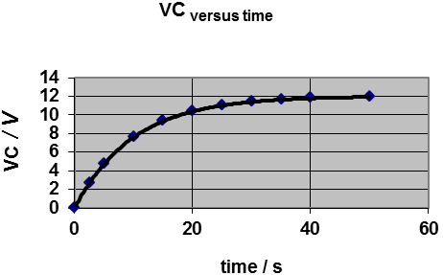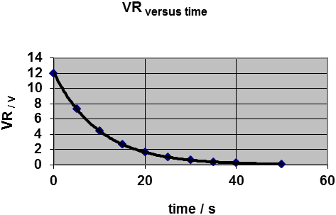

(a) Use these graphs to sketch a graph to show how the current varies with time in the circuit.

(b) The experiment is repeated with the resistance changed to 2 kΩ.

Sketch the graphs above and on each graph sketch the new lines which show how *V*C, *V*R and *I* vary with time.

(c) The experiment is repeated with the resistance again at 1 kΩ but the capacitor replaced with one of capacitance 20 mF. Sketch the original graphs again and on each graph sketch the new lines which show how *V*C, *V*R and *I* vary with time.

(d) (i) What does the area under the current against time graph represent?

(ii) Compare the areas under the current versus time graphs in part (a) and in your answers to (b) and (c). Give reasons for any increase or decrease in these areas.

(e) At any instant in time during the charging what should be the value of (*V*C + *V*R)?

(f) The original values of resistance and capacitance are now used again and the capacitor fully charged. The switch is moved to position 1 and the capacitor discharges.

Sketch graphs of *V*C, *V*R and *I* from the instant the switch is moved until the capacitor is fully discharged.

8. State what is meant by the time constant in an RC circuit.

9. In an RC circuit the time constant *t* is given by the relationship *t = RC*.

Show that the product *RC* has the unit of time.

10. A circuit is made up of a 2 F capacitor and a 4 k resistor. Calculate the capacitive time constant.

11 A student sets up a circuit to measure the capacitive time constants for three RC circuits as a capacitor discharges.

+

−

C

1 M

*V*

C is either a single capacitor or two capacitors in series. The table shows the resistance of R, the capacitor arrangement used and the value of the time constant.

|  |  |  |
| --- | --- | --- |
| **Resistance of R** | **Capacitor arrangement** | **Time constant (s)** |
| 1 M | 1 F only | 1 |
| 1 M | 4 F only | 4 |
| 1 M | 1 F and 4 F in series | 0.8 |

Use the results in the table to show that the total capacitance *C*total of two capacitors of capacitance *C*1 and *C*2 in series is given by



12. A circuit comprises a resistor of resistance *R* and capacitor of capacitance *C* connected in series. The capacitor is fully charged then discharged. The p.d. across the capacitor as it discharges is given by .

where *V*o is the p.d. across the capacitor when fully charged.

Show that at a time equal to the capacitive time constant RC, after the capacitor starts to discharge, the p.d. across the capacitor will be given by .

(b) A 4·0 F capacitor is charged to a p.d. of 12 V. It is then connected across a 2.0 M resistor so that it discharges.

(i) Calculate the capacitive time constant.

(ii) Calculate the p.d. across the capacitor 4 s after it starts to discharge.

# Tutorial 7.1

**Capacitors in a.c. circuits**

1. A capacitor is connected to a variable frequency a.c. supply as shown below. The amplitude of the output voltage from the supply is kept constant.

Variable frequency

Constant amplitude supply

˜

C

(a) The capacitor has reactance. State what is meant by the term ‘reactance’.

(b) The frequency of the output from the a.c. supply is increased.

Sketch a graph to show how:

(i) the reactance of the capacitor varies with the frequency of the supply

(ii) the current in the circuit varies with the frequency of the supply.

2. A 1·0 F capacitor is connected to 5·0 V a.c. power supply. The frequency of the a.c. supply is 50 Hz.

(a) Calculate the capacitive reactance of the capacitor.

(b) Calculate the current in the circuit.

3. A capacitor is connected across a 250 V r.m.s supply having a frequency of 50 Hz. The current in the capacitor is 0·50 A r.m.s.

Calculate:

(a) the reactance of the capacitor at this frequency

(b) the capacitance of the capacitor.

4. A 500  resistor and a capacitor are connected in series across an a.c. supply. The frequency of the a.c. is 50 Hz. The p.d. across the resistor is 120 V. The p.d. across the capacitor is 160 V.

(a) Calculate the current in the circuit.

(b) Calculate the capacitance of the capacitor.

5. A 300  resistor and a capacitor are connected in series with an a.c. supply of frequency 100 Hz.

The p.d. across the capacitor is 5.00 V. When the frequency of the output from the supply is 100 Hz the capacitive reactance of the capacitor is 265 

Calculate:

(a) the capacitance of the capacitor

(b) the current in the circuit

(c) the p.d. across the resistor.

6. A resistor and a capacitor are connected in series with a variable frequency constant amplitude a.c. supply. The combined effect of the resistance *R* and capacitive reactance *X*C in series is known as the impedance *Z* of the circuit where



*Z* can be calculated from *Z* = *V*/*I* where *V* is the voltage of the supply and *I* is the current in the circuit.

The value of *Z* is found for different frequencies and the data used to plot the following graph.

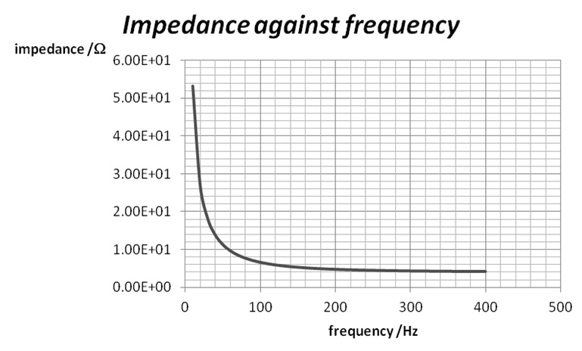

Use the graph and knowledge of the relationship for *Z* and to estimate:

(a) the value of the resistance;

(b) the value of the capacitance.

# Tutorial 8.0

**Self-inductance**

1. (a) A student is investigating the production of an induced e.m.f. across a coil.

Describe a simple experiment which would allow her to do this.

(b) State three ways in which the magnitude of the induced e.m.f. across a coil can be increased.

2. An inductor, resistor and battery are joined in series as shown below.



(a) The inductor has a large number of turns. The switch is closed. Sketch a graph to show how the current in the circuit varies with time.

(b) Explain why the current does not reach its maximum value immediately.

(c) The resistance of the resistor is reduced. How would the shape of the graph alter ?

(d) The number of turns on the inductor is considerably reduced. State how the graph drawn in part (a) would alter.

3. A circuit is set up as shown below.



Explain how an induced e.m.f. is produced across the coil.

4. When the current through an inductor is increasing the induced e.m.f. opposes this increase in current. The current takes time to reach its maximum value.

(a) Explain what happens when the current through an inductor decreases.

(b) The current through an inductor decreases. Use the conservation of energy to explain the direction of the induced e.m.f.

5. (a) The current through a coil changes. State the equation for the e.m.f. induced across the coil in terms of the self-inductance of the coil.

(b) State the unit of inductance.

(c) State the equation for the energy stored in the magnetic field of an inductor.

6. An inductor, resistor and d.c. supply are connected in series as shown below.



The internal resistance of the d.c. supply is negligible.

The inductance of the inductor is 0.40 H. The resistance of the resistor is 15 .

The switch is now closed.

(a) Why does it take a short time for the current to reach its steady value?

(b) Calculate the steady current reached.

(b) When the current reaches a steady value, calculate the energy stored in the inductor.

7. An inductor is connected to an ammeter and an 8.0V direct supply of negligible internal resistance, as shown below. The resistance of the inductor coil is 20 .



When the reading on the ammeter is 0.10 A, the rate of change of current is 100 A s-1.

(a) Calculate the p.d. across the coil.

(b) Find the induced e.m.f. across the coil.

(c) Calculate the inductance of the coil.

(d) Calculate the energy stored in the inductor.

9. Which of the following are vector quantities:

induced e.m.f., self-inductance, energy stored in an inductor, rate of change of current.

10. An inductor is connected to a variable a.c. supply as shown below.



(a) (i) The frequency of the a.c. supply is increased.   
Draw a graph to show how the current in the circuit varies with the frequency of the supply.

(ii) The inductor is removed and replaced by a capacitor. Draw another graph to show how the current in the circuit varies with the frequency of the supply.

(b) The inductor has reactance. State what is meant by the term ‘reactance’.

11. Describe an example of the use of an inductor:

(a) as a source of a high e.m.f.

(b) in blocking a.c. signals while transmitting d.c. signals.

# Tutorial 8.1

**Self-Inductance**

1 The sketch below shows an inductor connected to a 12 V direct supply of negligible internal resistance. The resistance of the coil is 1  (as shown). When switched on the current grows from zero. The rate of growth is 400 A s-1 when the current is 8.0 A.

_

+

L

1 

12 V

(a) Calculate the induced e.m.f. across the coil when the current is 8 A.

(b) Calculate the inductance of the coil.

(c) Calculate the rate of increase of current when the switch is closed.

(d) A final steady value of current is produced in the coil.

Find the value of this current.

(e) Calculate the final energy stored in the inductor.

2 An inductor with a removable soft iron core is connected in series with a 3.0 V direct supply of negligible internal resistance as shown below. A milliammeter is used to monitor the current in the circuit.

10

0

15

I/mA

t/s

+

_

L

A

The switch is closed. The graph above shows the variation of current with time.

(a) (i) Explain why it takes some time for the current to reach its maximum value.

(ii) Why does the current remain constant after it reaches its maximum value.

(b) The soft iron core is then partly removed from the coil and the experiment repeated.

Draw a sketch graph showing how the current varies against time for this second experiment. Use the same numerical values on the axes as those in the graph above.

(c) Calculate the resistance of the coil.

3 In the circuit shown below, the resistance of resistor R is 40  and the inductance of inductor L is 2.0 H. The resistance of the inductor may be neglected. The supply has an e.m.f. of 10 V and a negligible internal resistance.

R

_

+

L

10 V

(a) Immediately after the switch is closed:

(i) state the p.d. across the 40  resistor

(ii) calculate the size of the current

(iii) state the induced e.m.f. across the 2.0 H inductor

(iv) calculate the energy stored in the inductor.

(b) Some time later the current reaches a value of 0.040 A.

(i) At this time, calculate the p.d. across R.

(ii) Calculate the p.d. across the inductor at this time.

(iii) Hence calculate the rate of growth of current when the current in the circuit is 0.040 A.

(iv) Calculate the energy stored in the inductor.

4 (a) Describe what is meant by the self-inductance of a coil.

(b) The circuit diagram below shows a resistor, inductor and two lamps connected to a direct supply of 10 V. The supply has negligible internal resistance. The rating of each lamp is 6 V, 3 W.

R

S

_

+

Y

L

X

10 V

After the switch is closed each lamp operates at its rated power. However lamp Y lights up before lamp X.

(i) Explain why lamp Y lights before lamp X.

(ii) The current in lamp X grows at a rate of 0.50 A s-1 just as the switch is closed. Calculate the inductance of the coil.

(iii) Calculate the resistance of the coil.

5. The diagram below shows the principle of the spark plug for a car engine.

primary

_

+

12 V

car battery

cam

contact S

secondary

spark plug

The cam, which is rotated by the engine, makes and breaks contact at S. This switches on and off the current to the primary of a transformer.

When the contact at S is **opened** a high voltage spark of around 20 kV is induced across the spark plug.

(a) Explain why a voltage is induced across the spark plug particularly when S is opened.

(b) Explain whether a step-up or step-down transformer would be more useful in this case.

(c) Where does the energy for the spark come from?

6 The magnet in the sketch below is mounted like a pendulum. It is allowed to swing to and fro into and out of a coil which has N turns.

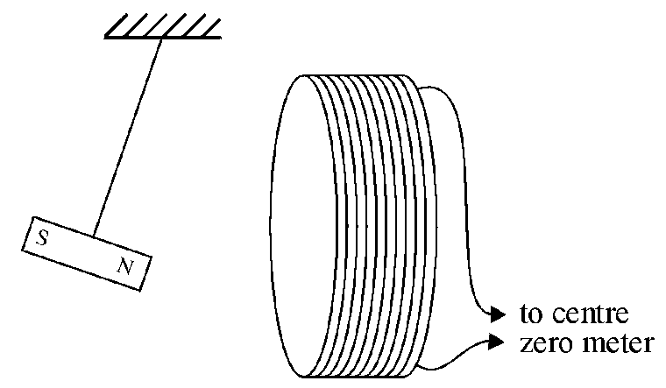

(a) Sketch a graph to show the variation of induced e.m.f. with time as the pendulum magnet swings to and fro.

(b) What is the induced e.m.f. when the magnet momentarily stops?

(c) State what happens to the induced e.m.f. as the magnet reverses its direction of movement.

(d) What happens to the induced e.m.f. at the positions where the magnet moves fastest?

# Tutorial 8.2

**Inductors and a.c.**

1. An inductor is connected to a variable frequency a.c. supply as shown below. The amplitude of the output voltage is kept constant.

L

˜

Variable frequency

Constant amplitude supply

(a) The inductor has reactance. State what is meant by the term ‘reactance’.

(b) The frequency of the a.c. supply is increased.

Sketch a graph to show how

(i) the reactance of the inductor varies with the frequency of the output from the supply

(ii) the current in the circuit varies with the frequency of the output from the supply.

2. A coil has an inductance 0f 0.80 H and negligible resistance. It is connected to a 30 V a.c. supply of frequency 50 Hz.

(a) Calculate the reactance of the inductor.

(b) Calculate the r.m.s current in the inductor.

3. A pure inductor is connected across a 250 V r.m.s supply having a frequency of 50 Hz. The current in the inductance is 0·50 A r.m.s.

Calculate:

(a) the inductive reactance of the inductor at this frequency

(b) the inductance of the inductor.

4. A pure inductor and resistor are connected across an a.c. supply with a frequency of 50 Hz.

100 

0.80 H

˜

The inductance of the inductor is 0·8 H and the resistor has a resistance of 100  The p.d. across the resistor is 12 V r.m.s.

(a) Calculate the current in the circuit.

(b) Calculate the r.m.s voltage across the inductor.

5. A circuit is set up as shown below.

Z

Y

~

X

The a.c. supply is of constant amplitude but variable frequency. The frequency of the supply is varied from a very low frequency to a very high frequency.

Explain what you would expect to happen to the average brightness of each of the lamps X, Y and Z as the frequency is increased.

6. The output from an amplifier is connected across XY in the circuit shown below. This is designed to direct low frequency signals to one loudspeaker and high frequency signals to the other loudspeaker.

Y

X

C1

L

A

C2

B

(a) Suggest which of the loudspeakers A or B is intended to reproduce high-frequency signals.

(b) Explain how the high- and low-frequency signals are separated by this circuit.

7. In a series circuit containing a resistor, a capacitor and an inductor the combined effect is known as the impedance *Z* of the circuit where



A series circuit is made of a pure inductor and a capacitor. It is connected across an a.c. supply of constant amplitude but variable frequency.

(a) Describe how the impedance *Z* of the circuit can be measured.

(b) The measurements of *Z* are used to plot the following graph of *Z* against frequency.

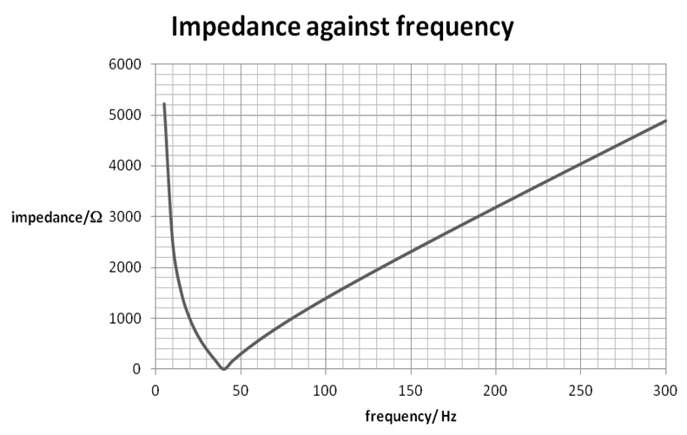

(i) Use the graph to estimate the capacitance of the capacitor.

(ii) Use the graph to estimate the inductance of the inductor.

(iii) The relationship shows that at a certain frequency the inductive reactance and the capacitive reactance will be equal. At this frequency the impedance will be zero. Use your results from (i) and (ii) to find this frequency and compare it to the value from the graph.

# Tutorial 9.0

**Electromagnetic radiation**

1. Electromagnetic waves in a vacuum are said to be transverse. Explain the meaning of *transverse* in this context.

2. Which of the following cause/s electromagnetic radiation?

(a) A stationary electric charge.

(b) An electric charge moving with a constant acceleration.

(c) An accelerating electric charge.

(d) An electric charge in a circular particle accelerator.

(e) A charged particle in a linear accelerator.

(f) An electron in a Bohr orbit in an atom.

3. The theory of electromagnetic radiation includes the relationship



Show that has the units m s–1.

4. The electric field *E* of an electromagnetic wave is given by

$$E=4∙0×{10}^{2}\sin\left[3∙0×{10}^{6}π\left(x-3∙0×{10}^{8}t\right)\right]$$

where *E* is in V m–1.

Compare this relationship to that for a transverse wave

$$y=A\sin{\frac{2π}{λ}}\left(x-vt\right)$$

(a) What is the amplitude of the electric field in the electromagnetic wave?

(b) Calculate the frequency of the electric field in the electromagnetic wave.

(c) Given that the electric field *E* is related to the magnetic field *B* by $E=cB$:

(i) write down the expression for the magnetic field of the electromagnetic wave

(ii) what is the amplitude of the magnetic field in the electromagnetic wave?