17th January 2019

SHM Practicals
In groups
Group 1 | Group 2 | Group 3
V | J | Rw
E | Rr | Rb
A can choose which group to make up to a 3. OR YOU CAN WORK ALONE AND DO THE EASY BIT!
By the end of this double period I expect
- You to have the spring constant for two of the springs by two different methods.
- A graph of d v t, v v t, and a v t
- A value of the period of spring for various masses
- Discovered the effect of amplitude on the period
- Found the effect of damping (so find out what that is)

https://www.webassign.net/question_assets/ncsucalcphysmechl3/lab_7_1/manual.html
http://www.dartmouth.edu/~physics/labs/descriptions/spring.mass.oscillator/spring.mass.oscillator.writeup.pdf
https://www.birmingham.ac.uk/undergraduate/preparing-for-university/stem/Physics/stem-legacy-SHM.aspx
https://www.cyberphysics.co.uk/topics/shm/springs.htm

Investigating a mass-on-spring oscillator

Demonstration
A mass suspended on a spring will oscillate after being displaced. The period of oscillation is affected by the amount of mass and the stiffness of the spring. This experiment allows the period, displacement, velocity and acceleration to be investigated by datalogging the output from a motion sensor. It is an example of simple harmonic motion.

Apparatus and materials
Motion sensor, interface and computer
Slotted masses on holder, 100 g-400 g
Clamp and stand
String
Springs, 3
Card

Health & Safety and Technical notes

Unless the stand is very heavy, use a G-clamp to anchor it to the bench.
Read our standard health & safety guidance

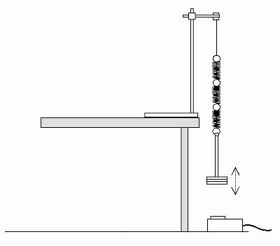
Suspend the spring from a clamp and attach a mass to the free end. Adjust the height of the clamp so that the mass is about 30 cm above the motion sensor, which faces upwards.
The clarity of measurements depends upon the choice of spring stiffness and mass. Good results can be obtained with three springs linked in series, and masses in the range 100 - 400 g. With this choice, it is necessary to place the sensor on the floor and allow the mass and spring to overhang the edge of the bench.
When the mass is displaced and released, its vertical motion is monitored by a motion sensor connected via an interface to a computer.
In general, the magnitude of the initial displacement should not exceed the extension of the spring. It is best to lift the mass to displace it, rather than pull it down.
The mass may acquire a pendulum type of motion from side to side. Eliminate this by suspending the spring from a piece of string up to 30 cm.
For the collection and analysis of the data, data-logging software is required to run on the computer. Configure the program to measure the distance of the mass from the sensor, and to present the results as a graph of distance against time. Scale the vertical axis of the graph to match the amplitude of oscillation.

Procedure

Data collection
a Lift and release a 400 g mass to start the oscillation. Start the data-logging software and observe the graph for about 10 seconds.
b Before the oscillation dies away, restart the data-logging software and collect another set of data, which can be overlaid on the first set.
c Repeat the experiment with 300 g, 200 g and 100 g masses.

Analysis
Measurement of period
d The period of the sinusoidal graph may be measured using a time-interval analysis tool in the software. Measure the period from peak to peak.
e Take measurements at several different places on the time axis, and observe that the period does not vary with elapsed time.
f Take similar measurements on the set of results with a smaller amplitude, and observe that the period appears to be independent of amplitude.
Effect of mass
g Measure the period for each of the other graphs resulting from using different masses. Plot a new graph of period against mass. (Y axis: period; X axis: mass.)
h Use a curve-matching tool to identify the algebraic form of the relationship. This is usually of the form 'period is proportional to the square root of mass'.
i Use the program to calculate a new column of data representing the square of the period. Plot this against mass on a new graph. A straight line is the usual result, showing that the period squared is proportional to the mass.
Velocity and acceleration
j On the 'distance vs. time' graph, the gradient at any point represents the velocity of the oscillating mass. Choose the clearest set of data and use the program to calculate the gradient at every point on the graph.
A plot of the resulting data shows a 'velocity vs. time' graph. Note that the new graph is also sinusoidal. However, compared with the 'distance vs. time' graph, there is a phase difference - the velocity is a maximum when the displacement is zero, and vice versa.
k A similar gradient calculation based on the 'velocity vs. time' graph yields an 'acceleration vs. time' graph. Comparing this with the original 'distance vs. time' graph shows a phase difference of 180°. This indicates that the acceleration is always opposite in direction to the displacement.

Teaching notes

1 This experiment illustrates the value of rapid collection and display of data in assisting thinking about the phenomenon under investigation. Data is collected within a few seconds and the graph is presented simultaneously. Students can observe connections between features on the graph and the actual motion of the mass. For example, the crests and troughs on the graph represent the mass at the extremes of its displacement.
The parameters suggested here usually produce displacements of a few centimetres. The motion sensors can detect these with suitable precision. Small amplitude oscillations produce rather noisy data. Starting with the largest mass should show the clearest results first.
Software tools for taking readings from the graph are employed: measuring gradients and time intervals. The detail available in the data allows the idea that the periodic time remains constant for a given mass to be tested.
2 A particularly useful software function is that which calculates the velocity for all points on the graph and plots these as a new graph. A notable feature of the velocity graph is the phase difference from the distance data. This can provoke useful discussion about the change in magnitude and direction of velocity during each cycle of oscillation. The 'noisiness' of the measurements begins to show more markedly on the velocity graph. The process by which the program calculates the velocity (usually by taking differences between distance readings) should be questioned.
3 The further derivation of acceleration from the gradients of the velocity graph usually shows even more measurement noise. Nevertheless, the form of the graph convincingly shows the antiphase relation with the distance graph. This is useful for prompting discussion about the conditions for simple harmonic motion (SHM). This can be reinforced by plotting a further graph of acceleration against displacement. The negative gradient straight line supports the basic condition for SHM: acceleration is proportional to displacement, but in the opposite direction.
Additional activities
4 You could add a card to the bottom of the masses to increase the damping. Students can see if the presence or amount of damping affect the natural frequency. Secondly, the amplitude can be extracted from each peak and a damping curve plotted. This can be tested to see if it is exponential.
This experiment was safety-checked in May 2006
Aim
To find the force constant of a helical spring by plotting a graph between load and extension.
Apparatus
Spring, a rigid support, a 50 g or 20 g hanger, six 50 g or 20 g slotted weights, a vertical wooden scale, a fine pointer, a hook.
Theory
When a load F suspended from lower free end of a spring hanging from a rigid support, increases its length by amount l,
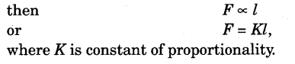
It is called the force constant or the spring constant of the spring,
From above if l = 1, F = K.
Hence, force constant (or spring constant) of a spring may be defined as the force required to produce unit extension in the spring.

Simple Harmonic Motion – Concepts

INTRODUCTION
Have you ever wondered why a grandfather clock keeps accurate time? The motion of the pendulum is a particular kind of repetitive or periodic motion called simple harmonic motion, or SHM. The position of the oscillating object varies sinusoidally with time. Many objects oscillate back and forth. The motion of a child on a swing can be approximated to be sinusoidal and can therefore be considered as simple harmonic motion. Some complicated motions like turbulent water waves are not considered simple harmonic motion. When an object is in simple harmonic motion, the rate at which it oscillates back and forth as well as its position with respect to time can be easily determined. In this lab, you will analyze a simple pendulum and a spring-mass system, both of which exhibit simple harmonic motion.

DISCUSSION OF PRINCIPLES
A particle that vibrates vertically in simple harmonic motion moves up and down between two extremes y = ±A. The maximum displacement A is called the amplitude. This motion is shown graphically in the position-versus-time plot in Figure 1.
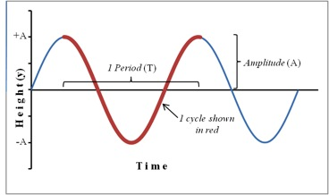
Figure 1: Position plot showing sinusoidal motion of an object in SHM
One complete oscillation or cycle or vibration is the motion from, for example,
y = −A
to
y = +A
and back again to
y = −A.
The time interval T required to complete one oscillation is called the period. A related quantity is the frequency f, which is the number of vibrations the system makes per unit of time. The frequency is the reciprocal of the period and is measured in units of Hertz, abbreviated Hz;
1 Hz = 1 s⁻¹.
f = 1/T
If a particle is oscillating along the y-axis, its location on the y-axis at any given instant of time t, measured from the start of the oscillation is given by the equation
y = A sin(2πft).
Recall that the velocity of the object is the first derivative and the acceleration the second derivative of the displacement function with respect to time. The velocity v and the acceleration a of the particle at time t are given by the following.
v = 2πfA cos(2πft)

a = −(2πf)²[A sin(2πft)]
Notice that the velocity and acceleration are also sinusoidal. However, the velocity function has a 90° or π/2 phase difference while the acceleration function has a 180° or π phase difference relative to the displacement function. For example, when the displacement is positive maximum, the velocity is zero and the acceleration is negative maximum.Substituting from equation 2 into equation 4 yields
a = −4π²f²y.
From equation 5, we see that the acceleration of an object in SHM is proportional to the displacement and opposite in sign. This is a basic property of any object undergoing simple harmonic motion.Consider several critical points in a cycle as in the case of a spring-mass system in oscillation. A spring-mass system consists of a mass attached to the end of a spring that is suspended from a stand. The mass is pulled down by a small amount and released to make the spring and mass oscillate in the vertical plane. Figure 2 shows five critical points as the mass on a spring goes through a complete cycle. The equilibrium position for a spring-mass system is the position of the mass when the spring is neither stretched nor compressed.
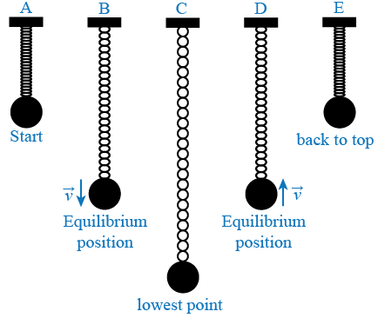
Figure 2: Five key points of a mass oscillating on a spring
The mass completes an entire cycle as it goes from position A to position E. A description of each position is as follows.
Position A: The spring is compressed; the mass is above the equilibrium point at y = A and is about to be released.
Position B: The mass is in downward motion as it passes through the equilibrium point.
Position C: The mass is momentarily at rest at the lowest point before starting on its upward motion.
Position D: The mass is in upward motion as it passes through the equilibrium point.
Position E: The mass is momentarily at rest at the highest point before starting back down again.
By noting the time when the negative maximum, positive maximum, and zero values occur for the oscillating object's position, velocity and acceleration, you can graph the sine (or cosine) function. This is done for the case of the oscillating spring-mass system in the table below and the three functions are shown in Figure 3. Note that the positive direction is typically chosen to be the direction that the spring is stretched. Therefore, the positive direction in this case is down and the initial position A in Figure 2 is actually a negative value. The most difficult parameter to analyze is the acceleration. It helps to use Newton's second law, which tells us that a negative maximum acceleration occurs when the net force is negative maximum, a positive maximum acceleration occurs when the net force is positive maximum and the acceleration is zero when the net force is zero.
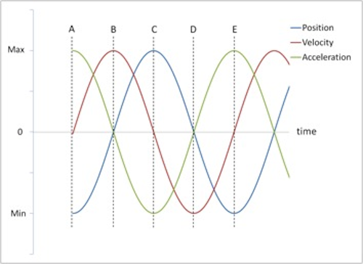
Figure 3: Position, velocity and acceleration vs. time
For this particular initial condition (starting position at A in Figure 2), the position curve is a cosine function (actually a negative cosine function), the velocity curve is a sine function, and the acceleration curve is just the negative of the position curve.

Mass and Spring
A mass suspended at the end of a spring will stretch the spring by some distance y. The force with which the spring pulls upward on the mass is given by Hooke's law
F = −ky
where k is the spring constant and y is the stretch in the spring when a force F is applied to the spring. The spring constant k is a measure of the stiffness of the spring.The spring constant can be determined experimentally by allowing the mass to hang motionless on the spring and then adding additional mass and recording the additional spring stretch as shown below. In Figure 4a, the weight hanger is suspended from the end of the spring. In Figure 4b, an additional mass has been added to the hanger and the spring is now extended by an amount
Δy.
This experimental set-up is also shown in the photograph of the apparatus in Figure 5.
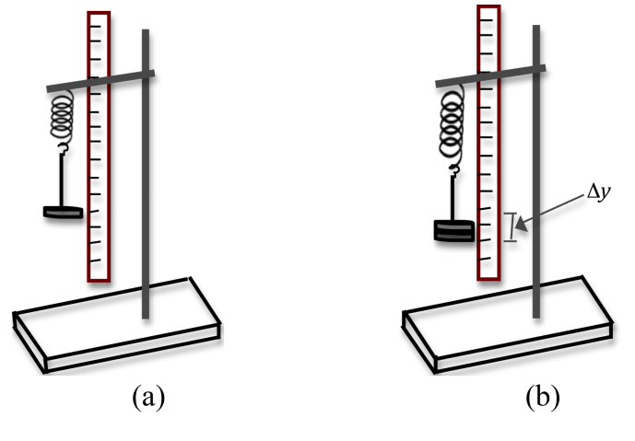
Figure 4: Set up for determining spring constant
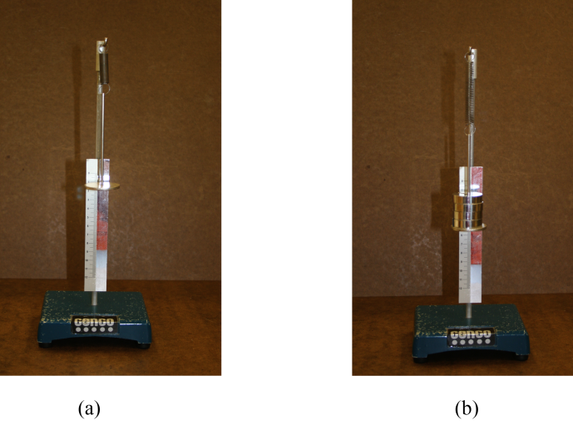
Figure 5: Photo of experimental set-up
When the mass is motionless, its acceleration is zero. According to Newton's second law, the net force must therefore be zero. There are two forces acting on the mass: the downward gravitational force and the upward spring force. See the free-body diagram in Figure 6 below.
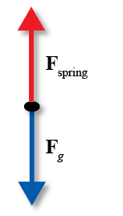
Figure 6: Free-body diagram for the spring-mass system
So Newton's second law gives us
Δmg − kΔy = 0
where
Δm
is the change in mass and
Δy
is the change in the stretch of the spring caused by the change in mass, g is the gravitational acceleration, and k is the spring constant. Equation 7 can also be expressed as
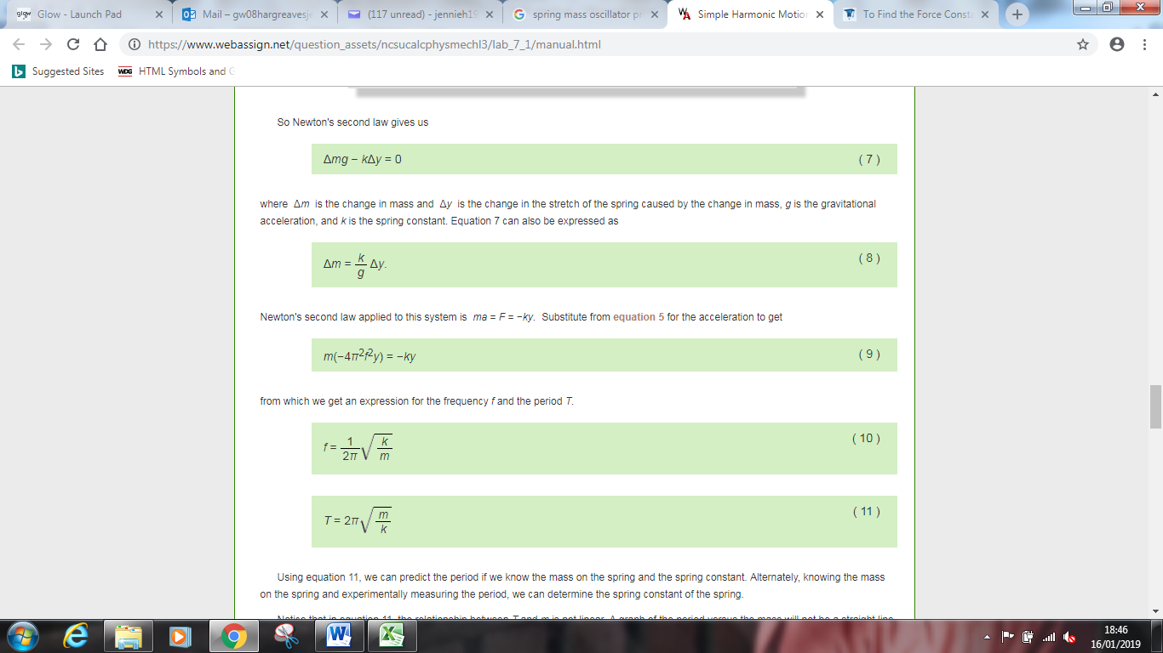Newton's second law applied to this system is
ma = F = −ky.
Substitute from equation 5 for the acceleration to get
( 9 )
m(−4π²f²y) = −ky
from which we get an expression for the frequency f and the period T.
( 10 )
f =
1
2π

k
m

$$T=2π\sqrt{\frac{m}{k}}$$
Using equation 11, we can predict the period if we know the mass on the spring and the spring constant. Alternately, knowing the mass on the spring and experimentally measuring the period, we can determine the spring constant of the spring.Notice that in equation 11, the relationship between T and m is not linear. A graph of the period versus the mass will not be a straight line. If we square both sides of equation 11, we get
$$T^{2}={4π}^{2}\frac{m}{k}$$
Now, a graph of
T² versus m will be a straight line, and the spring constant can be determined from the slope.
Diagram
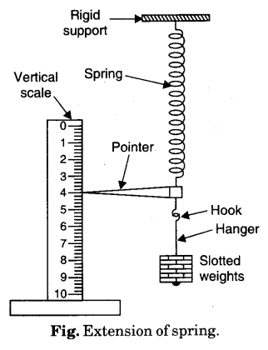
Procedure
- Suspend the spring from a rigid support. Attach a pointer and a hook from its lower free end.
- Hang a 50 g hanger from the hook.
- Set the vertical wooden scale such that the tip of the pointer comes over the divisions on the scale but does not touch the scale.
- Note the reading of the position of the tip of the pointer on the scale. Record it in loading column against zero load.
- Gently add suitable load of 50 g or 20 g slotted weight to the hanger. The pointer tip moves down.
- Wait for few minutes till the pointer tip comes to rest. Repeat step 4.
- Repeat steps 5 and 6 till six slotted weights have been added.
- Now remove one slotted weight. The pointer tip moves up. Repeat step 6. Record the reading in unloading column.
- Repeat step 8 till only hanger is left.
- Record your observations as given below.
Observations
Least count of vertical scale = 0.1 cm.
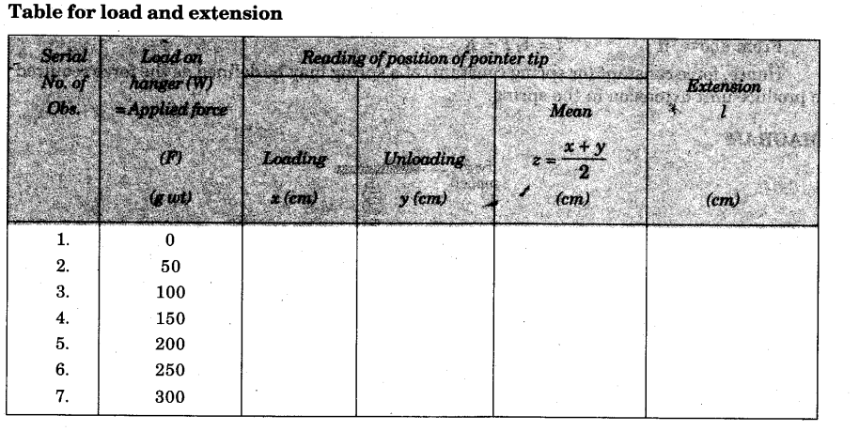
Graph
Plot a graph between F and l taking F along X-axis and l along Y-axis. The graph comes to be a straight line as shown below.
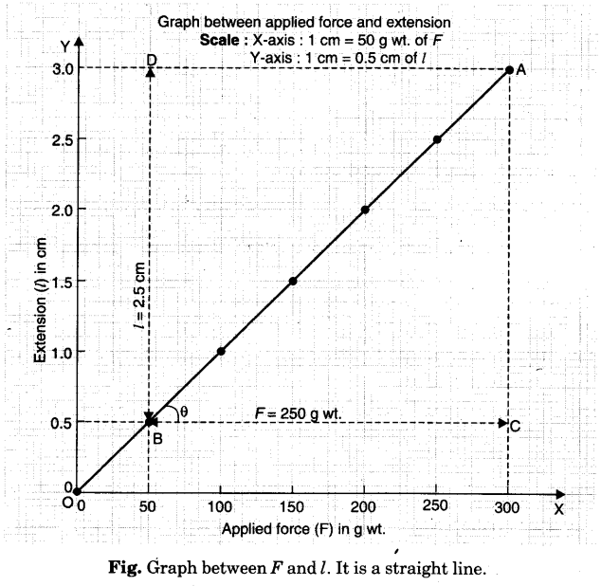
from graph, change of F from B to C changes l from B and D. It means that 250 g wt produces 2.5 cm extension.
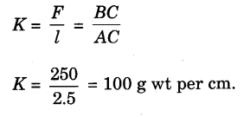
Result
The force constant of the given spring is 100 g wt per cm. [Remember with this spring, a spring balance of range 1 kg will have a scale of length 10 cm]
Precautions
- Loading and unloading of weight must be done gently.
- Reading should be noted only when tip of pointer comes to rest.
- Pointer tip should not touch the scale surface.
- Loading should not be beyond elastic limit.
Sources of error
- The support may not be rigid.
- The slotted weights may not have correct weight.

