NATIONAL QUALIFICATIONS CURRICULUM SUPPORT

Physics

Stellar Physics

Advice for Practitioners

Nathan Benson

[REVISED ADVANCED HIGHER]

The Scottish Qualifications Authority regularly reviews the arrangements for National Qualifications. Users of all NQ support materials, whether published by Education Scotland or others, are reminded that it is their responsibility to check that the support materials correspond to the requirements of the current arrangements.

Acknowledgement
The author gratefully acknowledges Prof Martin A. Hendry FRSE, University of Glasgow, for his constructive comments and contributions.

The publisher gratefully acknowledges permission to use the following sources: HR diagram and Solar Wind diagram courtesy of NASA; Figure: Hertzsprung–Russell diagram © European Space Agency.

© Crown copyright 2012. You may re-use this information (excluding logos) free of charge in any format or medium, under the terms of the Open Government Licence. To view this licence, visit http://www.nationalarchives.gov.uk/doc/open-government-licence/ or e-mail: psi@nationalarchives.gsi.gov.uk.
Where we have identified any third party copyright information you will need to obtain permission from the copyright holders concerned.

Any enquiries regarding this document/publication should be sent to us at enquiries@educationscotland.gov.uk.
This document is also available from our website at www.educationscotland.gov.uk.

Contents

Introduction 4

Section 1: Properties of stars 6
Possible introduction to learners 6
Apparent brightness 9
Detectors 9
Temperature 10
Flux 12
Luminosity 13
Radius/diameter 13
Mass 14
Hertzsprung–Russell diagrams 15
Mass–luminosity relationship 19
Hydrostatic equilibrium 19
Nuclear fusion 20
Hydrogen fusion in a star 20
Proton–proton chain 21
The C–N–O cycle 22
The solar neutrino problem 23

Section 2: Stellar evolution 25
Star formation 25
The ultimate fate 27

Appendix 1: Spectral class 32
Appendix 2: H–R analogy 33
Appendix 3: Detecting neutrinos 34

Glossary 35

Recommended reading 37

Bibliography 39

Useful websites 40

Introduction

These notes have been written primarily to support practitioners with the introduction of the properties of stars and the stellar evolution topics as specified in the Rotational Motion and Astrophysics unit of the new Advanced Higher Physics course.

The sections in this document correspond to the headings in the Content column of the SQA Arrangements document. The sub-headings correspond to the first sentence or key words in the relevant paragraph in the Notes or Contexts columns.

As this is an area in which many practitioners may not have extensive experience, this document provides a background from which to present the topics in an informed way and confident manner. Consequently, information is given beyond the bare requirements of the Arrangements document. Fuller information can be obtained from the recommended texts and bibliography.

With the widespread use of the internet, it is important to anticipate alternative terminology and units of measurement that learners may come across.

Anecdotes and interesting facts are included to add curiosity and intrigue. These can be used as appropriate to enrich lessons.

The very nature of this subject matter means practical work is somewhat limited, but where possible suggestions have been included for quick illustrations of principles and sometimes further investigations.

Some teaching points are included, especially in areas of possible common misconception.

Suggested reading as well as the normal bibliography is included. Stellar physics is a constantly changing subject, but the Arrangements contain some of the most up-to-date topics ever included in an Advanced Higher Physics course.

These notes are not prescriptive, neither do they imply that every suggested activity should be undertaken or every anecdote used. Hopefully practitioners will find them a useful resource in gaining a background in the topics and providing avenues for further inquiry if and when required.

Section 1: Properties of stars

Possible introduction to learners

The properties to be covered in this topic are diameter (or radius), surface temperature, mass, luminosity and apparent brightness. Although temperature has been met at Higher Physics, a possible introduction to learners could be through a demonstration on apparent brightness, which is how bright we perceive a star when viewed from Earth.

For example, imagine you are a rabbit crossing a country road in the pitch black of night. You see a single light, which may be a motorcycle. How do you know how far way it is? How do you know it is a motorcycle and not something else?

Practical demonstration

Various small light sources of varying brightnesses could be placed in a totally darkened room or corridor. Four would be a suitable number, with them positioned side by side. Ask learners which is closest to them. It depends on brightness and distance.

Suggest the lamp of intermediate brightness is placed closest to the learners. The simplest solution is for learners to assume the brightest light is closest, whilst others may assume you have done the ‘opposite’ to emphasise the point.

Historic

The Greek astronomer Hipparchus is usually credited with creating the first ever catalogue of stars, containing over 1000 stars and compiled possibly around 135 BC. He also ranked stars according to their brightness into a six-point scale. He assigned the value of 1 to the brightest stars, magnitude 2 to the next brightest and so on with magnitude 6 being assigned to those stars that were just visible and no more. This formed the basis of the magnitude system that is still in use today.

Such rough visual estimates were used up until the 1800s, when William Herschel started using two telescopes to compare the brightness of pairs of stars.

Practical activity: Measuring apparent brightness of the Sun

This can be done using a 200 W light bulb and a grease-spot photometer.
See: http://www.exploratorium.edu/snacks/solar_brightness/index.html

Practical activity: Measuring apparent brightness using Herschel’s method

Use Herschel’s original method for measuring the relative brightness of stars.

Instead of stars, light sources could be used, in which case lenses could be used in place of telescopes.

Herschels’ method
Two telescopes are pointed at two different stars. The one pointing at the brighter star has its objective lens partially covered, for example using an iris. This is adjusted until both stars appear equally bright when viewed through the telescopes.

The ratio of the uncovered areas of the two lenses is proportional to the relative brightness of the two stars (see Figure 1).

Brighter star
Dimmer star
Telescope
Adjustable aperture
Figure 1 Herchsel’s original method.

Herschel consequently discovered that Ptolemy’s magnitude 1 stars were on average 100 times brighter than magnitude 6 stars. He also found that there was an equal factor of difference in magnitude between each magnitude factor. Astronomers used this information to devise a standard scale of magnitudes based on Ptolemy’s original magnitude groups.

Thus, in the standard magnitude scale for an increase in magnitude of 5 (eg from 1 to 6) the brightness goes down by a factor of 100. Each increase in magnitude of 1 therefore corresponds to a decrease in brightness of = 2.512 times in brightness. (There are five steps between 1 and 6.) So a magnitude 1 star is 2.512 times brighter than a magnitude 2 star. A magnitude 2 is 2.512 times brighter than a magnitude 3 and so on.

Objects brighter than the brightest stars are given negative magnitudes whilst very dim objects have large positive magnitudes. This is analogous to the score in golf, where a low score is better than a high one. The apparent magnitudes of some familiar objects are given in Table 1.

Table 1 Apparent magnitudes (Limits of instruments highlighted)

Object | Apparent magnitude
Sun | –26.5
Moon (full) | –12.5
Venus (at its brightest) | –4
Jupiter or Mars (at brightest) | –3
Sirius (brightest star) | –1.4
Polaris | 2.0
Uranus | 5.5
Limit of naked eye | 6.5
Neptune | 7.8
Limit with binoculars | 10
Pluto | 15
Limit of large ground-based optical telescope | 24*
Limit of Hubble Space Telescope | 29*
*These figures are given as a rough guide only, since other factors will determine the apparent brightness, eg exposure time, adaptive optics to process the image etc.

Apparent brightness

The apparent brightness of a star is the brightness we perceive here on Earth. This is what can be measured directly with telescopes and detectors, as outlined below.

Detectors

Clearly early ‘measurements’ of brightness were done subjectively by the eye. With the advent of photography, photographic film was used to record the apparent brightness of stars.

The use of detectors other than the naked eye provides more objective and consistent results. Such methods can also have additional benefits, for example they may:

- be more sensitive
- accumulate the effect of light over a long period of time
- produce numerical rather than qualitative results
- sense other parts of the electromagnetic spectrum outwith the visible part.

Photographic film

This produces a permanent record that can be analysed. It can also be exposed for many hours and hence record images of objects that may be millions of times too faint to be seen by the naked eye. Although photographic film played a crucial role in the history and development of stellar astrophysics all the way through to the 1980s, it is no longer used by professional astronomers.

Photometers

Photometers are instruments that allow brightness or radiant intensity to be measured and an objective numerical value to be recorded. In some instruments the light-sensitive element uses the photoelectric effect, so there are clear links to be made here with the Higher Physics course.

Charge-coupled devices

Charge-coupled devices (CCDs) are much more sensitive than photographic film, as only a small fraction of the photons striking photographic film are recorded. CCDs also have a higher dynamic range, meaning that they respond in a more uniform, or linear, way to brighter sources. Photographic film has a
tendency to saturate when brightly illuminated and therefore does not give an accurate measure of the true brightness of the source.

A CCD is a collection of millions of light sensitive elements (or pixels) arranged in an array. When light strikes an element it builds up an electric charge dependent on the brightness of the light striking that part. The charge is produced via the photoelectric effect, as the photons striking each pixel ejects electrons from the semiconductor material in the pixel. These are semiconductor devices and similar to those used extensively in digital cameras and indeed the technology now found in modern digital cameras was first developed for astrophysical applications. Since CCDs are digital in nature the information they collect can be fed directly into a computer for manipulation and analysis.

Details of how CCDs work can be found at http://en.wikipedia.org/wiki/Charge-coupled_device.

Interesting fact

As a measure of how CCDs have replaced film, the 4.2 m William Herschel telescope in La Palma, Canary Islands (first operated in 1987) was probably the first to have no photographic instruments at all. All imaging by major telescopes nowadays is done with CCDs.

Temperature

The effective temperature of a star is defined as the surface temperature of a black body that has the same luminosity and surface area as the star. The starlight we see comes from the gases on the outer surface of the star (known as the photosphere). Gases deep inside the star also emit light, but it is absorbed and re-radiated many times before it can reach the surface. The density of gases above the photosphere is too small to emit significant amounts of light.

When astronomers talk about the temperature of a star, they generally mean its surface temperature, as this is what can be measured directly from the radiation it emits. The temperature of a star can be estimated from the peak wavelength of its spectrum by applying Wien’s displacement law, ie:

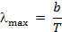

where b is Wien’s displacement constant = 2.90 × 10^{–3} m K, λ_{max} is the peak wavelength and T is the temperature in kelvin.

(See also Higher Physics Teacher’s Notes on the Expanding Universe and the Big Bang, 2011.)

‘Balmer thermometer’

The strength of the Balmer hydrogen absorption lines can be used to give an accurate measurement of a star’s temperature.

The Balmer absorption lines are produced only by atoms whose electrons are in the second energy level (level 2 in Figure 2).

1
2
3
6
4
5
Emission
Absorption
α β γ δ
α β γ δ
Figure 2 Balmer series.

If the star is cool, there are few violent collisions between atoms to excite electrons; most atoms will have their electrons in the ground state (level 1 in Figure 2). Hence they cannot absorb photons in the Balmer series and so the absorption lines are faint.

On the other hand, if a star is hot, there will be lots of violent collisions exciting electrons into higher energy levels or even knocking them out of atoms completely to produce ionisation, so very few atoms will have their electrons in the second energy level and, as for very cool stars, the Balmer series will also be faint.

At some in-between temperature, the conditions will be just right to excite a large number of electrons into the second energy level, with a resultant strong set of Balmer lines.

The strength of Balmer lines for various temperatures can be predicted from theoretical calculations. The results produce a curve with maximum line strength for a unique temperature. Clearly this is not sufficient on its own since for all other strengths there are two possible temperatures. The solution is to add one or more graphs for other elements, which increases the precision with which the temperature can be measured. This technique is sometimes called the ‘Balmer thermometer’.

Flux

For electromagnetic radiation, flux is defined as the rate of flow of energy passing through the unit area (or average power per unit area). For visible light this is called brightness and is in effect the apparent brightness at the surface of the star.

From the Stefan–Boltzmann law for a black body:

flux = σT⁴

where T is the temperature in kelvin (K) and σ is the Stefan–Boltzmann constant (σ = 5.67 × 10^{–8} J s^{–1} m^{–2} K^{–4}), which gives the flux in J s^{–1} m^{–2} or
W m^{–2}.

Various symbols are used for flux. Many books use F, which has the obvious disadvantage of possible confusion with F for force. The use of phi (φ) may cause confusion with magnetic flux, although sometimes a subscript m is used with φ for magnetic flux and v for visible or luminous flux. However, magnetic and luminous flux are two very different parameters and the use of subscripts may imply they are the same physical quantity in a different form (as for using E for energy and subscripts for the form of energy).

Note that the flux or brightness is proportional to the fourth power of the kelvin temperature. Consequently small differences in temperature have a big effect on a source’s flux or brightness.

Luminosity

Luminosity (L) is defined as the total amount of energy per second radiated from a star. It is measured in watts and so is a bit like the power of a light bulb:

luminosity = flux × surface area

where R is the radius of the source (assumed to be spherical).

Note that this embodies the inverse law for apparent brightness (luminous flux), ie:

If r is the distance from the source, the apparent brightness (or flux) varies with the inverse of the distance squared.

Learners need to be warned to be clear in their mind of when r represents the distance from a source (star), when it represents the radius of a star and when it is the distance from the star. (The SQA relationships sheet uses d in the apparent brightness equation for this reason.)

This gives a way of obtaining a star’s luminosity from its apparent brightness if we can measure the distance to the star. Note, however, that this relationship takes no account of the effect of interstellar dust, which will absorb and scatter light.

Radius/diameter

Stars appear much too small, even when viewed through a telescope, to resolve their discs and measure their diameter. However, their diameters can be obtained if their temperatures and luminosities are known, using

Alternatively astronomers may work in units relative to the Sun (solar units) for simplicity and convenience, as follows.

Taking the ratio of the luminosity of the star (L) to the luminosity of the Sun (L_{S}):

The equation can be written as:

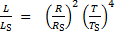

Working in solar units for all three parameters:

luminosity = (radius)² × (temperature)⁴

Mass

It is difficult to determine the mass of a star. It can only be found by calculating the star’s gravitational attraction on a companion star (ie in a binary system) or planet. Two stars in a binary system revolve around their common centre of mass (Figure 3).

X Centre of mass
m_{A}
m_{B}
a
Figure 3 Binary star system.

For two stars of masses m_{A} and m_{B} separated by a distance a (Figure 3) and with a period P (use P rather than T to distinguish it from temperature in kelvin):

m_{A} + m_{B} =
For the solar system, virtually all the mass is in the Sun, so m_{A} + m_{B} = 1 (solar mass) or a constant, hence the equation embodies Kepler’s third law of planetary motion (a³/p² is constant for the Sun’s planets).

For binary star systems, if we can measure the distance between the stars (say from their angular separation times their distance from Earth) in astronomical units (AU, 1 AU = average distance from the Earth to the Sun) and their period (P) in Earth years, then we can find their total mass (m_{A} + m_{B}) in Earth units (m_{E}). The individual masses can then be found using the distances from the common centre of mass, ie m_{A}r_{A} = m_{B}r_{B} (like the lever rule).

In practice of course it is not quite that simple. The orbit may be elliptical or the plane of the orbit may be at an angle to our line of sight etc. Corrections can be made for these factors.

Hertzsprung–Russell diagrams

A Hertzsprung–Russell (H–R) diagram is a plot of luminosity against temperature for stars. The positions of individual stars are plotted on the diagram. See Figure 4.

H–R diagrams are extremely useful for understanding the nature and evolution of stars.

Introduction/analogy

A possible introduction or analogy to H–R diagrams is to consider the power and mass of cars. Discuss the possible relationship, ie one would expect cars with greater mass to be more powerful than those with small mass.

Use cards (Top Trumps, Top Gear ‘cool wall’) and do a plot of power versus mass. ‘Ordinary’ cars are analogous to the main-sequence stars. High-performance cars (supercars or racing cars) and economy or diesel cars are not on the main sequence (see Appendix 2).

Points to note
Stellar magnitude may be used in place of luminosity, and spectral type or colour in place of temperature (since a star’s surface temperature determines the colour distribution of light it emits – as with black-body radiation). See Figures 5 and 6.

Both axes scales are logarithmic, so equal divisions represent an increment (or decrement) by an equal factor. For example, in Figures 5 and 6, on the
luminosity scale each division represents an increment by a factor of 100 (0.01 = 0.0001 × 100, 1 = 0.01 × 100 and so on.)

The luminosity scale (ordinate) is logarithmic since it was originally based (and often still is in astronomy books) on stellar magnitudes, rather than actual luminosity, eg in watts. Also, since there is such a large dynamic range of luminosities a logarithmic scale is necessary to be able to show them clearly on a single diagram.

Sometimes relative luminosity is used, ie the luminosity relative to that of the Sun. This may be written as L/L_{Sun} or L/L_{ʘ}.

The temperature scale decreases from left to right, which is the opposite of the normal convention for graphs.

H–R diagrams also provide direct information about a star’s radius, since luminosity depends on both the surface temperature and the surface area, hence stellar radii increase as we move from the high temperature, low luminosity corner (bottom left) to the low temperature, high luminosity corner (top right).

Anecdote
The reason for this is that historically Hertzsprung and Russell based their data on the spectral sequence OBAFGKM (see Appendix 1).

Historical
In 1905 Ejnar Hertzsprung (a Danish amateur astronomer) observed that stellar luminosities generally decreased with spectral type, from O to M, but there were a few with much higher luminosity than other stars in their spectral class. His findings were presented in tabular form.

He produced early versions of his diagram for clusters as early as 1908 and that same year showed these to Karl Schwarzschild in Göttingen. In 1910 during travel to America, Schwarzschild met Henry Norris Russell (an American), who had independently observed the same pattern when he plotted the absolute magnitude of stars against their spectral type.

In 1911 Hertzsprung published colour-magnitude diagrams for both the Hyades and Pleiades clusters.

Russell was unaware of this new work of Hertzsprung and presented his own so-called Russell diagram (a diagram of absolute visual magnitude against Harvard spectral type for nearby field stars) to the Royal Astronomical Society in London in June 1913. It wasn’t published until 1914.

Interesting fact
The first published Hertzsprung–Russell diagram (ie a diagram of magnitude versus spectral type) was by Hans Rosenberg (1879–1940) at Göttingen in 1910.

Rosenberg was a colleague of Schwarzschild and his diagram of the Pleiades star cluster showing photographic apparent magnitude against an index based on the strength of the Balmer lines Hδ and Hζ relative to the K line of calcium was submitted to Astronomische Nachrichten in June 1910.

It may be worth reinforcing to learners that the H–R diagram is a scattergraph of luminosity versus temperature and that the position of a star on the diagram has nothing to do with its position in space. Some people may refer to the ‘position of star X on the diagram’ when strictly speaking they mean ‘the point representing star X’.

The diagram has areas where there are many stars and others where there are very few or none.

The region that contains most stars is a broad diagonal band sloping downwards from hot luminous stars to cool dim stars. These are called main-sequence stars.

Other well-populated regions are:

- the super-giant region, which contains the most luminous stars at the top of the diagram
- the giants region, which contains cool luminous stars
- the white dwarfs region, which contains hot but dim stars in the lower left of the diagram.

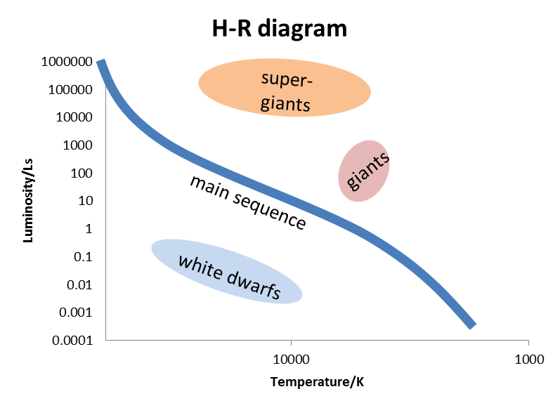
Figure 4 Simplifed H–R diagram.

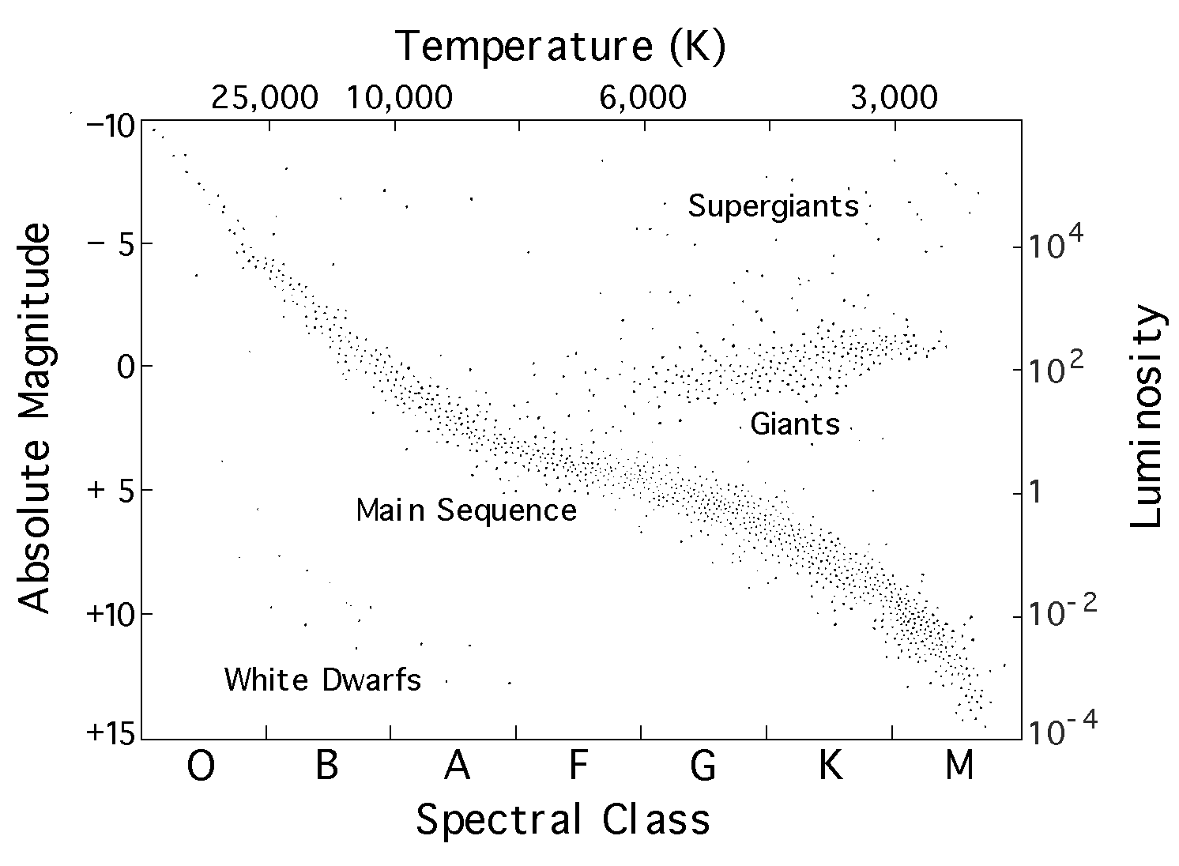
Figure 5 H–R diagram.
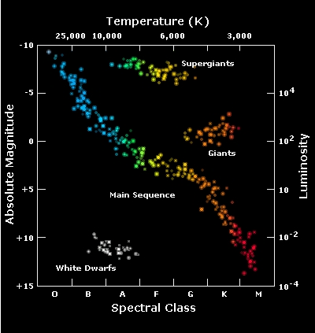
Figure 6 Colour H–R diagram.

Mass–luminosity relationship

If a graph of luminosity against mass is plotted for main-sequence stars, using log–log scales, it is found to be approximately a straight line of gradient 3.5, so

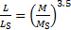

where L_{S} and M_{S} are the luminosity and mass of the Sun, respectively.
Stars with large masses therefore have high luminosities. This gives an alternative method for estimating mass for main-sequence stars.

Hydrostatic equilibrium

Stars form when interstellar gas clouds are pulled together by the force of gravity. When the pressure and temperature are high enough, nuclear fusion begins, which generates heat (increasing the kinetic energy of particles) and
this starts to exert an outward pressure. When this balances the inward gravitational force, the star is in hydrostatic (or gravitational) equilibrium. For any point in a star in hydrostatic (gravitational) equilibrium, the underlying pressure supports the weight of the material above.

Nuclear fusion

Although covered at Higher, some reminders and revision of the conditions required and problems to be overcome for nuclear fusion to occur may be useful.

- The need for high kinetic energy of particles (temperature) to overcome the mutual repulsion of the positively charged nuclei (Coulomb barrier).
- The nuclei need to be forced close enough for the nuclear (residual) strong force to act and bind nucleons together in the new nucleus.
- Nuclear fusion only occurs if the temperature is at least 10 million kelvin.

Hydrogen fusion in a star

Learners need to be warned and cautioned about the misuse of words in astronomy literature and the popular press regarding the concept of nuclear fusion. Texts often refer to ‘burning’ when they mean nuclear fusion and ‘igniting’ when they are really referring to the onset of nuclear fusion. Similarly, the use of the word ‘atom’ in the context of stars is often misused. The high temperature inside stars means any gas is ionised or in a plasma state.

Most early theories about the Sun assumed it was burning, ie a chemical reaction in which a substance combines with oxygen. A quick order of magnitude check shows that this cannot be the case as follows:

Burning hydrogen in oxygen produces about 10⁷ joules per kilogram of fuel.

Solar data:
Mass = 2.0 × 10³⁰ kg
Luminosity = 3.8 × 10²⁶ W = 4 × 10²⁶ W (to 1 significant figure)
Total energy available = 2 × 10³⁰ × 10⁷ = 2 × 10³⁷ joules
Time = energy/power = 2 × 10³⁷/4 × 10²⁶ = 5 × 10¹⁰ seconds = 1.6 × 10³ years.

This is not even as long as recorded history, never mind any estimated age of the Earth itself.
It wasn’t until Einstein developed the concept of mass–energy equivalence and his famous equation E = mc² that the possibilities of nuclear fusion or fission were considered.

Nuclear fission produces about 1 million times more energy per kilogram of fuel than combustion. However, there is not enough fissionable material in the Sun to account for its luminosity, for example only 1 in 10¹² nuclei are uranium.

In 1920 A S Eddington proposed the process of fusion of hydrogen into helium. It was another 20 years before the full details of the process were worked out. It is known as the proton–proton chain, as described below.

Proton–proton chain

This is a three-step process.

Step 1

Two protons come together to form deuterium, which also involves the emission of a positron and a neutrino.

In the Sun this process occurs 10³⁸ times per second!

Equation: ¹H + ¹H → ²He + e⁺ + ν

Step 2

The deuterium nucleus combines with a proton to form helium-3, with the emission of gamma radiation.

Equation: ²H + ¹H → ³He + γ

Step 3

Two helium-3 nuclei combine to form helium-4 with the emission of two protons. (There are other ways helium-3 can convert to helium-4 with the effective addition of a neutron, but this is the most common.)

Equation: ³He + ³He → ⁴He + 2 ¹H

The overall process is that four hydrogen nuclei are transformed into one helium nucleus plus energy, ie:

4 ¹H → ⁴H + energy

mass of 4 hydrogen nuclei = 6.693 × 10^{–27} kg

mass of 1 helium nucleus = 6.645 × 10^{–27} kg

mass difference = 0.048 × 10^{–27} kg

Applying E = mc² = (0.048 × 10^{–27} )(3 × 10⁸)² = 0.43 × 10^{–11} J

The C–N–O cycle

Main-sequence stars with masses more than 10% greater than that of the Sun fuse hydrogen into helium using the C–N–O cycle. This begins with a carbon nucleus and consequently requires much higher temperatures for fusion to occur (higher than 16 million kelvin) since a carbon nucleus has a charge of +6 compared to the +1 charge of a hydrogen nucleus. Consequently, higher kinetic energies are required to overcome the electrostatic repulsion (Coulomb barrier).

¹²C + ¹H → ¹³N + γ (proton absorbed)

¹³N → ¹³C + e⁺ + ν (positron and neutrino emitted)

¹³C + ¹H → ¹⁴N + γ (proton absorbed)

¹⁴N + ¹H → ¹⁵O + γ (proton absorbed)

¹⁵O → ¹⁵N + e⁺ + ν (positron and neutrino emitted)

¹⁵N + ¹H → ⁴He + ¹²C (proton absorbed)

Note that the cycle begins and ends with a carbon-12 nucleus, so it acts as a kind of catalyst.
In between four hydrogen nuclei (protons) are absorbed and two positrons and two neutrinos are emitted, resulting in a helium-4 nucleus.

Interesting fact

In the Sun 600 million tons of hydrogen is converted into 596 million tons of helium every second, ie 4 million tons of mass becomes energy (according to E = mc²) every second (ie of the order of 10³⁸ reactions per second).
The energy appears in the form of:

- gamma radiation
- positrons
- kinetic energy of the nuclei
- neutrinos.

The gamma rays (photons) are absorbed by the surrounding gas before travelling less than 1 mm. This heats the gas up and helps maintain the pressure.

The positrons combine with free electrons, annihilating each other and converting their mass into gamma radiation. The positrons therefore also help to keep the centre of the star hot.

The neutrinos almost never interact with other particles.

Interesting fact

The average neutrino could pass unaffected through a lead wall 1 light-year thick.

Thus neutrinos don’t contribute to heating the star up, but in fact carry roughly 2% of the energy produced away.

The solar neutrino problem

A vast number of solar neutrinos pass through the Earth as if it isn’t there.

Interesting fact

Over one trillion (10¹²) solar neutrinos flow though our bodies every second.

Since neutrinos rarely interact with other particles, they are notoriously difficult to detect. However, in the late 1960s a method was devised to detect neutrinos using a particular nuclear reaction that can be triggered by neutrinos. An experiment was set up to detect solar neutrinos, but the number of neutrinos detected was only a third of the theoretical number expected (approximately one every 3 days rather than one every day).

Despite repeated attempts to refine, test and calibrate the detector over decades the ‘missing’ neutrinos have never been detected. In the late 1980s a detector was constructed and used by Japanese scientists, but this also only detected a third of the expected number of neutrinos.
The theoretical model was questioned, as was the ability to effectively detect neutrinos.

Recent refinements in studying the Sun using telescopes and spacecraft have confirmed the theoretical model.

The current explanation is that the detectors are only able to detect one type (family or ‘flavour’) of neutrino, the electron-neutrino. (Remember that the others are the mu-neutrino and the tau-neutrino.)

It has also been suggested that neutrinos oscillate among the three types as they pass through matter. Thus if the electron-neutrinos produced inside the Sun oscillate among these three types as they pass through it then on average only a third will be electron-neutrinos, a third having changed to tau-neutrinos and the remaining third to muon-neutrinos.

Data from particle detectors (SuperKamiande in Japan in 1998 and –the Sudbury Neutrino Observatory in Canada in 2001, http://www.sno.phy.queensu.ca/) has since confirmed neutrino oscillation and so now the data match that of the solar model.

Section 2: Stellar evolution

Star formation

Stars form inside giant interstellar gas and dust clouds known as molecular clouds. They are called molecular because they are cool and dense enough to contain molecules, eg molecular hydrogen (H₂) and carbon monoxide (CO), rather than individual atoms or ions. Dust (ie small solid particles) blocks the passage of visible light from inside these clouds, but infrared and radio telescopes have been used to gather information on star formation within them. These clouds have a temperature of only a few kelvin and densities of the order of 10²⁰ times less than a star.

Normally the gravity is too weak to cause the dust and molecules to be pulled together and start to form a star. There are at least four factors which act against any contraction into a dense core:

- Thermal energy (pressure), ie the movement of the atoms and molecules. Even at temperatures of 10 K, molecules are moving at around 350 ms^{–1} (almost 800 mph).
- Interstellar magnetic field. Ions in the cloud, being electrically charged, are affected by a magnetic field. The average magnetic field throughout our galaxy is about 10^{–4} times as strong as that on Earth.
- Rotation. As the gas cloud contracts it spins more and more rapidly due to the conservation of momentum (like an ice-skater).
- Turbulence makes it difficult for a large molecular cloud to contract.

Both theory and observation suggest that some trigger is required to compress the cloud sufficiently for gravity to become the stronger factor. Possibilities are a passing shock wave, eg from a supernova explosion, or a density wave from a passing galactic spiral arm.

Once the process begins, gravity pulls the matter together, but in so doing it heats up. By conservation of energy the particles will be moving faster. This creates a pressure which tries to push the particles apart again.

When these effects are balanced the star stays the same size and is said to be in hydrostatic (gravitational) equilibrium.

Analogy for hydrostatic (gravitational) equilibrium

A possible analogy is a balloon. The elastic material (rubber) tries to pull the balloon in (together), like gravity. The air pressure inside the balloon tries to push it outwards to expand it (like the thermal pressure.) As with all analogies, great care is required in its use.

As an interstellar cloud is compressed it may flatten into a spinning disc with a star being formed at its centre and possibly orbiting planets forming elsewhere in the disc.

Eventually the pressure, temperature and density will increase enough for nuclear fusion to commence. This then usually creates enough thermal pressure to prevent further collapse of the star. In the stage prior to the onset of nuclear fusion the star is called a protostar.(ie ‘earliest form of’, as in ‘prototype’.) After fusion commences and the star is in hydrostatic (gravitational) equilibrium, it remains in that state for most of its active life. It has become a main-sequence star (like the Sun). As the hydrogen fuel is used up, it will shift its position on the H–R diagram.

The main-sequence stars on an H–R diagram lie in a band, not a line. Newly formed stars start off on the lower edge of the band and move across it as nuclear fusion alters their composition (Figure 7).

Temperature (K)
luminosity (L_{sun})
Newly formed stars
Older stars
Figure 7 Main sequence band.

Note: Use of the term ‘life’ can be quite ambiguous. Sometimes it is used to mean the time for which the star is undergoing some form of nuclear fusion,
ie as a main-sequence star. It can also mean the length of time of its entire existence. Most of a star’s existence is spent as a main-sequence star so the difference can be quite small and not significant. However, ambiguity is best avoided by using explicit terms where possible.

The smallest main-sequence stars have the least gravitational pull and hence the least gas pressure. They therefore have a low temperature (so appear red) and have the slowest nuclear reaction rates. As a consequence, although they start with a small amount of hydrogen fuel, they use it up more slowly and actually live longer than other stars, about ten trillion years, ie 10¹³ years, which is more than the present age of the Universe (13.7 billion years). These are the red dwarfs.

Large main-sequence stars have exactly the opposite properties: strong gravity, high temperature and fast reaction rates. The higher fusion rate means greater luminosity and temperature (so they appear blue). Although these stars start life with more hydrogen, they use it up at such a higher rate that they are the shortest lived stars (a few million years).

The ultimate fate

The most interesting part of a star’s life cycle is the last phase, when it begins to run out of the nuclear fuel (hydrogen) required to sustain gravitational equilibrium. The ultimate fate of a star is determined by its initial mass.

Low mass stars

Low mass stars (up to about 10 solar masses) never get hot enough in their core to form any elements beyond carbon and oxygen – and in some cases not even beyond helium. When equilibrium can no longer be sustained the core collapses again, releasing this gravitational energy as heat. The rest of the star swells up and it becomes a red supergiant. Through time, the outer layers blow off into space and leave behind an Earth-sized carbon core, called a white dwarf. This is its ultimate fate, unless it interacts with another star and gains mass, creating gravitational collapse again with the subsequent nuclear fusion making it explode as a type Ia supernova.

Interesting fact

A spectacular explosion heralding the appearance of a new type Ia supernova (SN2011fe) was observed in August 2011. It occurred in the Pinwheel galaxy (M101), which is 21 million light-years away, reaching its peak brightness between the 9 and 12 September. This is the nearest example of this type of
supernova seen in 40 years. It was also caught at an earlier stage than any other supernova of this type.

See http://astrosurf.com/aras/surveys/supernovae/sn2011fe/obs.html for some nice images and data.

High mass stars

The cores of high mass stars (more than 10 solar masses) are much hotter than those of low mass stars since they need to create enough pressure to balance the gravitational pull of their greater mass. They have a complicated core and shell structure, within which elements beyond carbon and oxygen are fused, for example neon, magnesium, silicon and iron.

¹²C + ¹²C → ²⁴Mg + γ

¹⁶O + ⁴He → ²⁰Ne + γ

¹⁶O + ¹⁶O → ³²S + γ

Processes like these lead to the production of heavier and heavier nuclei.

Smaller quantities of other elements (almost all those below iron, atomic number 26 in the periodic table) are formed.

At the centre a core of iron forms, which becomes unstable. This sets off a series of events that result in the star exploding.

Iron is the key to understanding what happens. Iron-56 has the lowest binding energy per nucleon. As such, nuclei lighter than hydrogen can fuse together to form heavier nuclei. Nuclei heavier than iron can split by fission to create lighter nuclei. Iron is the most stable of all nuclei since it has the lowest binding energy.

Once a star’s core is made of iron it can no longer use nuclear fusion to create the heat and pressure needed to resist the pull of gravity. (The creation of elements heavier than iron would absorb energy.) The core therefore collapses in on itself until its density is enormous – of the order of one thousand trillion times (10¹⁵) that of water.

If its original mass was more than about 30 solar masses, its collapse cannot be halted, not even by nuclear forces, and the result is a black hole.

The popular or simple definition of a black hole is that it is where gravity is so strong that even light cannot escape. The ‘boundary’ of a black hole, ie the
position beyond which nothing can escape even if it can travel at the speed of light, is called the event horizon.

Karl Schwarzschild solved Einstein’s equations for general relativity to describe the gravitational field around a single non-rotating electrically neutral piece of matter. His solution shows that if enough matter is packed into a small enough volume, then space-time curves back on itself. Objects can still follow paths that lead into a black hole, but no paths lead out. The radius of a black hole’s event horizon (remember it is spherical) is called the Schwarzschild radius and is given by:

where R_{S} is the Schwarzschild radius (m), M is the mass of the black hole (kg), G is the gravitational constant (6.67 × 10^{–11} m³ kg^{–1} s^{–2} and c is the speed of light (3.00 × 10⁸ m s^{–1}).

Although this solution is highly mathematical and developed from Einstein’s general relativity, the same equation is obtained by equating the speed of light to the escape velocity as computed from Newtonian gravity.

Note: Every object with mass has a Schwarzschild radius, but clearly every object is not a black hole. For example, the Earth has a Schwarzschild radius of about 1 cm, which means it would need to be squashed down to that size to become a black hole.

The Schwarzschild radius of the Sun is about 3 km.

During the collapse the iron nuclei disintegrate from the heat produced by photons in a process called photodisintegration. The stellar core is now made of elementary particles. As gravity squeezes everything even closer, electron capture reactions occur, transforming protons into neutrons:

p⁺ + e⁻ → n + ν

The resulting body is composed almost entirely of neutrons and is called a neutron star. Despite being more massive than the Sun, a neutron star may only be about 30 km (19 miles) in diameter.

Another 20 solar masses of material still remains outside the core. When the core finally stops collapsing, it rebounds and blasts this remaining material off into space in a massive explosion called a type II supernova.

The expanding debris from the supernova carries with it elements created at two different stages:

- elements up to iron-56, created prior to the collapse of the core
- elements beyond iron-56 created during the supernova.

Nucleosynthesis is the process of creating new atomic nuclei from pre-existing nucleons (ie protons and neutrons).

Cosmic (or Big Bang) nucleosynthesis is the process by which atomic nuclei were first formed in the Universe. This produced mainly hydrogen and helium-4 (with trace amounts of deuterium, helium-3, lithium-7 and beryllium-7) and took place 3 minutes after the Big Bang, when conditions were just right for the creation of these nuclei.

The creation of all the other elements heavier than helium is called stellar nucleosynthesis since this occurs inside stars as outlined above.

Throughout a star’s existence its position on the H–R diagram changes, for example see Figure 8 (and the corresponding steps below the diagram) which shows a possible evolutionary path of a star.

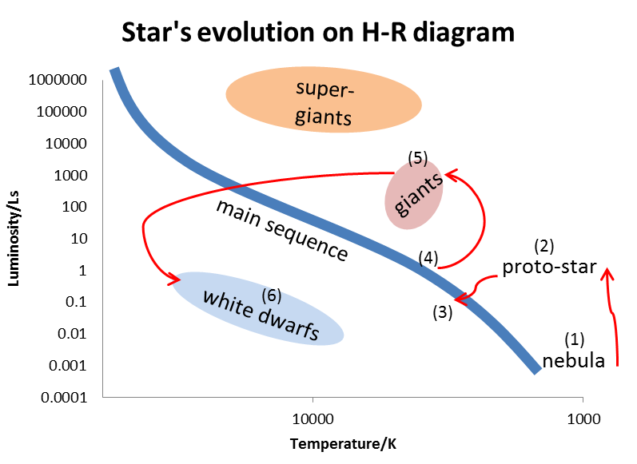Figure 8 Stellar evolution.

- Gas and dust in a nebula start to accumulate into the early beginnings of a star.
- Gravitational collapse raises the temperature to around 3000 K and a proto-star forms.
- The star evolves onto the main sequence, its initial position being determined by its mass of hydrogen.
- As hydrogen converts to helium it moves across the main sequence band.
- It eventually converts into a giant.
- The final stage depends on its mass. Smaller mass stars end up as a surviving core of a giant, which reduces in size to become a white dwarf.

Appendix 1: Spectral class

The Harvard programme of spectral spectroscopy was begun by Edward Charles Pickering and continued by Antonia Maury and Annie J Cannon for about 40 years. It eventually produced a catalogue of spectra for about 225,000 stars.

The stars were originally sorted according to the strength of their hydrogen absorption lines and given a letter ranging from A to O (15 groups), with A being the strongest (E C Pickering and Willianina Fleming, c1890).

This Harvard classification system was based entirely on the appearance of the spectra and not on any single physical parameter of the stars. In 1920 an Indian physicist, M N Saha, showed that the temperature of the outer layers of a star was primarily responsible for the appearance of its spectrum. Soon after, Cecilia Payne, an American astronomer, found that stars of different spectral classes had essentially the same chemical composition.

Annie Cannon then re-ordered by temperature, with some classes being merged and others rejected. Seven were left, O, B, A, F, G, K and M, with O being the hottest and M the coolest (a widely used mnemonic is Oh Be A Fine Girl (or Guy) Kiss Me).

Each of these was then further subdivided into ten subclasses, labelled 0 to 9. The hottest G stars, for example, are classified as G0 and the coolest as G9. The Sun is a G2 star. Some examples are given in Table 2.

Table 2 Spectral class and temperature

Spectral class | Approximate temperature (K) | Example (visible with naked eye)
O | 40,000 | Meissa (O8)
B | 20,000 | Achernar (B3)
A | 10,000 | Sirius (A1)
F | 7,500 | Canopus (F0)
G | 5,500 | Sun (G2)
K | 4,500 | Arcturus (K2)
M | 3,000 | Betelgeuse (M2)

Appendix 2: H–R analogy

Some car data (Table 3) and the corresponding ‘H–R’ diagram (Figure 9).
High-performance cars are highlighted in yellow, hybrids in green and diesels in grey.

Table 3: Car data

Make/model | Mass (kg) | Power (bhp)
Caterham | 570 | 260
Smart ForTwo | 810 | 70
Ariel Atom | 850 | 475
Mini Cooper S | 1173 | 173
Honda Insight | 1240 | 84
Renault Megane 250 | 1320 | 247
Volkswagon Scirroco | 1400 | 261
Toyota Prius | 1415 | 98
Ferrari 458 | 1535 | 562
Volvo S70 | 1700 | 310
Mercedes E350 CDi | 1995 | 228
Lexus LS460 | 2125 | 375
Rolls Royce Phantom | 2485 | 453
Toyota Land Cruiser D-4D | 2880 | 282

Type | key
High performance
Hybrid
Diesel
Normal petrol
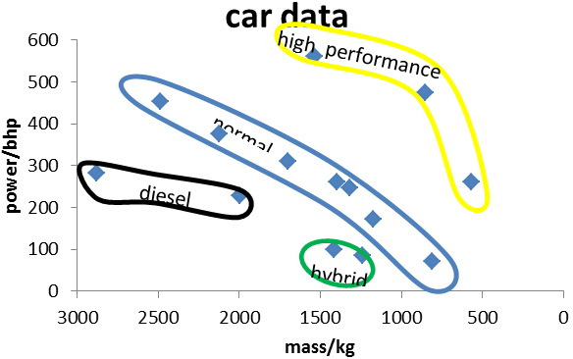
Figure 9 Car data.

Appendix 3: Detecting neutrinos

Since neutrinos hardly ever interact with atoms, they are notoriously difficult to detect. However, certain nuclear reactions can be triggered by neutrinos with the right energy. In the 1960s, Raymond Davis Jnr used the theoretical reaction that a neutrino would convert a chlorine atom into radioactive argon, which could be detected alter once it decayed. He filled a tank with 100,000 gallons of perchlorethylene (C₂Cl₄), a dry-cleaning fluid. The tank was buried nearly 1 mile deep in a gold mine in Dakota to protect it from cosmic radiation from space and used to detect solar neutrinos.

Anecdote: Rumour has it Davis was besieged by wire-coathanger salesmen after he purchased the 100,000 gallons of cleaning fluid for the experiment. This is a story which he denies.

In 1988 the Japanese built a detector at the Kamioka observatory (Institute for Cosmic Ray Research) called KamiokaNDE II (NDE stands for nucleon decay experiment)) and buried it deep in a lead mine. It was/is a large water Cherenkov detector. Using water to look for neutrino–electron interactions has a number of advantages:

- real-time detection (rather than month-by-month in radiochemical experiments)

- the characteristic ‘ring’ produced by the Cherenkov radiation allows discrimination of the signal from background radiation (Cherenkov radiation gives the characteristic blue glow in nuclear reactors)

- the electron recoils in roughly the direction the neutrino was travelling, so ‘points back’ towards the Sun

- neutrino–electron interaction is elastic, so the energy distribution of the neutrinos can be studied.

This experiment provided complimentary results to those of Davis since it used a completely different detection technique and location.

An excellent website on neutrinos and neutrino detection is http://hyperphysics.phy-astr.gsu.edu/hbase/particles/neutrino.html

Glossary

Apparent brightness | The amount of light energy per second reaching us per unit area.
Balmer thermometer | A technique that uses the intensity of hydrogen Balmer lines to determine the temperature of a star.
Big Bang nucleosynthesis | This occurred in the first 3 minutes after the Big Bang and formed mainly hydrogen and helium-4.
Black hole | A region in space from which no matter or radiation can escape. It results from the extreme curvature of space due to a compact mass.
Brightness | See apparent brightness and intrinsic brightness.
Charge-coupled device (CCD) | A semiconductor device consisting of an array of many light-sensitive elements.
Degeneracy pressure | This occurs at extremely high densities as a result of the Pauli exclusion principle, which prevents constituent particles from occupying identical quantum states.
Event horizon | The boundary of a black hole. No matter or radiation can escape from within the event horizon.
Flux | The amount of radiant energy per second flowing perpendicularly through a unit area.
Giant star | Large, cool luminous star. Typically 10–100 times the diameter of the Sun.
Gravitational equilibrium | See hydrostatic equilibrium.
Hertzsprung–Russell diagram | A plot of luminosity versus the surface temperature of stars. By convention the temperature is plotted in decreasing order.
Hydrostatic equilibrium | When the thermal pressure inside a star balances the inward force of gravity.
Intrinsic brightness | The total amount of visible light energy per second radiated by a star. See also luminosity.

Luminosity | The total amount of energy per second radiated by a star.
Main sequence | The region in an H–R diagram occupied by stars that are fusing hydrogen into helium in their cores.
Neutron star | A star composed almost entirely of neutrons and prevented from collapsing by the degeneracy pressure of the neutrons.
Nucleosynthesis | The formation of more massive nuclei from less massive ones. See stellar nucleosynthesis and Big Bang nucleosynthesis.
Photometer | An instrument for measuring brightness or luminous intensity.
Proto-star | A star in the process of formation, before nuclear fusion commences.
Schwarzschild radius | The radius of the event horizon of a black hole. The radius to which a mass needs to be compressed to form a black hole.
Stellar nucleosynthesis | The creation of heavy nuclei (heavier than helium), which occurs in stars.
Super-giant | A very luminous star with a large mass and large diameter.
Supernova | An explosion that temporarily increase the brightness of a star by up to 1 billion times (hence a ‘new’ star).  Type I are caused by the rapid fusion of carbon and oxygen within a white dwarf.  Type II are produced by the collapse of the core of a star.
White dwarf | A small dense star that is prevented from gravitational collapse by the degeneracy pressure of its electrons.

Recommended reading

Fix J D, Astronomy: Journey to the Cosmic Frontier
This book is highly recommended. The most up-to-date editions is the 6th edition, published in 2011). It is pitched at a suitable level with good clear explanations and illustrations. There are also additional online resources available to support the book. See also http://highered.mcgraw-hill.com/sites/0073512184/student_view0/index.html

Of particular interest for this unit are:
- Chapter 16 Basic properties of stars
- Chapter 17 The Sun
- Chapter 18 The formation of stars and planets
- Chapter 19 The evolution of stars
- Chapter 20 White dwarfs neutron stars and black holes

Seeds, M A, Foundations of Astronomy
This is another highly recommended book.
In addition to the conventional layout of chapter summaries etc it has some novel ideas in its layout, including:
- occasional double-page poster-like spreads, eg The family of stars
- windows on science, eg Quantum mechanics: the world of the very small
- parameters of science, eg Temperature and heat
- review: critical enquiry panels, eg ‘Why does nuclear fusion require that the gas to be very hot?’

Part 2: The Stars is the most relevant section and includes:
- Chapter 7 Starlight and atoms
- Chapter 8 The Sun – our star
- Chapter 9 The family of stars
- Chapter 11 The formation of stars
- Chapter 12 Stellar evolution
- Chapter 13 The death of stars
- Chapter 14 Neutron stars and black holes

Bennett J, Donahue M, Schneider N, Voit M, The Cosmic Perspective
An introduction to astronomy for non-science undergraduates. Very clear and useful summaries at the end of each chapter.

This book also has the following novel features:
- common misconceptions panels, eg The sun is not on fire
- mathematical insight sections where equations and numerical calculations are dealt with, eg The luminosity–distance formula.

The most relevant part is Part V Stellar Alchemy, which includes:
- Chapter 15 Our star
- Chapter 16 Properties of stars
- Chapter 17 Star stuff
- Chapter 18 The Bizarre stellar graveyard

Nicolson I, Unfolding Our Universe
Good, clear colour diagrams throughout the book explain the concepts well to a ‘physics’ audience. Inset boxes give additional information, often including equations and calculations. Good glossary included.

Unlike other books in this list, this one is targeted at the general reader rather than undergraduates, although unlike many astronomy books aimed at a general readership it does use panels to deal with equations and a mathematical aspects. It also has good clear diagrams and graphs. Unfortunately there only appears to be the original edition published in 1999.

The relevant chapters are:
- Chapter 8 The Sun: Our neighbourhood star
- Chapter 9 Stars: Basic properties
- Chapter 11 Stellar life cycles
- Chapter 12 Collapsing, exploding and interacting stars

Duncan T, Tyler C, Your Cosmic Context: an introduction to modern cosmology
An excellent book aimed at a single-term undergraduate course on cosmology. As the subtitle states, it has more emphasis on cosmology, but Chapter 9: The Nuclear Realm is particularly good and relevant on the evolution of stars with subheadings:

- 9.1 Energy
- 9.2 Nuclear interactions
- 9.3 Thermonuclear fusion in stars
- 9.4 Heavy elements and stellar genetics
- 9.5 Exotic particles
- 9.6 Elemental abundances

Bibliography

Bennett J, Donahue M, Schneider N, Voit M, The Cosmic Perspective, 3rd edition, Addison-Wesley, 2004, ISBN 0-8053-8762-5.

Bennett J, Donahue M, Schneider N, Voit M, The Cosmic Perspective Fundamentals, Addison-Wesley, 2010, ISBN 0-321-56704-8.

Duncan T, Tyler C, Your Cosmic Context, Addison Wesley, 2009, ISBN 978-0-13-240010-7.

Fix J D, Astronomy: Journey to the Cosmic Frontier, 2nd edition, McGraw-Hill, 1999, ISBN 0-07-289854-2

Green, S F et al., An Introduction to the Sun and Stars, Cambridge University Press, 2004, ISBN-10: 0521546222, ISBN-13: 978-0521546225.

Kippenhahn R, Discovering the Secrets of the Sun, Wiley, 1994, ISBN0-471-941-630.

Liddle A, Loveday J, The Oxford Companion to Cosmology, Oxford University Press, 2008, ISBN 978-0-19-956084-4.

Nicolson I, Unfolding Our Universe, Cambridge University Press, 1999, ISBN 0-521-59270-4.

Seeds M A, Foundations of Astronomy, 7th edition, Thomson, 2003, ISBN 0-53439204-0.

Shaviv G, The Life of Stars, Springer, 2009, ISBN 978-3-642-02088-9.

Useful websites

European Space Agency
Six sets of Teachers’ Notes (also downloadable as pdf files):
- Introduction to the Universe
- Stellar radiation and stellar types*
- Stellar distances
- Cosmology
- Stellar Processes and Evolution*
- Galaxies and the Expanding Universe
*Particularly appropriate for this topic.
http://sci.esa.int/science-e/www/object/index.cfm?fobjectid=35713

Astrophysics Science Project Integrating Research and Education (ASPIRE)
Interactive online science lessons and labs.
This one is Star Life Cycle, which is in three parts:
- Protostars
- Stars
- Hertzsprung–Russell diagrams.
Runs a nice analogy with human development.
http://aspire.cosmic-ray.org/labs/star_life/starlife_main.html

Fix J D, Astronomy: Journey to the Cosmic Frontier
This website offers additional resources to support the 4th edition of this book, including:
- multiple choice quizzes
- animations
- flashcards
- glossary.
http://highered.mcgraw-hill.com/sites/007299181x/student_view0l

NASA
Stellar evolution – aimed at younger children (S1-S3).
http://www.nasa.gov/audience/forstudents/9-12/features/stellar_evol_feat_912.html#backtoTop

NASA
The star life cycle, illustrated with Hubble Space Telescope images.
http://map.gsfc.nasa.gov/universe/rel_stars.html

Case Western Reserve University
Sets of online notes available at two levels (regular and academic).
http://burro.cwru.edu/stu/stars_lifedeath.html

