**Section 6: Stellar physics**

**(a) Properties of Stars**

**Proposal for learner activity/practitioner demonstration**

**Context**: Measuring apparent brightness using detectors such as CCDs.

**Overview**: Detecting the apparent brightness of MES lamps of different ratings at different distances, using a webcam and light sensor (eg ALBA linear light sensor).

**Apparatus**: 2 m length black plastic drainpipe

Around four to six 11-mm diameter MES lamps of various power ratings and MES lamp holders

Webcam

Light sensor (eg ALBA (from djb Microtech) or similar apparatus from alternative supplier)

PC/laptop with appropriate webcam and interfacing software

**Diagram**

Webcam

Light sensor

MES lamp and holder

2-m length of black plastic drainpipe

End blanked off

**Notes**

Electrical supplies, PC and interfacing apparatus have been omitted for clarity.

The webcam and light sensor should be aimed down the pipe through a suitable mask (eg neoprene form an old mouse-mat) to prevent light entering the pipe.

MES lamps have standard dimensions (11-mm diameter) and are available in a variety of ratings. Lamps and holders should be in plentiful supply in a reasonably stocked physics department.

Holes for mounting the holders should be drilled at various points around the circumference of the pipe to avoid alignment of the lamps.

Lamps should be able to be switched on and off independently, so that one or more or all may be switched on at a time.

By arranging different ratings of lamp at different distances a range of apparent brightness can be obtained, allowing lamps to give:

(a) equal brightness at different distances and

(b) different brightness at equal distances.

See Tables 1 and 2 for example data.

**Table 1** MES lamp data

|  |  |  |  |  |  |
| --- | --- | --- | --- | --- | --- |
| **Type** | **CPC/Farnell cat ref.** | **Voltage**  **(V)** | **Current**  **(A)** | **Power**  **(W)** | **Irradiance**  **@ 1 m**  **(W m–2)** |
| A | AR70334 | 1.5 | 0.3 | 0.45 | 0.11 |
| B | AR70335 | 3.5 | 0.2 | 0.70 | 0.17 |
| C | AR70336 | 4.8 | 0.3 | 1.44 | 0.34 |
| D | AR70337 | 6.0 | 0.1 | 0.60 | 0.14 |

**Table 2** Example distance and irradiance for MES lamps

|  |  |  |  |  |  |
| --- | --- | --- | --- | --- | --- |
| **Type** | **Power**  **(W)** | **Distance for**  ***I* = 0.3 W m–2 (m)** | **Distance for**  ***I* = 0.2 W m–2 (m)** | **Distance for**  ***I* = 0.1 W m–2 (m)** | **Distance for**  ***I* = 0.05 W m–2**  **(m)** |
| A | 0.45 | 0.60 | 0.73 | 1.04 | 1.47 |
| B | 0.7 | 0.75 | 0.91 | 1.29 | 1.83 |
| C | 1.44 | 1.07 | 1.31 | 1.85 | 2.62 |
| D | 0.6 | 0.69 | 0.85 | 1.20 | 1.69 |

**Table 3** Example fitting of lamps and predicted irradiances

|  |  |  |  |  |
| --- | --- | --- | --- | --- |
| **Lamp number** | **Type** | **Power**  **(W)** | **Distance**  **(m)** | **Irradiance**  **(W m–2)** |
| 1 | A | 0.45 | 1.04 | 0.1 |
| 2 | B | 0.7 | 0.75 | 0.3 |
| 3 | C | 1.44 | 1.85 | 0.1 |
| 4 | D | 0.6 | 1.69 | 0.05 |
| 5 | A | 0.45 | 0.73 | 0.2 |
| 6 | A | 0.45 | 1.47 | 0.05 |

**Procedure**

1. Start with all lamps switched on and view, by eye, light from each inside pipe.
2. Attach webcam and light sensor. View image and data on PC screen.
3. Note changes in image from webcam and reading from light sensor as lamps are switched off.
4. For each individual lamp, observe image from webcam and reading from light sensor.
5. From data identify pairs of lamps with same apparent brightness.
6. Note that three of the lamps have the same power (lamps 1, 5 and 6), and emphasise point that the differences in their apparent brightness are due to the distances between the source and the point of observation (inverse square law).

**Apparent brightness experiment**

**Development overview**

* Early attempts at using drainpipe proved fruitless due to reflections from the smooth internal surface of the plastic.
* An attempt was made to construct a similar length of tube from matt black card. This proved quite laborious, but did not require any special tool or skills, so was relatively straightforward.

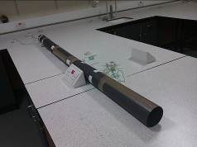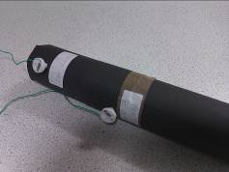

*Tube made from matt black card Light tube end and lamps*

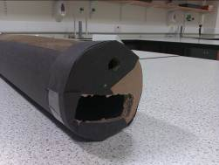

*Light tube sensor and webcam slots*

**Figure 1** *Light tube.*

* Having constructed the tube and placed MES lamps of different ratings at various distances along the tube a webcam and an ALBA light sensor were placed at its end (see the lamp data spreadsheet for details of ratings and positions of lamps).
* Attempts to obtain meaningful, reliable data were unsuccessful. The ALBA light sensor proved not to be sufficiently sensitive to detect the light from the lamps inside the tube. The relatively low resolution of the webcam (1 megapixel) and its narrow depth of field made it difficult to obtain any useful images of the lamps inside the tube.
* In an attempt to obtain some useful, reliable measurements an ETI-1301 hand-held light meter was used. This also proved unsuccessful.
* At this point, use of the light tube was abandoned and another approach attempted.
* By measuring apparent brightness against distance for different lamps using both the ALBA and ETI-1301 light meters, it was hoped to produce graphs of brightness versus distance. Such graphs could be used to find different combinations of lamps at different distances that would give the same apparent brightness.
* So that the results were not affected by ambient light levels, the apparatus was covered whilst measurements were taken.

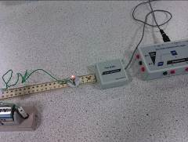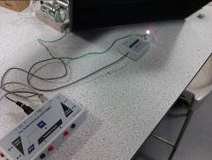

*Lamp, sensor and ruler Lamp and sensor uncovered*

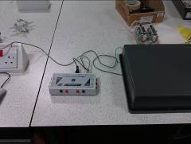

*Lamp and sensor covered*

**Figure 2** *ALBA light sensor and lamp.*

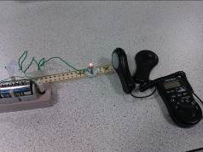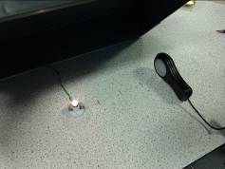

*Lamp, sensor and ruler Lamp and sensor uncovered*

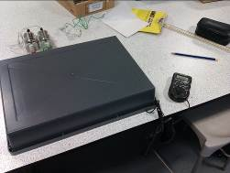

*Lamp and sensor covered*

**Figure 3** *Handheld lux sensor and lamp.*



**Figure 4** *Apparent brightness against distance. Lamp A at 0.1 m has the same apparent brightness as lamp B at 0.25 m and lamp C at 0.2 m.*

* As this experiment is effectively an extension of the inverse square law for irradiance in the current Higher Physics course, it was decided not to undertake any further development.
* Having had no success in developing experimental work on the apparent brightness of stars, it was decided to abandon it altogether.

**Section 6: Stellar physics**

**(b) Stellar evolution**

**Activity: Stellar classification – using the H–R diagram and stellar data to classify stars**

Having learned about the processes of stellar evolution learners are issued with a table of incomplete stellar data for a small number of stars and have to use a simplified copy of the Hertzsprung–Russell diagram to plot them on the graph and classify them.

Using their knowledge of the timescales of evolution and complete information about similar stars learners could also try to estimate the mass or ‘lifetime’ of stars.

**Simplified Hertzsprung–Russell diagram**

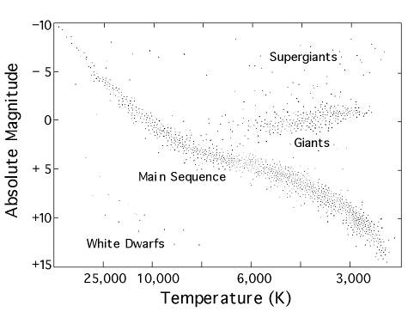

(Modified from <http://heasarc.gsfc.nasa.gov/docs/RXTE_Live/class.html>.)

(This H–R diagram is also available on its own on a single sheet – HR diagram.doc)

Exemplar stellar data (from wolframalpha.com) can be found in the attached Excel spreadsheet – stellar data.xls.

**Additional resources**

* H–R diagram animation: <http://aspire.cosmic-ray.org/labs/star_life/support/HR_animated.swf>
* Interactive H–R diagram and questions: <http://aspire.cosmic-ray.org/labs/star_life/support/HR_static.swf>
* H–R diagram simulator with evolution: <http://goo.gl/6itd8>
* H–R diagram explorer: <http://goo.gl/1iKhj>
* YouTube videos
  + Explanation (cosmic classroom): <http://youtu.be/mcPrSAKNeMI>
  + Example (omega Centauri cluster): <http://youtu.be/Kqe6F-Qf9Tk>

**Stellar data**

**Table 1** Complete

|  |  |  |  |  |  |
| --- | --- | --- | --- | --- | --- |
| **Star** | **Temp. (K)** | **Magnitude (Mv)** | **Stellar classification** | **Lifetime** | **End state** |
| Achernar | 19000 | –2.77 | Main sequence | 63 million | White dwarf/neutron star |
| Aldebaran | 4100 | 0.87 | Giant | 6.3 billion | White dwarf |
| Altair | 7800 | 0.76 | Main sequence | 2.2 billion | White dwarf |
| Antares | 3600 | –5.28 | Supergiant | 7.3 million | Black hole/neutron star |
| Betelgeuse | 3600 | –6.02 | Supergiant | 7.3 million | Black hole/neutron star |
| Canopus | 7500 | –5.53 | Supergiant | 20 million | Neutron star |
| Deneb | 9300 | –7.13 | Supergiant | 5.6 million | Black hole/neutron star |
| Mira |  | 6.47 | Giant |  |  |
| Proxima Centauri | 3200 | 15.4 | Main sequence | 490 billion | White dwarf |
| Regulus | 13000 | –0.519 | Main sequence | 230 million | White dwarf |
| Rigel | 15000 | –6.95 | Supergiant | 2.7 million | Black hole |
| Sirius | 9400 | 1.45 | Main sequence | 820 million | White dwarf |
| Sirius B | 25200 | 111.3 | White dwarf | N/A | N/A |
| Sun | 5780 | 4.85 | Main sequence | 10 billion | White dwarf |
| Vega | 9800 | 0.582 | Main sequence |  | White dwarf |

**Table 2** Incomplete – to be completed by learners

|  |  |  |  |  |  |
| --- | --- | --- | --- | --- | --- |
| **Star** | **Temp. (K)** | **Magnitude (Mv)** | **Stellar classification** | **Lifetime** | **End state** |
| Achernar | 19000 | –2.77 | Main sequence | 63 million | White dwarf/neutron star |
| Deneb | 9300 | –7.13 | Supergiant | 5.6 million | Black hole/neutron star |
| Rigel | 15000 | –6.95 | Supergiant | 2.7 million | Black hole |
| Vega | 9800 | 0.582 | Main sequence |  | White dwarf |

**Table 3** Incomplete – to be completed by learners

|  |  |  |  |  |  |
| --- | --- | --- | --- | --- | --- |
| **Star** | **Temp. (K)** | **Magnitude (Mv)** | **Stellar classification** | **Lifetime** | **End state** |
| Aldebaran | 4100 | 0.87 | Giant | 6.3 billion | White dwarf |
| Betelgeuse | 3600 | –6.02 | Supergiant | 7.3 million | Black hole/neutron star |
| Proxima Centauri | 3200 | 15.4 | Main sequence | 490 billion | White dwarf |
| Sirius B | 25200 | 111.3 | White dwarf | N/A | N/A |

**Table 4** Incomplete – to be completed by learners

|  |  |  |  |  |  |
| --- | --- | --- | --- | --- | --- |
| **Star** | **Temp. (K)** | **Magnitude (Mv)** | **Stellar classification** | **Lifetime** | **End state** |
| Altair | 7800 | 0.76 | Main sequence | 2.2 billion | White dwarf |
| Canopus | 7500 | –5.53 | Supergiant | 20 million | Neutron star |
| Regulus | 13000 | –0.519 | Main sequence | 230 million | White dwarf |
| Sun | 5780 | 4.85 | Main sequence | 10 billion | White dwarf |

**Table 5** Incomplete – to be completed by learners

|  |  |  |  |  |  |
| --- | --- | --- | --- | --- | --- |
| **Star** | **Temp. (K)** | **Magnitude (Mv)** | **Stellar classification** | **Lifetime** | **End state** |
| Antares | 3600 | –5.28 | Supergiant | 7.3 million | Black hole/neutron star |
| Betelgeuse | 3600 | –6.02 | Supergiant | 7.3 million | Black hole/neutron star |
| Sirius | 9400 | 1.45 | Main sequence | 820 million | White dwarf |
| Mira |  | 6.47 | Giant |  |  |