Title:

DRAUGHTS
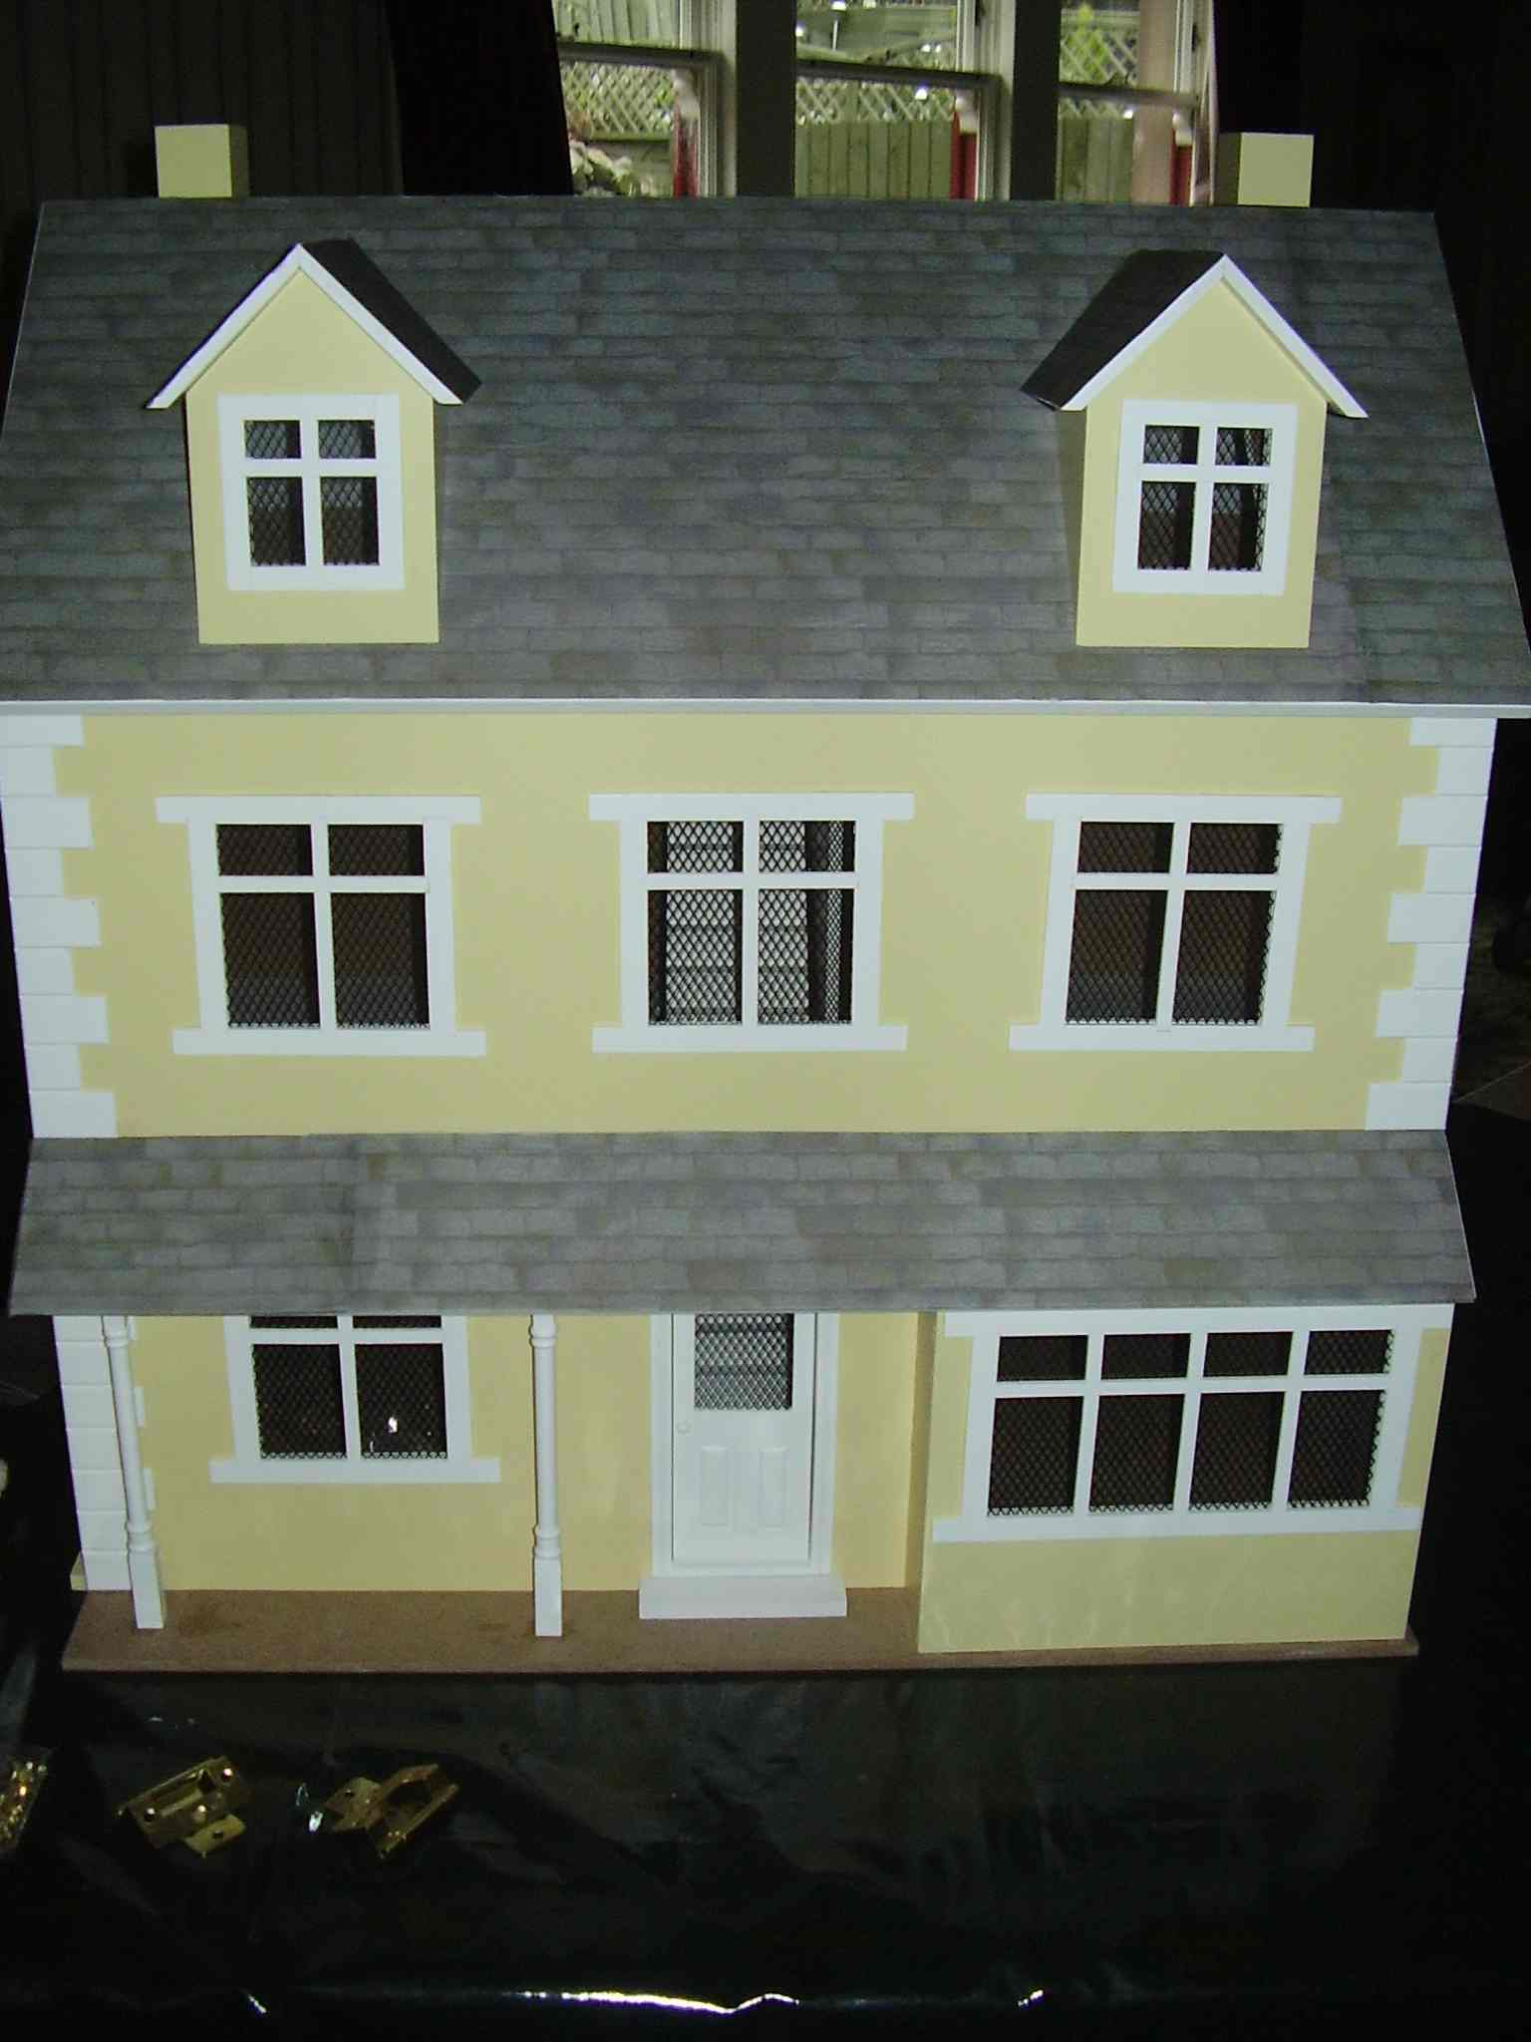
25%
35%
15%
10%
15%
Aim:
To find out if
25%
35%
15%
10%
15%
draughts cause heat loss from houses.
Aim:
To find out if draughts cause heat loss from houses.

Hypothesis:
Record your hypothesis (what you expect to happen)

Method / Plan
We cannot use real draughts in house - this would not be practical, can you think of a way this could be done in the lab without using the doll’s house?

Design an experiment
Design an experiment that will show how draughts can cause heat loss from houses.
Think about the following.
    - What could you use as a source of heat?
    - What could you use to measure the temperature?
    - How could you log (measure) the temperature?
    - What can you use as a source for the draught?
    - How will you know if a draught increases heat loss?
    - How long will your experiment last?
    - How will you present your information?
    - How will you make your experiment fair?
Results
Draw a table of your results.
How will you get all this information into the table?
Can you plot a graph of your results?

Conclusion
Do draughts make a difference to the heat loss? How can you tell?

Evaluation
Do you think that this experiment truly represents what might happen in a real house?

Enterprise Activity
- Is it practical to block up all draughts in your house?
- What are some of the risks of having limited draughts in your house?
- How can you check to find out if your house has enough fresh air?

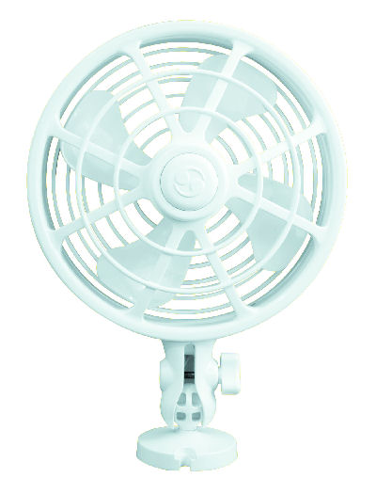
HELP SHEET

Time | Temperature (ºC)
(mins) | with draught (fan) | Without draught
0
1



