Causes of Road Traffic Accidents
In Great Britain, data collected about road traffic accidents in 1999 to 2002 examined the factors involved in each accident. Excessive speed was the most common contributory factor in fatal accidents, playing a part in 28% of all fatal accidents examined in the trial. Careless, thoughtless or reckless behaviour was next, being a contributory factor in 21% of all fatal accidents examined.
In accidents resulting in any severity of casualty, inattention was the most common contributory factor, found in 25% of all accidents examined in the trial. Failing to judge another person's path or speed was the next most common contributory factor, playing a part in 23% of all accidents examined.
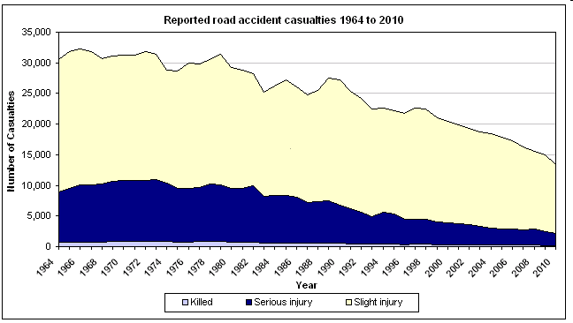
Crash Figures: http://www.gov.scot/Topics/Statistics/Browse/Transport-Travel/TrendRoadAccident
http://www.bobulous.org.uk/articles/road_traffic_accident.html

