TASK
We need to know the
- distance your vehicle will travel
- the displacement of the vehicle from the start
- the average speed over the whole journey
- the instantaneous speed of the vehicle as it goes round the roundabout (or alternative)

FOUR TEAMS OF 5 max (reduce team nos. but no less than 4 in a team)
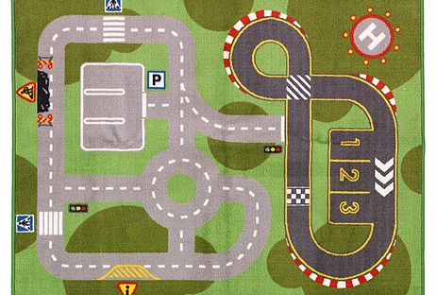
Issue work cards for the students to go through
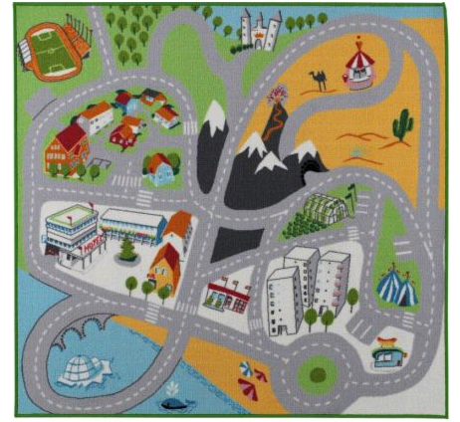
EQUIPMENT
- 7m of string
- scissors
- calculator
- road play mat
- radio controlled car
- results sheet
- ruler
- metre stick
- pens and pencils
- piece of chalk

YOUR TASK.
Working in teams you need to:
  - measure the DISTANCE that the car will travel following the pre-defined course.
  - record this value on your worksheet
  - measure the DISPLACEMENT of the car from the start to the finish.
  - record this value on your worksheet
  - time how long each person in the group takes to complete the course.
  - record this value on your worksheet
  - time how long note down
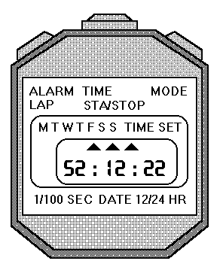
  - record as tally marks on your worksheet every time each person in the group leaves the track
Start & Stop
Reset
  - Find the average speed of the car for each person
  - Find the average velocity of the car for each person.
  - Using the ALBA package record the instantaneous speed of the vehicle at the specific place in the track (see the additional worksheet)

Reading the stopclock
The stopclock display can be a bit confusing. A number that looks like this: 0:0234 means 2.34 seconds.

(1) | (2) | (3) | (4) | (5) | (6) | (7) | (8)
Name of Contestant | Distance travelled by car (m) | Displacement  (m) | Time taken for run (s) | No. of times car went off the track | Average Speed (m/s) | Average Velocity  (m/s) | On a scale of 1-5 how good was the driver?

