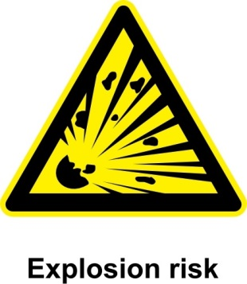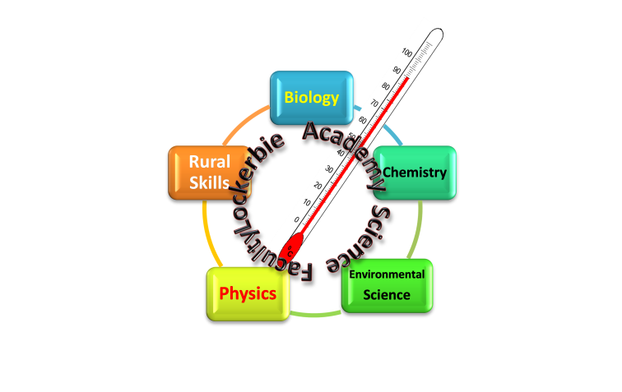

**2017**

J A Hargreaves

Lockerbie Academy

2/15/2017

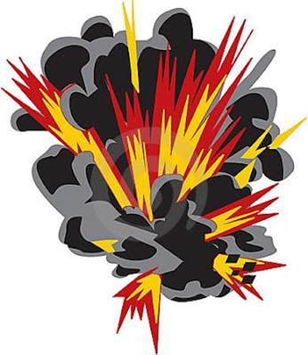

S1 Energy & Sound Homework

Homework 1- Forms of Energy

**Write in full sentences in your neatest hand writing**

1. Copy and complete the diagram showing the 9 different forms of energy.

Nuclear

Heat

Chemical

Electrical

Types

of

Energy

**2** Look at this picture of Bonfire Night.

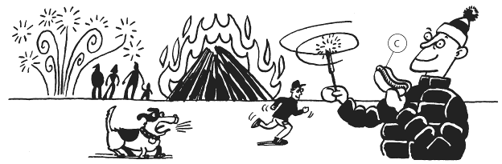

1. Make a list of the things in the picture that stored chemical energy.
2. List the things are converting stored energy to light.
3. List the things are converting stored energy to sound.
4. List the things are converting stored energy to heat.
5. Which of your answers to part d) are converting energy **usefully** as heat?

3.

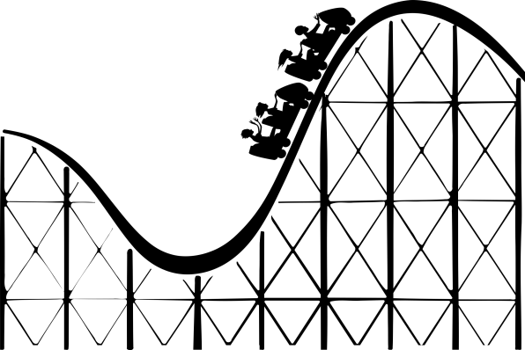

1. In what form is this rollercoaster storing energy when it is at the top of the track?
2. What will this be converted to as it goes down the slope?
3. Not all of the energy will be converted to the form you gave in your answer to part b.
4. What will happen to the rest of the energy?

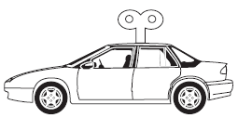4. Jack wound up a toy car and released it.

Paul told him he was storing energy in the car, which can be converted into other types.

1. How did Jack store the energy in the car?
2. What type of energy is stored in the car?
3. How can Jack increase the amount of stored energy the toy car is given?
4. How will Jack know when the car has changed all of its stored energy to other types?

I CAN...

* identify energy stores and transfers • use the idea of conservation of energy

I CAN...

* identify energy stores and transfers • use the idea of conservation of energy
* represent energy transfers using Sankey diagrams.

**Homework 2- Energy Changes/Transformations**

**Write in full sentences in your neatest hand writing**

1. Copy the following into your jotter

Energy cannot be created or destroyed we can only transfer it from one place to another or convert it into different forms. Eventually energy turns into heat which heats up our surroundings.

1. Copy and complete the energy transfer diagram, called a Sankey Diagram.
   1. Food Blender



Electrical

energy

..................... energy

..................... energy

* 1. Wood burning fire



Chemical

energy

in wood

..................... energy

..................... energy

* 1. Music player

MCj04242400000[1]

.....................

energy

Sound

energy

.....................

energy

..................... energy

..................... energy

* 1. Telephone

[](http://www.bing.com/images/search?q=cartoon+telephone&view=detail&id=F81FC769F5CC2E1D747768089EA72C94ED4441BE&first=0&FORM=IDFRIR)

.....................

energy

.....................

energy

* 1. Photosynthesis

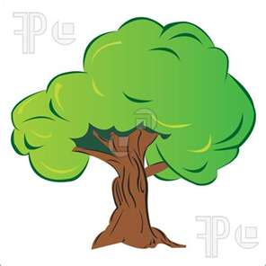

.....................

energy

.....................

energy

grandprixHere is a picture of a racing car. In the diagram 100 Joules of energy is stored in the fuel. This produces 30 Joules of energy to move the car forward. This means 70 Joules of energy has been wasted as heat. We can represent this in a Sankey diagram as shown below.

100 J 30 Joules movement energy

Potential energy

in fuel

70 Joules heat

1. A battery stores 70 Joules of energy. If 10 Joules is given off as light in a bulb complete the diagram below.

1. A kettle produces 600 kJ of energy of electrical energy during the time it is switched on. 500 kJ are used to boil the water,
2. How much has been lost as the kettle is left on?
3. Where has this energy gone?
4. Construct a Sankey Diagram to show the energy transfers and changes.

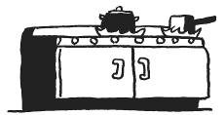The natural gas in this cooker transfers 200kJ of stored energy to boil the water in the pan. When the water is boiling there is 168kJ of thermal energy stored in the hot water.

1. How much wasted energy has been transferred?
2. Explain your answer to part a.
3. Where is this wasted energy stored?
4. Draw a Sankey diagram to represent these changes.

I CAN...

* identify energy stores and transfers • use the idea of conservation of energy
* represent energy transfers using Sankey diagrams.

**Homework 3- Waves**

Draw labelled diagrams to show the difference between a longitudinal and a transverse wave.

Draw a table with the headings longitudinal and transverse waves as shown below

|  |  |
| --- | --- |
| Transverse | Longitudinal |
|  |  |

Place the following words in the correct column in the table

Sound, Radio, Microwaves, Light, Water, p-waves (primary waves- earthquake), s-waves (secondary waves - earthquake). Can you add any of your own?

Copy and complete the diagram. Adding the following terms

wavelength, amplitude, crest, trough, axis

time

Explain the meaning of the following terms

wavelength, amplitude, crest, trough, frequency

I CAN...

* identify the two types of waves • draw and label waves
* use correctly the language associated with waves

Homework 4- Speed of Sound

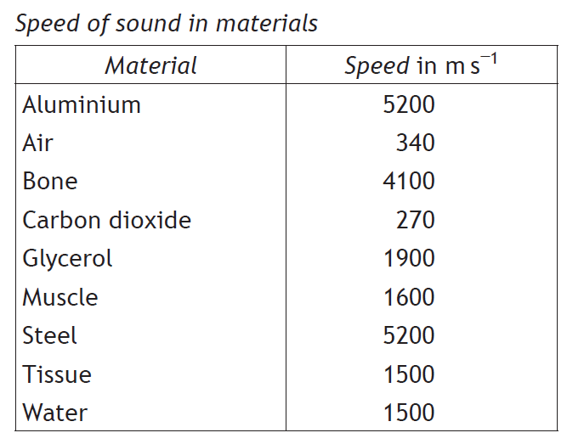

Sound travels at different speeds through different materials. It travels fastest through solids because the particles are closer together.

Calculations involving the speed of sound can be carried out using the equation:

|  |  |
| --- | --- |
| $$v=\frac{d}{t}$$ | d  v  t |
| $$d=v ×t$$ |
| $$t=\frac{d}{v}$$ | Where:  v is speed, measured in metres per second (m/s)  d is distance, measured in metres (m)  t is time, measured in seconds (s) |

# When laying out an equation remember IESSUU

During a storm, lightning is seen in the distance and the thunder is heard 5 seconds later. How far away was the lightning strike?

|  |  |
| --- | --- |
| d = ? | d = v t |
| v = 340 m/s | = 340 x 5 |
| t = 5 s | =**1700 m** |

# Speed of Sound Questions

**Information, Equation, Substitution, Solution, Units & Underline the answer**

Describe an experiment to measure the speed of sound in air

Find the missing values in the following table:

|  |  |  |  |
| --- | --- | --- | --- |
|  | Speed (m/s) | Distance (m) | Time (s) |
| (a) |  | 15 000 | 5 |
| (b) |  | 38 | 0·02 |
| (c) | 1 500 |  | 0·25 |
| (d) | 5 200 |  | 0·01 |
| (e) | 340 | 17 |  |
| (f) | 330 | 3 465 |  |

The speed of sound in tissue is 1500 metres per second. How far would sound travel in tissue in a time of 0·0002 seconds?

Sound in jelly can travel a distance of 0·435 metres in a time of 0·000 3 seconds. What is the speed of sound in jelly?

How long would it take for sound to travel 0·435 m through air if the speed of sound in air is 340 m/s?

The speed of sound in muscle is 1 600 m/s. How far would sound travel in muscle in a time of 0·0005 seconds?

Calculate the speed of sound in bone given that it takes 0·00005 s for sound to travel 0·15 m through bone.

I CAN...

* use speed= distance ÷time to calculate speed distance and time of sound waves

Alternative Homework 4- Sound levels

At home, go to a search engine, such as Google and type in the following:

‘**Human Hearing Range Youtube**’

Click on the first link.

Alternatively, type the full web address in to your browser:

[**www.youtube.com/watch?v=2G9Q-r2leyw**](http://www.youtube.com/watch?v=2G9Q-r2leyw)

Copy yhe table below into your jotter.

Play this to different people in your family and record the highest frequency that they can hear in the table below:

|  |  |  |
| --- | --- | --- |
| **Name** | **Age (don’t lie!)** | **Highest Frequency Heard (kHz)** |
|  |  |  |
|  |  |  |
|  |  |  |
|  |  |  |
|  |  |  |

See if you can try this with at least four people.

**One more thing! B**e careful when using Google…

In your house, there are lots of things that give off sound energy. Some are electrical appliances and some are even animals!

In this task you have to either take photographs of (or draw) some things in your house that are giving off **sound** energy.

Stick your photographs (or drawings) in the boxes below and write down the energy change occurring in that object.

**Example:**

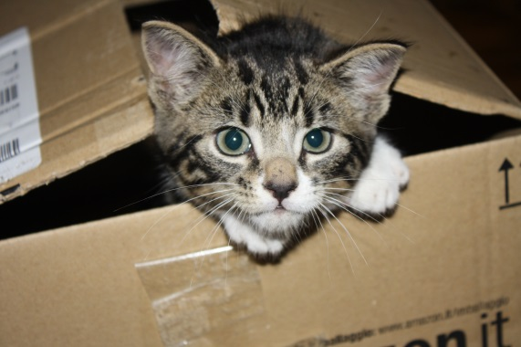

**Object:** Cat

**Energy Change:** Chemical → Kinetic + Heat

+ Sound

**Object:**

**Energy Change:**

Homework 5- Summary

Copy and complete the following passage about waves

1. Sound is a longitudinal wave caused by vibrating objects.
2. Sound can travel in solids , liquids and gases but not in a vacuum.
3. Sound travels faster/slower*(write in the correct word) in solids than in gases.
4. It travels at 340 m/s in air. Lighting and thunder is an example to show that speed of light is very much greater than the speed of sound.
5. The range of human hearing is 20 – 20,000 Hz and that sound above this frequency is called Ultrasound. This can be used to scan pregnant women.
6. On an oscilloscope traces can represent sound. Volume is indicated by the amplitude and frequency is represented by the pitch.
7. On graph paper or squared paper draw the following sound waves as seen on an oscilloscope Draw loud and quiet, high and low pitched sounds.

Normal Note loud note quiet note

high pitched note low pitched note

1. Sound levels are measured in decibels and that the danger level of sound is 85dB which can cause permanent damage to hearing.
2. Copy the Sound level column and write the correct sound level by each source.

|  |  |
| --- | --- |
| **Sound Source** | **Sound Level (dB)** |
| Jet Air craft @ 1m | 140 |
| Threshold of hearing (quietist sound human’s can hear) | 120 |
| Snoring quietly | 100 |
| Normal Conversation | 80 |
| Power Tools | 40 |
| Cars / Busy Street | 20 |
| A bird Singing | 0 |
| Pain |  |

1. Curved reflectors can be used to increase the strength of a signal, the larger the curved reflector the greater the strength of the signal collected.

I CAN...

* understand the terms relating to sound
* draw traces to show how different sounds would be represented on an oscilloscope.
* estimate different sound levels.