**Sound Homework 1**

These gentlemen are famous scientists who worked with energy in their lifetimes.

[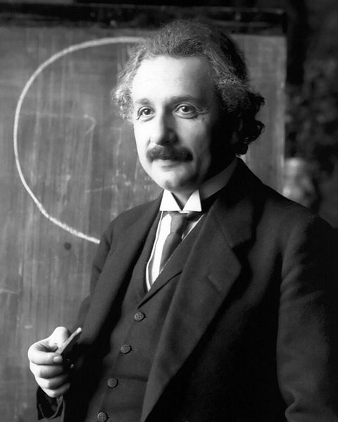](http://upload.wikimedia.org/wikipedia/commons/f/f5/Einstein_1921_portrait2.jpg)[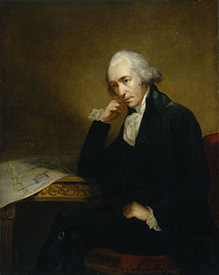](http://en.wikipedia.org/wiki/File:Watt_James_von_Breda.jpg)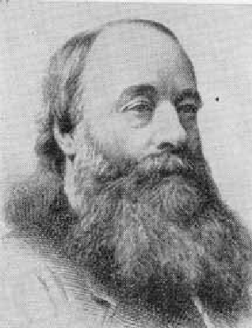

James Joule James Watt Albert Einstein

1. Copy and complete this table:

|  |  |  |  |
| --- | --- | --- | --- |
| **Scientist** | **James Joule** | **James Watt** | **Albert Einstein** |
| **Date of Birth** |  |  |  |
| **Place Of Birth** |  |  |  |
| **Date of Death** |  |  |  |

(b) Can you find out why each one is famous

1. The energy change in a radio is:

**Electrical → Sound + Heat**

1. Which energy is a ‘waste’ (unwanted) energy?
2. 2000 J of electrical energy is used up by a radio. If 600 J of heat energy is given off by the radio, how much sound energy is given off?

**Sound Homework 2**

In your house, there are lots of things that give off sound energy. Some are electrical appliances and some are even animals!

In this task you have to either take photographs of (or draw) some things in your house that are giving off **sound** energy.

Stick your photographs (or drawings) in the boxes below and write down the energy change occurring in that object.

**Example:**

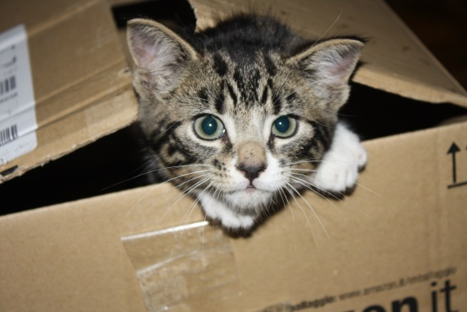

**Object:** Cat

**Energy Change:** Chemical → Kinetic + Heat

+ Sound

**Object:**

**Energy Change:**

**Object:**

**Energy Change:**

**Object:**

**Energy Change:**

**Sound Homework 3**



At home, go to a search engine, such as Google and type in the following:

‘**Human Hearing Range Youtube**’

Click on the first link.

Alternatively, type the full web address in to your browser:

**www.youtube.com/watch?v=2G9Q-r2leyw**

Play this to different people in your family and record the highest frequency that they can hear in the table below:

|  |  |  |
| --- | --- | --- |
| **Name** | **Age (don’t lie!)** | **Highest Frequency Heard (kHz)** |
|  |  |  |
|  |  |  |
|  |  |  |
|  |  |  |
|  |  |  |



**One more thing!**

Be careful when using Google…