THE STEAM ENGINE

In a steam engine the energy change starts with CHEMICAL POTENTIAL ENERGY in the FUEL. This turns into HEAT in the fuel ⇒Heat in the water⇒Kinetic in the water (steam)*⇒kinetic in the wheel)⇒kinetic in the draft shaft)⇒kinetic in the workshop.

OR
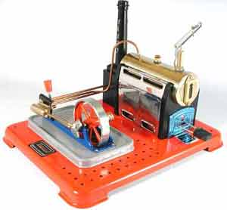
*⇒sound energy in the whistle
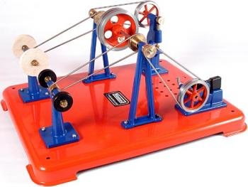

THE STEAM ENGINE

In a steam engine the energy change starts with CHEMICAL POTENTIAL ENERGY in the FUEL. This turns into HEAT in the fuel ⇒Heat in the water⇒Kinetic in the water (steam)*⇒kinetic in the wheel)⇒kinetic in the draft shaft)⇒kinetic in the workshop.

OR
*⇒sound energy in the whistle

