

**2019+**

Mrs Hargreaves

www.mrsphysics.co.uk

2019+

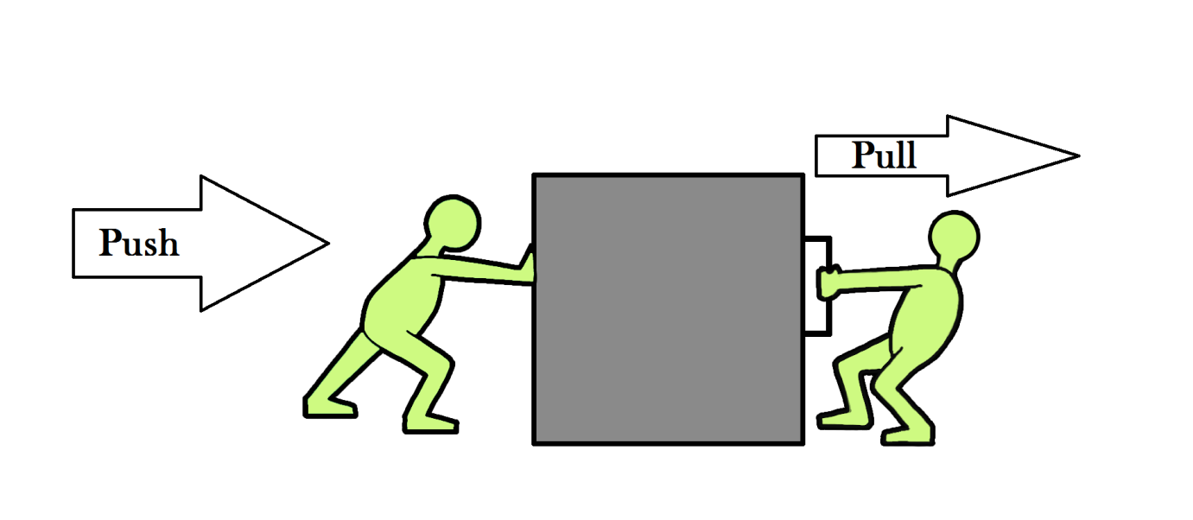

FORCES

S2 FORCES NEED TO KNOW SHEET

1. Mass is a measure of the amount of matter in an object.
2. Mass is measured in kilograms (kg).
3. Mass stays the same wherever it is taken.
4. Mass doesn't move unless forced to.
5. Forces are invisible. Sometimes we can see what causes the force or the effect of the force. egs of forces are: pushing, pulling, squeezing, tearing are all ways
6. For the effects of a force to be seen the forces must be unbalanced.
7. A force is needed to change an objects
   1. shape,
   2. direction,
   3. speed and
   4. start an object moving.
8. Weight is the force due to gravity on an object.
9. An object with a very large mass, eg the Earth, the moon, pulls other objects eg humans, towards it. This pull is called the force of gravity.
10. Any mass has a force of gravity but it is usually too small to measure
11. Adding twice the force to the spring makes the spring stretch by twice as much.
12. We say that force and extension are directly proportional.
13. A spring balance or Newton balance is used to measure forces.
14. The weight of a 100g mass is 1 Newton.
15. The rougher the surface the bigger the force of friction.
16. The heavier the object the bigger the friction force.
17. Give examples where friction is useful
18. Give examples where friction is not useful
19. Give examples of ways to increase friction
20. Give examples of ways to decrease friction
21. Forces can be drawn by using scaled arrows
22. Forces can be added by doing scale diagrams
23. Balanced forces are when two are more forces cancel out to give the same result as if there was no force acting on an object.

Homework 1

1. **Complete a title page called FORCES**
2. **In the back of your jotter write a piece “What I learned about myself in S1 Science”.**

HOMEWORK 2

# force walk.

1. Make a table in your jotter and record when you come across a force, how do you know? What are the effects of this force? An example is given below

|  |  |  |  |
| --- | --- | --- | --- |
| **What** | **Force** | **Effect** | **Comment** |
| Flushing the loo | Push on handle | Handle changes direction and speed | The harder you push the quicker it moves |

1. Has the forces walk made you more aware of forces around you?

Homework 3

**This is an assessment piece.**

**You will be asked to produce a table of your results in excel and plot a scatter graph. Marks will be given for headings, results, plots, labels, correct best line of fit etc.**

**You might also be asked to write up your experiment using the plan below.**

Use the helpsheet below to help you write up your investigations.

S2 Investigation –Help Sheet

<http://www.wikihow.com/Write-up-a-Science-Experiment>

**Title**

1. What is the title of your investigation? Make it clear and informative.

**Aim**

1. What are you trying to find out (we call this your aim)

**Hypothesis**

1. What do you expect to happen? Generally say *As one thing increases the other things increases/decreases\** (delete where applicable)

**Apparatus**

1. What equipment will you need? (this is your apparatus list, and it can be a list)

**Diagram**

1. Draw a diagram to show how you will set up. This should be at least half a page, drawn with a ruler and clearly labelled.

**Variables**

1. What things will you keep the same in your experiment? (It generally is everything apart from what you change and what you will measure) These are called your **control variables** and will help make your experiment a fair test)
2. What are you going to change? (what variable are you changing- remember to change only ONE thing) This is your independent variable, remember

**“I** change the **Independent** variable”

**Method**

1. Now write a method of what you did. It should be like a step by step guide to what exactly you did. Give as much detail as possible. (*Think of it like a recipe in HE. If there is not enough detail other people couldn’t cook the same meal.*)
2. Include in your method, what 2 things are you going to measure? What equipment will you use to measure this?
3. How many readings will you take?
4. How will you change your variable?

**Safety**

1. What are the hazards? Is there anything that you need to do to keep safe?

**Results**

1. Draw a table to show how you will record your results.
2. Plot a **line** graph of your results, and draw a best fit line through it with a ruler.

**Conclusion**

1. What do your results show? Does your independent variable increase as your dependent variable increases? Does your independent variable increase as your dependent variable decreases? Is it a straight line through the origin of the graph? (we like these in Physics!)

**Evaluation**

1. Did you get the results that you expected?
2. What could you have done differently to make the experiment better?
3. Are there any points that don’t fit on the line?
4. Did you take the readings properly?

## REFER TO THE HELP SHEET FILES TO SHOW HOW TO ENTER RESULTS INTO EXCEL AND PLOT A GRAPH. This will form part of your assessment

## Note

***Adding twice the force to the spring makes the spring stretch by twice as much.***

***We say that force and extension are directly proportional.***

**Background**

**HOOKE’S LAW**

INVESTIGATION

You are going to investigate how increasing the force on a spring changes its length. You can also try a similar experiment with an elastic band. We want to know if doubling the force changes the length of a spring. We call this Hooke’s Law

**For the experiment write down the following:-**

* **an AIM, (what you are trying to do),**
* **your PREDICTION,HYPOTHESIS (what you think will happen),**
* **use the METHOD to show you how to carry out the experiment,**
* **DO the experiment**
* **RECORD your RESULTS**
* **make your CONCLUSION**
* **Evaluate your experiment.**

|  |  |  |  |  |  |  |
| --- | --- | --- | --- | --- | --- | --- |
| **MASS**  **(kg)** | **Force (N)**  **(÷mass in g by 100)** | **LENGTH**  **(mm)**  **1** | **LENGTH**  **(mm)**  **2** | **LENGTH**  **(mm)**  **3** | **Average**  **LENGTH**  **(mm)** | **INCREASE IN LENGTH**  **(EXTENSION) (mm)**  **(Length - start length)** |
| **0** | **0** |  |  |  |  | **0.0** |
|  |  |  |  |  |  |  |
|  |  |  |  |  |  |  |

**Record the length of the spring without any load on the end.**

**Clamp the metre stick or rule vertically in the clamp, alongside the spring.**

**Record the metre stick or rule reading level with the bottom of the spring. The number of masses hanging from the spring is 0 and the extension of the spring is 0 cm.**



**Hang a mass hanger from the bottom of the spring. Record the new metre stick reading, the mass and the extension of the spring.**

**Add another load or hanger onto the spring.**

**Record the new length of the spring in your table.**

**Work out how much the spring has stretched. This is found by subtracting the length at the start of the experiment from the stretched spring length.(or Excel can work it out for you when you record your results into a spreadsheet.**

**Repeat stages 4 to 7.**

**BEWARE DO NOT STRETCH THE SPRING SO MUCH THAT IT DOESN'T GO BACK TO ITS ORIGINAL SHAPE.**

**On a piece of graph paper plot a graph of the results. The extension of the spring is the output (or dependent) variable and you should plot it on the vertical axis. Extension (y-axis) against weight force (x-axis) as below.**

Homework EXTENSION

**Practice plotting a line graph as shown below using the results shown,**

**Draw a graph using the data in this table so you will be able to compare the two springs.**

|  |  |  |
| --- | --- | --- |
| **Weight** | **Extension (cm)** | |
| **(N)** | **Spring 1** | **Spring 2** |
| 0 | 0.0 | 0.0 |
| 1 | 2.4 | 1.7 |
| 2 | 4.8 | 3.4 |
| 3 | 7.2 | 5.1 |
| 4 | 9.6 | 6.8 |
| 5 | 12.0 | 8.5 |
| 6 | 14.4 | 10.2 |
| 7 | 16.8 | 11.9 |
| 8 | 19.2 | 13.6 |
| 9 | 21.6 | 15.3 |
| 10 | 24.0 | 17.0 |

HOMEWORK 4

**RESEARCH**

**a) Find out about some aspect of space travel. For example training astronauts, eating in space etc.**

**OR**

**b) Find out more about force of gravity. For example, what causes it, does it change on other planets, what are black holes.**

**OR**

**c) Try to describe a room or an activity without force of gravity. (ignore the lack of air)**

Homework 5

# Background

1. Look in the table at the mass and weight of a bag of sugar. Work out how many times bigger your weight is on Earth, than your mass?
2. Copy the note below, if this was not completed in class.

# Formula :

**weight =mass × ??**

This value of ?? Newtons per kilogram is called the GRAVITATIONAL FIELD STRENGTH, g

**Weight =mass × gravitational field strength**

**W = m × g**

“g” is the gravitational field strength. It is measured in NEWTONS PER KILOGRAM. It is the WEIGHT PER UNIT MASS (force of gravity on every kilogram)

1. Copy the table below, work out the missing values and record them in your table. You must show all of your working using IESSUU.

|  |  |  |
| --- | --- | --- |
| Object | Mass (kg) | Weight (N) |
| A bag of sugar | **1** | 10 |
| A bag of tatties | **5** |  |
| A loaf of bread | **0.5** |  |
| An apple |  | 1 |
| A small car |  | 8000 |
| A small pupil |  | 450 |
| ME |  |  |
| Bag of crisps | 23g |  |

Change 23 g into kg =23 x 1/1000 = 0.023kg

|  |  |  |  |
| --- | --- | --- | --- |
| Planet | g (N/kg) | m (kg) | W (N) =m x g |
| Mercury | 3.7 |  |  |
| Venus | 8.8 |  |  |
| Earth | 10.0 |  |  |
| (Moon) | 1.6 |  |  |
| Mars | 3.8 |  |  |
| Jupiter | 26.4 |  |  |
| Saturn | 11.5 |  |  |
| Uranus | 11.7 |  |  |
| Neptune | 11.8 |  |  |
| Pluto | 4.2 |  |  |

1. Write the heading My Weight on other planets
2. Find your mass using scales, or take your mass as 50 kg.
3. Copy the table into your jotter.
4. Using the values of the “strength of gravity” (gravitational field strength), g given in the table, calculate your own weight on each of the planets.

**YOU MUST SHOW YOUR WORKING USING IESSUU**

Revision Questions.

1. State what is meant by the term mass.
2. State the units of mass.
3. If you travel into space or another planet what happens to your mass?
4. State what causes a mass to move.
5. Can we see a Force?
   1. How do we know we have applied a force?
6. State what would happen to an object if a force of 5N to the left was applied at the same time as a force of 5N was applied to the right.
7. State the effects of a Force.
8. Explain the term weight.
9. What causes objects to have weight?
10. Why don’t you feel the force of gravity from all objects?
11. If adding 4.0 N to a spring causes a stretch of 2.0 cm, what force would cause a spring to stretch to 4.0 cm.
12. How do we describe the link between Force and the extension (stretch) of a spring.
13. What equipment is used to measure Forces?
14. On Earth, what is the weight of a 100 g mass?
15. How does the roughness and smoothness of two surfaces affect the force of friction?
16. How does mass affect the force of friction?
17. Give examples where friction is useful
18. Give examples where friction is not useful
19. Give examples of ways to increase friction
20. Give examples of ways to decrease friction
21. How can Forces be drawn on a page in your jotter?
22. How can you show how Forces can be added in your jotter?
23. Describe the term Balanced forces.

# REVIEW YOUR WORK FOR THE ASSESSMENT