FRICTION.
A lubricant is a slippery substance which reduces the force of friction.
It can fill the rough parts of the surface. This has the effect of making the surface smoother and reduces the force of friction.
Friction is resistive force acting between any two surfaces in contact. It opposes the relative motion of two surfaces in contact. This means that it acts in the opposite direction to the relative movement of the two surfaces.
Friction between two solid surfaces depends on two factors:
- how rough the two surfaces are
- the size of the force between the two surfaces [how hard they are pressed together
Ways of increasing Friction | Way of decreasing Friction
less aerodynamic | lubrication eg oil, wax, grease, soap
greater surface area | Streamlining
spoilers | more aerodynamic
increase mass | reduce mass
surface rough eg sand | rollers
gritting roads | layer of air
stickier surface | polystyrene beads
rougher tyres | smooth surface
 | ice
 | water on road
 | LORRIES BOARD
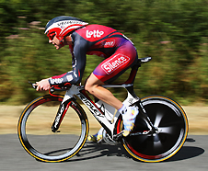
Figure 1 A streamlined racing cyclist

Air resistance
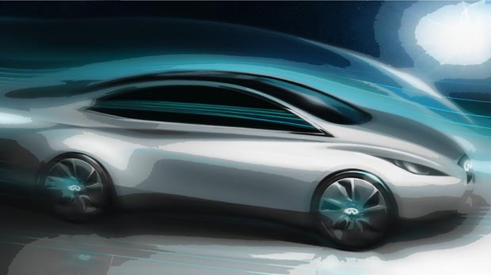
Air resistance is caused by the frictional forces of the air against the vehicle. The faster the vehicle moves, the bigger the air resistance becomes. The top speed of a vehicle is reached when the force from the cyclist or engine is balanced by air resistance.
Figure2:http://www.luxuriousmagazine.com/wp-content/uploads/2011/11/infiniti-electric-concept-1.jpg

Streamlining
Racing cyclists crouch down low on their bikes to reduce the air resistance on them. This helps them to cycle faster. They also wear streamlined helmets. These have special, smooth shapes that allow the air to flow over the cyclist more easily. Modern cars are also streamlined. Their smooth shapes make the air resistance smaller, which allows them to travel further on the same amount of fuel.
When there is a lot of friction between moving parts, energy is lost to the surroundings as heat.

Force diagrams
When two forces acting on an object are equal in size but act in opposite directions, we say that they are balanced forces.
We can show the forces acting on an object using a force diagram. In a force diagram, each force is shown as a force arrow. An arrow shows:
- the size of the force (the longer the arrow, the bigger the force)
- the direction in which the force acts.
The arrow is usually labelled with the name of the force and its size in newtons. Text books often show a force with a thick coloured arrow, but it is best if you just use a pencil and ruler to draw an arrow with a single line.
If the forces on an object are balanced (or if there are no forces acting on it) this is what happens:
- an object that is not moving stays still
- an object that is moving continues to move at the same speed and in the same direction
So notice that an object can be moving even if there are no forces acting on it.

Standing on the ground
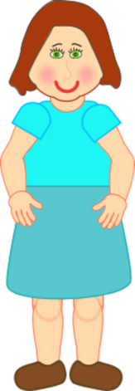
When an object rests on a surface such as the ground, its weight is balanced by the reaction force from the ground. The ground pushes up against the object.
The weight of a book lying on a table is balanced by the reaction force from the table top

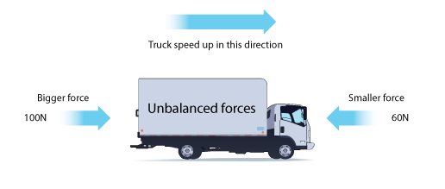
Unbalanced forces
When two forces acting on an object are not equal in size, we say that they are unbalanced forces.
If the forces on an object are unbalanced this is what happens:
- an object that is not moving starts to move
- an object that is moving changes speed or direction
Unbalanced forces make the truck speed up.

Resultant forces
When several forces act on one object, they can be replaced by one force which has the same effect. This single force is called the resultant or unbalanced force.
The size of the overall force acting on an object is called the resultant force. If the forces are balanced, this is zero. In the example above, the resultant force is the difference between the two forces, which is 100 - 60 = 40 N.

Newton’s First Law
“An object will remain at rest or move at a constant velocity in a straight line unless acted on by an unbalanced force”.
This means that if the forces acting on an object are balanced, then the object will remain stationary if it was already stationary. For a moving object, if the forces acting on it are balanced, then it will continue to move in a straight line at a constant velocity.
balanced forces ↔ Object at rest OR object moving at a constant velocity in a straight line
A vector is often drawn with an arrow to indicate its size and direction. The starting point of the arrow is called the “tail” and the arrow end is called the “head”.
head
tail

Use arithmetic to find the resultant:
Add together forces which act in the same direction
12 N
8 N
e.g F₁ + F₂ ₌ F_{u} 12 + 8 ₌ 20 N to the right
Subtract forces which act in the opposite direction
12 N
8 N
e.g F₁ + F₂ ₌ 12 - 8 ₌ 4 N to the right

