**53.** Complete the table below to convert between mass and weight for an object on Earth.

|  |  |
| --- | --- |
| Mass | Weight |
| 1 kilogram | (*a*) |
| 0·5 kilograms | (*b*) |
| 4 kilograms | (*c*) |
| (*d*) | 10 newtons |
| (*e*) | 49 newtons |
| (*f*) | 30 newtons |

**54.** A pupil says that her weight is 50 kilograms.

(*a*) What is wrong about her statement?

(*b*) Calculate the value of her weight on Earth.

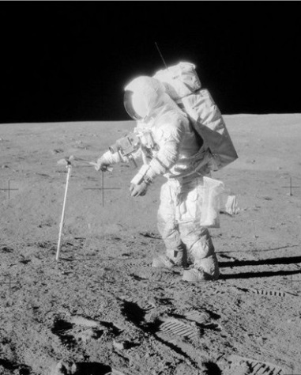**55.** A lift is designed to carry a maximum load of 10 people, each with a mass of 80 kilograms. The lift has a mass of 500 kilograms. Calculate the total weight of the lift when full.

**56.** An astronaut has a hammer with a mass of 0·8 kilograms on the moon

(*a*) Calculate the hammer’s weight on Earth where the value of *g* is 10 newtons per kilogram.

(*b*) Calculate the hammer’s weight on the moon where the value of *g* is 1·6 newtons per kilogram.

**57.** A satellite orbits the earth at a height of 2000 kilometres where the value of gravitational field strength is 5·7 newtons per kilogram. Calculate the weight of the satellite if it has a mass of 900 kilograms.