Cycle to Syracuse- Average Speed.
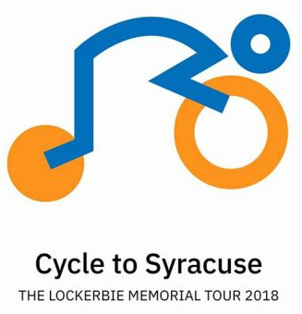
To honour the victims of Lockerbie Air Disaster on the 30th Anniversary, 5 people associated with Lockerbie set out on a mammoth bike ride. Colin Dorrance, David Whalley, Paul Rae, David Walpole and Brian Asher cycled 600 from Arlington Cemetery to Syracuse University to honour the 270 people killed and also former Head Boy Andrew Mcclune, who died whilst on a Syracuse Scholarship.

TASK
For each of the seven days of the trip.
- Use your calculator °’ ‘’ button to convert the time in hours and minutes to parts of an hour, record this in your jotter.
- Record the distance travelled in miles each day
- Write out the information for the each day (IESSUU)
- Find the average speed for the day using $v=\frac{d}{t}$
- Find the mean average speed for the whole journey, by adding up the average speeds you’ve calculated and dividing by the 6 days of travelling, the mean average of the 6 average speeds.
- Now add up the total the number of miles travelled for the whole journey
- Total the hours on the road for the whole journey.
- Find the average speed for the whole journey rather than the average speed for each day.
- Now compare the average for the whole journey completed by working out different methods.

Additional Task
- What happens to the average speed if you take the whole journey distance and divide this by the total number of hours from 7am on Friday 26th October to 15:30 on the 1st November
- Some days the actual distance cycled was more than registered. Repeat the activity using the figures in the table at the bottom.
(Day 1 is done for you as an example)

Day 1
Information  d=76.7 miles | Equation | $$\overline{v}=\frac{d}{t}$$
t= 5 hours 39 mins 11 s | Substitution | $$\overline{v}=\frac{76.7}{5.653}$$
=5.653 miles | Solution | $$\overline{v}=13.6 mph$$
$\overline{v}$=?

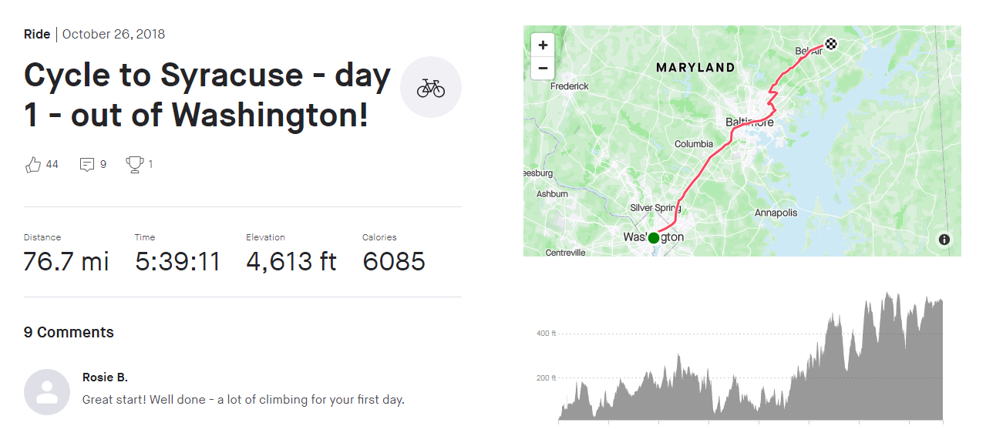

Day 2
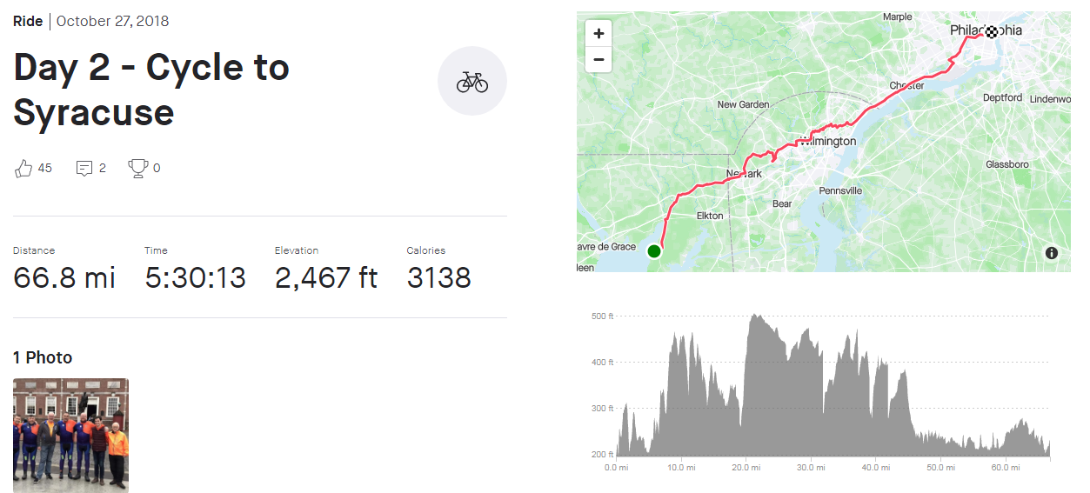

Day 3
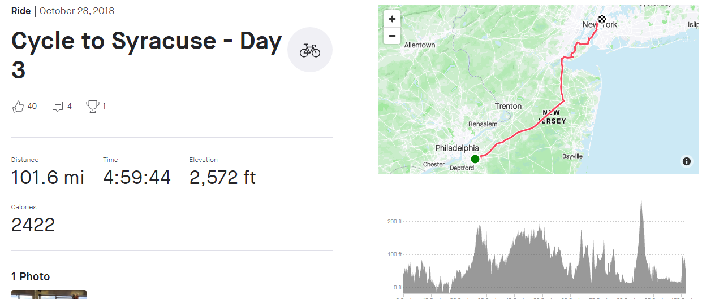

Day 4
Rest Day

Day 5
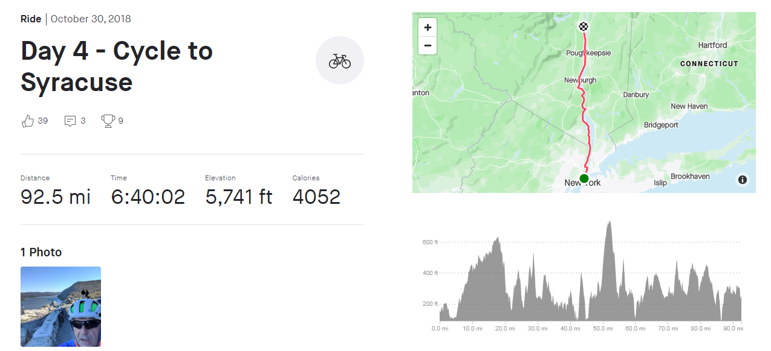

Day 6
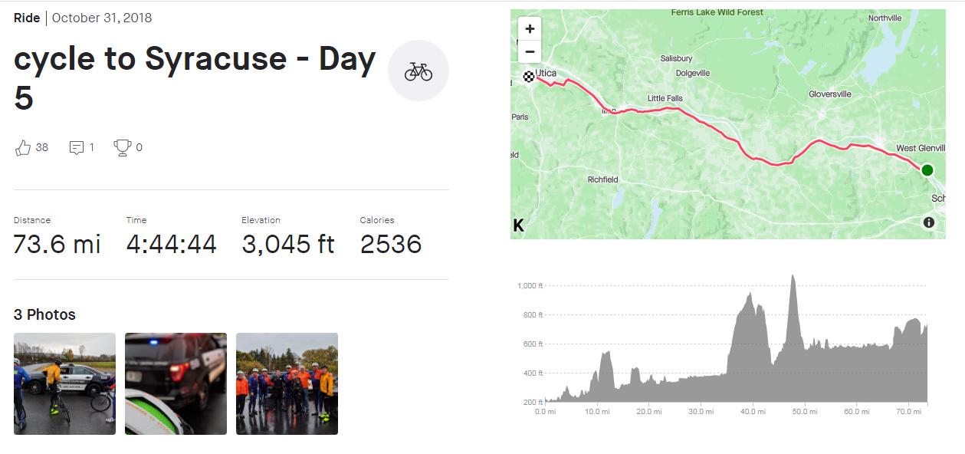

Day 7
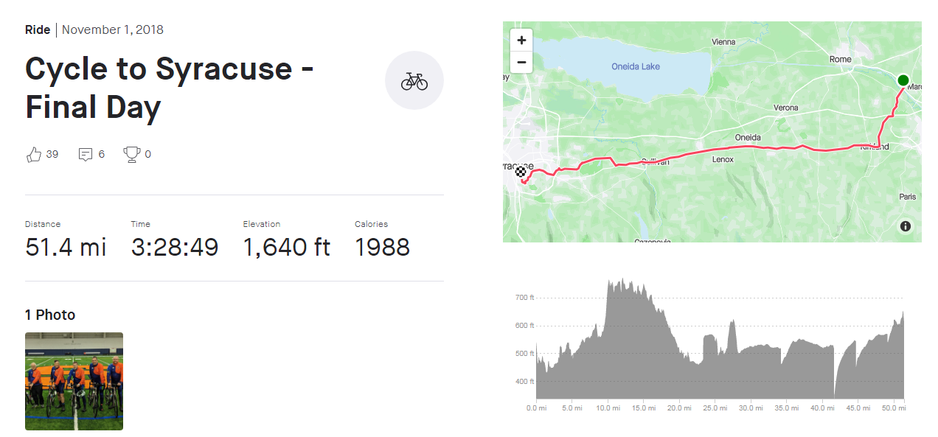

Itinerary.
- Friday, October 26 – Day 1 – Leave Washington D.C. (from Arlington Cemetery)
- Saturday, October 27 – Day 2 – Philadelphia area (arriving at Independence Park near the Liberty Bell)
- Sunday, October 28 – Day 3 – Arrive at Central Park, NYC (arriving at the SE corner, near 5th Ave. and 61st St, approximately 4 pm)
- Monday, October 29 – Day 4 – Rest Day
- Tuesday, October 30 – Day 5 – NYC north towards Albany
- Wednesday, October 31 – Day 6 – Albany area toward Utica
- Thursday, November 1 – Day 7 – Arrival at Syracuse University
- Thursday, November 1, 3:30 p.m. – Welcome Event on Syracuse University’s Einhorn Family Walk
Day | Date | Quoted distance (miles) | Actual distance (miles)
1 | 26/10/18 | 76.7 | 82
2 | 27/10/18 | 66.8 | 101
3 | 28/10/18 | 101.6 | 101
4 | 29/10/18 | 0
5 | 30/10/18 | 92.5
6 | 31/10/18 | 73.6
7 | 01/11/18 | 51.4
 | Total

