WAVES and OPTICS

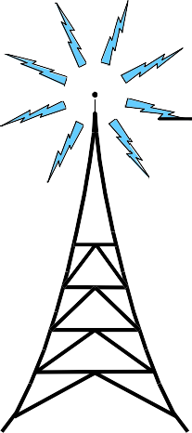
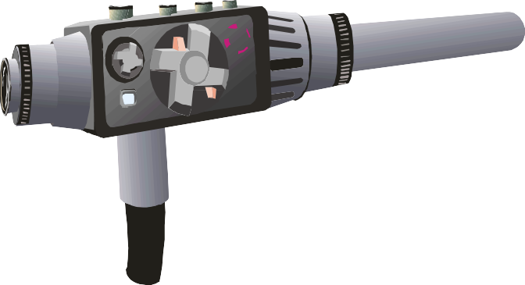
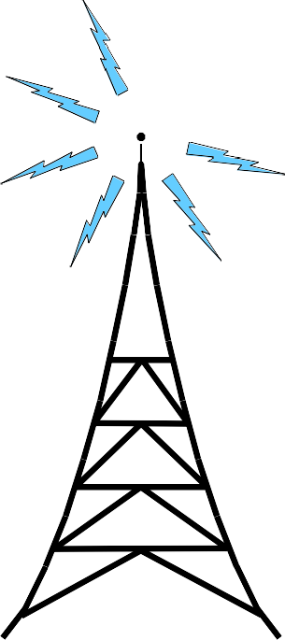

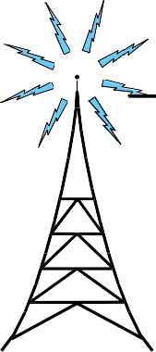
Name:
Class:
Teacher:

Waves and Energy

All waves transfer (carry)

e from one place to another - A tsunami sea wave
Experiment to Measure the Speed of Sound in Air
We can perform an experiment to measure the
speed of sound in air.
measured

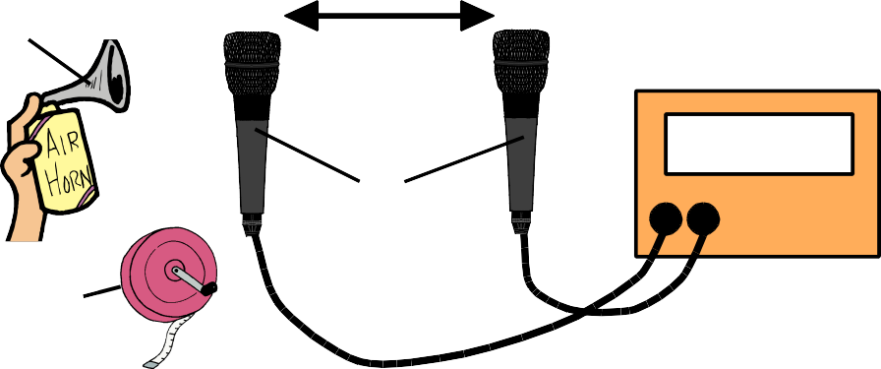
transfers an enormous amount of
sound
distance

e which can cause
extensive damage when the wave reaches land.

Waves and Signal Transmission
source
2.0 m

microphones

electronic timer

s

Sound and light signals are transmitted (sent) from one place to another by w _ _ _ _.

!!Remember!!

distance = speed x time
tape measure
- We use a t _ _ _ m to measure the
d _ _ _ _ _ _ _ between the 2 m _ .

We make a sharp s next to the left hand
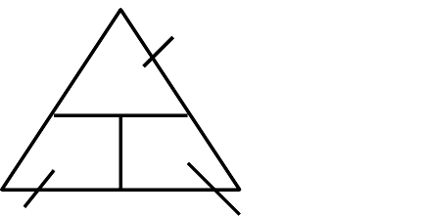
m _ .
d _ _ _ _ _ _ _
d unit:
v t
    - The s _ _ _ _ travels through the a _ _ between the
2 m _ _ _ _ _ _ _ _ _ _ . The t this takes is
recorded on the electronic t _ _ _ _ .

We calculate the speed of sound in air using the formula:
speed =
distance between microphones
time for sound to pass between microphones

s _ _ _ _ of s _ _ _ _ t _ _ _ unit: unit:

1) (a) What value

(b) How could you improve

You can use this equation to calculate the speed of sound in air..............
2
for the speed of sound in air do you obtain using the values shown on the apparatus above?
this experiment?

Comparing the Speed of Sound and Light in Air
In air, speed of sound = _ _ _ m/s
In air, speed of light =_ _ _ _ _ _ _ _ _ m/s ( _ x 10 _ m/s )
}
In air, light travels almost
times faster
than sound.

Light travels so quickly that we see an event happening at the instant it happens - light from the event reaches our eyes instantly (even when we are far away).
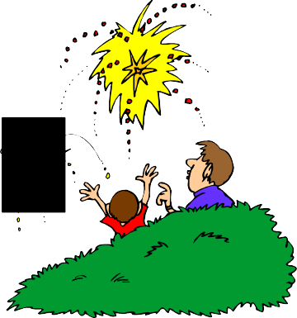
Use the word bank to complete the passage below.
hear
less
sound sound thunder
light
light
lightning
see
2) At a fireworks display, a rocket explodes high above your head, producing a loud explosion and a bright flash of light at the same time.

(a) What will reach you first? - the sound of the explosion or the flash of light:
(b) Explain why:
- On a golf course, you observe a golfer in the distance hitting a golf ball with her club.

  - What will you observe first? - the ball moving through the air or the sound of the club hitting the ball:
(b) Explain why:
3

During a storm, thunder and lightning are produced at exactly the same time.

We
the
before we the

because, in air, the speed of is less than the speed of .
The reaches us before the .

We can use this formula to solve problems about sound travelling through the air (or other materials):

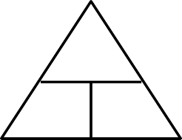
d _ _ _ _ _ _ _
distance = speed x time

- Susan shouts at a brick wall. After
0.8 seconds, she hears her "echo" - the sound of her shout reflected off the wall.
Calculate how far away from the wall

s _ _ _ _ of s _ _ _ _
unit:
d unit:
v t
t _ _ _
unit:
Susan is. BE CAREFUL ! - It might help if you draw the path taken by the sound on the diagram.

Susan

wall

  - Calculate the distance sound will travel through the air in
2 seconds.
  - How far will the sound of an explosion travel through the air
in 5 seconds?

Sound has a different speed in different materials. For example:
Speed of sound in steel = 5 200 m/s. Speed of sound in water = 1 500 m/s.

  - Calculate the time it will take sound to travel 1 020 metres
through the air.
  - How long will it take the sound of a bell to travel 850 metres through
the air?
- A steel wire is 6 760 metres long. Calculate the time it will take sound to travel along the
wire.

- Calculate the speed of sound in air if it takes 4 seconds for the
sound to travel 1 360 metres.

4

- The sound of a car horn is heard 1 190 metres away,
3.5 seconds after it has been sounded. Calculate the speed of
the horn sound in air.
- To find out the depth of water beneath its hull, a fishing boat sends a pulse of sound through the water from its hull to the sea bed.
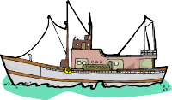
After 1.2 seconds, the fishing boat detects the sound pulse reflected from the sea bed.

How deep is the sea?
sea bed

Understanding Waves

- What is a wave?

- Do all waves transfer energy?

- Do all waves have certain things in common?

Use the word bank to label the wave diagram:

amplitude
wavelength wavelength
amplitude
crest
trough
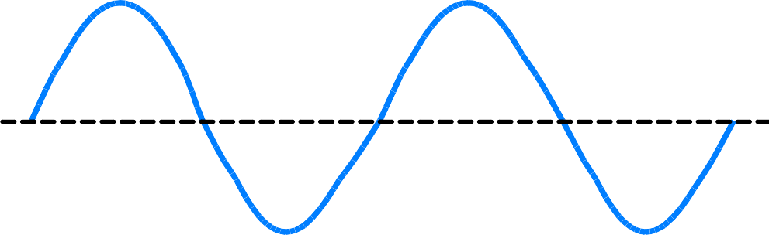
These diagrams represent waves viewed from above. The lines show the middle of wave crests.
No wave troughs are shown.

straight waves circular waves
On each diagram, show the wavelength. 5

Types of Waves
Transverse Longitudinal

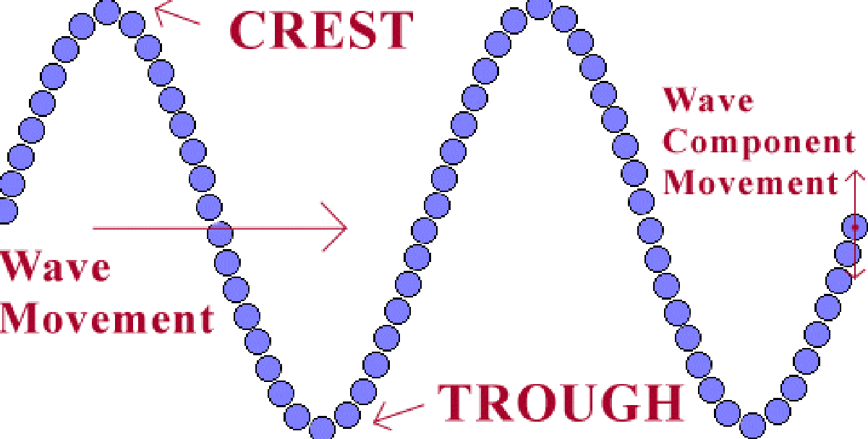

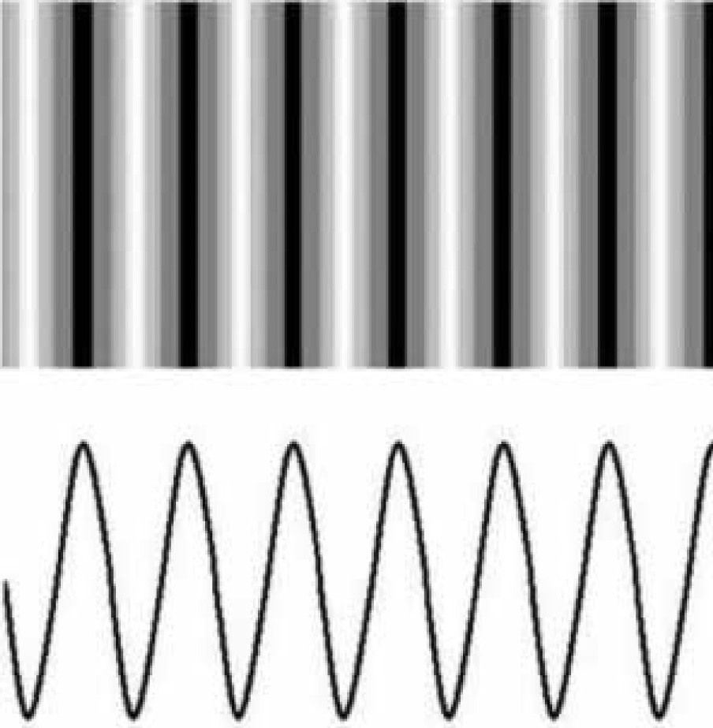
In a transverse wave, the particles vibrate up and down at right-angles (90º) to the direction in which energy is being carried.
In a longitudinal wave, the particles vibrate back and forward along the direction in which energy is being carried.
particles vibrate
movement of energy

particles
vibrate movement of energy
6

Describing Waves

Use the word bank to complete the table:
above
distance second wavelength
amplitude
amplitude
below
f Hz
λ m m m/s v

The frequency of a wave is:

This can be represented by the formula:
number of wavelengths (or crests or troughs)
frequency = time in seconds

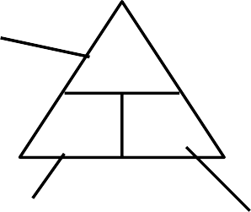
n of
N
Quantity | Symbol | Unit | Description
wave crest |  |  | Part of wave  centre line.
wave trough |  |  | Part of wave  centre line.
Height of wave crest or wave trough measured from the centre line.
The higher the
of a wave, the more energy it carries.
 | lambda |  | Distance between 2 identical neighbouring points on a wave, e.g., distance between 2 neighbouring wave crests.
frequency |  | hertz | Number of wavelengths (or crests or troughs) every .
speed |  |  | wave travels every second.

w _ _ _ _ _ _ _ _ _ _
or c or
f t
t _ _ _ _ _ _

f _ _ _ _ _ _ _ _
unit:
t _ _ _ unit:

The speed of a wave is:

This can be represented by the formula:

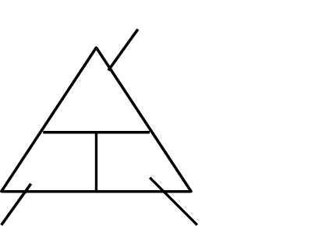
distance = speed x time
d
v t
d _ _ _ _ _ _ _
unit:

s _ _ _ _ of w _ _ _
unit:
t _ _ _
unit: 7

Water Wave Problems/Calculations

- (a) Which of these waves is carrying the most energy?
- Explain you answer:
0.2 m

  - B.
20) 0.8 m
- For this wave, state the value of:
  - the amplitude

  - the wavelength

- The wave shown below is travelling to the right.
    - As the wave travels, what happens to its amplitude?
    - The wave was produced in 2 seconds. State the value for its frequency.

- What must be happening to the wave's energy?

- (a) Determine the wavelength of these water waves.

20 m

18) (a) State the value for this wave's:

  - amplitude:
  - m

0.2 m 0 m
  - wavelength:

(b) These 5 wave crests were produced in 25 seconds. Determine the frequency of the waves.

0.2 m 0.4 m 0.6 m 0.8 m 1.0 m 1.2 m 1.4 m 1.6 m
(b) The wave was produced in 1 second.
State the value for its frequency: 6 m
19) Determine the frequency of the wave in each case:

- (a) What is the wavelength of these
circular water

- The 3 wave crests were produced in
  - seconds. What is

    - 5 wavelengths are produced every
second.
    - 10 water waves pass the end of a pier
in 2 seconds.
    - 12 circular waves spread across a pond
in 20 seconds
waves?
the wave frequency?

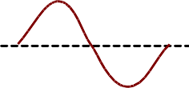
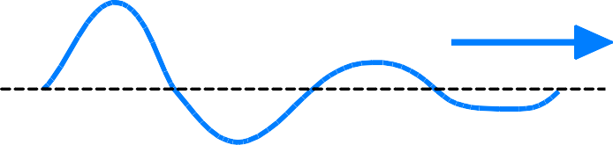
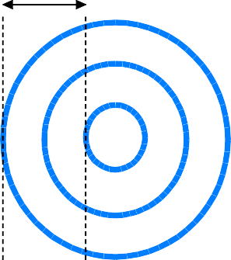
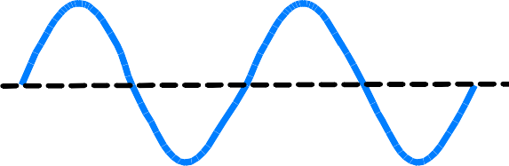

8

23) A tsunami sea wave takes 6 seconds to travel up a beach  with a speed of  15 metres per second.  What distance does the wave travel up the beach? | 26) Sid the surfer rides the crest of a sea wave travelling  at 6 metres per second for 8 seconds.  Calculate how far the wave carries Sid in this time.
24) When Sajidha threw a stone into a pond, circular waves travelled 7.5 metres  across the water in 2.5 seconds. | 27) A drop of water from a leaking tap causes waves on the surface of Brenda's bath  water.
Calculate the speed of these water waves. | If these waves travel 0.4 metres in 1.6 seconds, at what speed are they travelling?
25) Sea waves approach a cliff at 4 metres per second.

What time will the waves take to travel 20 metres?

28) As the tide goes out, sea waves travel 50 metres with a
speed of 2.5 metres per second.

How long do the waves take to
travel this distance? 9

Another Wave Formula

For any wave, the time taken ( T ) to produce
1 wavelength ( 1 λ ) is related to the frequency ( f ) of the wave by the formula:
frequency = 1
time
f = 1
T

Explain the equivalence of the 2 wave formulae:

speed (v) = frequency (f) x wavelength (λ)

If 1 wavelength ( 1 λ ) is produced in time ( T ), a wave will travel a distance ( d ) of 1 wavelength (1 λ ) in time ( T ):

speed (v) =
and

distance (d) time (T)

speed (v) = distance (d) = 1 λ = 1 x λ
time (T) T T

= f x λ
since f = 1
T
We have another formula which applies to waves:
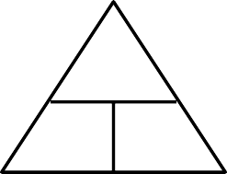
s of
v
w _ _ _
speed = frequency x wavelength
unit:
f λ

f _ _ _ _ _ _ _ _
unit:
10
w _ _ _ _ _ _ _ _ _
unit:

Speed, Wavelength and Frequency Calculations for Water and Sound Waves

29) Calculate the speed of  water waves which have a frequency of 2 hertz and a wavelength of 5 metres. | 32) Every second, 2 waves are  produced on Alan's bath water by water dripping from a tap. If these waves have a wavelength of 0.05 metres, calculate their speed. | 35) Calculate the speed of  sound waves in air which have a frequency of 500 hertz and a wavelength of 0.34 metres. | 38) A submarine sends a pulse  of sound through the sea. Determine the speed of the sound pulse if it has a frequency of 7 500 hertz and a wavelength of 0.2 metres.
30) Calculate the frequency of water waves in a harbour if they travel at 3 metres per second  and have a wavelength of 4 metres. | 33) The wind causes waves to travel across a puddle at  2.4 metres per second. If the waves have a wavelength of  0.6 metres, determine their frequency. | 36) Calculate the frequency of sound waves in air which travel at 340 metres per second and have a wavelength of 1.7 metres. | 39) Sound travels through steel at 5 200 metres per second. In the steel, sound waves have a  wavelength of 2 metres. Calculate their frequency.
31) Calculate the wavelength of water waves on a pond which  travel at 0.75 metres per second and have a frequency of 1.5 hertz. | 34) A wave generator in a swimming pool produces  2.5 waves every second. The waves travel across the pool at  1.2 metres per second. Determine their wavelength. | 37) Calculate the wavelength of sound waves in air if they travel at 340 metres per second and have a frequency of 6 800 hertz. | 40) Ultrasound (frequency 21 000 hertz) travels through human muscle at 1 600 metres  per second. Calculate the wavelength of ultrasound in the muscle.
 |  |  | 11

The Electromagnetic Spectrum
The electromagnetic (EM) spectrum is a name that scientists give to groups of transverse waves which have different wavelengths/frequencies but all travel at the same speed in air (300 000 000 m/s, i.e., 3 x 10⁸ m/s).
12 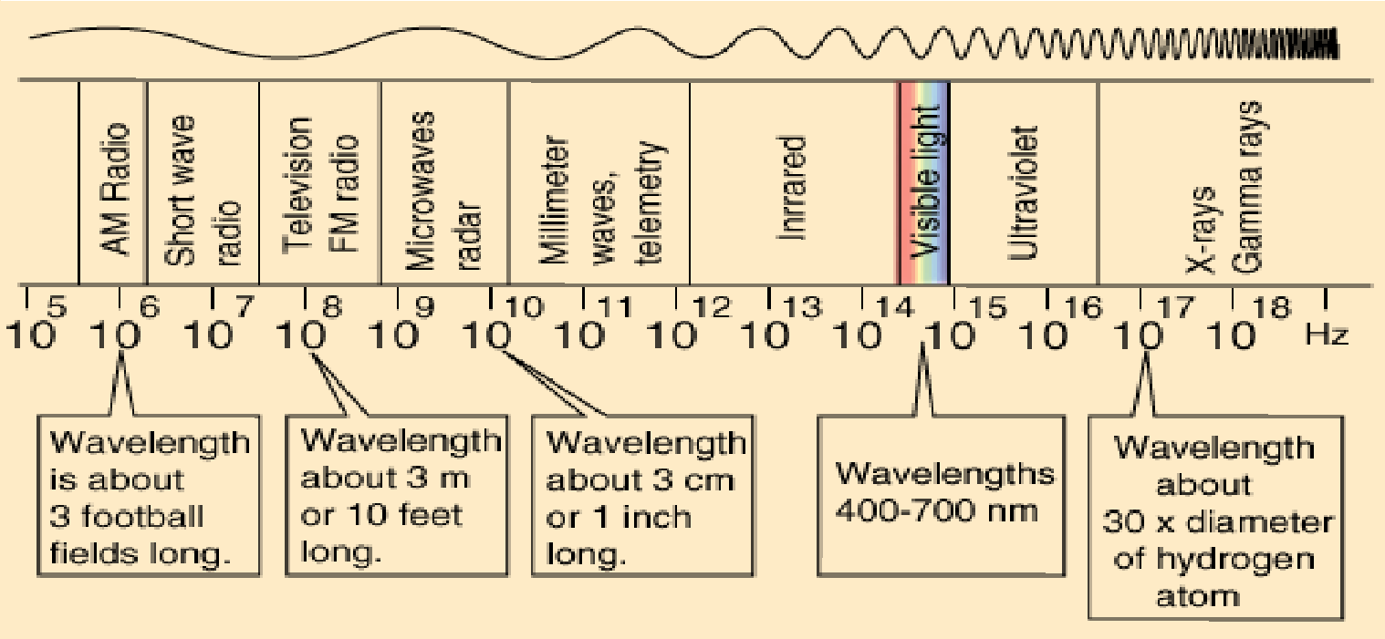

Light travels in straight lines
called light r _ _ _.

When a light ray hits a surface

Optics

Reflection of Light

like a plane mirror, the light ray
normal

is r off the surface.

A normal is a dashed line drawn at 90º to a surface where a light ray hits the surface.

During r ,
i
r
plane mirror
the angle of i (i) is always
equal to the angle of r (r).

=

The Principle of Reversibility of Ray Paths

If a light ray is shone from A to C via B or from C to A via B,
it will follow exactly the same path but in the reverse direction.

This is the principle of r _ _ _ _ _ _ _ _ _ _ _ _ of r _ _ p _ _ _ _.
B
plane mirror

A C
13

Total Internal Reflection

Fibre optics can be used as a transmission

This diagram shows parts of a

system for c _ _ _ light - No h _ _ _ energy
passes through the system.

L _ _ _ _ passes along an o _ _ _ _ f by

t _ _ _ _ i _ _ _ _ _ _ _ r _.

What do the words "total" and "internal" tell you about the reflection?
f _ _ _ _ _ _ _ _ _ (e )

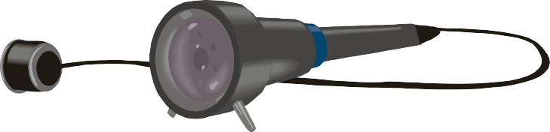

  - Complete this diagram to show light passing along an
optic fibre:

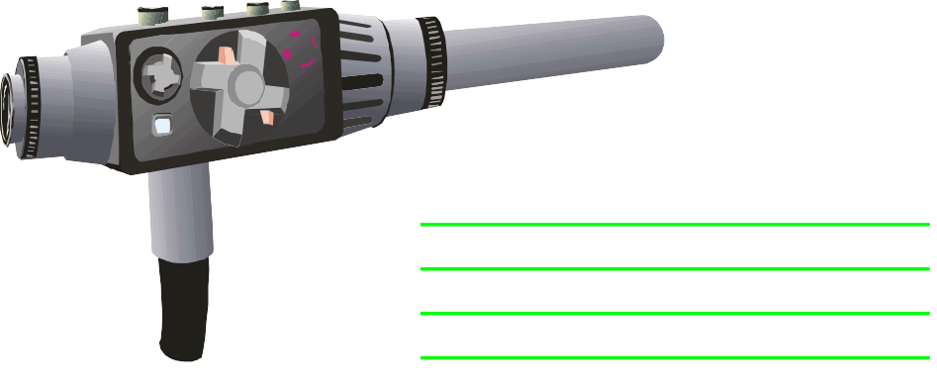
  - Describe and explain how it works:

- What is this device used for?

14

Curved Reflectors

Fitting a c _ _ _ _ _ r dish to a receiver aerial
can make the received signal s _.
When incoming signals hit the c _ _ _ _ _ r dish,
the dish f _ _ _ _ _ _ them all onto the r _ _ _ _ _ _ _ a _ _ _ _ _
- The r _ _ _ _ _ _ _ a _ _ _ _ _ therefore receives a s _ _ _ _ _ _ _

signal than it would if the dish was not fitted to it.

Show this by completing the diagram:

receiver aerial

curved reflector dish

Curved Reflector Transmitter and Receiver Systems

Complete the diagram below to show signals being transmitted from the transmitter aerial to the receiver aerial:

curved reflector dish
curved reflector dish

The above diagram could represent signals being passed from a satellite to the Earth, or a TV link

(e.g., television signals being sent from a sporting event to the television studio).
Sometimes, if signals have to travel a long distance over the Earth's surface, the signals get w _.
We make the signals s _ _ _ _ _ again by giving them e _ _ _ _ _ at a b station.

Show this on the diagram below:

main transmitter booster receiver and transmitter station main receiver15

Refraction of Light
Light travels in straight lines called light r _ _ _.
When light passes from one material into another of different density, its s _ _ _ _ changes and so its d _ _ _ _ _ _ _ _

changes (unless the light hits the material at 90º to its surface) - This is known as r _.

A normal is a dashed line drawn at 90º to the surface of a material where a light ray hits the material.

angle of
normal
i _ _ _ _ _ _ _ _
in air

When a light ray passes from air into glass/plastic/water, the ray bends t the normal
line.
i

angle of
r i _ _ _ _ _ _ _ _
in material

angle of
r _ _ _ _ _ _ _ _ _
in material

i

r
normal

angle of

When a light ray passes from glass/plastic/water into air, the ray bends a _ _ _ f _ _ _ the
normal line.

r _ _ _ _ _ _ _ _ _
16
in air

  - Using a ruler and protractor, complete each diagram below to show what happens to the
rays of light as they pass through the glass blocks. (Remember to draw normal lines).
TAKE YOUR TIME AND WORK VERY CAREFULLY.

17

Lenses
    - Name each shape of lens shown below.
- Using a ruler, complete both diagrams to show what happens to the light rays.

lens
ruler

- On each diagram, show the focal length of the
lens.

  - Describe a simple experiment you could perform to find the
focal length of a
18 convex lens. far away window

convex lens
lens

screen

Focal Length and Power of Lenses
T _ _ _ _ lenses refract (b _ _ _) light more than t _ _ _ lenses - so t _ _ _ _ lenses are more p _.
A powerful lens has a s focal length.
Convex lenses have a p _ _ _ _ _ _ _ ( ) power. Concave lenses have a n ( ) power.

1
power (P) = focal length in metres (f)
1
P f
focal length in metres (f) = 1
power (P)

Convex Lenses

dioptres (D)
metres (m)
A concave lens has a power of
-4 D
Calculate its focal length in metres
Concave Lenses
A concave lens has a focal length of
1.25 m. Calculate its power.
Calculate the focal length of a lens with power
-8 D.
Calculate the power of a concave lens of focal length
0.6 m
19

A convex lens has a power of
+ 5 D.
Calculate its focal length in metres.
A convex lens has a focal length of
0.5 m. Calculate its power.
Calculate the focal length of a lens with power
+ 40 D.
Calculate the power of a convex lens of focal length
0.25 m.

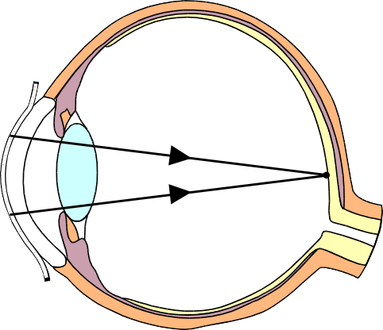
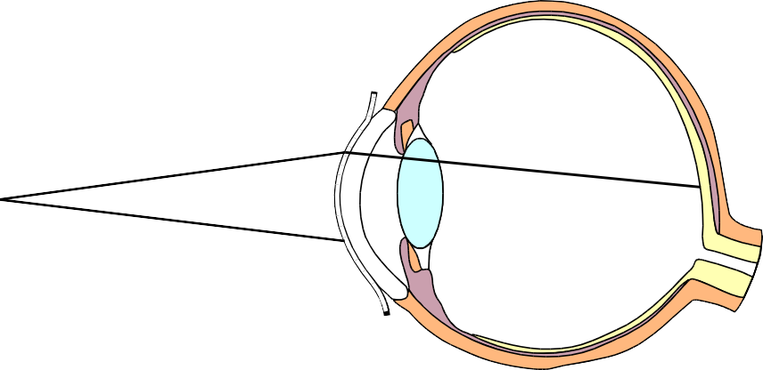
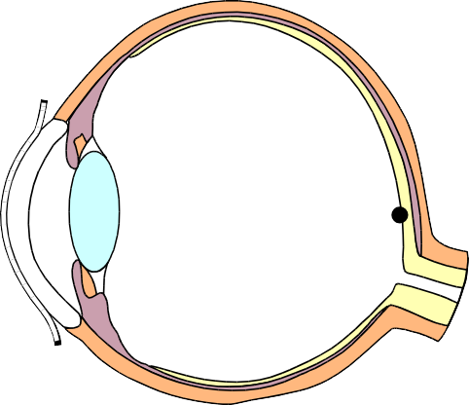
A person who is l _ _ _ s _ _ _ _ _ _ can see c _ _ _ _ _ _
20
Long Sight
objects which are f _ _ a _ _ _ - This is because the eye

c _ _ focus the p light rays coming from the object on the r _.

However, the person cannot see c objects which
are c _ _ _ _ to them - This is because the eye c _ _ _ _ _
focus the n _ _ - p light rays coming from the

object on the r _.
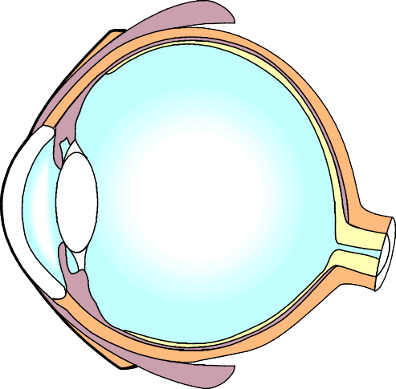
Complete this diagram to show how a "long-sighted eye" focuses light rays from a close object.

To correct long sight, a
c _ _ _ _ _ l is placed in front of
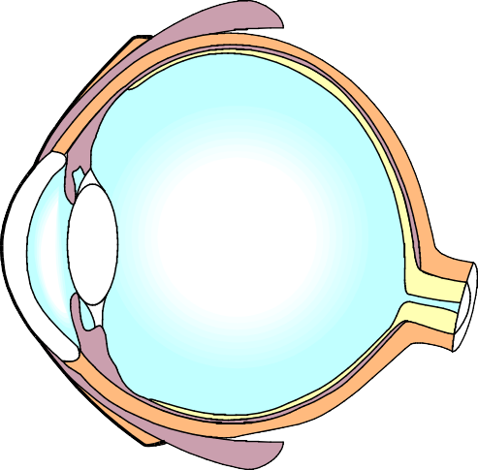
the eye. Complete this diagram to show the affect the lens has on light rays from a
close object.

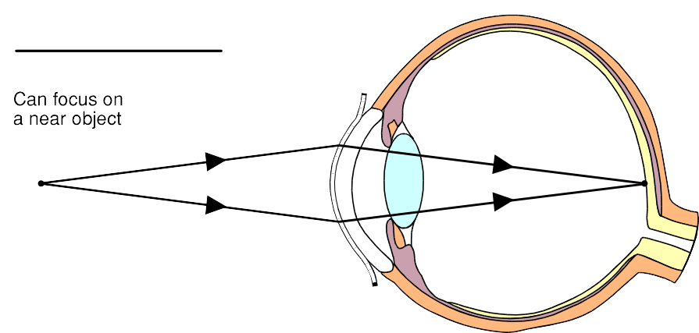
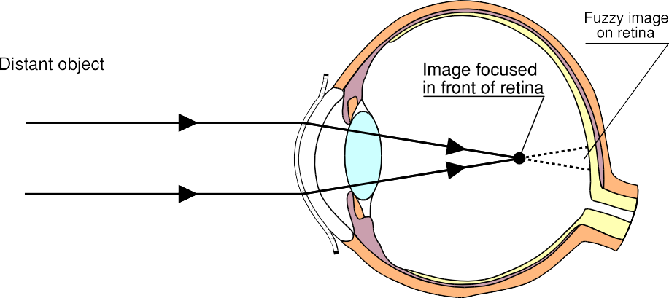
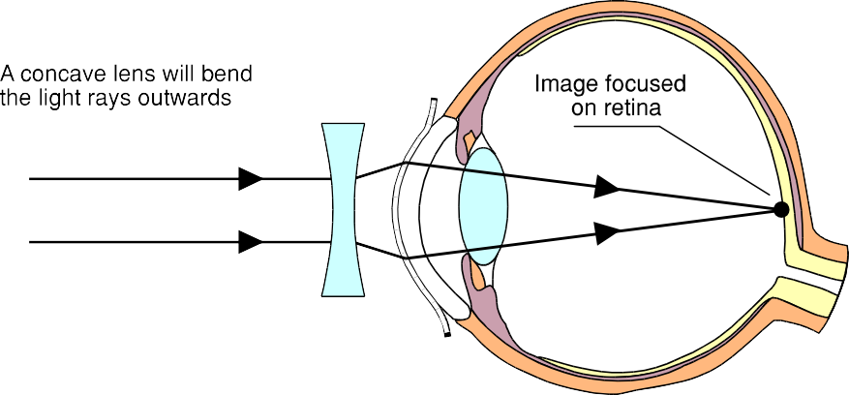
A person who is s _ _ _ _ s _ _ _ _ _ _ can see c _ _ _ _ _ _
Short Sight

objects which are c _ - This is because the eye
c _ _ focus the n _ _ - p light rays coming from

the object on the r _.

However, the person cannot see c objects which
are d _ _ _ _ _ _ (f _ _ a ) - This is because the eye
c _ _ _ _ _ focus the p light rays coming from the

object on the r _.
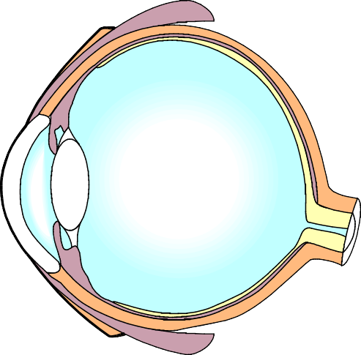
Complete this diagram to show how a "short-sighted eye" focuses light rays from a distant object.

To correct short sight, a
c _ _ _ _ _ _ l is placed in front of
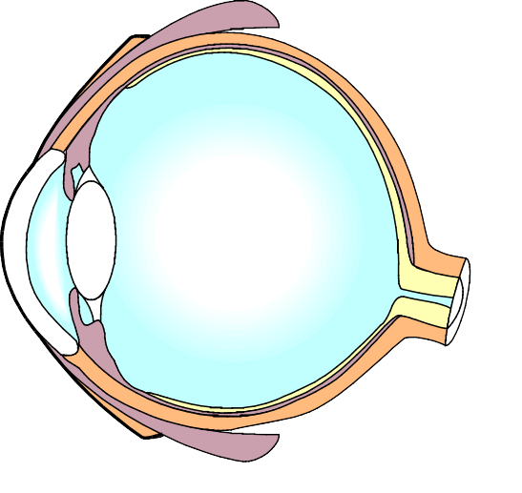
the eye. Complete this diagram to show the affect the lens has on light rays from a
distant object.

21

Images Formed by Convex Lenses

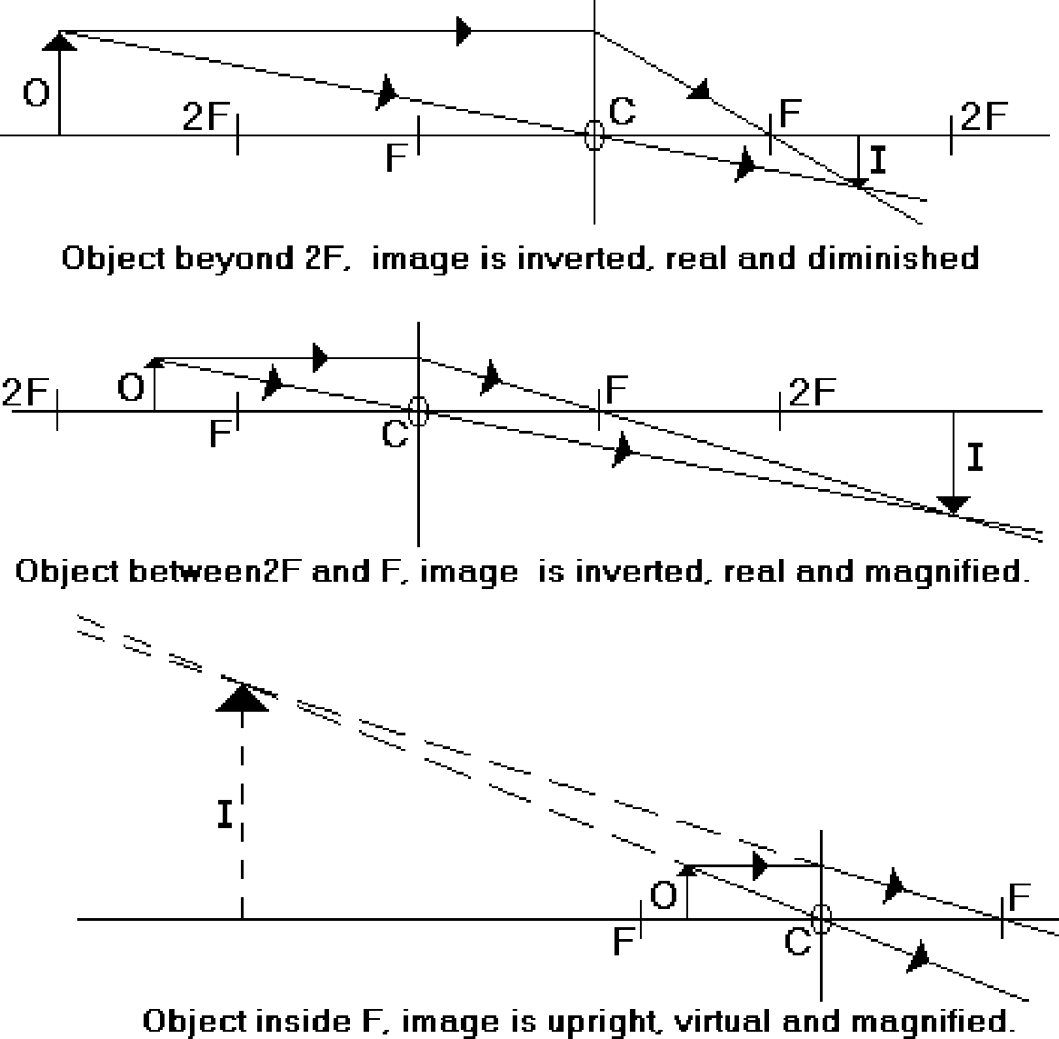
22

Complete each diagram, to show the image formed by the convex lens.
USE A PENCIL AND RULER. BE CAREFUL. TAKE YOUR TIME.

O 2F
F
F 2F

Object beyond 2F: Image is i _ _ _ _ _ _ _ , r _ _ _ and d _.

2F O

F
F 2F

Object between 2F and F: Image is i _ _ _ _ _ _ _ , r _ _ _ and m _.

O
F
F
Object inside F: Image is u _ _ _ _ _ _ , v _ _ _ _ _ _ and m _ _ _ _ _ _ _ _. 23

- ONCE AGAIN, complete each diagram, to show the image formed by the convex lens.
USE A PENCIL AND RULER. BE CAREFUL. TAKE YOUR TIME.

O 2F

F
F 2F

Object beyond 2F: Image is i _ _ _ _ _ _ _ , r _ _ _ and d _.

2F O

F
F 2F

Object between 2F and F: Image is i _ _ _ _ _ _ _ , r _ _ _ and m _.

O
F
F
24 Object inside F: Image is u _ _ _ _ _ _ , v _ _ _ _ _ _ and m _.

