S2 Chemistry Revision for Science Topic 2 Test
- (a) Make a table of the information in the pie chart, choosing correct headings and put in units where appropriate.
(b) Draw a bar graph of this information.
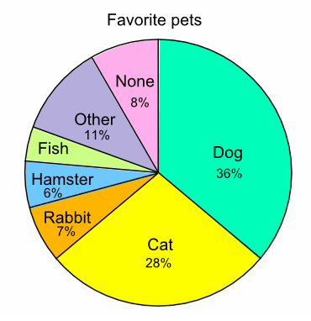
https://www.mathsisfun.com/data/bar-graphs.html

2. Read the following passage and use the information to answer the questions.
Biomass fuel is the name given to renewable fuels obtained from living things. The most commonly used biomass fuel is wood. In many parts of the world, wood is the main fuel used for domestic heating and cooking.
Charcoal and wood-alcohol are biomass fuels made from wood. Charcoal can be used in solid fuel heaters, while wood-alcohol is used as a liquid fuel. Charcoal is produced by heating wood in the absence of air. This process is called destructive distillation. The process also produces a mixture of gases which can be condensed to form an oily liquid.
Wood-alcohol is obtained from this liquid.
Sugar cane can be used to produce another liquid biomass fuel called ethanol. Sugar, which is extracted from sugar cane plants, is converted to ethanol by the process of fermentation. Ethanol can be burned to produce heat energy or used in a fuel cell to produce electrical energy.

(a) What is the most commonly used biomass fuel?
(b) Describe how charcoal is produced.
(c) What happens during the process of fermentation?
(d) Name two liquid biomass fuels.

- Read the following passage and then answer the questions.
Many people suffer from painful hip joints. Cartilage in the joint wears away to expose nerve endings and this makes movement painful. In severe cases, the joint can be replaced with an artificial hip. The materials used to make artificial hip joints must be resistant to corrosion, degradation and wear. They must also have similar mechanical properties to bone. For example, the materials must be strong enough to take the person’s weight and must be able to bear stress without fracturing.
There are no materials that perfectly match the mechanical properties of bone. Metals are strong and have good resistance to fractures but are not flexible enough. Ceramics are strong but have poor resistance to fractures. Polymers have the correct flexibility and good resistance to fractures but are not strong enough. An artificial hip joint is made from a combination of these materials. This gives the best range of properties.

New polymers are being developed which are stronger and even more resistant to fractures. They are also highly resistant to wear. This means that artificial hip joints made from these new polymers last longer and are less likely to need replacing.

(a) What happens in a hip joint to make movement painful?
(b) The materials used to make artificial hips must be resistant to degradation. What else must they be resistant to?
(c) Give a disadvantage of using metals and ceramics in artificial hip joints.
Metals ................................................................................................
Ceramics ............................................................................................
(d) Explain fully why artificial hip joints made from new polymers last longer.

