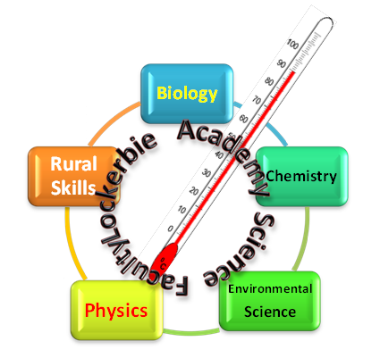
Topic: How Scientists from Scotland, or working in Scotland have made a big difference to our lives.

Task- Summary break down
- To identify a topic
- To research
- To present your work

Details
- You need to research and report on Scottish Science. Find some Science being carried out in Scotland that interests you, or some Scottish Scientists working abroad. The work must have happened after World War 2 (WW2).
- For the week beginning Monday 13th January, record on your template sheet who or what your chosen subject will be. Your teacher will tell you if it is suitable.
- Hand in your work by Friday 31st January including the following:
  - Your Name
  - Your Register class
  - Which Scientist or Science topic you have researched,
  - An explanation of the Science studied (this must be Science and not social science etc.)
  - How is this Science relevant to us
  - What effect they have made on the environment or society
  - What future impact they may have on the environment or society
  - Where you got your information (include the sources)
  - Include some pictures or diagrams

The minimum length is one side of A4 paper, the maximum is 4 sides of A4 paper.
The person submitting the best piece of work will win the JUNIOR SCIENCE TROPHY

DEADLINES
One sentence on whom or what you plan to study: Science period during week beginning 13th January
Final document: Wednesday 12th December

Homework Help
See your teacher if you need additional help or would like to attend a homework class to help get you started.

Possible sources of information

http://www.bbc.co.uk/news/15812174

http://www.gov.scot/Topics/Business-Industry/science

http://www.gla.ac.uk/students/researcherdevelopment/threeminutethesiscompetition/scienceandengineering/

http://www.rsc.org/

http://www.royalsoced.org.uk/cms/files/publications/directory/directory_nolist.pdf
For the link above it might be a good idea to start near the end (about p40), but make sure you choose a Scientist, not someone who is researching social or political trends.

http://www.strath.ac.uk/research/researchnews/

http://www.sciencescotland.org/

http://www.educationscotland.gov.uk/resources/index.asp?id=world%20of%20work

S1 Mark Sheet SCOTTISH SCIENCE
Pupil Name: _____________________________________ Register Class: ___________
One sentence summary of your chosen scientist or science topic: ______________________________________________________________________________________________________________________________________________________________________________________________________________________________________________________
Evidence | Self-Assessment | Teacher-  Assessment
It is a minimum of 1 side of A4 and max of 4 sides of A4
A Post-war Scottish Scientist or Science has been chosen
An explanation in simple language on what Science has been carried out is included
A Brief statement on the relevance to Society or on the Environment has been provided
At least 2 sources of information have been used from either books, the internet or personal discussion
At least one current impact is explained using relevant and accurate Science is given
Information about the future impact on society or the environment is given
Presentation: clear and concise
Presentation: pictures or drawings have been used
Presentation: well-structured report
The report has not been plagiarised
All references are clearly shown in a reference section at the back
References are mentioned in the text
By signing here you agree that the work that you have completed is your own and not directly copied from books, the internet or other students
Signed ________________________________________________
Parent of Guardian: ___________________________________
Teacher: ________________________________________

Title | Explanation of Scottish scientist/ procedure | Explanation of current impact | Explanation of future impact | Presentation (clear and concise) | Diagrams/pictures | Well-structured | 2 sources used and referenced

