ON THE LAUNCH PAD | AT TAKE OFF | AS THE ROCKETS ACCELERATES | IN SPACE
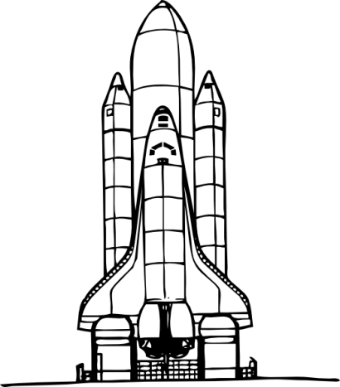 | 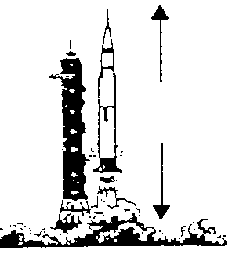  T  W | 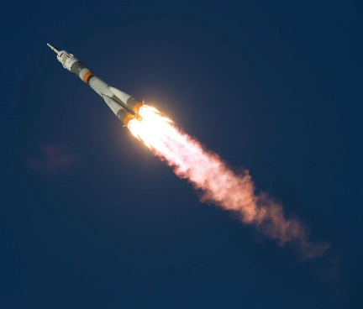 | 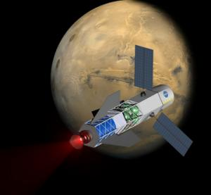
W=R  On the launch pad the Weight of the rocket is equal to the reaction force from the ground. The rocket is stationary. | T>>W  The weight of the rocket acts downwards, but the thrust of the rocket is much greater creating an unbalanced upwards force resulting in an acceleration  F_{un}= F_{thruest} – W  F_{un}=ma | F_{un} = ma  If m deceases a increases for the same thrust.  F_{un} = Thrust-(Weight+ frictional forces)  as mass decreases weight decreases giving a greater unbalanced force. | A rocket does not need to keep its engines going during interplanetary flight as there is no friction to slow it down. Newton’s First Law of Motion applies, which states  An object will remain at rest or move at constant speed in a straight line unless acted upon by an unbalanced force.
Newton’s Third Law, for every action there is an equal but opposite reaction | Newton’s Third Law  A rocket is pushed forward because the "propellant" is pushed back. | Newton’s Second Law  F_{un} = ma | Newton’s First Law to manoeuvre in space the rockets are briefly switched on and then the rocket thrusters are set in the opposite direction to slow the rocket down

In Summary

