Need to Know Sheet

Learn all your S2 work on Forces, Road Safety, ( get a copy of these from <https://www.mrsphysics.co.uk/bge/?cat=42> – Transport 1, and <https://www.mrsphysics.co.uk/bge/?cat=30> Forces)

# Acceleration

* Acceleration is defined as the “rate of change of velocity”, (that is how quickly you change your velocity )
* Acceleration is the change of velocity per second
$$acceleration=\frac{change in velocity}{time to change} \\ a=\frac{∆v}{∆t}$$

$$∆ =change in \\ a=\frac{final velocity-starting velocity }{time} \\ a= \frac{v-u}{t}$$

* If an acceleration is negative the car is slowing down (deceleration)
* Acceleration is measured in units of metres per second per second, or metres per second squared and is written ms-2.
* An acceleration of 2 ms-2 means that every second, the velocity increases by 2 ms-1.
* I know how to measure acceleration with one light gate and a double mask

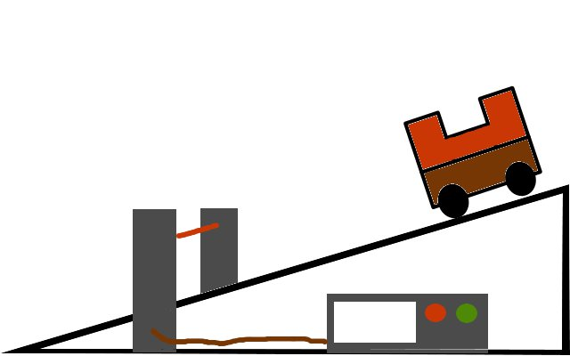

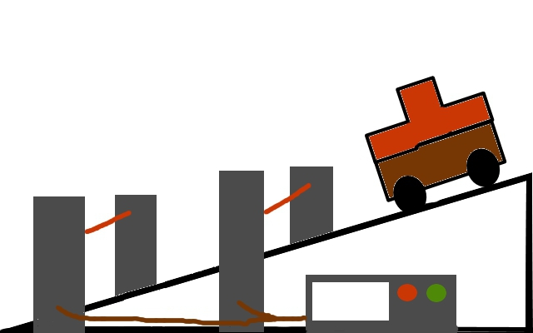

* I know how to measure acceleration with two light gates and a single mask

|  |  |
| --- | --- |
| **Measurements** | **Calculations** |
| t1 time to pass first light gate |  |
| t2 time to pass second light gate |  |
| t3 time between light gate |  |
| Length of mask | L |

* To calculate acceleration experimentally you need.

# Newton’s three laws of Motion

## Newton’s First Law

* A body will remain at rest or travel at a constant speed in a straight line, unless acted upon by an unbalanced force.
* A body will remain at rest or travel at constant velocity, unless acted upon by an unbalanced force.

## Newton’s Second Law

* Unbalanced forces produce acceleration.
* Identify when forces are balanced and unbalanced.
* The greater the unbalanced force the greater the acceleration.
* This law is usually written as an equation: $F=ma$
$Unbalanced Force= mass × acceleration$

* (Unbalanced force is measured in Newton, mass is measured in kilogram and acceleration is measured in metres per second squared.)
* Complete the experiments to show that F=ma

## Newton’s Third Law

* For every action there is an equal but opposite reaction.
* or If A exerts a force on B, B exerts an equal but opposite force on A.
* (for those that can, try to identify the difference between Newton Pairs and Balanced forces)
* **Rockets are an example of Newton’s third Law of motion**

# Road Safety

* The fact that a person without a seat belt continues to travel in a straight line is an example of Newton’s First Law in action.
* In any collision, if you can come to a stop over a long period of time then the forces on you are reduced. This reduces your chances of injury.
* **Road safety project / Tart Ma Kart / Road Crash Investigator / Egg belts**
* Crumple zones, air bags and seat belts are examples of safety equipment that increases the time for stopping and so reducing forces on passengers.

# Speed time graphs

* The motion of any object can be represented by a line drawn on a speed-time or velocity-time graph. This gives a visual indication of how objects are moving.
* A **speed-time graph** is a useful way to describe the motion of an object. Time is always plotted along the x-axis, and speed is plotted along the y-axis.

|  |  |  |
| --- | --- | --- |
| Examples |  |  |
| speeding up | uniform/ steady speed | slowing down |
| increasing velocity | (constant speed) | negative acceleration |
| (accelerating) | constant velocity | (decelerating) |

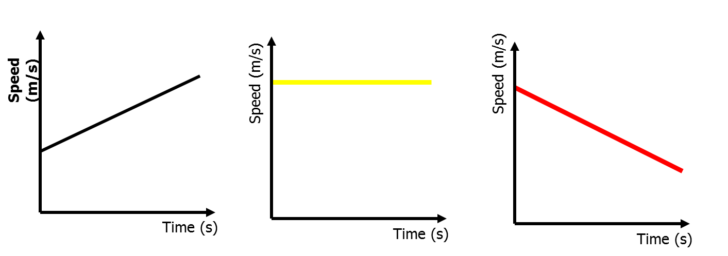

* If the object is travelling in a straight line the gradient of a speed time graph (steepness) tells us the acceleration of the object. The steeper the graph (bigger the gradient) the greater the acceleration.
* the area under the speed time graph tells us the distance travelled or the displacement.