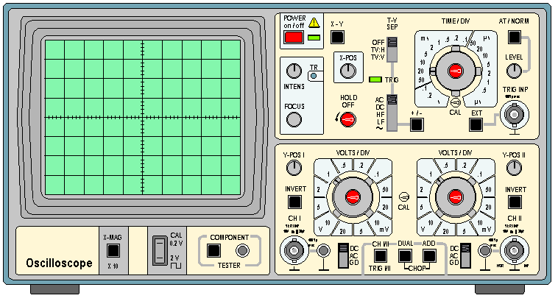Oscilloscope Traces.

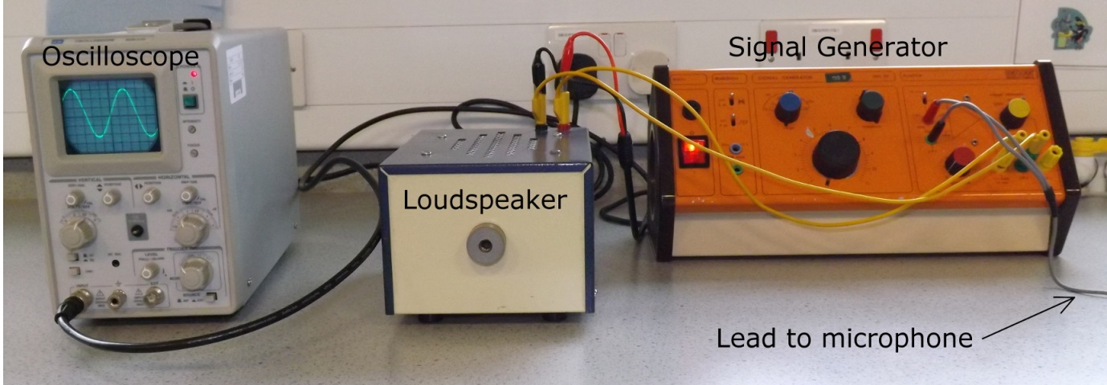

**Copy**

**An oscilloscope** is a type of electronic test instrument that **graphically displays** **varying signal voltages**.(shows a graph of the change in voltage)

It can be used to **display sound signals** after they've been **converted** to an **electrical signal by a microphone**. The **longitudinal sound waves** are **converted** to **transverse waves** and displayed on a screen.

The energy change would be

Sound ⇒ electrical ⇒ light

As we can’t currently do the practical you can try it for yourself.

# Academo

<https://academo.org/demos/virtual-oscilloscope/>

Start by setting the input to a sine wave.

Change the frequency and record what happens to the trace.

The gain acts like an amplifier for louder sounds.

Leave the seconds/div button.

Volts/div changes the sensitivity.

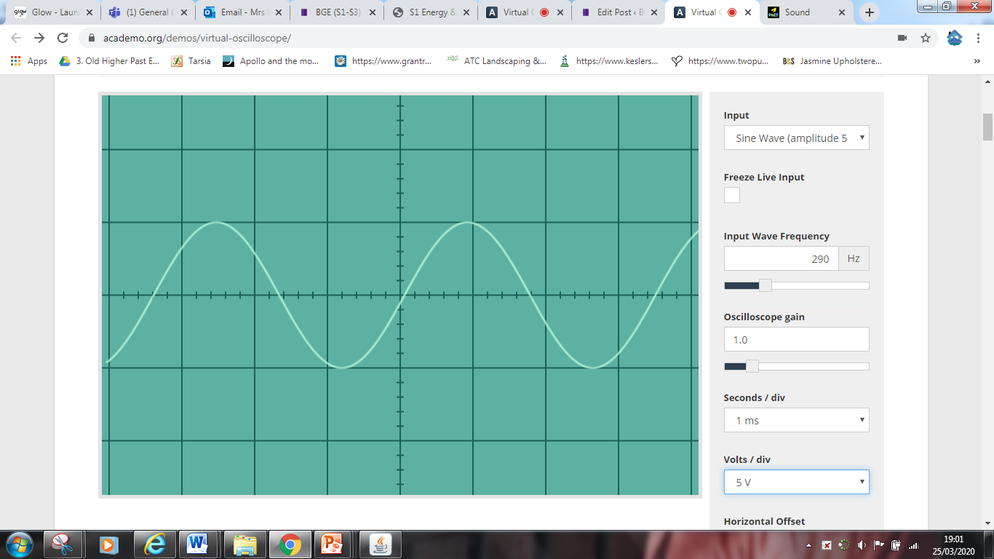

Now on the sheet below (print it out or use your jotter) draw the traces on the worksheet.

Then change the Input to LIVE INPUT (5V peak max) and see what happens to the trace on the oscilloscope. You might need to change the

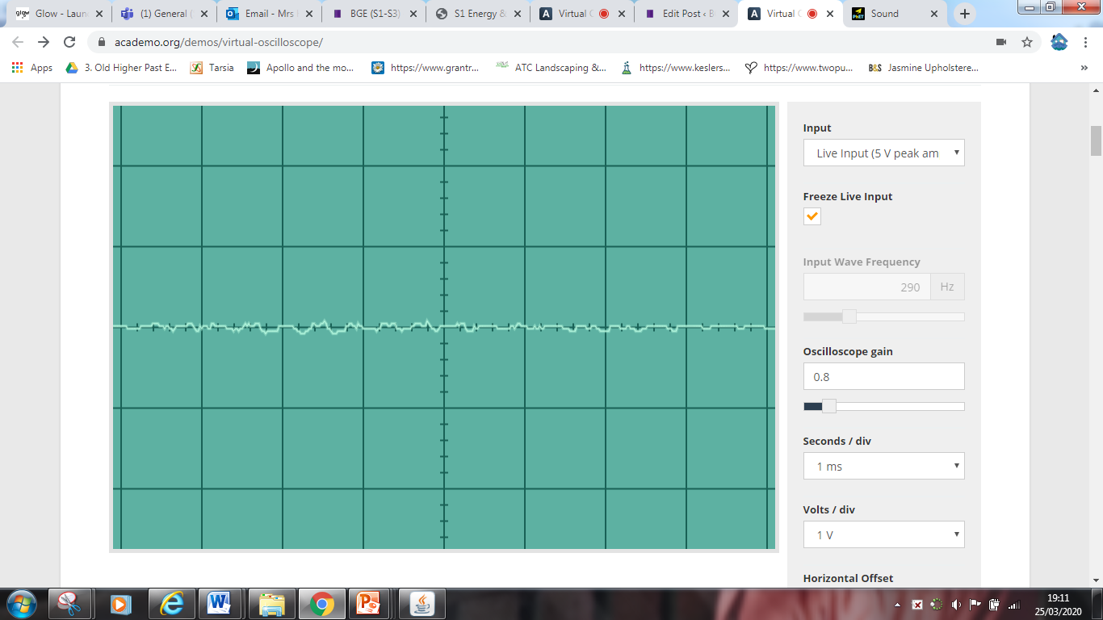

Complete the worksheet below

Using the grids on the other side of the page draw the patterns for the following sounds.

All diagrams should be drawn using the original pattern as the starting point.

1. A higher frequency with a quieter sound.

2. A louder sound with lower pitch.

3. A note of the same pitch which is louder.

4. A note of one octave higher with the same loudness.

# Phet Colarado Physics

<https://phet.colorado.edu/en/simulation/legacy/sound>

Set this demo to LISTEN TO SINGLE SOURCE

Set the Audio Control to Speaker

Adjust the frequency and look what happens to the wavelength of the waves

Adjust the amplitude and see what happens to the movement of the loudspeaker

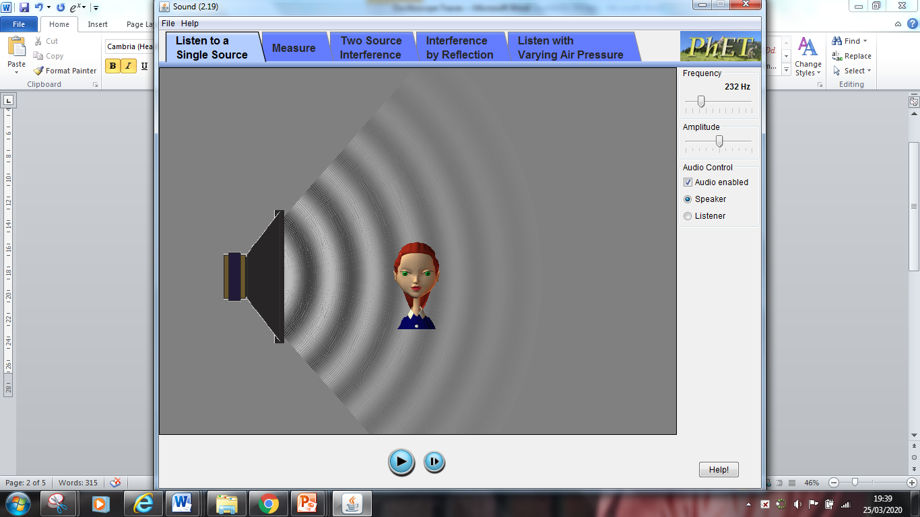

# Virtual Int 1 (available on TEAMS only) Ask your Physics Teacher if you live in Scotland

DON’T OPEN THE FOLDER, BUT OPEN THE DIAMOND, Open the SOUND and MUSIC section

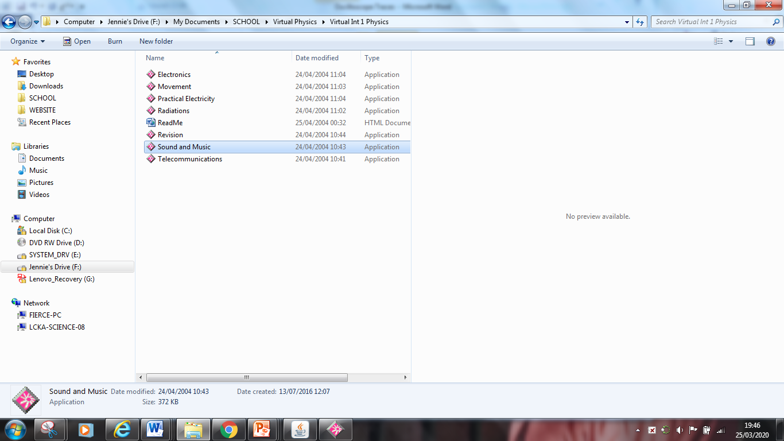

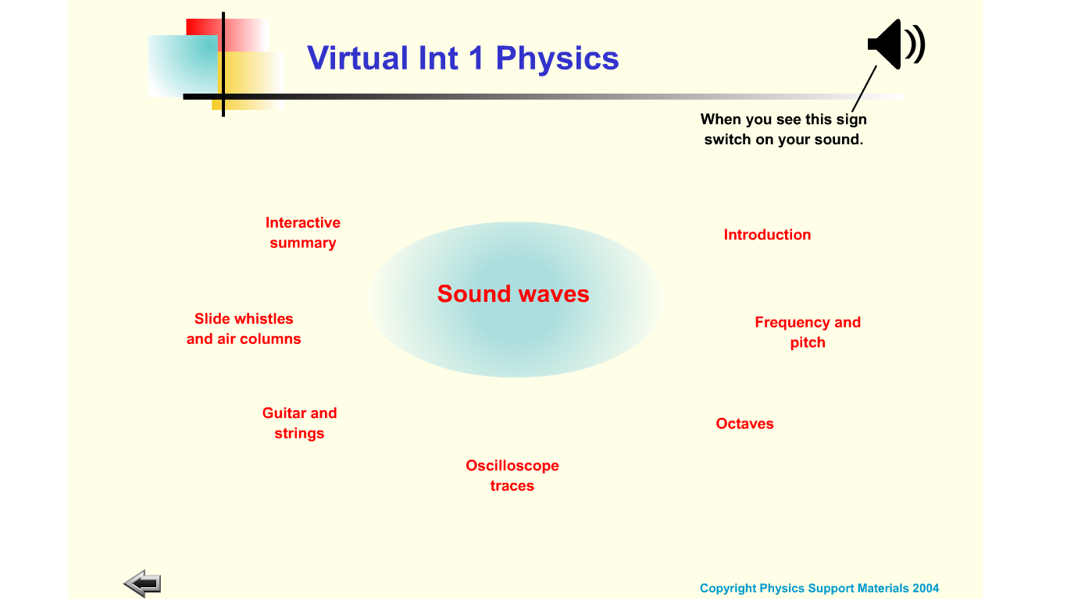

Turn on your sound

Read the introduction Section.

Go through the Frequency and Pitch section

Next do the Oscilloscope Traces

Finally look at what an octave is for a Physicist. Brilliant isn’t it!.

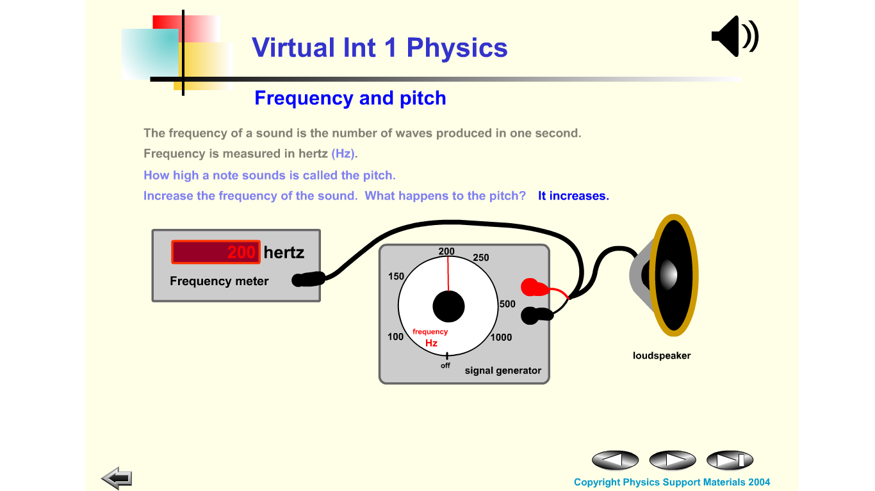

**Looking At Sound Waves Worksheet**

Normal Sound Wave Waves an octave apart

Higher Volume, Same Pitch Lower Volume, Same Pitch

Same Volume, Higher Pitch Same Volume, Lower Pitch

sound and patterns sheet

|  |  |
| --- | --- |
| Original Pattern | |
|  | |
| Pattern A | Pattern B |
|  |  |
| Pattern A Represents a sound with __________ frequency and ___________ loudness. | Pattern B Represents a sound with __________ frequency and ___________ loudness. |
|  | |
| Pattern C | Pattern D |
|  |  |
| Pattern C Represents a sound with __________ frequency and ___________ loudness. | Pattern D Represents a sound with __________ frequency and ___________ loudness. |

Answers up next week! Don’t cheat but check them off when you’ve done the work. Please contact me via the website or GLOW for assistance.

There is graph paper on mrsphysics if you need it

<https://www.mrsphysics.co.uk/advanced/wp-content/uploads/2016/06/multiwidth-graph-grey.pdf>